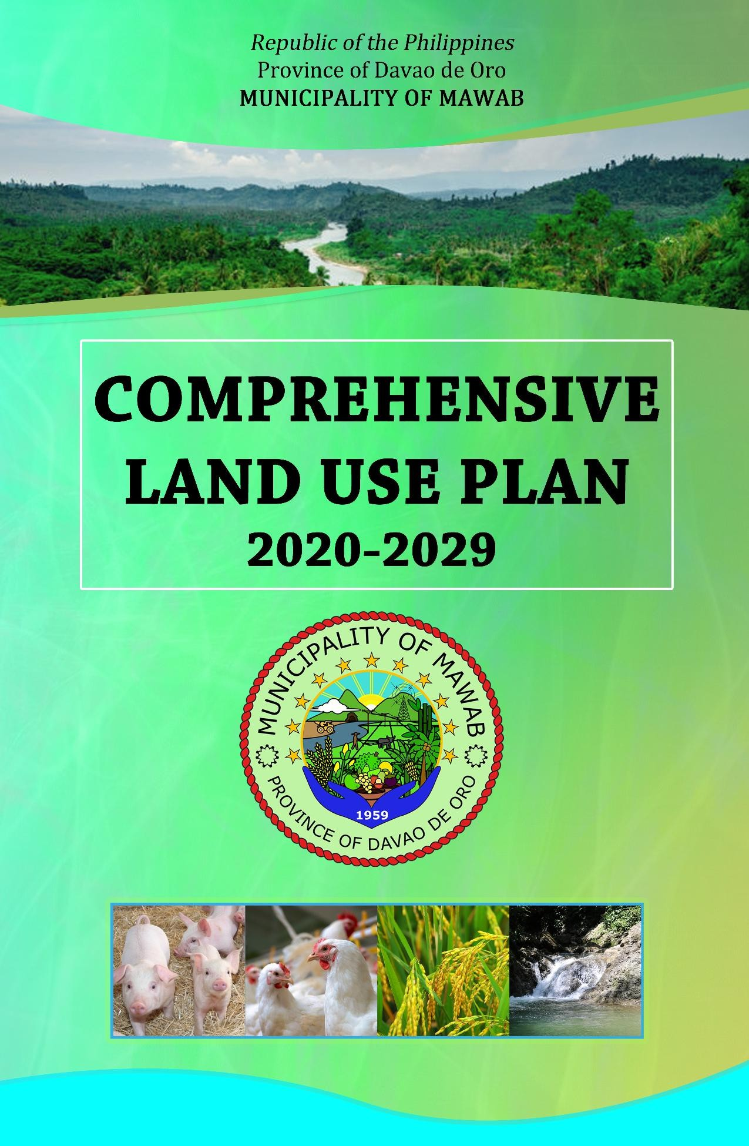

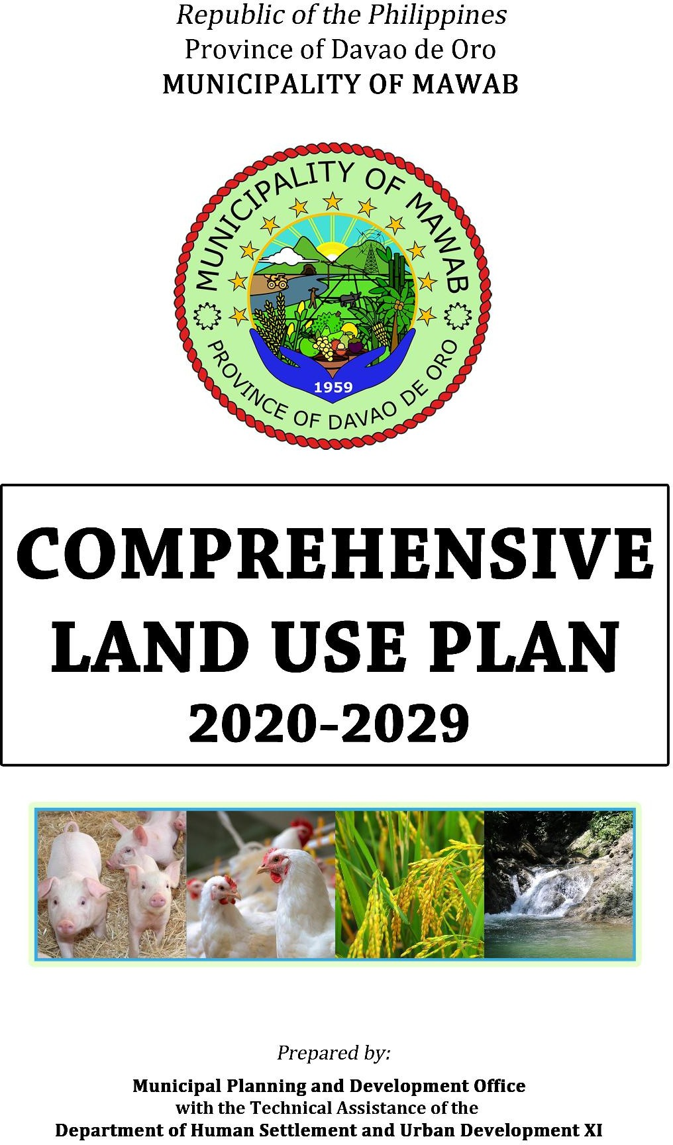

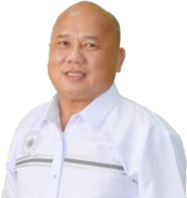

Republic of the Philippines Province of Davao de Oro Municipality of Mawab

**OFFICE OF THE MUNICIPAL MAYOR**

### MESSAGE

Greetings!

This nine (9) year **Comprehensive Land Use Plan** (**CLUP**) is a document purposely prepared to serve as a guide for the Municipality of Mawab to propel sustainability in the aspect of sectoral enlistment and development.

This is a product of tireless, exhaustive gathering of data and massive documentation by the Municipal Planning and Development Office (MPDO) Staff, the Technical Working Group/Planning Team, Technical staff and the different stakeholders. They have untiringly and unselfishly share their talents. All line agencies, non-government organizations, peoples’ organization and heads of the government office equally give their unselfish time and effort in providing data to make this Land Use Plan possible.

With this accomplishment, we submit ourselves to the Divine Providence of our Almighty who never fails in giving us his supreme guidance on the smooth and efficient implementation of this thrust in improving the living standard of our people.

RUPERTO S. GONZAGA, III

Municipal Mayor

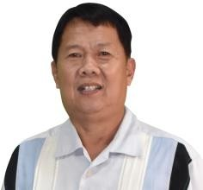

Republic of the Philippines Province of Davao de Oro Municipality of Mawab

**OFFICE OF THE MUNICIPAL VICE-MAYOR**

### MESSAGE

The idea of coming up of a Comprehensive Land Use Plan (CLUP) put into a document as ready – reference and blue print is loudable and worth praising. It is a cohesive force that guides and unites society. It mirrors the ethical standards of our chosen leaders.

The process of pouring and collating bright ideas from various stakeholders manifests participatory democracy an ingredient of good governance.

The enactment into law adopting the Comprehensive Land Use Plan (CLUP) 2020-2029 calls for partnership. It is designed to promote oneness in vision and therefore holds strength, a factor for development.

Our municipality's vision-mission statement synthesizes aggressiveness of our elected officials. It is a yoke too heavy to carry but becomes lighter because of our unified effort and force.

As team captain of the legislative body and with the guidance of the holy providence, I am duty bound to anchor our ship of dreams into reality.

Congratulations to the CLUP Technical Working Group/Planning Team for their shared- talents in making this document available.

Let this paper be a guiding light to make Mawab a beautiful, bountiful, and progressive community by the year 2020 and thereafter...

RUPRIO S. GONZAGA

Municipal Vice-Mayor

****Republic of the Philippines Province of Davao de Oro **MUNICIPALITY OF MAWAB**

MUNICIPAL DEVELOPMENT COUNCIL (MDC)

**EXCERPT FROM THE MINUTES OF THE MUNICIPAL DEVELOPMENT COUNCIL (MDC) MEETING, HELD AT THE OFFICE OF THE BARANGAY HALL,BARANGAY POBLACION, MAWAB, DAVAO DE ORO ON APRIL 27, 2021.**

Present:

**MR. ELITO E. ESUERTE** - PTA Fed. President/MDC Co-Chairperson

**HON. BONIFACIO E. MONLEON** - Committee on Finance and Appropriation/SB

MDC Member

**HON. ALEJANDRO C. DUGOY** - Punong Barangay, Saosao/MDC Member **HON. ALEX D. SEBASTIAN** - Punong Barangay, Malinawon/MDC Member **HON. ANECITO M. MOTO** - Punong Barangay, Concepcion/MDC Member **HON. ROLANDO A. GONO** - Punong Barangay, Tuboran/MDC Member **HON. DANNY O. PLAZO** - Punong Barangay, Andili/MDC Member **HON. CHARLES S. COLEGADO** - Punong Barangay, Nueva Visayas/MDC

Member

**MS. JULIETA L. APUTAN** - VRP Coordinator/MDC Member

**MS. MA. MIRASOL C. LICO** - SEA-K Happiness Rice and Corn Grits &

Gen. Merch/MDC Member

**MS. IRENE M. PELANDAS** - Sta. Monica Small Farmers Assoc./MDC

Member

**MS. JOVITA M. MOTO** - Mawab Teachers MPC/MDC Member

**MS. ROWENA E. CORPUS** - Pantawid Pamilya Parent Leader/MDC

Member

Also Present:

**HON. JOVELYN M. MEJORADA** - Brgy. Kagawad, Brgy, Sawangan Rep.

**MS. ROSIE ASIDERO** - BHW Representative

**MR. AMELITO S. LUCAS** - Municipal Accountant/LFC Member

**MS. MARIVIC S. OBEÑITA** - Budget Officer 1/MBO-Designate/LFC

Member

**MS. MENCHIE I. RAÑISES** - Executive Assistant 1/LFC Member **MS. ANGEL MARGRETHE B. MONLEON -** Supply Officer II/LFC Member **MR. DALE S. ENARGAN** - Accountant I/LFC Member

**MS. BEATRIZ C. MAGBANUA** - Clerk/MEO

**MS. EVITA E. CAUSING** - MCOW Multi-Purpose Cooperative Rep.

**MR. ROLAND JOSE E. ESCANLAR** - MDC Secretary/MPDC

**MS. BETHLEHEM M. BAUTISTA** - Planning Officer I **MS. FEVELYN B. MANDAFE** - Statistician Aide **MR. JANN RAE P. BALTAZAR** - GIS Mapper

**MR. ROMMEL T. JUINIO** - EMS II

**MS. JEANY U. VELARDE** - MPDO Staff

On official Business:

**HON. RUWEL PETER S. GONZAGA** - District II Representative

**HON. RUPERTO S. GONZAGA, III** - Municipal Mayor/MDC Chairperson

**HON. SILVESTRE R. APIT** - Punong Barangay, Nuevo Iloco/MDC

Member

**HON. MONIQUE BRYAN D. GONZAGA** - Punong Barangay, Poblacion/MDC Member

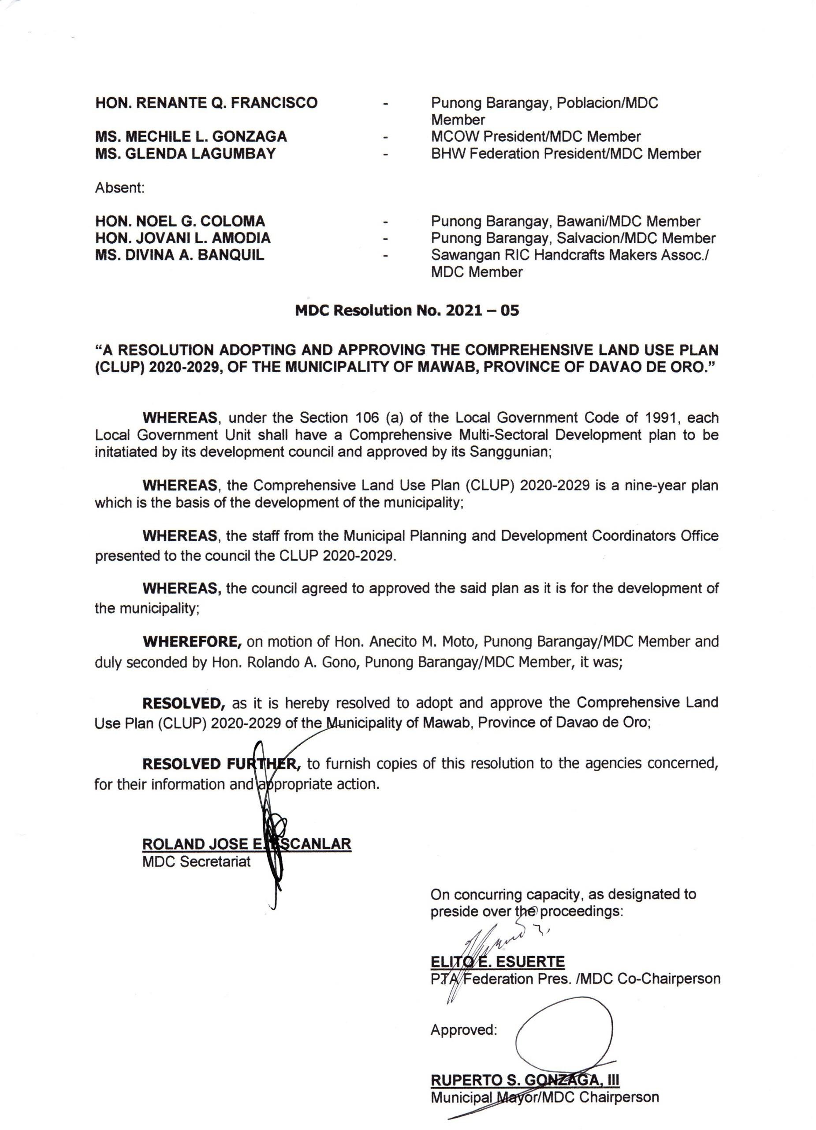

Republic of the Philippines

Province of Davao de Oro

**OFFICE OF THE SANGGUNIANG BAYAN**

Municipality of Mawab

“EXCERPT FROM THE MINUTES OF THE 20TH REGULAR SESSION OF THE YEAR 2022, OF THE 20TH COUNCIL OF THE MUNICIPALITY OF MAWAB, PROVINCE OF DAVAO DE ORO, HELD AT THE SB SESSION HALL ON DECEMBER 5, 2022”.

**PRESENT: HON. RUPRIO S. GONZAGA**, Vice Mayor, Presiding Officer

**HON. BOB R. MIRASOL**, Sangguniang Bayan Member

**HON. ERNIE G. TAN**, Sangguniang Bayan Member

**HON. ROLAND C. ESPINA**, Sangguniang Bayan Member **HON. AMADEO R. ESUERTE, JR.**, Sangguniang Bayan Member **HON. ROLANDO N. MILARAN**, Sangguniang Bayan Member **HON. JURISMAE JERMIA-LOMANTAS**, Sangguniang Bayan Member **HON. SILVESTRE R. APIT**, SB Member/ABC President

**HON. MARJORIE J. DONATO**, SB Member/IP Representative

ABSENT:

**HON. MYRILL L. APIT**, Sangguniang Bayan Member (On Official Business)

**HON. ESTRELLA L. ESTOISTA**, Sangguniang Bayan Member (On Official Business)

**HON. RICKY JOHN R. COQUILLA**, SB Member/SKMF President

(On Sick Leave)

**RESOLUTION NO. 2022-087**

“A RESOLUTION TO APPROVE AND ADOPT THE COMPREHENSIVE LAND USE PLAN (CLUP) 2020-2029, OF THE MUNICIPALITY OF MAWAB, DAVAO DE ORO”.

**WHEREAS,** on December 3, 2022, the office of the Secretary to the Sanggunian received a Letter from the Local Chief Executive dated November3, 2022, endorsing Municipal Development Council (MDC) Resolution No. 2021-05, in re: “A Resolution Adopting and Approving the Comprehensive Land Use Plan (CLUP) 2020-2029, of the Municipality of Mawab, Province o Davao de Oro, was presented to the body for legislative action;

**WHEREAS,** this matter was calendared last December 5, 2022, at the 20th Regular Session of the year 2022, of the 20th Council;

**WHEREAS**, the Committee on Housing & Land use, to which this matter was referred to, favorably recommends its approval, under Committee Report No. 2021-144, dated August 31, 2021;

**WHEREAS,** Section 20 of Republic Act No. 7160, paragraph c, states that the local government units shall, in conformity with existing laws, continue to prepare their respective CLUP enacted through zoning ordinances which shall be the primary and dominant bases for the future use of land resources;

**WHEREAS,** Section 447 (a) (2) (vii), states that the sangguniang bayan, as the legislative body, shall adopt a CLUP for the municipality; provided that the formulation, adoption, or modification of said plan shall be in coordination with the approved provincial comprehensive land use plan;

**WHEREAS,** the Body considered to approve said measure, considering that it was already reviewed by the PLUC under PLUC Resolution No. 1, Series of 2022;

**WHEREAS,** the Committee on Housing and Land Use, to which this matter was referred to, favorably recommends its approval, under Committee Report No. 2022-080, dated December 5, 2022;

**WHEREFORE**, on motion of Kgd. Jurismae Jermia-Lomantas, duly seconded by Kgd.

Rolando N. Milaran, Kgd. Ernie G. Tan and Kgd. Roland C. Espina, it was;

**RESOLVED**, as it is hereby resolved, **TO APPROVE AND ADOPT THE COMPREHENSIVE LAND USE PLAN (CLUP) 2020-2029, OF THE MUNICIPALITY OF MAWAB, DAVAO DE ORO.**

CARRIED . . .

**I HEREBY CERTIFY** to the correctness of the above-quoted resolution.

JOSEPHINE C. BUEMIL

Attested: Secretary II

(Acting Sec. to the Sanggunian)

RUPRIO S. GONZAGA

Vice Mayor (Presiding Officer)

Approved:

RUPERTO S. GONZAGA III

Municipal Mayor

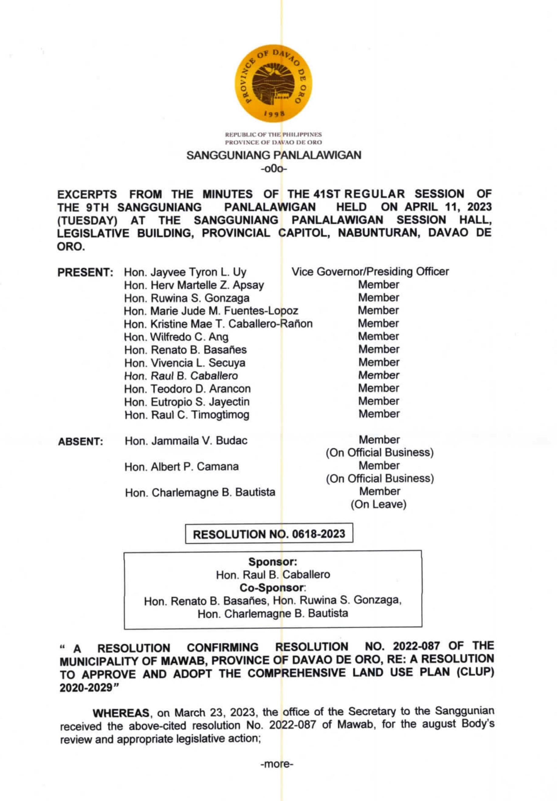

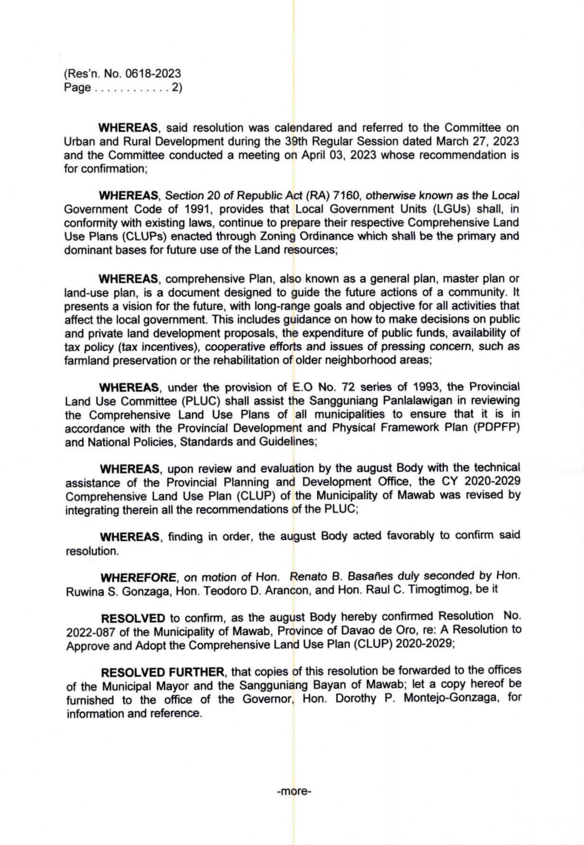



### FOREWORD

The Municipality of Mawab has gone a long way since its modest beginning in 1960s. Its simple beginning has put forth a great challenge to the leaders to provide development and progress to the constituents. From a sleepy town, in-migrants from Luzon, Visayas and nearby areas in Mindanao, settled in Mawab. This paved to development as one of the agricultural production areas in the province of Davao de Oro.

The re-modelling of the direction of the municipality is essentially becoming urgent. Hence, this nine-year Comprehensive Land Use Plan (CLUP) of the Municipality of Mawab for the year 2020-2029 is enshrined.

The plan unifies and strengthens the development activities of the municipality at all levels: executive, legislative, barangay, implementing agencies and the different stakeholders. The CLUP of the Municipality of Mawab harnesses the collective experiences and the respective programs in order to respond to the key concerns and issues of the people who will assist in effectively implementing genuine development.

It is our final hope that this plan will inspire the different stakeholders to the pursuit of development that is consistent with the needs and aspirations of peace and a better life for the people of Mawab.

RUPERTO S. GONZAGA, III

Municipal Mayor

#### ACKNOWLEDGEMENT

The Municipal Planning and Development Office (MPDO) and the Technical Working Group/Planning Team expresses their heartfelt appreciation to the following agencies, institutions and individuals for their dedication, support and cooperation in the completion of this Comprehensive Land Use Plan.

1. Heads of the Local and National Offices
2. Members of the SB Land Use Committee
3. National Mapping and Resource Information Authority (NAMRIA)
4. Philippine Statistics Authority (PSA)
5. Department of Environment and Natural Resources (DENR)
6. Mines and Geosciences Bureau (MGB)
7. Philippine Institute of Volcanology and Seismology (PHIVOLCS)
8. Philippine Atmospheric, Geophysical and Astronomical Services Administration (PAGASA)
9. Department of Public Works and Highways (DPWH)
10. Department of Education (DepEd)
11. Department of Agrarian Reform (DAR)
12. Department of Agriculture (DA)
13. National Irrigation Administration (NIA)
14. Provincial Planning and Development Office (PPDO)
15. Philippine National Police (PNP)
16. Bureau of Soil and Water Management (BSWM)
17. Members of the Provincial Land Use Committee
18. Northern Davao Electric Cooperative (NORDECO)
19. Weather Bureau, DOST, PAGASA, Region XI
20. Other agencies

A special recognition is given to the Honorable Congressman Ruwel Peter S. Gonzaga who vouched his support for the CLUP preparation for the assistance and encouragement.

A special recognition is similarly accorded to the Department of Human Settlements and Urban Development (DHSUD) – Region XI through its Regional Director, Atty. RM Miguel T. Palma Gil, staff and technical experts, Ms. Jovita G. Solarte, Ms. Eden Santiago, Mr. Iyarmoon G. Dulay and the rest of the DHSUD team.

Finally, a sincere gratitude is given to all individuals, offices institutions who in one way or another contributed in the completion of this 2020-2029 Comprehensive Land Use Plan.

##### TABLE OF CONTENTS

CONTENTS PAGE

**NO.**

Message i

Resolution Adopting the CLUP and enacting the ZO v

Foreword vii

Aknowledgement viii

Table of Contents ix

List of Tables xii

List of Maps xiv

List of Acronyms xvi

Exectuvie Summary xviii

CHAPTER I PROFILE OF THE MUNICIPALITY

* 1. Historical Background 2
  2. Human Resource/Demographic Profile
     1. Population Composition By School-Age, Working Age, 5

Dependent Age Group And Sex

* + 1. Population Distribution By Age Group And Sex 5
    2. Urbanization Levels For The Past 35 Years 7
    3. Household Population By Urban And Rural Barangay And 8

Average Household Size

* + 1. Population Density By Barangay 9
    2. Historical Growth Of Population 11
    3. Crude Birth Rate (CBR) And Crude Death Rate (CDR) For 13

The Past Five Years

* + 1. Literacy Rate Of Population 10 Years Old And Over, By 13

Sex

* + 1. Mother Tongue Distribution Among Households 13
    2. Population By Religious Affiliation 15
    3. Inventory Of Religious Establishments 15
    4. Labor Force Population By Sex And Employment Status 18
    5. Overseas Workers 18
    6. Household Population 5 Years Old And Over By Highest 19

Educational Attainment

* + 1. Population Projection 20
  1. Physical Features 23
     1. Geographical Location 23
     2. Land Area by Barangay 23
     3. Land Classification 23
     4. Climate 28
     5. Topography/Slope 30
     6. Basic Soil Type 35
     7. Hydrogeologic or Geologic Study 35
     8. Watershed 38

CONTENTS PAGE

NO.

* + 1. Flood Prone Areas 38
    2. Erosion Area/s/Erosion Potential 39
    3. Liquefaction Susceptibility Areas 39
    4. Land Capability Studies 40
    5. Soil Suitability Studies 40
  1. Hazard Profile 50
     1. Inventory of Hazard 50
     2. Records of Previous Disaster 51
     3. Likelihood of Occurrence 52
  2. Physical/Infrastructure Resources 53
     1. Transportation Network (Internal and External Linkages) 53
     2. Social Services Facilities/Utilities/Amenities 56
     3. Utilities 62
     4. Water 65
     5. Waste Management 65
  3. The Economic Structure 67
     1. Revenue Sources on Agriculture, Industries, Commerce 67

and Trade, Tourism

* + 1. Employment 67
    2. Average Family Income & Expenditures vis-à-vis poverty 67

level

* 1. Existing Land and Water Use 68
  2. Land Use Trend 84
     1. Comparative data on existing land uses 84

(previous and current)

* 1. Comparative/Competitive Advantages 85
  2. Priority Issues And Concerns (Weaknesses) 86

CHAPTER II THE LAND USE PLAN

* 1. The Comprehensive Land Use Plan 88
  2. VISION 91
  3. MISSION 91
  4. GOALS 91
     1. Ecosystem Analysis 91
     2. Sectoral Studies 91
        1. Economic 91
        2. Social 92
        3. Infrastructure 92
        4. Special Studies 93

CONTENTS PAGE

NO.

* 1. OBJECTIVES 93
     1. Ecosystem Analysis 93
     2. Sectoral Studies 93
        1. Economic 93
        2. Social 95
        3. Infrastructure 97
        4. Special Studies 98
  2. SCALOGRAM 99
  3. URBANIZATION AND SETTLEMENT PATTERN 102
     1. Existing Settlement Pattern 102
     2. Proposed Settlement Pattern 103
  4. THE LAND USE PLAN 106
  5. DEVELOPMENT THRUST AND SPATIAL STRATEGY 114
     1. Alternative Development Thrusts/Strategy 114
        1. Alternative 1- Agricultural Development 114
        2. Alternative 2- Commercial Development 114
        3. Alternative 3- Agri-Industrialization Development 114
     2. Evaluation of Alternative Thrusts/Strategies Using Goal Achievement Matrix

114

* + 1. Preferred Development Thrust and Spatial Strategy 118

THE CONCEPT/STRUCTURE PLAN OF THE MUNICPALITY

**2.9**

124

* 1. BALANCING LAND SUPPLY AND DEMAND 125
     1. Available Land Supply 125
     2. Additional Area Requirement 127
     3. Strategic Interventions for the Availability of Lands 130
  2. THE PROPOSED LAND AND WATER USE ANALYSIS 131
  3. LAND USE POLICIES 146
  4. PRIORITY PROGRAMS AND PROJECTS 150
     1. Ecosystem Analysis: Forest and Water Bodies 150
     2. Sectoral Studies 150
        1. Economic 150
        2. Social 151
        3. Infrastructure 154
        4. Special Studies 155

Plan Implementation Scheme 156

Monitoring And Evaluation 161

##### LIST OF TABLES

|  |  |  |
| --- | --- | --- |
| **TABLE NO.** | **TITLE** | **PAGE NO.** |
| 1 | Population Composition by School-Age, Working-Age, Dependent-Age | 5 |
| 2 | Group And Sex  Population Distribution by Age Group and Sex | 5 |
| 3 | Urbanization Level for the Past 35 years | 7 |
| 4 | Household Population by Urban and Rural Barangay and Average | 8 |
| 5 | Household Size  Population Density per Barangay | 9 |
| 6 | Historical Growth of Population, Year 2015 | 11 |
| 7 | Crude Birth Rate and Crude Death Rate for the Past 5 Years | 13 |
| 8 | Literacy Rate of Population 10 years old and Over, by Sex | 13 |
| 9 | Household Population by Mother Tongue | 14 |
| 10 | Population by Religious Affiliations | 15 |
| 11 | Inventory of Religious Establishments | 15 |
| 12 | Labor Force Population by Sex and Employment Status | 18 |
| 13 | Comparative Data of Overseas Workers | 18 |
| 14 | Household Population 5 years old and over by Highest Educational | 19 |
| 15 | Attainment  Projected Population and Household | 20 |
| 16 | Projected Population by Barangay, Year 2020-2029 | 21 |
| 17 | Projected School-Going Age Population, Labor Force | 22 |
| 18 | Doubling Time of Growth Rate Population | 22 |
| 19 | Land Area by Barangay | 23 |
| 20 | Land Area by Percent Slope (in hectares) | 30 |
| 21 | Elevation Class by Area | 31 |
| 22 | Basic Soil Type Land Area and Location | 35 |
| 23 | Hydrogeologic Type by Area | 36 |
| 24 | Geologic Type by Area | 36 |
| 25 | Watershed by Barangay | 38 |
| 26 | Flooding Susceptibility by Land Area | 39 |
| 27 | Landslide Susceptibility by Land Area | 39 |
| 28 | Liquefaction Susceptibility Areas | 39 |
| 29 | Soil Suitability by Types of Use and By Barangay | 41 |
| 30 | Soil Suitability Study | 41 |
| 31 | Inventory of Hazards and their description | 50 |
| 32 | Records of Previous Disasters | 51 |
| 33 | Likelihood of Occurrence of Hazard per Barangay | 52 |
| 34 | Road Network System, Year 2018 | 53 |
| 35 | Bridge and Other Transportation Facilities | 53 |
| 36 | Number of Social Services Facilities | 56 |
| 37 | Power Facilities | 62 |

**TABLE NO.**

**TITLE PAGE**

**NO.**

1. Communication Facilities 62
2. Water Facilities 65
3. Inventory of Waste Disposal Facilities/Equipment 65
4. Existing Land and Water Uses, 2019 Municipality of Mawab 70
5. Existing Land and Water Uses by Barangay, Year 2019 71
6. Comparative General Land Use Plan 84
7. Existing Settlement Pattern 103
8. Proposed Settlement Pattern 103
9. Development Constraints Areas 108
10. Biophysical Environment Matrix 110
11. Constraints Areas vs. Available Land Supply 125
12. Additional Urban Land Area Requirement 127
13. Proposed Land and Water Uses, 2020-2029 132
14. Proposed Land and Water use By Barangay, 2020-2029 133
15. Review of Organization Structure and Support 156
16. Proposed Composition of Multi-Sectoral Monitoring Body 161

##### LIST OF MAPS

|  |  |  |
| --- | --- | --- |
| **FIGURE NO.** | **TITLE** | **PAGE NO.** |
| 1 | Population Density Map | 10 |
| 2 | Map of Region IX Showing the Province of Davao de Oro | 24 |
| 3 | Map of Davao de Oro Showing the Municipality of Mawab | 25 |
| 4 | Municipal Map Showing the Barangays | 26 |
| 5 | Land Classification Map | 27 |
| 6 | Climate Map | 29 |
| 7 | Topographic Map | 32 |
| 8 | Slope Map | 33 |
| 9 | Elevation Map | 34 |
| 10 | Soil Map | 42 |
| 11 | Hydrologic Map | 43 |
| 12 | Watershed Areas Map | 44 |
| 13 | Flood Susceptibility Map | 45 |
| 14 | Landslide Susceptibility Map | 46 |
| 15 | Fault Line Map | 47 |
| 16 | Liquefaction Susceptibility Map | 48 |
| 17 | Soil Suitability Map | 49 |
| 18 | Road Network and Bridges Map | 54 |
| 19 | Transportation Facilities Map | 55 |
| 20 | Health and Sanitation Facilities Map | 57 |
| 21 | Education Facilities Map | 58 |
| 22 | Social Welfare Services Facilities Map | 59 |
| 23 | Protective Services Facilities Map | 60 |
| 24 | Sports and Recreation Facilities Map | 61 |
| 25 | Power Facilities Map | 63 |
| 26 | Information and Communication Technology Facilities Map | 64 |
| 27 | Water Facilities Map | 66 |
| 28 | General Existing Land and Water Use Map | 72 |
| 29 | Existing Land and Water Use Map of Barangay Andili | 73 |
| 30 | Existing Land and Water Use Map of Barangay Bawani | 74 |
| 31 | Existing Land and Water Use Map of Barangay Concepcion | 75 |

|  |  |  |
| --- | --- | --- |
| **FIGURE NO.** | **TITLE** | **PAGE NO.** |
| 32 | Existing Land and Water Use Map of Barangay Malinawon | 76 |
| 33 | Existing Land and Water Use Map of Barangay Nueva Visayas | 77 |
| 34 | Existing Land and Water Use Map of Barangay Nuevo Iloco | 78 |
| 35 | Existing Land and Water Use Map of Barangay Poblacion | 79 |
| 36 | Existing Land and Water Use Map of Barangay Salvacion | 80 |
| 37 | Existing Land and Water Use Map of Barangay Saosao | 81 |
| 38 | Existing Land and Water Use Map of Barangay Sawangan | 82 |
| 39 | Existing Land and Water Use Map of Barangay Tuboran | 83 |
| 40 | Existing Settlement Pattern Map | 104 |
| 41 | Proposed Settlement Pattern Map | 105 |
| 42 | Development Constraints Map | 109 |
| 43 | Structure/Concept Plan Map | 126 |
| 44 | General Proposed Land and Water Use Map | 134 |
| 45 | Proposed Land and Water Use Map of Barangay Andili | 135 |
| 46 | Proposed Land and Water Use Map of Barangay Bawani | 136 |
| 47 | Proposed Land and Water Use Map of Barangay Concepcion | 137 |
| 48 | Proposed Land and Water Use Map of Barangay Malinawon | 138 |
| 49 | Proposed Land and Water Use Map of Barangay Nueva Visayas | 139 |
| 50 | Proposed Land and Water Use Map of Barangay Nuevo Iloco | 140 |
| 51 | Proposed Land and Water Use Map of Barangay Poblacion | 141 |
| 52 | Proposed Land and Water Use Map of Barangay Salvacion | 142 |
| 53 | Proposed Land and Water Use Map of Barangay Saosao | 143 |
| 54 | Proposed Land and Water Use Map of Barangay Sawangan | 144 |
| 55 | Proposed Land and Water Use Map of Barangay Tuboran | 145 |

**List of Acronyms**

A.O - Administrative Order

ADSDPP - Ancestral Domain Sustainable Development and Protection Plan AFMA - Agricultural and Fishery Modernization Act

AFP - Armed Forces of the Philippines

BP - Batas Pambansa

BSWM - Bureau of Soil and Water Management CADT - Certificate of Ancestral Domain Title CARL - Comprehensive Agrarian Reform Law CARP - Comprehensive Agrarian Reform Program

CBFM - Community-Based Forest Management Progress CBMS - Community-Based Monitoring System

CBR - Crude Birth Rate

CDR - Crude Death Rate

CDRA - Climate and Disaster Risk Assessment CIDA - Canadian Integrated Development Agency CLUP - Comprehensive Land Use Plan

CSO - Civil Society Organization

CZC - Certificate of Zoning Compliance DA - Department of Agriculture

DAR - Department of Agrarian Reform DEM - Digital Elevation Model

DENR - Department of Environment and Natural Resources DENR - Department of Environment and Natural Resources

DHSUD - Department of Human Settlements and Urban Development DOT - Department of Tourism

DPWH - Department of Public Works and Highways DRRM - Disaster Risk Reduction and Management DTI - Department of Trade and Industry

E.O - Executive Order

FDG - Focus Group Discussion

GIS - Geographic Information System

HLURB - Housing and Land Use Regulatory Board HSRC - Human Settlement Regulatory

HVCC - High Value Commercial Crops IP - Indigenous People

LC - Locational Clearance

LCE - Local Chief Executive

LDC - Local Development Council

LDIP - Local Development Investment Program LGSP - Local Government Support Program LGU - Local Government Unit

LPA - Low-Pressure Area

LZRC - Local Zoning and Review Committee MAO - Municipal Agriculture Officer MAGRO - Municipal Agriculture Office

MC - Memorandum Circular

MDRRMO - Municipal Disaster Risk Reduction and Management Office MENRO - Municipal Environment and Natural Resources Office

MEO - Municipal Engineering Office MGB - Mines and Geosciences Bureau MHO - Municipal Health Office

MIO - Municipal Information Office

MOA - Memorandum of Agreement MOU - Memorandum of Understanding MPB - Multi-Purposed Building

MPDO - Municipal Planning and Development Office MPH - Multi-Purposed Hall

MPRC - Municipal Project Review Committee MRE - Monitoring, Review and Evaluation

NCIP - National Commission on Indigenous Peoples

NDRRMC - National Disaster Risk Reduction and Management Council NEDA - National Economic and Development Authority

NGA - National Government Agencies NGO - Non-Government Organization NGP - National Greening Program

NIA - National Irrigation Administration

NPAA - Network of Protected Agricultural Areas

NPAAD - Network of Protected Agricultural Areas Development NWRB - National Water Resources Board

OFW - Overseas Filipino Worker

P.D - Presidential Decree

PAG-ASA - Philippines Atmospheric, Geophysical and Astronomical Services Administration

PHILVOLCS - Philippine Institute of Volcanology Seismology PLGU - Provincial Local Government Unit

PMC - Project Monitoring Committee

PNP - Philippine National Police POPCEN - Population Census

PR - Participation Rate

PSA - Philippine Statistics Authority

Php - Philippine Peso

RA - Republic Act

RCDG - Reinforced Concrete Deck Girder RDP - Regional Development Plan

RHU - Rural Health Unit

SAFDZ - Strategic Agriculture and Fisheries Development Zone SB - Sangguniang Bayan

SP - Sangguniang Panlalawigan

SPES - Employment of Students

UTM - Universal Transverse Mercator WGS - World Geodetic System

ZO - Zoning Ordinance

**EXECUTIVE SUMMARY**

##### EXECUTIVE SUMMARY

**Vision.** “A progressive, dynamic, ecologically-balanced, peaceful, disaster-resilient, climate change adaptive, gender sensitive Municipality with a sustained agri-industrial and eco-tourism development, where the constituents enjoy a better quality of life by living in a highly urbanized setting with a rural concept, within the context of a participative, democratic governance and principled leadership.”

**Brief Situationer.** The municipality of Mawab has a total population of 37,065, 8,272 households and an average household size of 4.48. The total labor force is 25,343 of which 14,119 or 55.7% are employed while 11,224 or 44.3% are unemployed. Mawab being a rural municipality, agriculture is the highest generator of employment, followed by the commerce and trade as the secondary source of employment. Other sources of income of the residents are from the industry and service establishments.

The municipality has different critical point facilities that caters the different social needs of the constituents. These facilities are Public/Private Elementary Schools, Private Pre-School, Public/Private Secondary Schools, Private Hospitals/Clinics, Health Centers, Day Care Centers, Public Cemeteries, Senior Citizen Buildings, Gawad Kalinga Housing Project. Morbidity rate is at 221 per 1,000 population; About 1.36 percent or 124 households do not have access to sanitary toilet which is one of the targets for sanitation program. For education sector, it has an average of 97.62 percent enrolment participation rate (EPR) for elementary level and an average of 97.74 percent for secondary level in past five school years. For housing concerns, there is about 1,211 housing backlog in 2013 which include the doubled-up households, those living in makeshift salvage/improvised housing units and displaced households. These households are the target of the housing program of the municipality. Though it has 3 resettlement sites, other barangays also need to acquire and develop relocation sites. Social welfare services in the municipality was benefited by the marginalized sectors. A total of 19,244 clients availed of social welfare services in the past years 2016-2019 which includes Women in especially difficult circumstances, Children in need of special protection, pre-schoolers, Reformed Voluntary Surrenderers, Solo Parents, Persons with Disabilities and Senior Citizens. For peace and public safety, it has a decreasing incidence of crime from 94 cases in 2015, 54 cases in 2016, 38 cases in 2017, 28 cases in 2018

and 26 cases in 2019. The crime resolution rate is 95.74% in 2015, 94.44% in 2016, 97.37%

2017 and 100% in 2018 and 2019.

For infrastructure sector, the total road length of the municipality connecting the component 11 barangays is 194.34 kilometers. Out of this road length, 58.366 kilometers or 30% are concreted, 75.827 kilometers or 39% are gravelled and 60.147 kilometers or 31% are earth filled. The municipality has also 26 bridges along the road network. These consist of eight (8) concrete bridges, three (3) bailey bridges, four (4) cable bridges, two (2) wood bridges and nine (9) steel bridges. For power sector, the municipality is directly connected to NORDECO Power Substation in Montevista with average consumption of 19,668 kilowatt-hour per month. Out of 8,334 households, only 6,653 households were served with electricity while 1,681 households remain unserved. These households were located in the far-flung sitios of the 11 barangays. For water services, the source of water supply for drinking and cooking of the 8,334 households were from the following, namely: Own use faucet community water system – 1,100 Hhs.; Shared faucet community water system – 1,712 Hhs.; Own use tubed/piped deep well – 479 Hhs.; Shared tubed/piped deep well – 2009 Hhs.; Tubed/piped shallow well – 469 Hhs.; Dug well – 385 Hhs.; Protected spring – 900 Hhs.; Unprotected spring – 4, Lake, river and rain – 67 Hhs.; Peddler – 870 Hhs.; and Bottled water – 339 Hhs.

For hazard exposure analysis, Barangays Concepcion, Bawani, Malinawon, Poblacion, Saosao and Nuevo Iloco are highly affected by flooding distressing the population, agriculture area, critical point facilities and lifeline utilities. Remaining barangays such as Andili, Nueva Visayas, Salvacion, Sawangan and Tuboran are moderately affected by flooding. For landslide, only barangay Tuboran is at high risk majorly affecting the road network connecting Mawab and Tagum City. Portion of some elements such as population, resource based production areas, urban use areas, critical points facilities and lifeline utilities were also affected.

**Development Constraints**. The constraints of land use development and allocation of the municipality include among others the following: 1). The presence of 1,133.19 hectares of land with 18% slope and in which according to P.D. 389 it should be declared as areas for permanent forest or forest reserves regardless of the condition of vegetable cover. These hectarage of land constitute 6.7 percent of the total 16,952 hectares of the municipality; 2). The presence of CARP covered areas; 3). The presence of 775.30 hectares of flood prone areas which is 4.62 percent of the total flood prone areas of the province and 8.77 percent of the total land area of the municipality; 4.) The presence of fault line traversing barangays Malinawon, Tuboran and Sawangan; 5). The presence of boundary conflict between the municipality of Maco, City of Tagum and Municipality of Nabunturan; 6). The presence of 890.33 hectares irrigated areas which is 86.14 percent of the total rice production area of 1,282.671 hectares; 7). The presence of

203.84 hectares built-up areas.

**Development Opportunities and Challenges.** In the attainment of the vision of Mawab, following opportunities and threats were taken into consideration, to wit: For opportunities – 1. Significant Financial Assistance from National Agencies; 2. Accessibility to Market Centers; 3. High potential agricultural products supplier for Davao de Oro. 4. On-going construction of Provincial road (Sawangan, Mawab to Limbo Maco); 5. Influx of Investors; and 6. Active participation of CSOs, NGOs and POs in the local governance. For threats – 1. High risk flooding at Barangays Bawani, Concepcion, Malinawon, Nuevo Iloco, Poblacion and Saosao; 2. High risk landslide at Barangay Tuboran; 3. Fault line along the national highway from Barangay Sawangan to Poblacion to Malinawon; 4. The existence of mineral processing plant without anti-pollution device; 5. The possible eruption of Lake Leonard; 6. Boundary disputes between the City of Tagum and the Municipalities of Nabuntuiran and Maco; and 7) Siltation due to erosion from denuded forest.

**Development Goals and Objectives**. The following are the goals and objectives of the municipality, to wit: 1) Increase and sustain the food sufficiency level of the municipality employing the modern farming technologies and sustainable farming practices and management under a wholistic agricultural development approach to alleviate and empower the farming communities to raise their socio-economic condition; 2) Provide adequate basic infrastructure facilities and utilities such as transportation, power, communication, water, drainage, and sewerage, and solid and liquid waste disposal to accelerate the socio-economic progress and growth of the municipality and ease the way of living of the populace; 3) Attain and sustain vibrant economy through the establishment of medium scale shopping centers wholesale trade centers, agro-based industries that will generate employment opportunities, fueled by the private investors and other market players/stakeholders firmed up by the LGUs’ business investment incentives, pro-business policies, subsidies, tax holidays and appropriately in-placed infra-support facilities; 4) Establish an eco-friendly environment through proper conservation, preservation and protection and utilization of the natural resources and achieve a sustainable forest management and development; 5) Provide comprehensive delivery of equitable and accessible basic social services in the field of health, education, housing, social welfare, protective, services and sports and recreation that the municipal constituents may full enjoy a quality of life at its best’; 6) Firm up and sustainably maintain effective, efficient and dynamic local governance tailored-fit to the present and future needs of the constituents and the scheme of socio-political development in tandem with the Non-Government Organization (NGO’s), Private Sectors (PS’s) and Cooperatives; 7) Provide Knowledge, Skills and Ability (KSA) Enhancement Training/Workshop for Human Resources Development to become active civil service agents in rendering appropriate and quality public services; 8) Augment police manpower to ensure the safety, peace and order

situation of the municipality that the constituents may live in a peaceful environment; 9) Ensure the preservation and conservation of the socio-cultural heritage in the municipality particularly the cultural practices of the indigenous peoples (lPs’); 10) Improve and develop potential eco- tourism areas in municipality as added come-on for both the local and foreign tourist to boost economic stability; 11) Increase local Revenue Generation to reduce dependence on the Internal Revenue Allotment (IRA) in financing the local government operation and the implementation of various socio-economic projects; and 12) Allocate and appropriately manage municipal land resource equitably to various uses to meet the land requirement of the present and future land development of various sectors;

**Development Thrusts and Spatial Strategy.** The proposed settlement pattern retains Barangay Poblacion as the major growth center throughout the planning period, 3 barangays as Minor Growth Center, namely: Andili, Nuevo Iloco and Malinawon; 2 barangays as Emerging Growth Center like Tuboran and Nueva Visayas; and 5 Satellite Barangays such as Bawani, Concepcion, Salvacion, Saosao and Sawangan. Each category shall function throughout the planning period based of the following:

|  |  |  |  |
| --- | --- | --- | --- |
| **Major Growth Center** | **Minor Growth Center** | **Emerging Growth Center** | **Satellite** |
| Provision of Education and Tertiary Health Services;  Provision of Social and Welfare Services; | Expansion of major growth center;  Provide other services to the lower order centers; | Transition Barangays from satellite to minor growth center;  Provide other  services to the lower order centers; | Agricultural production area/agri- based barangays;  Provision of clay – for pottery making; |
| Center of the economic activities; | Provision of water supply to the populace of Mawab; | Presence of other facilities; | Basic services;  Small stores; |
| Seat of governance; |  |  |  |
| Provision of  Marketing opportunities; |  |  |  |

**Proposed Land and Water Uses and Zoning Ordinance.** This CLUP has determined the specific uses of land for the planning period, to wit:

|  |  |  |  |  |
| --- | --- | --- | --- | --- |
| **Land Use Category** | **Existing** | | **Proposed** | |
| **Area (hectares)** | **% to Total** | **Area (hectares)** | **% to Total** |
| Forest | **4,585.094** | **31.95** | **4,337.845** | **30.23** |
| Easement Area |  |  | **605.392** | **4.22** |
| Agriculture | **8,923.52** | **62.18** | **7,856.548** | **54.76** |
| - Protection | 890.332 | 6.20 | 955.995 | 6.66 |
| - Production | 8,033.188 | 55.98 | 6,900.553 | 48.10 |
| Water | **218.356** | **1.52** | **281.964** | **1.96** |
| - Protection | 200.597 | 1.40 | 269.383 | 1.88 |
| - Production | 17.759 | 0.12 | 12.581 | 0.09 |
| Urban Areas | **560.026** | **3.90** | **1,260.756** | **8.80** |
| - Residential | 81.969 | 14.64 | 417.237 | 2.91 |
| - Socialized Housing | - | - | 22.516 | 0.16 |
| - Commercial | 8.642 | 1.54 | 86.241 | 0.60 |
| - Institutional | 13.888 | 2.48 | 50.697 | 0.35 |
| - Special Institutional | - | - | 96.217 | 0.67 |
| - Agri-Industrial | 8.243 | 1.47 | 137.124 | 0.96 |
| - Industrial | 0.148 | 0.03 | 89.182 | 0.62 |

|  |  |  |  |  |
| --- | --- | --- | --- | --- |
| - Parks and Recreation | 5.647 | 1.01 | 1.122 | 0.01 |
| - Infrastructure | 133.853 | 23.90 | 300.546 | 2.09 |
| - Open Space | 296.546 | 52.95 |  |  |
| - Tourism Area | - | - | 0.615 | 0.004 |
| - Buffer area | - | - | 59.259 | 0.41 |
| Special Uses |  |  |  |  |
| - Cockpit | 0.096 | 0.02 |  |  |
| - Sanitary Landfill | 3.953 | 0.71 |  |  |
| - Cemetery | 7.041 | 1.26 | **7.659** | **0.05** |
| Mining and Quarrying | **63.17** | **0.44** |  |  |
| **TOTAL** | **14,350.165** | **100** | **14,350.165** | **100** |

**Proposed Major Spatial Programs and Projects*.*** Major programs and projects identified for the planning period include the following:

**Sectoral Developments**

* Economic:

1. Diversified Agricultural Crop Production and Development Program;
2. Livestock and Poultry Production and Development Program;
3. In-land Fisheries Production and Development Program;
4. Demo Farm/Nurseries Development Program (SALT, HVCC and Multi-cropping method);
5. Artificial Breeding Center Development Program;
6. Small Water Impounding Project;
7. Fingerlings Production and Dispersal Program;
8. Watershed Conservation, Protection, Utilization and Development Program;
9. Community Based Forest Management Programs (CBFMP)
10. Integrated Social Forestry Program
11. Community Forestry Program
12. Soil Conservation and Water Management Program
13. Agro-forestry Program
14. CBFM Nurseries development Program
15. Sustainable Forest Management Program
16. Commercial Land Acquisition and Development Project
17. Construction of New Public Market Project
18. Construction of Public Commercial Buildings and Facilities Project
19. Establishment of One-stop Business Information Center
20. Construction of Blocktiendas at New Public Transport Terminal
21. Industrial Area Expansion Development Project
22. Industrial Zone Development Program
23. View Deck Development Project
24. Tourist Destinations Development Projects
25. Tourism Infrastructure Support Facilities and Utilities Development Project
26. Sto. Niño Hot Spring Development Project
27. Cawa-cawa Waterfalls Development Project
28. Tuboran Caves Development Project
29. Kaputian Waterfalls Development Project
    * Social:
30. Upgrading of Barangay Health Stations Program
31. Repair/Rehab/Maintenance of School Building Program;
32. Construction of School Buildings and other School Facilities Project
33. Establishment of School Parks and Playgrounds Program;
34. Development of Resettlement Area Project
35. Construction of Low-Cost Housing Project
36. Construction of Infrastructure Support Facilities Project
37. Resettlement/Subdivision Tree Parks and Production Forest Protection, Conservation and Development Program
38. Social Welfare Relocation Program
39. Housing Emergency Shelter Assistance Program
40. Urban Poor Relocation and Development Program;
41. Pottery Development Project;
42. Construction of Crisis Center Project;
43. Construction of Barangay Council of Women Building Project;
44. Construction of Senior Citizens Building Project;
45. Construction of Barangay Police Outposts Project
46. Rehabilitation/Improvement of Municipal Jail Project
47. Installation of Fire Hydrants Project
48. Municipal Park and Playground Site Acquisition and Development Project
49. Volleyball Courts Construction Project
50. Municipal Gymnasium Improvement/Rehabilitation Project
51. Tourist Spots Development Program
52. Completion of Municipal View Deck Project
    * Infrastructure:
53. Water Supply Development and Protection Project;
54. Water System Expansion Project;
55. Rehabilitation and Water-Infra Support Facilities Project;
56. Rehabilitation and Protection of Watershed Areas Program;
57. Waterworks System Development Project;
58. Deep wells Construction/Rehabilitation Project;
59. Shallow wells Construction/Rehabilitation Project;
60. Communal Faucets Installation Project.
61. Power Lines Distribution, Upgrading and Rehabilitation Program
62. Infrastructure Support Facilities Development Program
63. Concreting of Barangay linkages roads
64. Expansion of road concreting of municipal roads
65. Municipal and Barangay Roads and Bridges maintenance Program
66. Flood Control Mitigation Program
67. Barangay flood control and drainage and sewerage system Project
68. Repair and maintenance of Drainage and Sewerage System Project
69. Telephone System Installation Program
70. Postal Services Development Program
71. Communication Development Program
72. Development and Improvement of Sanitary Landfill
73. Construction of Purok Material Recovery Facility (MRF)
74. Ecological Solid Waste Management Program

# I

**PROFILE OF THE MUNICIPALITY**

###### I HISTORICAL BACKGROUND/BRIEF HISTORY

**Project Background**

1. **Rationale, Legal Basis and Official Authority**

The enactment of the Local Government Code of 1991 has put forward a stronger sense of authority and responsibility of the local government units to plan and manage comprehensively its local constituency.

The Municipality of Mawab has engaged itself in this undertaking as a continuing and developing process of achieving progress and sustainable development for its people.

In 1980, the LGU formulated its first Comprehensive Development Plan for Development Period 1980-1990 with the technical assistance of the Human Settlement Regulatory Commission (HSRC). In 1993, the Local Government of Mawab began to update its Comprehensive Development Plan now Comprehensive Land Use Plan with the technical assistance of the Housing and Land Use Regulatory Board (HLURB)-Region XI and the logistical and financial support of the Canadian Integrated Development Agency – Local Government Support Program (CIDA-LGSP).

The revision of the Comprehensive Land Use Plan is being mandated by law pursuant to Section 20 of RA 7160 which provides under paragraph (c) subject to applicable laws, rules, regulations, cities and municipalities shall continue to prepare their respective comprehensive land use plans enacted through zoning ordinances.

1. **Methodology**

The technical planning staff of the Municipal Planning and Development Office and the Technical Working Group serve as an action group of the local development council on the planning process.

The principle of community participation is being employed in the formulation of the plan. The process engages the following: research on the baseline data and information of the municipality according to sectoral classification and area of urgent issues and concerns.

Data input from the barangay level were brought up through the series of consultations and seminar-workshop at the Municipal Development Council level. Community Based Monitoring System (CBMS) and other data were gathered and validated through Interview of key informants and development stakeholders, review of previous documents primary survey, comparative studies and other related methodologies.

* 1. HISTORICAL BACKGROUND

1. **History**

Indigenous people known as the Mansaka, Mandayas and Dibabawnons historically inhabited Mawab. Mawab has been named “**Maawag**” by the indigenous people to mean “**wide valley**”. Mawab used to have verdant forests, teeming with wild flora and fauna and rich in other natural resources. Monkeys, wild boars and deer were common sight. Hunting was the major means for setting food in the table.

The four rivers traveling Mawab namely Hijo, Mawab, Galinan and Gamawan were abounding with various species of fresh water fish, lobsters, crabs and mollusks.

The indigenous groups in Mawab were primitive in their ways but were not hostile. They built fire by striking two stones or by rubbing two sticks together. Both the men and the women had long hair and were scantily dressed. They spoke only with their native tongue. If one were to communicate with them, sign language was used.

There was farming then. It was minimal and was done by patches. The early farmers used Kaingin for land preparation. There were rice, camote, gabi, taro and other root crops. Fruits like durian, lanzones, papaya and others grew wildly in abundance.

In 1919 the Philippine government deployed the first batch of “sacadas” to the Island of Mindanao to hasten its development and introduce civilization in the area. The government recruited qualified young men from Luzon and the Visayas who were willing to explore and blaze the trail in Mindanao. Among the recruits was Mr. Celestino E. Esuerte, a young man from Cabalagnan, Guimaras, Iloilo. He was more than willing to take the chance of adventuring in Mindanao because of severe financial crisis in his hometown. He was the first Christian to set foot in Mawab.

Mawab then can only be reached by foot or by a hired banca. Hijo River used to be the only way to pass through. Marketing farm products were so difficult.

In 1920 the Bureau of Public Schools opened the first school in Mawab. Mr. Esuerte being a trade school graduate with basic knowledge in carpentry undertook the mission of putting up a school building using indigenous materials with the assistance of the indigenous people. As the barter was practiced and money was not recognized as a means of compensation, labor was paid with wild boars or monkey caught with the use of a shotgun issued by the government.

When the school building was completed classes where opened and the rudiments of the 3 R’s (Reading, Writing, Arithmetic) were taught.. among the pupils were Sukna-an, Baklog, Macumpas, Sangya-an, Dagi-Dagi, Bulante, Dungan, Buboda, and others.

About three years later other Christian settlers arrived. Among them were Mr. Delfin Jampayas, Lt. Feliciano Acopio, Mr. Felipe Bingil, Mr. Vicente Lanuza and others. More and more settlers were coming to live in Mawab. Over time, the sleepy barrio developed and there were more people coming. The indigenous people were either assimilated or moved to another place and mountains.

In the later part of 1930 the Davao – Agusan road was constructed. With this development, initial zonification was done. There was relocation of the barrio site or seat of government, school site and the market site. This was followed by the construction of roads and bridges.

Marketing farm products became easy then. This encouraged the farmers to increase agricultural production. Durian and lanzones were grown as major fruits for the municipality while coconut, abaca, rice and corn were the major agricultural products. Since then and up to the present Mawab emerged as the agricultural center and food bowl in the province.

1. **Political Profile**

Mawab was created into a barrio under the Municipality of Compostela with **MR. CELESTINO E. ESUERTE** as the first Tiniente del Barrio. Later the barrio of Mawab became a part of the Municipality of Tagum and Mr. Esuerte was also appointed as Municipal Councilor of Tagum, representing the Barrio of Mawab for a brief period.

President Carlos P. Garcia finally created Mawab into a regular municipality by virtue of Executive Order No. 351 made on August 14, 1959. The declaration of Mawab as a municipality was credited to the favorable endorsement of the Municipal Council of Tagum headed by Mayor Herminigildo Baloyo and Provincial Governor of Davao, Hon. Vicente G. Duterte, Congressman Gavino Sepulveda and Senator Alejandro Almendras. On January 3, 1960 Mawab was formally inaugurated as a municipality.

Shortly after its creation, the municipal government of Mawab was organized with the appointment of the municipal officials. They were:

**HON. CELESTINO E. ESUERTE** Municipal Mayor

**HON. MARIA G. BITOY** Municipal Vice Mayor

**HON. DELFIN JAMPAYAS, SR.** Councilor

**HON. SAMUEL CORTADO** Councilor

**HON. ANATALIO BARCENA** Councilor

**HON. RICARDO MACOMPAS** Councilor

**HON. HONORATO LUCERO** Councilor

Other officials were appointed later on. Heads of Office and other key personnel were also appointed, to wit:

**MR. AQUILINO SANTIAGO** Municipal Treasurer

**BONIFACIO JAMERO** Municipal Judge

**FEDERICO SINDINGAN** Municipal Secretary

**VICENTE MATA** Chief of Police

**BENJAMIN MELENDRES** Police Investigator

**LORENZO YSULAT** Municipal Clerk

THE SUCCESSION OF CHIEF EXECUTIVES OF THE MUNICIPALITY OF MAWAB WERE AS FOLLOWS:

|  |  |  |
| --- | --- | --- |
| **NAME OF THE MAYOR** | **YEARS SERVED** | **REMARKS** |
| HON. CELESTINO E. ESUERTE | 1960 - 1962 | Appointed First Mayor |
| HON. DELFIN JAMPAYAS, SR. | 1962 - 1964 | Appointed Second Mayor |
| HON. RUPERTO C. GONZAGA | 1964 - 1971 | The first elected Municipal Mayor who was appointed Board of Davao del Norte during the last part of his term, Vice Board Member Garcia who  retired. |
| HON. VICTOR BRUNO | 1971 - 1972 | Who was then Vice Mayor when Board Member Gonzaga was appointed. He served the remaining term of office of  Mayor Gonzaga. |
| HON. BENJAMIN JAMPAYAS | 1972 - 1986 | Elected Mayor |
| HON. JUSTINA GONZAGA | 1986 - 1988 | Appointed Mayor |
| HON. BENJAMIN JAMPAYAS | 1989 - 1994 | Served as elected mayor until he died in 1994. |
| HON. FRUCTUSO CRUDA | 1994 - 1998 | Served the remaining term of Mayor Jampayas and he was subsequently elected as Mayor |
| HON. SAMUEL G. JAMPAYAS, M.D | 1998 – 2007 | Elected Mayor during 1998 national and local elections |
| HON. EVALINA J. JAMPAYAS, M.D | 2007 – 2016 | Elected Mayor during 2007 national and local elections |
| HON. RUPERTO S. GONZAGA, III | 2016 - Present | Elected Mayor in the 2016 national and local elections |

* 1. HUMAN RESOURCE/DEMOGRAPHIC PROFILE
     1. **Population Composition by School-Age, Working Age, Dependent Age group and Sex, Year 2015**

The total population of 37,065 of the municipality is composed of school-going age, working age and the dependent age population. School-going age population is composed of the pre-school (3-5), elementary (6-12), secondary (13-18) and tertiary (19-22) population which is comprised of 7,732 males and 7,304 females. Working age population has a total of 23,391 people and is made up of 12,205 males and 11,186 females. The dependent age population consists of 6,926 males and 6,748 females, which totals to 13,674 or equivalent to 58.46% dependency ratio. Young dependent age population is at 11,722 and has a dependency ratio of 50.11% while old dependent age population has total of 1,952 and an 8.35% dependency ratio. (See Table No. 1)

**Table 1. Population Composition by School-Age, Working-Age, Dependent-Age Group And Sex Year 2015**

|  |  |  |  |  |  |  |
| --- | --- | --- | --- | --- | --- | --- |
| **Age Group** | **Both Sexes** | **Male** | | **Female** | | **Sex Ratio** |
| **No.** | **%** | **No.** | **%** |
| School going population |  |  |  |  |  |  |
| Pre-school (3-5) | 2,339 | 1,194 | 51.05 | 1,145 | 48.95 | 104 |
| Elementary (6-12) | 5,642 | 2,911 | 51.76 | 2,731 | 48.24 | 107 |
| Secondary (13-18) | 4,332 | 2,216 | 51.15 | 2,116 | 48.85 | 105 |
| Tertiary (19-22) | 2,723 | 1,411 | 51.82 | 1,312 | 48.18 | 108 |
| Working age (15-64) | 23,391 | 12,205 | 52.18 | 11,186 | 47.82 | 109 |
| Labor Force (15 and over) | 25,343 | 13,102 | 51.70 | 12,241 | 48.30 | 107 |
| Dependent population | 13,674 | 6,926 | 50.65 | 6,748 | 49.35 | 103 |
| Young (0-14) | 11,722 | 6,029 | 51.43 | 5,693 | 48.57 | 106 |
| Old (65-over) | 1,952 | 897 | 45.95 | 1,055 | 54.05 | 85 |

Source: Computed based on the 2015 PSA data on household population by Age-Group

* + 1. **Population Distribution by Age Group and Sex, Year 2015 and 2010**

In year 2015, age grouping distribution, age group 5 – 9 years old has the highest number of population with a total of 3,963, followed by 10-14 years old with a total of 3,937.This two age group is dominated by male. Female population in year 2015 is lesser than male population, with a total of 19,131 and 17,934, respectively.

In year 2010, age group 15-19 years old has the highest number of population with a total of 3,876, followed by age 5-9 with a total of 3,820. Also male dominated the number of female with a total of 18,418 and 17,297, respectively.

Table 2 states that male dominates female population both in year 2015 and 2010.

**Table 2. Population Distribution by Age Group and Sex, Year 2015 and 2010**

|  |  |  |  |  |  |  |
| --- | --- | --- | --- | --- | --- | --- |
| **Age Group** | **2015** | | | **2010** | | |
| **Male** | **Female** | **Total** | **Male** | **Female** | **Total** |
| Under 1 | 366 | 353 | 719 | 303 | 318 | 621 |
| 1 - 4 | 1,596 | 1,507 | 3,103 | 1,505 | 1,433 | 2,938 |
| 5 - 9 | 2,035 | 1,928 | 3,963 | 1,976 | 1,844 | 3,820 |
| 10 - 14 | 2,032 | 1,905 | 3,937 | 1,890 | 1,809 | 3,699 |
| 15 - 19 | 1,794 | 1,711 | 3,505 | 1,955 | 1,921 | 3,876 |
| 20 - 24 | 1,719 | 1,646 | 3,365 | 1,921 | 1,734 | 3,655 |
| 25 - 29 | 1,664 | 1,463 | 3,127 | 1,520 | 1,307 | 2,827 |

|  |  |  |  |  |  |  |
| --- | --- | --- | --- | --- | --- | --- |
| 30 - 34 | 1,372 | 1,209 | 2,581 | 1,282 | 1,164 | 2,446 |
| 35 - 39 | 1,251 | 1,100 | 2,351 | 1,120 | 1,020 | 2,140 |
| 40 - 44 | 1,124 | 995 | 2,119 | 1,113 | 1,045 | 2,158 |
| 45 - 49 | 1,023 | 932 | 1,955 | 1,016 | 941 | 1,957 |
| 50 - 54 | 922 | 868 | 1,790 | 905 | 820 | 1,725 |
| 55 - 59 | 787 | 724 | 1,511 | 669 | 573 | 1,242 |
| 60 - 64 | 549 | 538 | 1,087 | 452 | 403 | 855 |
| 65 - 69 | 371 | 341 | 712 | 278 | 336 | 614 |
| 70 - 74 | 217 | 296 | 513 | 231 | 268 | 499 |
| 75 - 79 | 175 | 197 | 372 | 142 | 193 | 335 |
| 80 - 84 | 0 | - | - | 95 | 94 | 189 |
| 85 and over | - | - | - | 45 | 56 | 101 |
| 80 and over | 134 | 221 | 355 | - | - | - |
| **Total** | **19,131** | **17,934** | **37,065** | **18,418** | **17,297** | **35,697** |

Source: Computed based on the 2010 & 2015 PSA data



**Population Distribution by Age Group and Sex, Year 2010 and 2015**

**80 and over**

**75 - 79**

**70 - 74**

**65 - 69**

**60 - 64**

**55 - 59**

**50 - 54**

**45 - 49**

**40 - 44**

**35 - 39**

**30 - 34**

**25 - 29**

**20 - 24**

**15 - 19**

**10 - 14**

**5 - 9**

**1 - 4**

**Under 1**

2,500

2,000

1,500

1,000

500

0

500

1,000

1,500

2,000

2,500

**2010 Female 2010 Male 2015 Female 2015 Male**

* + 1. **Urbanization Levels for the Past 35 Years**

The population of the municipality is gradually increasing. From 1990 to 2007, the level of urbanization had been steady at 27%, and as much as the population living in the urban area increased during this period, so did the population living in rural areas, thus the 0% tempo of urbanization. In 2010, the tempo of urbanization rose to 2.38% but decreased to 0.30% in the following censual year of 2015.

The level of urbanization of Mawab (27.0%) in the censual year of 2007 is lower than that of the provincial and regional levels with 32.7% and 54.2% respectively. In 2010, it increased to 28.1%, a slight increase from the previous censual year but still lower than the provincial and regional levels which were 43.1% and 59.3%, respectively. (See table 3)

**Table 3. Urbanization Level for the Past 35 years**

|  |  |  |  |  |  |  |  |  |  |
| --- | --- | --- | --- | --- | --- | --- | --- | --- | --- |
| **Year** | **Municipal Population** | | | **Average Yearly Population Growth Rate**  **(%)** | | **Average 5- Year Tempo of Urbanization (%)** | **Level of Urbanization (%)** | | |
| **Urban** | **Rural** | **Total** | **Urban** | **Rural** | **Municipal** | **Provincial** | **Regional** |
| 1980 | 5,654 | 15,306 | 20,960 | - | - | - | 27.0 | - | - |
| 1990 | 7,573 | 20,499 | 28,072 | 3.39 | 3.39 | 0 | 27.0 | - | - |
| 1995 | 8,060 | 21,818 | 29,878 | 1.29 | 1.29 | 0 | 27.0 | - | - |
| 2000 | 8,633 | 23,370 | 32,003 | 1.42 | 1.42 | 0 | 27.0 | - | - |
| 2007 | 9,349 | 25,307 | 34,656 | 1.18 | 1.18 | 0 | 27.0 | 32.7 | 54.2 |
| 2010 | 10,031 | 25,667 | 35,698 | 2.43 | 0.47 | 2.38 | 28.1 | 43.1 | 59.3 |
| 2015 | 10,524 | 26,541 | 37,065 | .98 | 0.68 | 0.30 | 28.39 | - | - |

Source: Computed based on the 2015 NSO/PSA data

* + 1. **Household Population by Urban and Rural Barangay and Average Household Size**

Mawab has 11 barangays of which only one (1) was categorized as urban which is Barangay Poblacion, while the remaining 10 barangays were categorized as rural; namely Andili, Bawani, Concepcion, Malinawon, Nueva Visayas, Nuevo Iloco, Salvacion, Saosao, Sawangan and Tuboran.

Barangay Poblacion, being an urban barangay, has the highest population with a total of 10,524 or 28.39% of the total population of the Municipality of Mawab. It has a total of 2,278 households and an average household size of 4.62. The major contributing factors to the barangay’s high population are its status as the town center of the municipality, as well as its central business district, and finally, the barangay’s high density of housing units.

The combined population of all 10 rural barangays totalled to 26,541 or 71.61% of the total population of the municipality. Barangay Concepcion has the least population count among all the barangays with only 1,119 people, which accounts for only 3.02% of the total population. Its total number of households is at 255 only, and its average household size is 4.39. The barangay being situated along hilly to mountainous areas, its rolling to steep slopes, its location which is 5.9-kilometers away from the town center Barangay Poblacion, and some of its areas being highly susceptible to landslide are the key factors that contribute to the barangay’s low population. (See Table no. 4)

**Table 4. Household Population by Urban and Rural Barangay and Average Household Size Year 2015**

|  |  |  |  |
| --- | --- | --- | --- |
| **Barangay** | **Population** | **Number of Household** | **Average Household Size** |
| ***Urban*** |  |  |  |
| Poblacion | 10,524 | 2,278 | 4.62 |
| ***Sub-Total*** | ***10,524*** | ***2,278*** | ***4.62*** |
| ***Rural*** |  |  |  |
| Andili | 4,886 | 1,109 | 4.41 |
| Bawani | 1,948 | 425 | 4.58 |
| Concepcion | 1,119 | 255 | 4.39 |
| Malinawon | 2,810 | 631 | 4.45 |
| Nueva Visayas | 2,329 | 520 | 4.48 |
| Nuevo Iloco | 4,543 | 1,045 | 4.35 |
| Salvacion | 2,261 | 454 | 4.98 |
| Saosao | 1,519 | 371 | 4.09 |
| Sawangan | 2,360 | 551 | 4.28 |
| Tuboran | 2,766 | 633 | 4.37 |
| ***Sub-Total*** | ***26,541*** | ***5,994*** | ***4.43*** |
| **GRAND TOTAL** | **37,065** | **8,272** | **4.48** |

Source: Computed based on the 2015 PSA data

* + 1. **Population Density by Barangay, Year 2015**

In 2015, Mawab’s population density was 2.19 persons per hectare. The population density for urban area was at 8.86 persons per hectare while for rural areas, it was 1.68 persons per hectare. The highest population density was found in the urban barangay of Poblacion with

8.86 persons per hectare while the lowest population density was found in the rural barangays of Saosao with 0.77 persons per hectare, and then followed by Barangay Concepcion with 0.83 persons per hectare. The population densities of the rural barangays were significantly lower than those of Barangay Poblacion’s since compared to the urban barangay, the cluster of houses in rural barangays are usually smaller in size, surrounded by vast agricultural lands. For built-up density, Barangay Andili has the largest built-up density with a total of 171 persons per built-up area, followed by Barangay Nuevo Iloco with a total of 145 persons per built-up area. The smallest built-up density was recorded in Barangay Tuboran with only a total of 19 persons per built-up area.

**Table 5. Population Density per Barangay**

|  |  |  |  |
| --- | --- | --- | --- |
| **Barangay** | **Population** | **Gross Area (has.)** | **Population Density**  **(Gross Barangay Area)** |
| ***Urban*** |  |  |  |
| Poblacion | 10,524 | 1,187.7185 | 8.86 |
| ***Sub-total*** | ***10,524*** | ***1,187.7185*** | ***8.86*** |
| ***Rural*** |  |  |  |
| Andili | 4,886 | 1,577.993 | 3.10 |
| Bawani | 1,948 | 1,020.458 | 1.91 |
| Concepcion | 1,119 | 1,351.60 | .83 |
| Malinawon | 2,810 | 1,949.683 | 1.44 |
| Nueva Visayas | 2,329 | 1,383.700 | 1.68 |
| Nuevo Iloco | 4,543 | 1,241.472 | 3.66 |
| Salvacion | 2,261 | 949.499 | 2.38 |
| Saosao | 1,519 | 1,973.336 | .77 |
| Sawangan | 2,360 | 1,236.714 | 1.91 |
| Tuboran | 2,766 | 1,368.495 | 2.02 |
| Other Claimed Areas | - | 792.2435 | - |
| Pandapan (boundary) | - | 919.088 | - |
| ***Sub-total*** | ***26,541*** | ***15,764.28*** | ***19.69*** |
| **TOTAL** | **37,065** | **16,952** | **28.55** |

Source: PSA 2015

**Figure 1. Population Density Map**

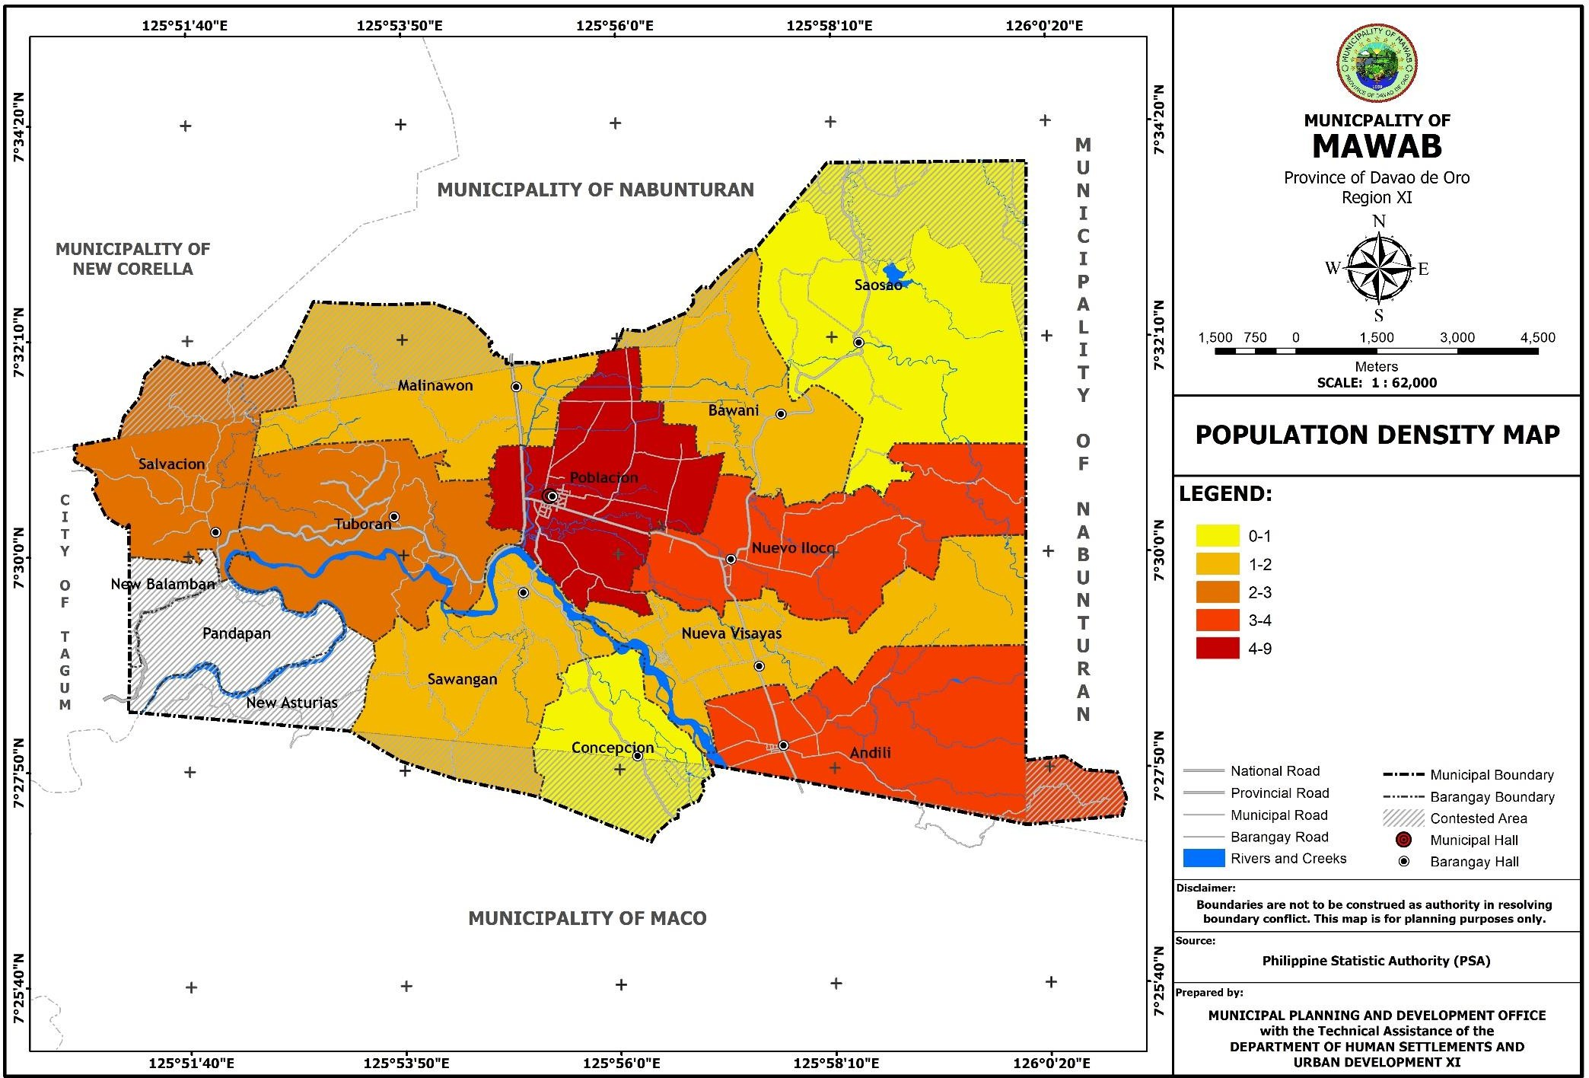

* + 1. **Historical Growth of Population**

Since the creation of the municipality of Mawab on August 14, 1959 it recorded its first official population count of 7, 818 during the February 15, 1960 census of population.

Ten years later in May 6, 1970 its population count rose to 13,537, registering an increase of 5,719 or 73.15 percent with a growth rate of 5.64.

A continuous rise of population was noted during the May 1, 1975 census of population. It posted a total population figure of 17,085, an increase of 3,548 or 26.21 percent or a growth rate of 4.77 for just a five-year period from the previous census of population.

On May 1, 1980, another increase of population was observed that reached to 20,960 recording an increase of 3, 875 or 22.68 percent for a growth rate of 4.17.

The municipality’s population kept on mounting that on May 1, 1990 census of population its count totaled to 28,072. An increase of 7,112 or 33.93 percent for an average growth rate of 2.96.

During the mid-year census of population on September 1, 1995, the population count just inched up to 29,878. It registered an increase of 1,806 or 6.43 percent with a growth rate of

1.25 the smallest increase ever recorded in all various censuses.

Five years later, on May 1, 2000 census, a slight increase of population count was observed. A total of 32,003 people were counted showing an increase of only 2,125 or 7.11 percent or just a 0.68 percent difference in 1995 percentage increase for a growth rate of 1.38. The census of population and housing on August 1, 2007 disclosed that the municipality continues to experience a slow growth of population count. From 32,003 population figure in 2000 it only moved to 34,656, just an increase of 2,653 or 8.29 percent or a difference of 1.18 percentage increase in 2000 with a growth rate of 1.10 percent the slowest rate ever noted in historical population count. The municipality is also the least populated among the 11 municipalities of the province which only represents 5.43 percent of the provincial population of 637,366.

The annual population growth rate of the municipality for 1995-2000 periods was calculated at 1.40 percent. In 2000-2007, it reduced to 1.10 percent growth rate. Year 2010, the National Statistics office conducted a census with a population of 35,698 which increases 1,042 from year 2007. In the year 2015, the population increases to 1,367 with an average growth rate of 0.72. It reaches the total population of 37,065. The gradual increase of the population in the municipality could be attributed to the steady increase of the birth rate, while on the other hand, the increase/decrease of the death rate was not constant. (Table 6)

**Table 6. Historical Growth of Population, Year 2015**

|  |  |  |  |  |  |  |
| --- | --- | --- | --- | --- | --- | --- |
| **YEAR** | **POPULATION** | **INCREASE/ DECREASE (%)** | **AVERAGE GROWTH RATE (%)** | | | |
| **Municipal** | **Provincial** | **Regional** | **National** |
| 1960 | 7,818 | - | - | - | - | 0.12 |
| 1970 | 13,537 | 5,719 | 5.64 | - | - | 0.13 |
| 1975 | 17,085 | 3,541 | 4.77 | - | - | 0.23 |
| 1980 | 20,960 | 3,875 | 4.17 | - | - | 0.23 |
| 1990 | 28,072 | 7,112 | 2.96 | - | - | 0.13 |
| 1995 | 29,878 | 1,806 | 1.25 | .013 | 0.23 | 0.22 |
| 2000 | 32,003 | 2,125 | 1.38 | 0.12 | 0.22 | 0.23 |
| 2007 | 34,656 | 2,653 | 1.10 | 0.13 | 0.23 | 0.22 |
| 2010 | 35,698 | 1,042 | 1.08 | 0.12 | 0.22 | 0.23 |
| 2015 | 37,065 | 1,367 | .72 | 0.12 | 0.2 | 0.23 |

Source of Data: 2015 Census of Population and Housing, Philippine Statistics Authority (PSA)

2015

2010

2007

2000

1995

1990

1980

1975

1970

1960



**Historical Growth of Population, 1960 - 2015**

40,000

35,000

30,000

25,000

20,000

15,000

10,000

5,000

0

1960 1970 1975 1980 1990 1995 2000 2007 2010 2015

6

5

4

3

2

1

0

National Regional Provincial

Municipal

2015

2010

2007

2000

1995

1990

1980

1975

1970

1960

HISTORICAL AVERAGE GROWTH RATE, 1960 - 2015

* + 1. **Crude Birth Rate (CBR) and Crude Death Rate (CDR) for the Past Five Years**

The Crude Birth Rate (CBR) of Mawab in 2015 recorded at 19.37. In 2016, it has increased to 21.07 or a percentage increase of 8.07. CBR in 2017 however, decreased to 19.43 or a percentage of -8.44. In 2018, it has increase to 20.12 or a percentage increase of 3.43. Yet, it has decrease in 2019 to 16.83 or a percentage decrease of -19.55.

For Crude Death Rate (CDR), report shows that in 2017 and 2018, CDR is increasing with a rate of 2.31 and 5.17, respectively. On the other hand, in 2019, it has decreased to 3.93 or a percentage of -31.55.

**Table 7. Crude Birth Rate and Crude Death Rate for the Past 5 Years**

|  |  |  |  |  |
| --- | --- | --- | --- | --- |
| **Period** | **CBR** | **%**  **Increase/Decrease from Previous Year** | **CDR** | **%**  **Increase/Decrease from Previous**  **Year** |
| 2015 | 19.37 | - | - | - |
| 2016 | 21.07 | 8.07 | 1.34 | - |
| 2017 | 19.43 | -8.44 | 2.31 | 41.99 |
| 2018 | 20.12 | 3.43 | 5.17 | 55.32 |
| 2019 | 16.83 | -19.55 | 3.93 | -31.55 |

Source: Municipal Health Office

* + 1. **Literacy Rate of Population 10 Years Old and Over, by Sex, Year 2015**

In the municipality of Mawab, there are 33,243 total population of 10 years old and over with 17,169 total male population and 16,074 total female population.

Among the total male population, ten (10) years old and over, about 16,778 of these are literate, or 98 %, while 15,674 or 98 % of the female population is considered literate. Table shows the literacy rate of 97.62 % or 32,452 and a remaining 2.38 % is considered as illiterate. See Table 8.

**Table 8. Literacy Rate of Population 10 years old and Over, by Sex, Year 2015**

|  |  |  |  |  |  |  |  |  |  |  |  |  |
| --- | --- | --- | --- | --- | --- | --- | --- | --- | --- | --- | --- | --- |
| **Indicator** | **Municipal** | | | | | | **Provincial** | | | | | |
| **Male** | | **Female** | | **Both Sex** | | **Male** | | **Female** | | **Both Sex** | |
| **No.** | **Rate**  **%** | **No.** | **Rate**  **%** | **No.** | **Rate**  **%** | **No.** | **Rate**  **%** | **No.** | **Rate**  **%** | **No.** | **Rate**  **%** |
| Literate | 16,778 | 97.72 | 15,674 | 97.51 | 32,452 | 97.62 | 327,438 | 95.9 | 296,559 | 96.0 | 623,997 | 95.9 |
| Illiterate | 391 | 2.28 | 400 | 22.49 | 791 | 2.38 | 14,367 | 4.2 | 12,484 | 4.0 | 26,851 | 4.1 |
| Total (Population  >10yr) | 17,169 |  | 16,074 |  | 33,243 |  |  |  |  |  |  |  |

Source: Computed based on the 2015 PSA data

* + 1. **Mother Tongue Distribution among Households**

There are so many languages/dialects being used by the people of Mawab. Based on the 2011 data shown below, the most common dialect being used is Bisaya or Binisaya with 10,623 or 31.44 % of the total population, followed by the Boholano with 6,708 or 19.85 % of the total population. Other languages/dialects like Bagobo, Binukid/Bukidnon, Chavacano, Dibabawon, Kalagan, Kamayo, Mandaya, Ata-Manobo, Tagalog, Tausug and the like totalled to 2,491 or 7.37% of the total population of the municipality.

**Table 9. Household Population by Mother Tongue, Year 2011**

|  |  |  |
| --- | --- | --- |
| **Mother Tongue** | **Household No.** | **% of Total Households** |
| Bisaya/Binisaya | 10,623 | 31.44 |
| Boholano | 6,708 | 19.85 |
| Cebuano | 6,171 | 18.27 |
| Ilonggo/Hiligaynon | 3,272 | 9.68 |
| Mansaka | 2,428 | 7.19 |
| Ilocano | 2,092 | 6.19 |
| Others | 2,491 | 7.37 |
| **Total** | **33,785** | **100** |

Source: CBMS 2011

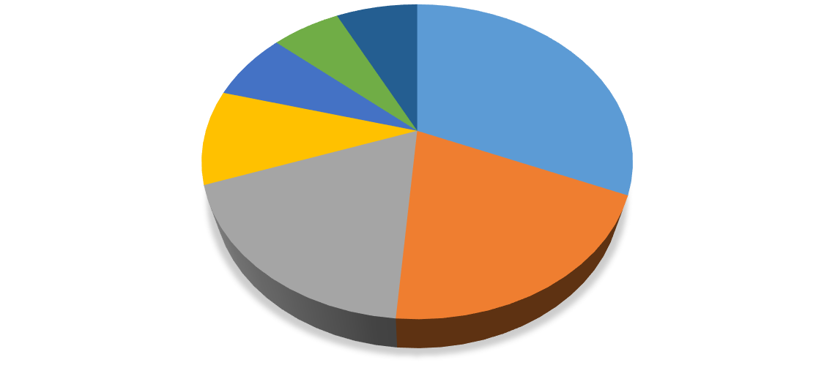

Mother Tongue Distribution Among Households, Year 2011

**2,491, 7%**

**2,092, 6%**

**2,428, 7%**

**10,623, 32%**

**3,272, 10%**

**6,171, 18%**

**6,708, 20%**

Bisaya/Binisaya Boholano Cebuano Ilonggo/Hiligaynon Mansaka Ilocano Others

* + 1. **Population by Religious Affiliation, Year 2015**

The religious sector in the municipality is dominantly populated by Roman Catholic members with a total 29,170 or 78.70% of the total population. This is followed by Evangelicals (Philippine Council of Evangelical Churches) with 2,198 or 5.93% of the total population. Aglipay has the smallest number of population with 310 or 0.84% of the total population. Other religious affiliations are Seventh Day Adventist with 2.29%, Islam with 1.68%, Jehova’s Witnesses with 1.68%, Iglesia ni Cristo with 1.28%, United Church of Christ in the Philippines with 1.10%, International One Way Outreach with 1.00%, United Pentecostal Church (Philippines) Incorporated with 0.89% and other religious affiliations not hereto specified with 4.62% of the total population.

**Table 10. Population by Religious Affiliations, Year 2015**

|  |  |  |
| --- | --- | --- |
| **Religious Affiliation** | **No. of People** | **% of Total Population** |
| Roman Catholic including Catholic Charismatic | 29,170 | 78.70 |
| Evangelicals (Philippine Council of Evangelical Churches) | 2,198 | 5.93 |
| Seventh Day Adventist | 848 | 2.29 |
| Islam | 622 | 1.68 |
| Jehovah’s Witnesses | 621 | 1.68 |
| Iglesia ni Cristo | 474 | 1.28 |
| United Church of Christ in the Philippines | 409 | 1.10 |
| International One Way Outreach | 370 | 1.00 |
| United Pentecostal Church (Philippines) Incorporated | 330 | 0.89 |
| Aglipay | 310 | 0.84 |
| Others | 1,713 | 4.62 |
| **TOTAL** | **37,065** | **100%** |

* + 1. **Inventory of Religious Establishments, Year 2019**

The municipality has a total of 81 religious establishments consists of different type of religions. These are located in the 11 barangays of the municipality. Barangay Poblacion has the highest number of religious establishments with a total of 14 structures followed by Barangays Andili and Nuevo Iloco with 13 structures each. Lowest number of religious establishments were found in Barangay Salvacion with only 3 structures and Barangay Concepcion with 4 structures.

**Table 11. Inventory of Religious Establishments, Year 2019**

|  |  |  |  |
| --- | --- | --- | --- |
| **Barangay** | **Name of Religious Establishment** | **Type of Religion** | **Used as Evacuation Center**  **(Yes=Y/No=N)** |
| Andili | Gagmay’ng Kristohanong Katilingban (GKK) Sta. Monica Birhen sa Rosario | Roman Catholic | N |
| Jehovah's Witnesses | Jehovah's Witnesses | N |
| Iglesia ni Cristo | Iglesia ni Cristo | N |
| Islam (Mosque) | Islam | N |
| Bible Baptist | Bible Baptist | N |
| Fundamental Baptist | Fundamental Baptist | N |
| United Pentecostal Church (UPC) | United Pentecostal Church (UPC) | N |
| CAMMACOP Alliance Church | CAMMACOP Alliance Church | N |
| One-Way-Outreach (OWO) | One-Way-Outreach (OWO) | N |
| Four Square Church | Four Square Church | N |

|  |  |  |  |
| --- | --- | --- | --- |
|  | Assembly of God | Assembly of God | N |
| Seventh Day Adventist | Seventh Day Adventist | N |
| Missionary Baptist | Missionary Baptist | N |
| Bawani | Assembly of God | Assembly of God | N |
| Faith Tabernacle | Faith Tabernacle | N |
| GKK San Ferrer, GKK San Miguel | Roman Catholic | N |
| Seventh Day Adventist | Seventh Day Adventist | N |
| Concepcion | GKK Immaculate Conception, GKK San Vicente Ferrer, GKK Sto. Niño | Roman Catholic | N |
| Remnant Family of God in the Far East | Remnant Family of God in the Far East | N |
| Malinawon | Four Square Gospel | Four Square Gospel | N |
| GKK San Isidro (3), GKK Sto. Niño | Roman Catholic | N |
| Seventh Day Adventist | Seventh Day Adventist | N |
| Nueva Visayas | One Way Outreach | One Way Outreach | N |
| Jesus Covenated Worldwide Inc. | Jesus Covenated Worldwide Inc. | N |
| Seventh Day Adventist (SDA) Reform | Seventh Day Adventist (SDA) Reform | N |
| Seventh Day Adventist (SDA) | Seventh Day Adventist (SDA) | N |
| GKK Sr. San Antonio de Padua, GKK Black Nazarene | Roman Catholic | N |
| United Church of Christ (UCC) | United Church of Christ (UCC) | N |
| Nuevo Iloco | House of Praise Fellowship Church | House of Praise Fellowship Church | N |
| Seventh Day Adventist (SDA) | Seventh Day Adventist (SDA) | N |
| Calvary Church | Calvary Church | N |
| United Church of Christ of the Philippines (UCCP) | United Church of Christ of the Philippines (UCCP) | N |
| United Methodist Church (UMC) | United Methodist Church (UMC) | N |
| RAAH Fellowship Center | RAAH Fellowship Center | N |
| GKK San Isidro Labrador | Roman Catholic | N |
| One Way Outreach | One Way Outreach | N |
| Evangelical Bible Church | Evangelical Bible Church | N |
| Joyful Bible Church | Joyful Bible Church | N |
| Independent Assembly of God | Independent Assembly of God | N |
| King of Majesty Assembly of God | King of Majesty Assembly of God | N |
| Community Church | Community Church | N |
| Poblacion | Faith Tabernacle | Faith Tabernacle | N |
| Born Again Church | Born Again Church | N |
| Victory Chapel | Victory Chapel | N |
| San Roque Parish, GKK Sto. Niño, GKK Sta. Milagrosa | Roman Catholic | N |
| Fundamental Baptist | Fundamental Baptist | N |
| Bible Baptist | Bible Baptist | N |
| United Church of Christ of the Philippines (UCCP) | United Church of Christ of the Philippines (UCCP) | N |
| CAMMACOP Alliance Church | CAMMACOP Alliance Church | N |
| Assembly of God | Assembly of God | N |
| Seventh Day Adventist(SDA) | Seventh Day Adventist(SDA) | N |
| Jehova's Witnesses | Jehova's Witnesses | N |
| Iglesia ni Cristo | Iglesia ni Cristo | N |

|  |  |  |  |
| --- | --- | --- | --- |
| Salvacion | Born Again Church, Faith Jesus Christ Fellowship | Born Again Church, Faith Jesus Christ Fellowship | N |
| The Church Triumphant | The Church Triumphant | N |
| GKK Sto. Niño | Roman Catholic | N |
| Saosao | Ancho Bay Church | Ancho Bay Church | N |
| Fundamental Baptist Church | Fundamental Baptist Church | N |
| Wesleyan Church | Wesleyan Church | N |
| Seventh Day Adventist | Seventh Day Adventist | N |
| Roman Catholic | Roman Catholic | N |
| Church of Christ | Church of Christ | N |
| Sawangan | GKK Sta. Cruz, GKK San Miguel, GKK San Roque, GKK Sto. Niño | Roman Catholic | N |
| One Way Outreach | One Way Outreach | N |
| Tuboran | Foursquare Gospel (Tagmanok) | Foursquare Gospel (Tagmanok) | N |
| Foursquare Gospel | Foursquare Gospel | N |
| GKK San Isidro Labrador, GKK Immaculate Conception | Roman Catholic | N |
| Jamaah Rashida | Islam | N |
| Ocean of Life Ministry | Ocean of Life Ministry | N |

* + 1. **Labor Force Population by Sex and Employment Status, Year 2015**

The municipality has a total labor force of 25,343 of which 13,102 are males and 12,241 are females. Of this labor force, about 10,221 males or 78% and 3,898 females or 31.8% of the total labor force are employed. The remaining 2,881 males or 22% and 8,343 females or 68.2% of the total labor force are unemployed. For the population who were not part of the labor force, there was a total of 14,741 people recorded. This number consisted of 5,118 males and 9,623 females. The reason for the female population of those who are not part of the labor force to be almost double of their male counterpart is that most females, especially those who are already married and have their own families, choose or are forced to be full-time housewives who need to look after their children and homes.

Comparative data shows that employment rate for municipal level is lower than the provincial level with employment rate of 55.7% and 56.3%, respectively. Employment rate for male labor force in the municipal level is 78% while provincial level is 80.9%. For female labor force, employment rate in the municipal level is higher than the provincial level with employment rate of 31.8% and 28.8%, respectively.

**Table 12**. **Labor Force Population by Sex and Employment Status, Year 2015**

|  |  |  |  |  |  |  |  |  |  |  |  |
| --- | --- | --- | --- | --- | --- | --- | --- | --- | --- | --- | --- |
| **Sex** | **Municipal** | | | | |  | **Provincial** | | | | |
| **Populati on 15 Yrs and Over** | **Employ ed** | **%** | **Unemp loyed** | **%** | **Not in Labor Force** | **Populati on 15 Yrs and Over** | **Employe d** | **%** | **Unempl oyed** | **%** |
| Male | 13,102 | 10,221 | 78.0 | 2,881 | 22.0 | 5,118 | 257,039 | 207,888 | 80.9 | 49,151 | 19.1 |
| Female | 12,241 | 3,898 | 31.8 | 8,343 | 68.2 | 9,623 | 229,847 | 66,086 | 28.8 | 163,761 | 71.2 |
| Both Sexes | 25,343 | 14,119 | 55.7 | 11,224 | 44.3 | 14,741 | 486,886 | 273,974 | 56.3 | 212,912 | 43.7 |

Source: PSA 2015

* + 1. **Overseas Workers**

Comparative data shows that overseas workers from Mawab has increased from 292 in 2010 to 481 in 2015, which means that there were 189 people more or a 64.73% increase in the number of overseas workers. It should be noted that most of these overseas workers are female, constituting 61.30% of the total overseas workers in 2010 and 68.40% in 2015. The largest population of overseas workers recorded was in Barangay Poblacion with a total of 107 in 2010 and 162 in 2015, while the lowest recorded in 2010 was in Barangay Salvacion with only 5, and in 2015, it was Barangay Bawani with only 13.

**Table 13. Comparative Data of Overseas Workers**

|  |  |  |  |  |  |  |
| --- | --- | --- | --- | --- | --- | --- |
| **Barangay** | **2010** | | | **2015** | | |
| **Male** | **Female** | **Total** | **Male** | **Female** | **Total** |
| Andili | 4 | 6 | 10 | 24 | 38 | 62 |
| Bawani | 5 | 12 | 17 | 3 | 10 | 13 |
| Concepcion | 10 | 8 | 18 | 6 | 12 | 18 |
| Malinawon | 3 | 12 | 15 | 18 | 23 | 41 |
| Nueva Visayas | 5 | 9 | 14 | 8 | 17 | 25 |
| Nuevo Iloco | 21 | 43 | 64 | 23 | 54 | 77 |
| Poblacion | 47 | 60 | 107 | 58 | 104 | 162 |
| Salvacion | 4 | 1 | 5 | 2 | 18 | 20 |
| Saosao | 4 | 5 | 9 | 0 | 15 | 15 |
| Sawangan | 4 | 10 | 14 | 6 | 15 | 21 |
| Tuboran | 6 | 13 | 19 | 4 | 23 | 27 |
| **TOTAL** | **113** | **179** | **292** | **152** | **329** | **481** |

Source: NSO 2010 & PSA 2015

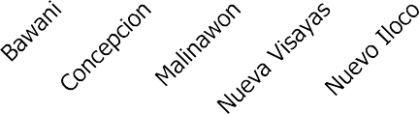

Overseas Workers, 2010 & 2015

180

160

140

120

100

80

60

40

20

0

2010

2015

* + 1. **Household Population 5 Years Old and Over by Highest Educational Attainment**

Of the total population of those who are aged five years old and over, 13.77% or 4,578 persons finished elementary education, 20.52% or 6,820 persons completed secondary education, 2.72% or 903 persons were post-secondary graduates, 7.01% or 2,329 persons were academic degree holders and 29 people or 0.09% of the population have taken post baccalaureate courses. Among those with academic degrees, females outnumbered the males with 1,409 people or 60.50% of the total number of people with academic degrees, compared to males with only 920 people which accounts for 39.50% of the total number. Similarly, there were more females than males among those with post baccalaureate courses with 20 and 9 people respectively.

**Table 14. Household Population 5 years old and over by Highest Educational Attainment**

|  |  |  |  |  |  |  |  |  |
| --- | --- | --- | --- | --- | --- | --- | --- | --- |
| **Highest Educational Attainment** | **Municipal** | | | | | | **Provincial** | |
| **Male** | | **Female** | | **Both Sexes** | | **Both Sexes** | |
| **No.** | **%** | **No.** | **%** | **No.** | **%** | **No.** | **%** |
| No Grade Completed | 429 | 2.50 | 463 | 2.88 | 892 | 2.68 | 18903 | 2.90 |
| Preschool | 547 | 3.19 | 493 | 3.07 | 1040 | 3.13 | 20706 | 3.18 |
| Special Education | 7 | 0.04 | 1 | 0.01 | 8 | 0.02 | 109 | 0.02 |
| Elementary Grade 1 | 573 | 3.34 | 461 | 2.87 | 1034 | 3.11 | 24845 | 3.82 |
| Elementary Grade 2 | 767 | 4.47 | 574 | 3.57 | 1341 | 4.03 | 30497 | 4.69 |
| Elementary Grade 3 | 1155 | 6.73 | 785 | 4.88 | 1940 | 5.84 | 39242 | 6.03 |
| Elementary Grade 4 | 1198 | 6.98 | 835 | 5.19 | 2033 | 6.12 | 45485 | 6.99 |
| Elementary Grade 5 | 1214 | 7.07 | 970 | 6.03 | 2184 | 6.57 | 48590 | 7.47 |
| Elementary Grade 6 | 0 | 0.00 | 0 | 0.00 | 0 | 0.00 | 0 | 0.00 |
| Elementary Graduate | 2458 | 14.32 | 2120 | 13.19 | 4578 | 13.77 | 91881 | 14.12 |
| 1st Year High School | 841 | 4.90 | 773 | 4.81 | 1614 | 4.86 | 36166 | 5.56 |
| 2nd Year High School | 1146 | 6.67 | 1064 | 6.62 | 2210 | 6.65 | 46809 | 7.19 |
| 3rd Year High School | 914 | 5.32 | 934 | 5.81 | 1848 | 5.56 | 36740 | 5.64 |
| 4th Year High School | 0 | 0.00 | 0 | 0.00 | 0 | 0.00 | 5 | 0.001 |
| High School Graduate | 3416 | 19.90 | 3404 | 21.18 | 6820 | 20.52 | 116179 | 17.85 |
| 1st Year Post Secondary | 12 | 0.07 | 1 | 0.01 | 13 | 0.04 | 202 | 0.03 |

|  |  |  |  |  |  |  |  |  |
| --- | --- | --- | --- | --- | --- | --- | --- | --- |
| 2nd Year (Post- Secondary) | 10 | 0.06 | 13 | 0.08 | 23 | 0.07 | 263 | 0.04 |
| Post-Secondary Graduate | 447 | 2.60 | 456 | 2.84 | 903 | 2.72 | 11042 | 1.70 |
| 1st Year College | 342 | 1.99 | 443 | 2.76 | 785 | 2.36 | 17342 | 2.66 |
| 2nd Year College | 426 | 2.48 | 481 | 2.99 | 907 | 2.73 | 16071 | 2.47 |
| 3rd Year College | 302 | 1.76 | 342 | 2.13 | 644 | 1.94 | 11495 | 1.77 |
| 4th Year College | 21 | 0.12 | 16 | 0.10 | 37 | 0.11 | 906 | 0.14 |
| 5th Year College | 0 | 0.00 | 0 | 0.00 | 0 | 0.00 | 23 | 0.004 |
| 6th Year College | 0 | 0.00 | 0 | 0.00 | 0 | 0.00 | 1 | 0.0002 |
| Academic Degree Holder | 920 | 5.36 | 1409 | 8.77 | 2329 | 7.01 | 35049 | 5.39 |
| Post Baccalaureate | 9 | 0.05 | 20 | 0.12 | 29 | 0.09 | 428 | 0.07 |
| Not Reported | 15 | 0.09 | 16 | 0.10 | 31 | 0.09 | 1869 | 0.29 |
| GRAND TOTAL | 17,169 | 100.00 | 16,074 | 100.00 | 33,243 | 100.00 | 650,848 | 100.00 |

Source: Computed based on the 2015 PSA data

* + 1. **Population Projection**

1. **Projected Population and Households**

The projected population of the municipality at the end of the planning period in 2029 will reach to 41,197 and a total households of 9,194. It indicates an increase of 4,132 persons or

11.15 percent of the 37,065 population in 2015. The annual average growth rate used in the projection is .72 percent.

**Table 15. Projected Population and Household**

|  |  |  |
| --- | --- | --- |
| **Year** | **Population** | **Household** |
| 2015 | 37,065 | 8,272 |
| 2020 | 38,491 | 8,590 |
| 2021 | 38,783 | 8,655 |
| 2022 | 39,076 | 8,721 |
| 2023 | 39,671 | 8,854 |
| 2024 | 39,671 | 8,854 |
| 2025 | 39,972 | 8,921 |
| 2026 | 40,275 | 8,988 |
| 2027 | 40,580 | 9,056 |
| 2028 | 40,887 | 9,125 |
| 2029 | 41,197 | 9,194 |

1. **Projected Population by Barangay**

In the current population (2015), Barangay Poblacion pegged the highest figure of 10,524 or 28.39 percent of the total population. While Barangay Concepcion had the lowest number with only 1,119 or 3.02 percent.

The same trend of population count will be observed in the projected population. By 2029, still Barangay Poblacion will have the highest count of 11,697 for an increase of 1,173 persons or

11.15 percent of the 10,524 count in 2015. Likewise, Barangay Concepcion still be having the smallest figure of 1,244 or just 3.02 percent of the total projected population of 41,197. (Table 15)

**Table 16. Projected Population by Barangay, Year 2020-2029**

|  |  |  |  |  |  |  |  |  |  |  |  |  |
| --- | --- | --- | --- | --- | --- | --- | --- | --- | --- | --- | --- | --- |
| **BARANGAY** | **Y0\*** | **Participati on Rate (PR)** | **Population** | | | | | | | | | |
| **2020** | **2021** | **2022** | **2023** | **2024** | **2025** | **2026** | **2027** | **2028** | **2029** |
| **TOTAL** | **37,065** | **1** | **38,491** | **38,783** | **39,076** | **39,373** | **39,671** | **39,972** | **40,275** | **40,580** | **40,887** | **41,197** |
| ***Urban*** | | | | | | | | | | | | |
| Poblacion | 10,524 | 0.28 | 10,929 | 11,012 | 11,095 | 11,179 | 11,264 | 11,349 | 11,435 | 11,522 | 11,609 | 11,697 |
| ***Sub-Total*** | **10,524** | **0.28** | **10,929** | **11,012** | **11,095** | **11,179** | **11,264** | **11,349** | **11,435** | **11,522** | **11,609** | **11,697** |
| ***Rural*** | | | | | | | | | | | | |
| Andili | 4,886 | 0.13 | 5,074 | 5,112 | 5,151 | 5,190 | 5,230 | 5,269 | 5,309 | 5,349 | 5,390 | 5,431 |
| Bawani | 1,948 | 0.05 | 2,023 | 2,038 | 2,054 | 2,069 | 2,085 | 2,101 | 2,117 | 2,133 | 2,149 | 2,165 |
| Concepcion | 1,119 | 0.03 | 1,162 | 1,171 | 1,180 | 1,189 | 1,198 | 1,207 | 1,216 | 1,225 | 1,234 | 1,244 |
| Malinawon | 2,810 | 0.08 | 2,918 | 2,940 | 2,962 | 2,985 | 3,008 | 3,030 | 3,053 | 3,076 | 3,100 | 3,123 |
| Nueva Visayas | 2,329 | 0.06 | 2,419 | 2,437 | 2,455 | 2,474 | 2,493 | 2,512 | 2,531 | 2,550 | 2,569 | 2,589 |
| Nuevo Iloco | 4,543 | 0.12 | 4,718 | 4,754 | 4,789 | 4,826 | 4,862 | 4,899 | 4,936 | 4,974 | 5,011 | 5,049 |
| Saosao | 1,519 | 0.04 | 1,577 | 1,589 | 1,601 | 1,614 | 1,626 | 1,638 | 1,651 | 1,663 | 1,676 | 1,688 |
| Salvacion | 2,261 | 0.06 | 2,348 | 2,366 | 2,384 | 2,402 | 2,420 | 2,438 | 2,457 | 2,475 | 2,494 | 2,513 |
| Sawangan | 2,360 | 0.06 | 2,451 | 2,469 | 2,488 | 2,507 | 2,526 | 2,545 | 2,564 | 2,584 | 2,603 | 2,623 |
| Tuboran | 2,766 | 0.07 | 2,872 | 2,894 | 2,916 | 2,938 | 2,960 | 2,983 | 3,006 | 3,028 | 3,051 | 3,074 |
| **Sub-Total** | **26,541** | **0.72** | **27,562** | **27,771** | **27,981** | **28,194** | **28,407** | **28,623** | **28,840** | **29,058** | **29,278** | **29,500** |

1. **Projected School-Going Age Population, Labor Force and Dependent Population**

The current school going-age population has a total of 15,018 or 40.52 percent of the municipal population count of 37,065. This is composed of pre-school having a total of 2,339 or

15.57 percent, elementary with 5,624 or 37.45 percent, secondary with 4,332 or 28.85 percent and tertiary with 2,723 or 18.13 percent of the total school going-age population.

The municipality’s labor force or productive age-group (15-64 years old) aggregated to 25,343 or 68.37 percent of the total 37,065 municipal populations. Labor force population will reach to 44,739 in 2029 indicating an increase of 19,396 or 76.53 percent of 2015 POPCEN.

The total dependent population of the municipality in the current year is 13,674 or 54 percent of the total labor force. It denotes that in every 100 working population 54 persons sourced out their support for living from those who were gainfully employed. Age dependency group is composed of child youth and the old age-groups, who were too young or too old to earn a living. Young and old dependency ratio is recorded at 46.25 percent and 7.70 percent respectively. (Table 16)

**Table 17. Projected School-Going Age Population, Labor Force**

|  |  |  |  |  |  |  |  |  |
| --- | --- | --- | --- | --- | --- | --- | --- | --- |
| **Grouping** | **Base year** | **Participation Rate** | **Projected Population** | | | | | |
| **Y1** | **Y2** | **Y3** | **Y4** | **Y5** | **Y10** |
| **Population** | **37,065** | **-** | **51,257** | **52,666** | **54,115** | **55,603** | **57,132** | **65,432** |
| School-going population | 15,018 | 0.41 | 20,768 | 21,339 | 21,926 | 22,529 | 23,149 | 26,512 |
| Pre-school | 2,339 | 0.06 | 3,235 | 3,324 | 3,415 | 3,509 | 3,605 | 4,129 |
| Elementary | 5,624 | 0.15 | 7,777 | 7,991 | 8,211 | 8,437 | 8,669 | 9,928 |
| Secondary | 4,332 | 0.12 | 5,991 | 6,155 | 6,325 | 6,499 | 6,677 | 7,647 |
| Tertiary | 2,723 | 0.07 | 3,766 | 3,869 | 3,976 | 4,085 | 4,197 | 4,807 |
| Labor Force | 25,343 | 0.68 | 35,047 | 36,010 | 37,001 | 38,018 | 39,064 | 44,739 |
| Dependent | 13,674 | 0.37 | 18,910 | 19,430 | 19,964 | 20,513 | 21,077 | 24,139 |
| Young (0-14) | 11,722 | 0.32 | 16,210 | 16,656 | 17,114 | 17,585 | 18,068 | 20,693 |
| Old (65 and over) | 1,952 | 0.05 | 2,699 | 2,774 | 2,850 | 2,928 | 3,009 | 3,446 |

1. **Doubling time of growth rate of population**

The growth rate of population of the municipality from the earliest census to the latest census recorded as descending. With growth rate of 5.64%, population will double in 12 year- time while with growth rate of 0.72%, population will double in 96 year-time.

**Table 18. Doubling Time of Growth Rate Population**

|  |  |
| --- | --- |
| **RATES OF GROWTH (%)** | **DOUBLING TIME (years)** |
| 5.64 | 12.29 |
| 4.77 | 14.53 |
| 4.17 | 16.62 |
| 2.96 | 23.41 |
| 1.25 | 55.44 |
| 1.38 | 50.22 |
| 1.1 | 63.00 |
| 1.08 | 64.17 |
| 0.72 | 96.25 |

* 1. PHYSICAL FEATURES
     1. **Geographical Location**

The municipality of Mawab is one of the municipalities of Davao de Oro (formerly Compostela Valley) Province. It is located southeastern section of the province. It lies between 7’ 3” North Latitude and 125’ 22” East Longitude. It is bounded on the Northeast by the municipality of Nabunturan, on the Northwest by the city of Tagum, on the west by the municipality of New Bataan and on the south by the municipality of Maco.

Mawab has 11 barangays and 49 sitios interconnected with barangay/municipal and provincial roads and bridges.

Barangay Poblacion, the seat of the municipal government is 75 kilometers away from Davao City and 19 kilometers away from Tagum City. It is 17 kilometers from Nabunturan, the capital town of the province, where the provincial capitol is located.

* + 1. **Land Area by Barangay**

The municipality has a total land area of 16,952 hectares which is 3.63 percent of the total 466, 693 hectares of the province. Its alienable and disposable land area total to 9,997 hectares or 58.97 percent of the total area of the municipality while its forestland is 41.03 percent or 6,955 hectares of the municipality’s land area.

Out of the 11 barangays, Saosao has the widest area with 1,973.336 hectares which is

11.64 percent of the municipality’s land area. Barangay Bawani has the smallest land area with only 949.499 hectares or 5.60 percent of the municipal land area. (Table 18)

**Table 19. Land Area by Barangay**

|  |  |  |
| --- | --- | --- |
| **Barangay** | **Land Area** | |
| **Hectares** | **% Distribution** |
| 1. Andili | 1,577.993 | 9.31 |
| 2. Bawani | 1,020.458 | 6.02 |
| 3. Concepcion | 1,351.60 | 7.97 |
| 4. Malinawon | 1,949.683 | 11.50 |
| 5. Nuevo Iloco | 1,383.700 | 8.16 |
| 6. Nueva Visayas | 1,241.472 | 7.32 |
| 7. Poblacion | 1,187.7185 | 7.01 |
| 8. Salvacion | 949.499 | 5.60 |
| 9. Saosao | 1,973.336 | 11.64 |
| 10. Sawangan | 1,236.714 | 7.30 |
| 11. Tuboran | 1,368.495 | 8.07 |
| Other Claimed Areas | 792.2435 | 4.67 |
| Pandapan (Boundary) | 919.088 | 5.42 |
| ***TOTAL*** | ***16,952.00*** | ***100.00*** |

Basic Source of Data: Municipal Planning Development Office (MPDO)

* + 1. **Land Classification**

Of the 16, 952.00 hectares, 32.3 percent is classified as forestland while 67.7 percent is alienable and disposable land. The entire area constitutes about 3.36 percent of the total land area of Davao de Oro.

**Figure 2. Map of Region IX showing the Province of Davao de Oro**

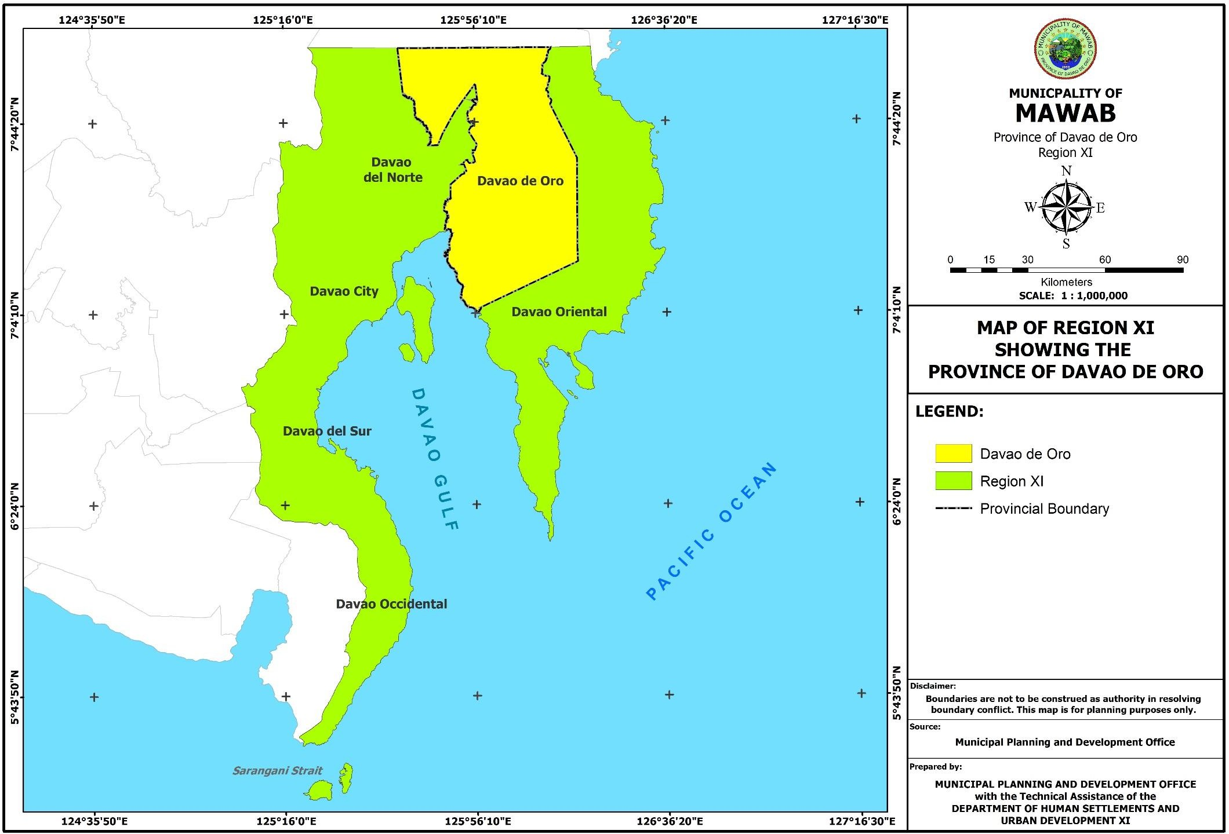

**Figure 3. Map of Davao de Oro Showing the Municipality of Mawab**

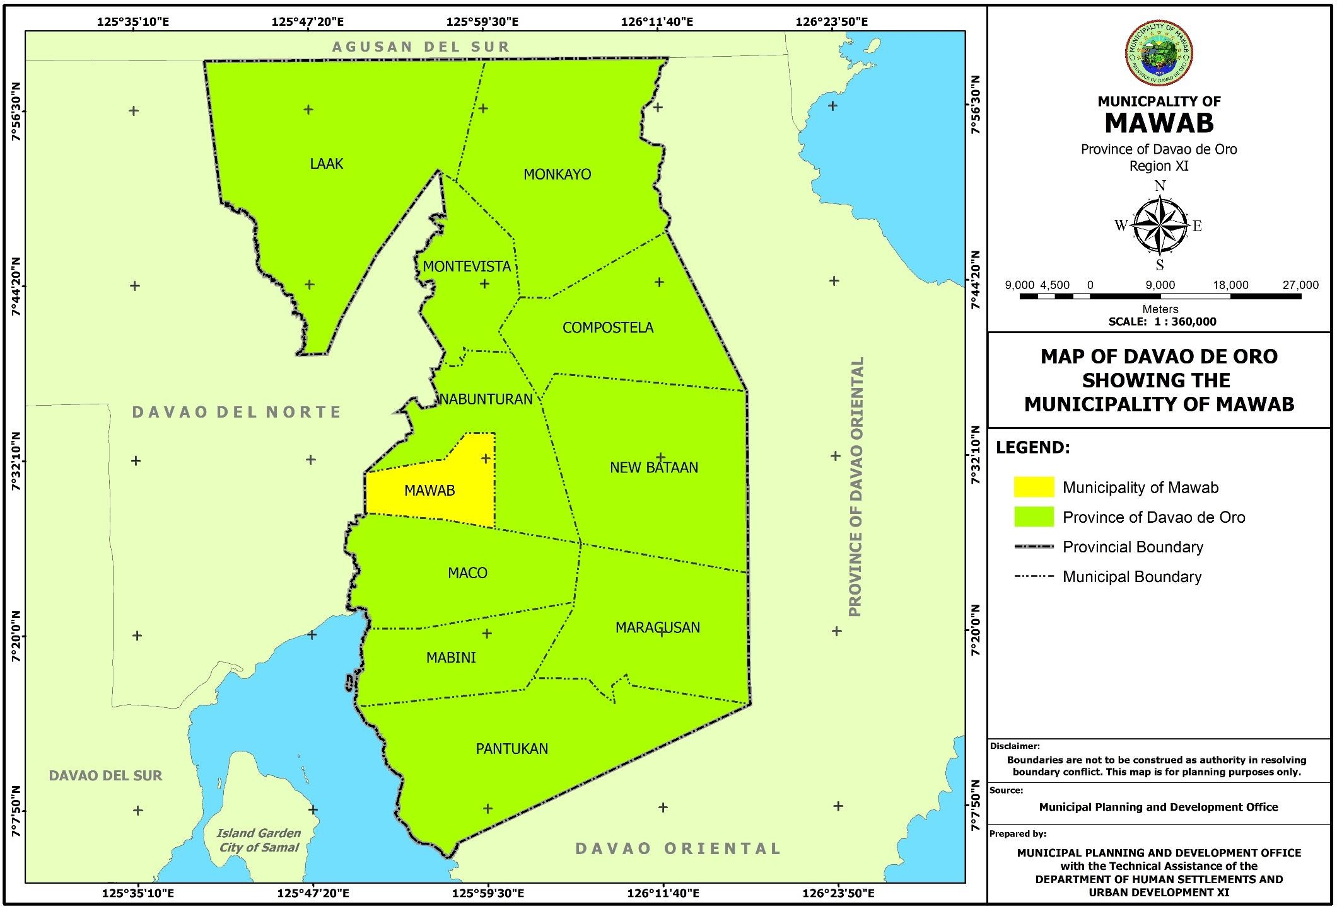

**Figure 4. Municipal Map Showing the Barangays**

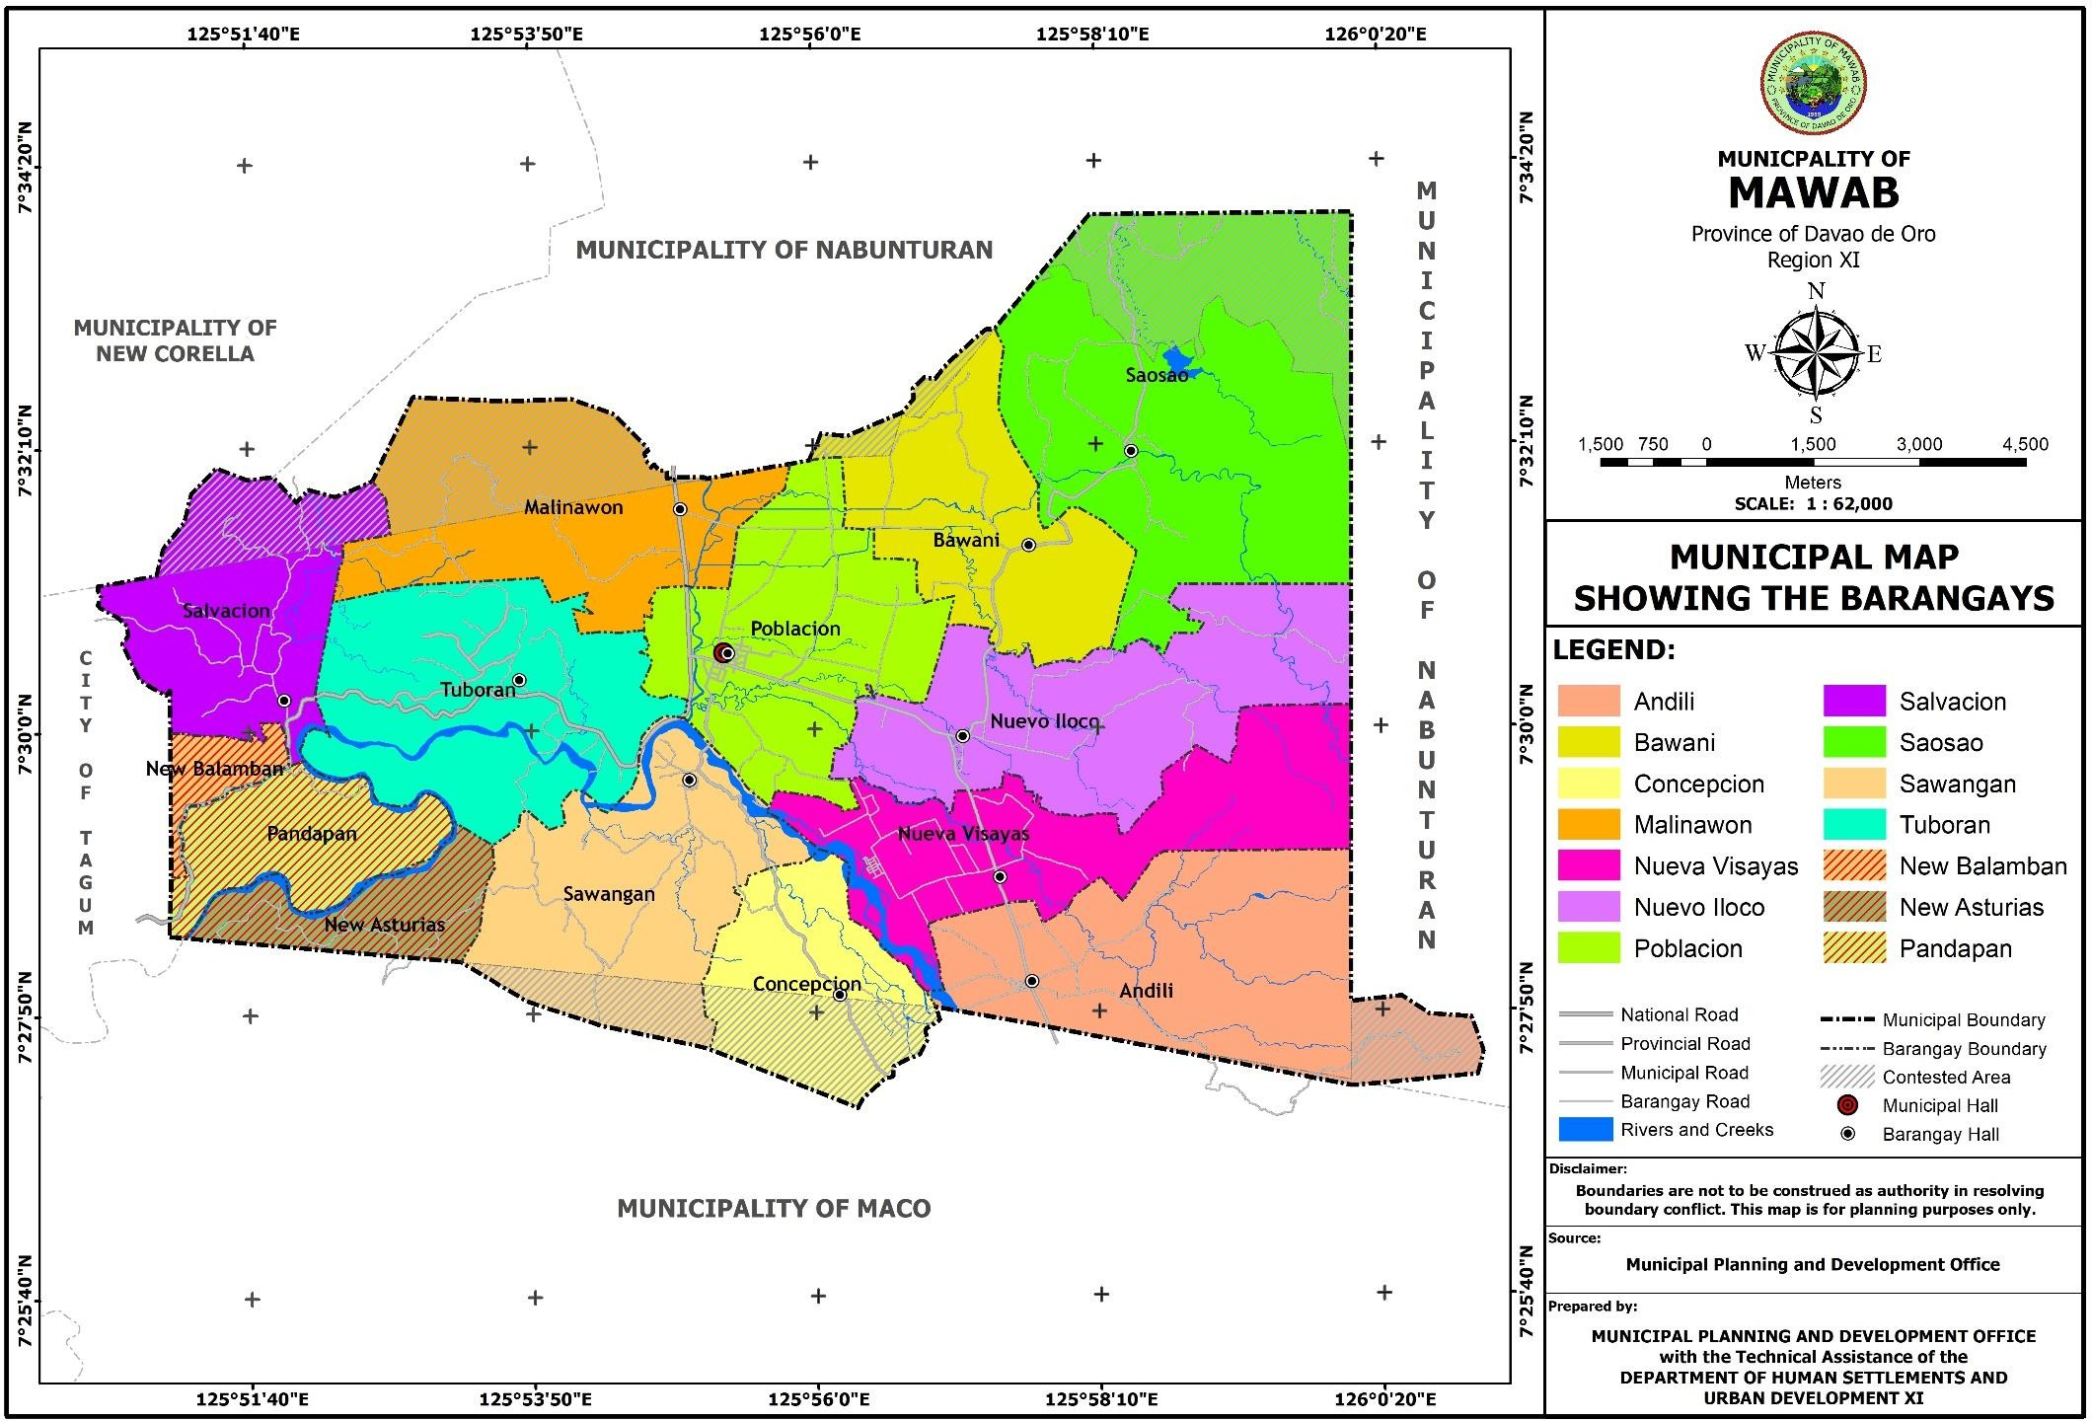

**Figure 5. Land Classification Map**

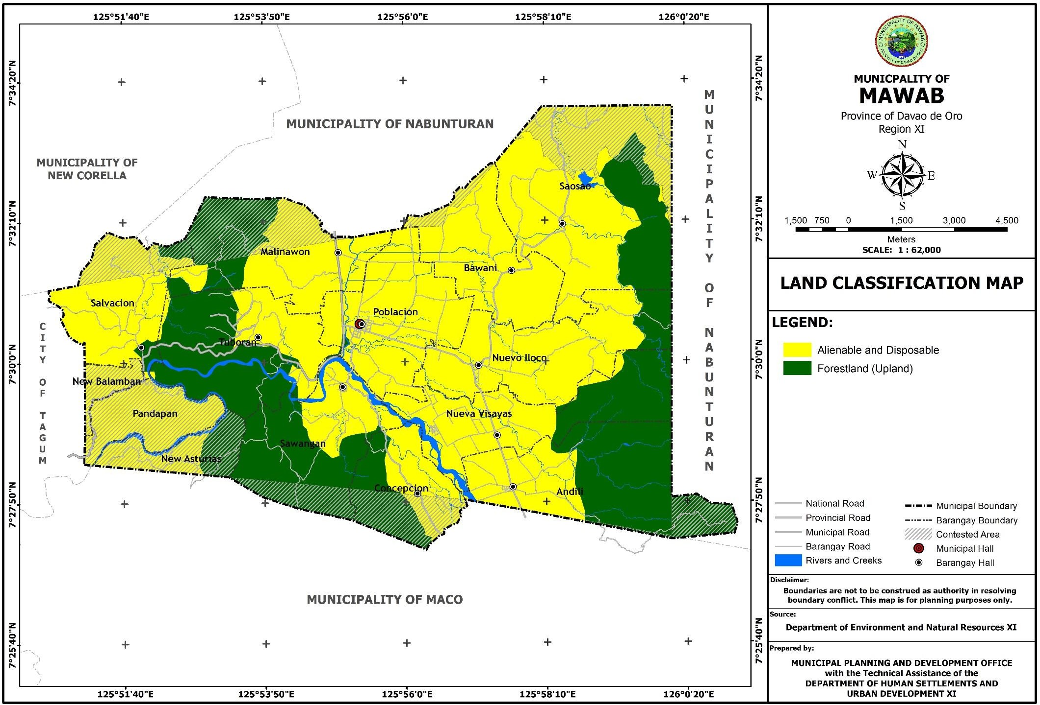

* + 1. **Climate**

**Climatological Conditions, Type of Climate, Prevailing Winds, Average Annual Rainfall and Mean Temperature**

The Municipality of Mawab belongs to the forth type climate which is characterized by two pronounced season, dry from the month of November to April, wet during the rest of the year.

The “mean daily maximum” (solid red line) shows the maximum temperature of an average day for every month for Mawab. Likewise, “mean daily minimum” (solid blue line) shows the average minimum temperature. Hot days and cold nights (dashed red and blue lines) show the average of the hottest day and coldest night of each month of the last 30 years. For vacation planning, you can expect the mean temperatures, and be prepared for hotter and colder days. Wind speeds presented in solid green line.

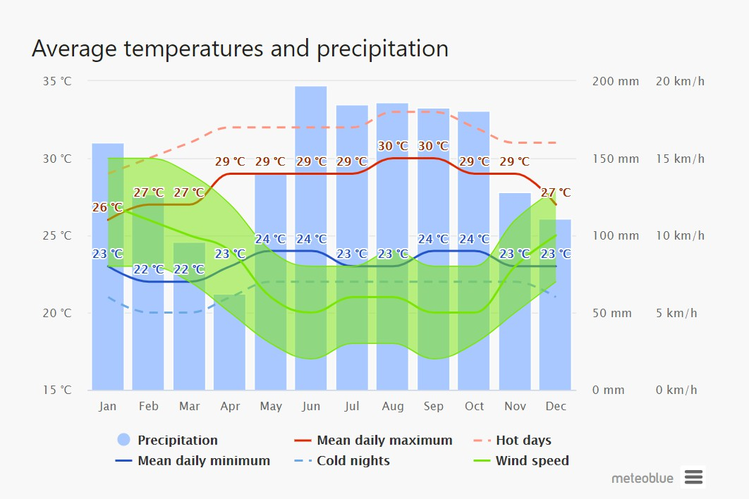

Source: Meteoblue

**Figure 6. Climate Map**

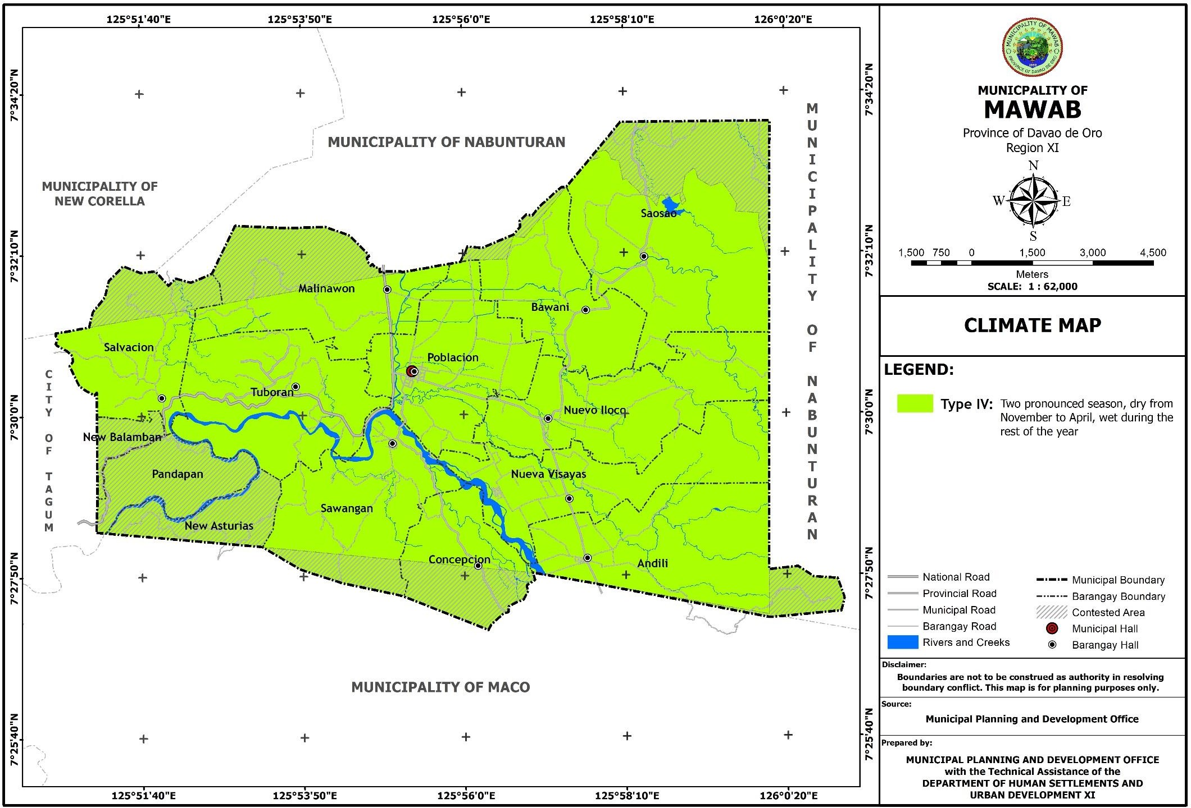

* + 1. **Topography/Slope**

The topography of the municipality is characterized with a flat rolling hills and mountains. The municipality’s ranges and plains are traversed by four (4) rivers of which Hijo River is the widest.

* + - 1. **Slope**

As to the slope classification of the municipality, 50.83% of the total land area or 7,857.3 hectares are situated in slopes 18 degrees and above, or what we consider as uplands, while the remaining 49.17% or 7,600.98 hectares are below 18 degrees or what we call lowlands and are areas of multi-use. The largest lowland area in the municipality was found in Barangay Poblacion with a total of 1,124.162 hectares, followed by Barangay Saosao with a total of 1,016.404 hectares, while the smallest lowland area was found in Barangay Salvacion with a total of 264.312 hectares, and then in Barangay Pandapan, a contested area, with a total of 296.578 hectares. For upland areas, the largest area was found in Barangay Saosao with a total of 1,333.85 hectares, followed by Barangay Andili with a total of 992.728 hectares. The smallest upland area was found in Barangay Poblacion with only 63.558 hectares, and then followed by Barangay Pandapan with 252.929 hectares.

**Table 20. Land Area by Percent Slope (in hectares)**

|  |  |  |  |  |  |  |  |  |
| --- | --- | --- | --- | --- | --- | --- | --- | --- |
| **Barangay** | **0-8%** | **8-18%** | **Sub-total** | **18-30%** | **30-50%** | **Above 50%** | **Sub-total** | **Grand Total** |
| **Level to Undulati ng** | **Undulati ng to Rolling** | **Rolling to Hilly** | **Hilly to Mountain ous** | **Mountain ous** |
| Andili | 519.71 | 65.557 | 585.267 | 135.383 | 379.081 | 478.264 | 992.728 | **1,577.995** |
| Bawani | 552.82 | 167.605 | 720.425 | 157.31 | 120.337 | 22.379 | 300.026 | **1,020.451** |
| Concepcion | 340.364 | 51.945 | 392.309 | 71.573 | 123.978 | 163.605 | 359.156 | **751.465** |
| Malinawon | 229.723 | 195.075 | 424.798 | 290.137 | 389.757 | 176.373 | 856.267 | **1,281.065** |
| Nueva Visayas | 656.947 | 53.826 | 710.773 | 96.122 | 238.231 | 196.345 | 530.698 | **1,241.471** |
| Nuevo Iloco | 646.689 | 133.481 | 780.17 | 207.299 | 311.393 | 84.887 | 603.579 | **1,383.749** |
| Poblacion | 1,095.299 | 28.862 | 1,124.161 | 32.657 | 26.726 | 4.175 | 63.558 | **1,187.719** |
| Salvacion | 79.563 | 184.749 | 264.312 | 264.621 | 333.338 | 87.227 | 685.186 | **949.498** |
| Saosao | 503.561 | 512.843 | 1,016.404 | 602.18 | 593.58 | 138.09 | 1,333.85 | **2,350.254** |
| Sawangan | 303.548 | 224.875 | 528.423 | 331.472 | 271.359 | 105.469 | 708.3 | **1,236.723** |
| Tuboran | 198.829 | 254.158 | 452.987 | 376.799 | 404.274 | 134.435 | 915.508 | **1,368.495** |
| Pandapan (Boundary) | 177.075 | 119.503 | 296.578 | 117.321 | 111.164 | 24.444 | 252.929 | **549.507** |
| Other Claimed  Areas | 138.149 | 166.216 | 304.365 | 159.161 | 80.277 | 16.065 | 255.503 | **559.868** |
| **Total** | **5,442.28** | **2,158.70** | ***7,600.98*** | **2,842.04** | **3,383.50** | **1,631.76** | ***7,857.3*** | **15,458.26** |

Source: Department of Environment and Natural Resources/ Digital Elevation Model (DEM)

* + - 1. **Elevation**

The highest elevation noted in the municipality is within the range from 1,000 meters to 1,100 meters with a total of 1.128 hectares or 0.01 percent of the total municipal land area. This was followed by an elevation ranges from 500 meters to 1,000 meters with an area of 376.099 hectares or 2.43 percent of the total land area. The lowest elevation is less than 100 meters which has the largest land area of 7,711.727 hectares or 49.89 percent of the total land area.

**Table 21. Elevation Class by Area**

|  |  |  |
| --- | --- | --- |
| **Elevation (meters)** | **A R E A** | |
| **Hectares** | **Percentage** |
| < 100 | 7,711.727 | 49.89 |
| 100 – 300 | 6,547.341 | 42.36 |
| 300 – 500 | 821.936 | 5.32 |
| 500 – 1,000 | 376.099 | 2.43 |
| 1,000 – 1,100 | 1.128 | 0.01 |
| **TOTAL** | **15,458.23** | **100** |

Source: Department of Environment and Natural Resources

**Figure 7. Topographic Map**

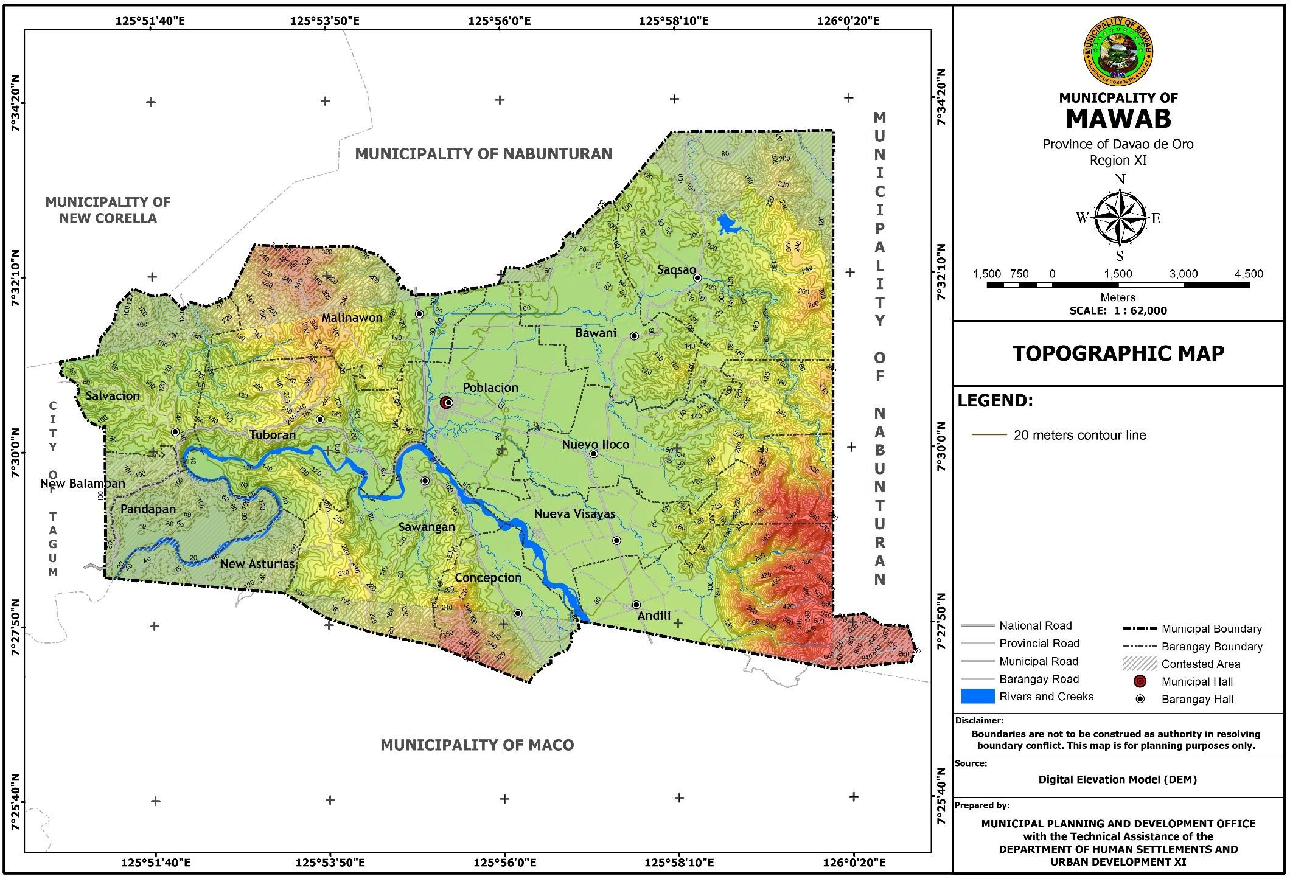

**Figure 8. Slope Map**

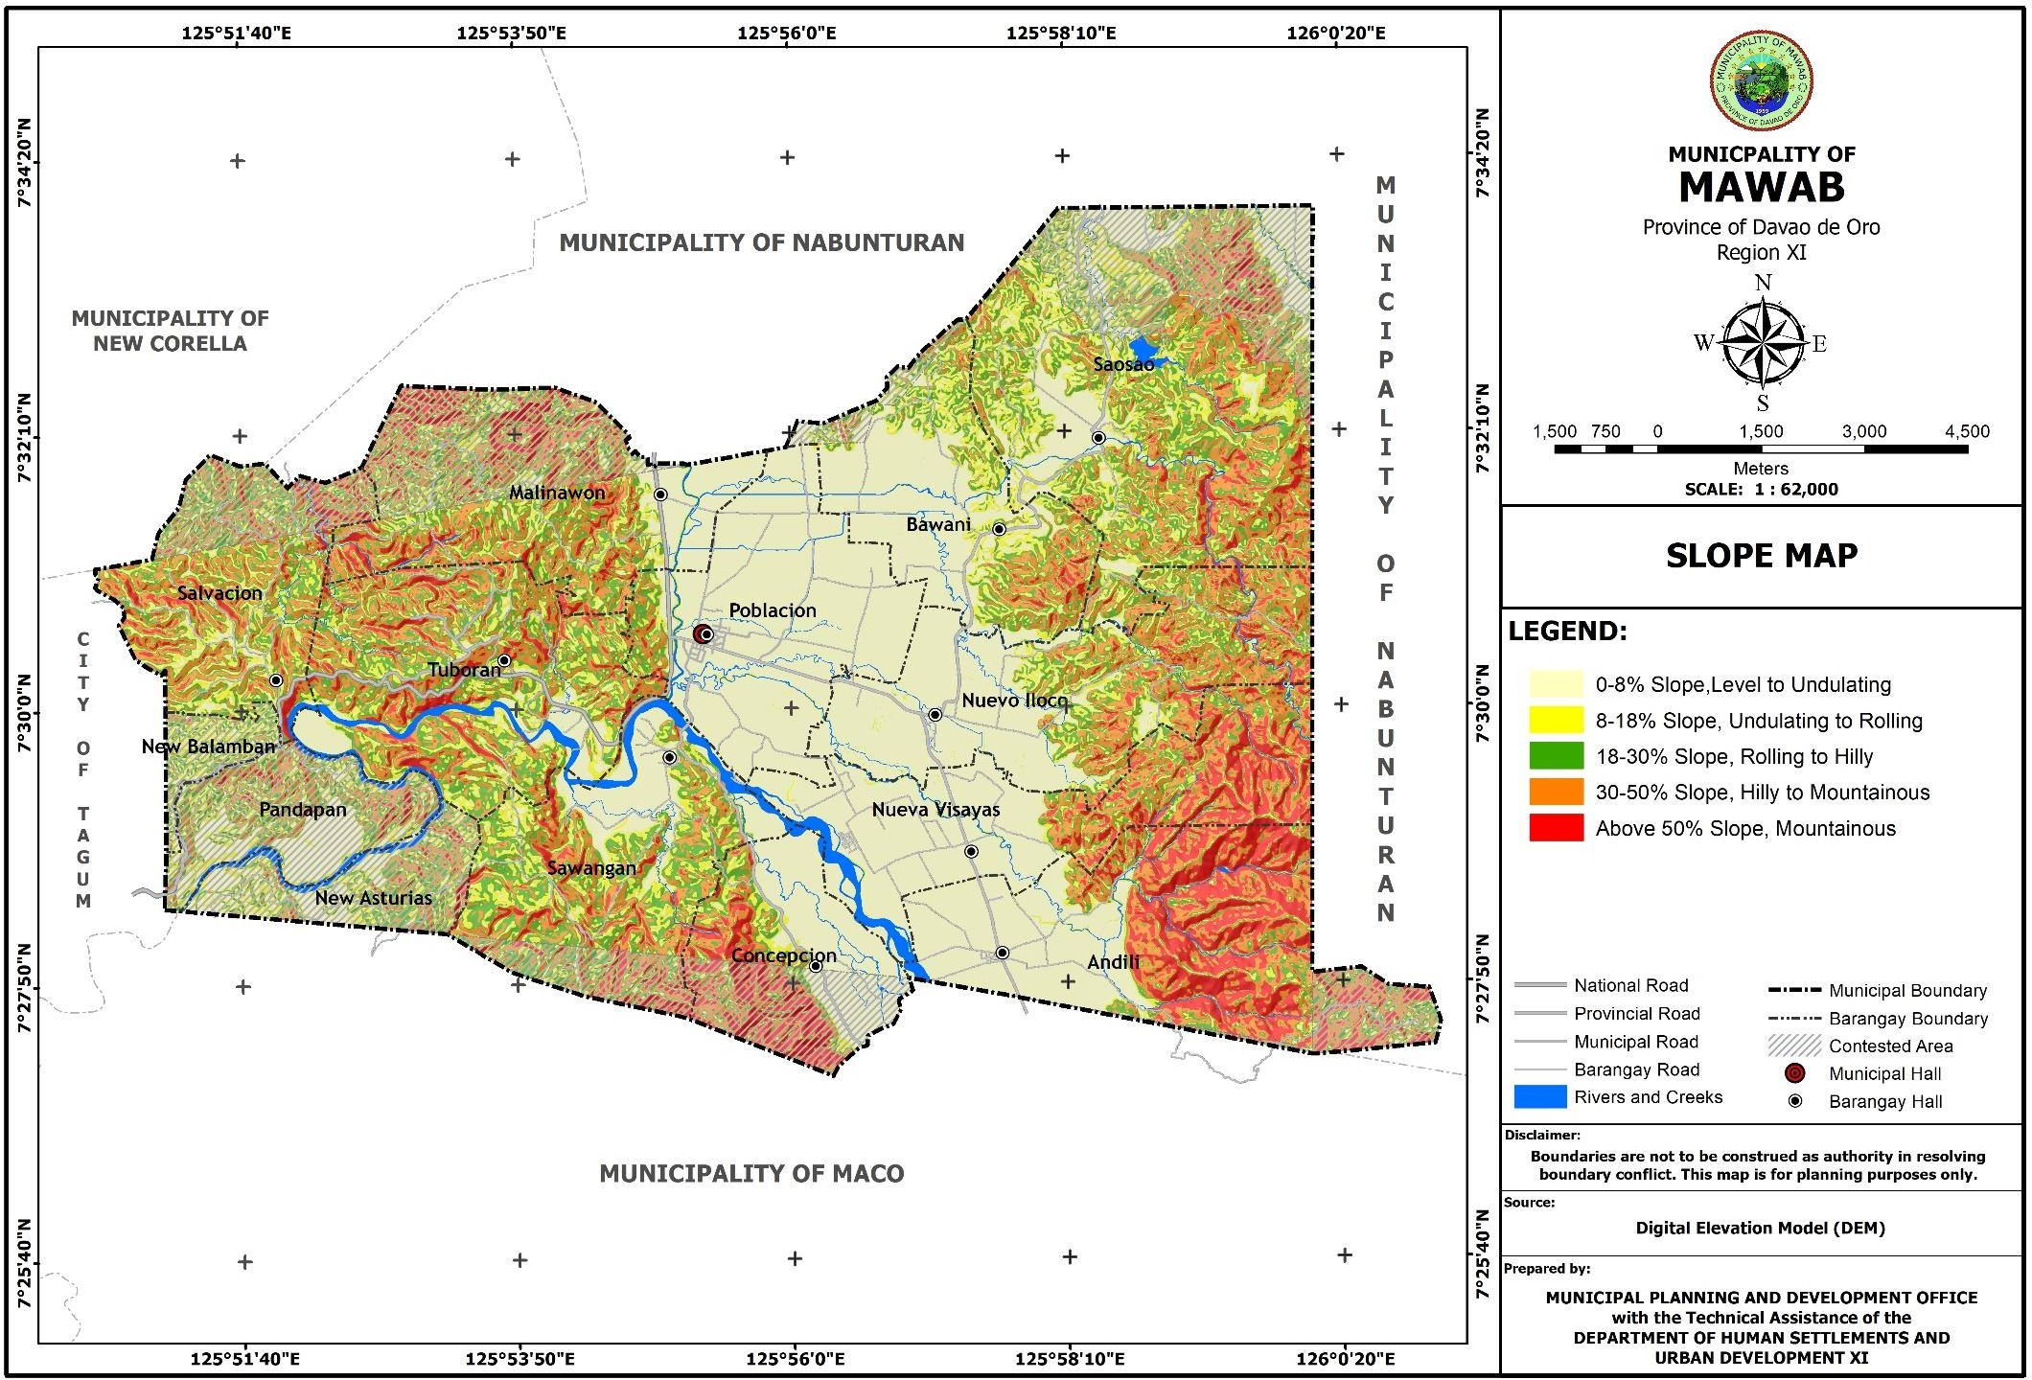

**Figure 9. Elevation Map**

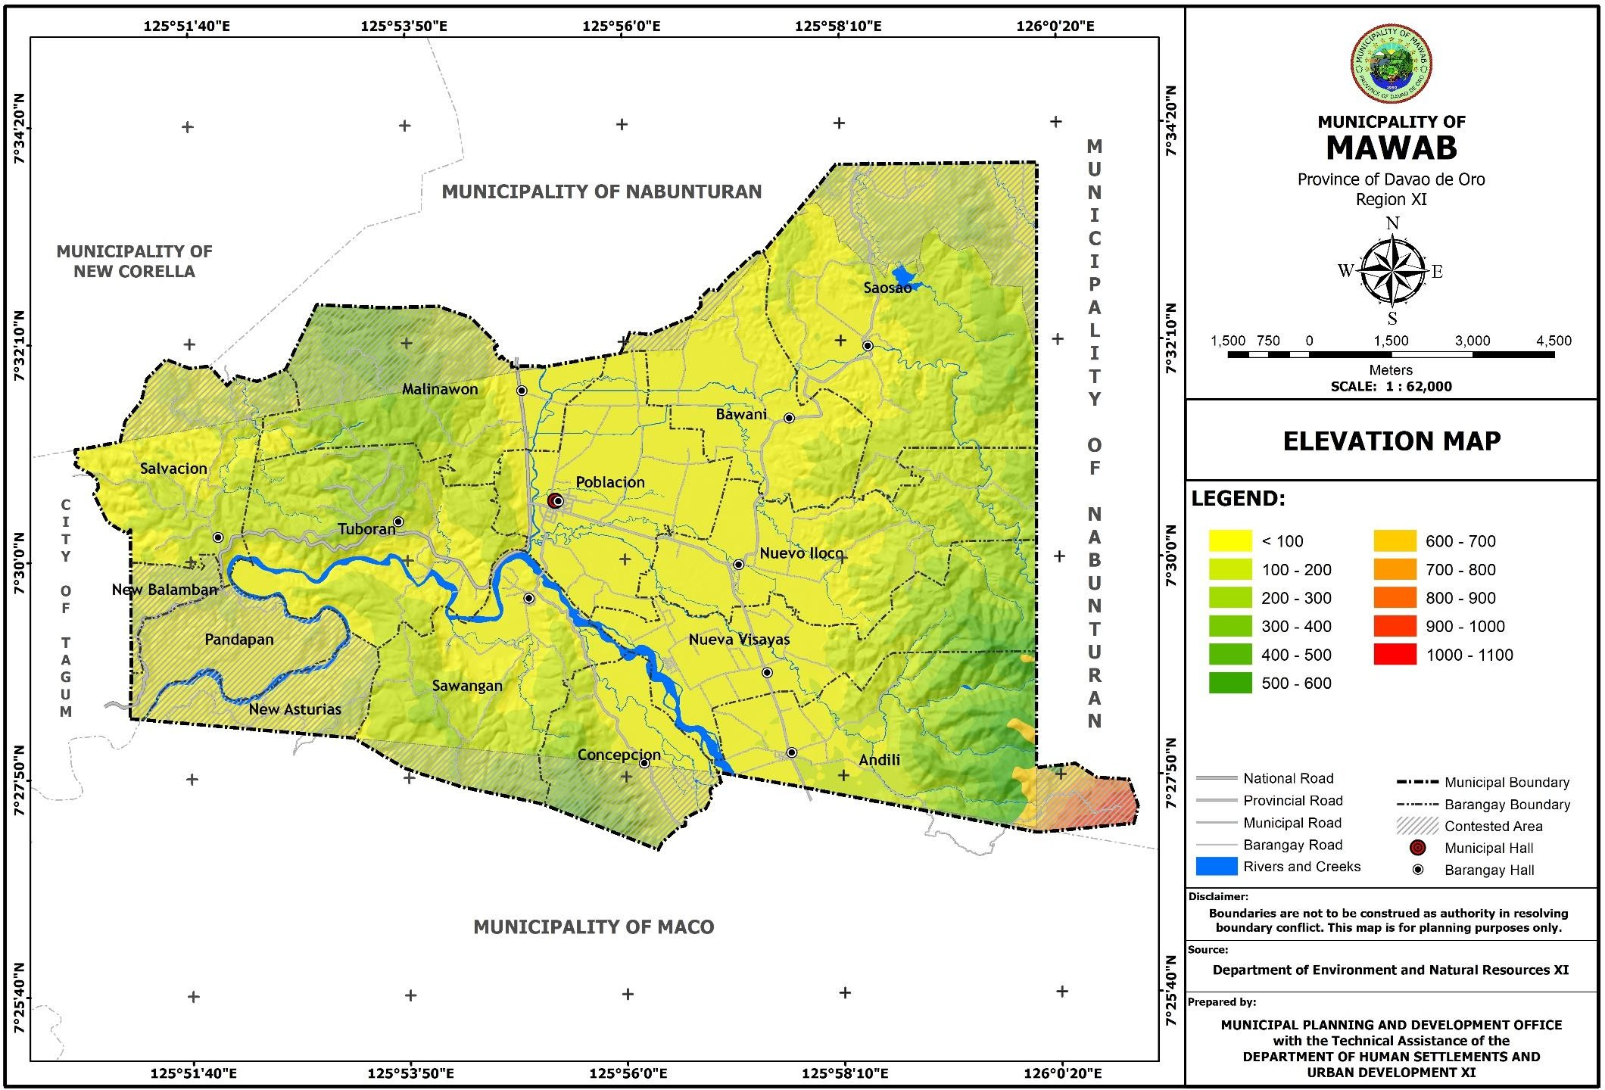

* + 1. **Basic Soil Type**

The municipality has three (3) basic soil types namely:

1. **San Manuel Silty Clay Loam** – this type has 30-40 centimeters surface soil. This is characterized by having light brown to grayish brown, fine to medium granular and friable silty clay loam. Its natural fertility gives the land high yield on any crop raised and is very slightly susceptible to erosion. This type of soil exists in the barangays of Malinawon, Nueva Visayas, Andili and part of Nuevo Iloco.
2. **Camansa Sandy Clay Loam** – this type is one of the extensive soils. It occupies the hilly and mountainous portions in the barangays of Tuboran, Salvacion, Sawangan, Concepcion, and part of Nuevo Iloco, Nueva Visayas and Andili.
3. **Cabangan Clay Loam** – this type is good for agricultural purposes such as rice paddy. It can also be used for upland crops with simple drainage system. It has a depth of 50-10 cm. deep. (Table 21)

**Table 22. Basic Soil Type Land Area and Location**

|  |  |  |  |
| --- | --- | --- | --- |
| **Basic Soil Type** | **Location** | **Land Area** | |
| **Hectares** | **Percentage** |
| Camansa Sandy Clay Loam | Tuboran, Salvacion, Sawangan, Concepcion and part of Nuevo  Iloco, Nueva Visayas, Andili and Pandapan | 9,268.59 | 4.67 |
| Cabangan Clay Loam | Saosao, Bawani and Poblacion | 4,216.99 | 24.88 |
| San Manuel Silty Clay | Malinawon and part of Nuevo Iloco, Nueva Visayas and Andili | 3,409.41 | 20.11 |
| Other types | Across the municipality | 57.00 | 0.34 |
| **TOTAL** |  | **16,952** | **100** |

Source: Bureau of Lands

* + 1. **Hydrogeologic or Geologic Study**

Based on the hydrogeologic data per Mines and Geosciences Bureau (MGB), Mawab is endowed with different stones as plotted in the table below. Alluvium has the largest area occupied with a total of 9,634.195 hectares or 62.32% of the total land area. Barangay Sawangan has the most area occupied by alluvium, accounting for all of the 1,236.723 hectares total land area of the barangay. The area with the least alluvium deposit is in Barangay Saosao with only

448.279 hectares.

The second-most common rock type in the municipality is Sandstone which occupies a total land area of 3,911.198 hectares or 25.30% of the total land area of Mawab. It occupies a total of 1,901.976 hectares of Barangay Saosao’s land area, the biggest land area occupied by the said rock type in the whole municipality, while the smallest area is in Barangay Malinawon with only 0.286 hectares.

The third most-common type of rock found in Mawab is Sand and Shale which occupies a total land area of 1,386.855 hectares or 8.97% the municipality’s land area. The largest deposit of Sand and Shale can be found in Barangay Malinawon with a total of 505.516 hectares, while the smallest is in Barangay Salvacion with a total land area of 50.380 hectares.

Finally, the fourth and least-common rock type that can be found in the municipality of Mawab is the Marine conglomerate which can only be found in the barangay of Andili and occupies a land area of 526.018 hectares or 3.40% of the total land area of Mawab. (Table 22)

For geologic data, a total of 7,666.50 hectares of Mawab’s land area have been around since the Miocene–Pliocene period, most of it in Barangay Saosao with a total of 2,139.53 hectares, and the smallest expanse of it in Barangay Andili with only 0.48 hectares. This is then followed by the recent type with a total of 5,158.93 hectares and largely occupies the land area of Barangay Poblacion with a total of 1,174.10 hectares, and the least area in Barangay Tuboran with a total of 9.09 hectares. The next most common type are those from the Cretaceous– Paleogene period (Mesozoic Era- Cenozoic Era) which occupies a total land area of 1,428.53 hectares and can only be found in the barangays of Andili and Nueva Visayas with a total of 1,126.98 hectares and 301.55 hectares respectively. The last two categories are those from the Pliocene–Pleistocene and Oligocene–Miocene which occupy a total area of 623.03 hectares and

581.28 hectares respectively. Pliocene–Pleistocene (5.3 MYA – 11,700 years BCE) types of land can only be found in the barangays of Salvacion with 543.48 hectares, Malinawon with 69.56 hectares, and Tuboran with 9.99 hectares, while land from the Oligocene–Miocene period can only be found in barangays Sawangan with 249.71 hectares occupied, Concepcion with 211.78 hectares and Andili with 119.80 hectares. (Table 23)

**Table 23. Hydrogeologic Type by Area**

|  |  |  |  |  |  |
| --- | --- | --- | --- | --- | --- |
| **Barangay** | **Alluvium** | **Sandstone** | **Sand and Shale** | **Marine Conglomerate** | **Total** |
| Andili | 661.783 | 390.195 | - | 526.018 | **1,577.996** |
| Bawani | 503.253 | 517.199 | - | - | **1,020.452** |
| Concepcion | 751.464 | - | - | - | **751.464** |
| Malinawon | 775.263 | 0.286 | 505.516 | - | **1,281.065** |
| Nueva Visayas | 771.819 | 469.652 | - | - | **1,241.471** |
| Nuevo Iloco | 751.860 | 631.890 | - | - | **1,383.750** |
| Poblacion | 797.446 | - | 390.274 | - | **1,187.720** |
| Salvacion | 899.119 | - | 50.380 | - | **949.499** |
| Saosao | 448.279 | 1,901.976 | - | - | **2,350.255** |
| Sawangan | 1,236.723 | - | - | - | **1,236.723** |
| Tuboran | 927.810 | - | 440.685 | - | **1,368.495** |
| Pandapan (Boundary) | 549.507 | - | - | - | **549.507** |
| Other Claimed Areas | 559.869 | - | - | - | **559.869** |
| **Grand Total** | **9,634.195** | **3,911.198** | **1,386.855** | **526.018** | **15,458.266** |

Source: Mines and Geosciences Bureau

**Table 24. Geologic Type by Area**

|  |  |  |  |  |  |  |
| --- | --- | --- | --- | --- | --- | --- |
| **Barangay** | **Cretaceous**  **- Paleogene** | **Miocene - Pliocene** | **Oligocene**  **- Miocene** | **Pliocene - Pleistocene** | **Recent** | **Grand Total** |
| Andili | 1,126.98 | 0.48 | 119.80 | - | 330.74 | **1,578.00** |
| Bawani | - | 518.75 | - | - | 501.70 | **1,020.45** |
| Concepcion | - | - | 211.78 | - | 539.69 | **751.46** |
| Malinawon | - | 985.47 | - | 69.56 | 226.04 | **1,281.06** |
| Nueva Visayas | 301.55 | 285.87 | - | - | 654.05 | **1,241.47** |
| Nuevo Iloco | - | 858.47 | - | - | 525.28 | **1,383.75** |
| Poblacion | - | 13.63 | - | - | 1,174.10 | **1,187.72** |
| Salvacion | - | 406.02 | - | 543.48 | - | **949.50** |
| Saosao | - | 2,139.53 | - | - | 210.72 | **2,350.26** |
| Sawangan | - | 599.84 | 249.71 | - | 387.18 | **1,236.72** |
| Tuboran | - | 1,349.42 | - | 9.99 | 9.09 | **1,368.50** |
| Pandapan (Boundary) | - | 280.45 | - | - | 269.06 | **549.51** |
| Other Claimed Areas | - | 228.59 | - | - | 331.28 | **559.87** |
| **Grand Total** | **1,428.53** | **7,666.50** | **581.28** | **623.03** | **5,158.93** | **15,458.27** |

Source: MGB

|  |  |
| --- | --- |
| **Cretaceous - Paleogene** | Thick sequence of slightly metamorphose graywacke and siltstone with thin lenses of chert, quarzite ferrugineous shale and conglomerate intercolated occasionally with basalt flows. Intruded by diorite and ultramafic rocks. |
|  |  |
| **Miocene - Pliocene** | Composed of well consolidated compacted and indurated sandstone shale & conglomerate. Associated with calcarenite and / silty limestone. |
|  |  |
| **Oligocene - Miocene** | Massive limestone, some recrystallized. |
|  | Sequence of pyroclastics, siltstone, sandstone and conglomerate as basal unit of thick. |
|  |  |
| **Pliocene - Pleistocene** | Composed of well consolidated to poorly consolidated sandstone and shale with some sequence of conglomerate and pebbly to conglomerate sandstone. |
|  |  |
| **Recent** | Poorly sorted, unconsolidated alluvium, fuviated paludal and beach deposits, raised coral reefs. |

* + 1. **Watershed**

The Municipality has three (3) sub watersheds, namely Agusan, Hijo and Saug watershed. The biggest watershed is Hijo River watershed with an area of 12,637.26 hectares or 79.63 percent of the total watershed area that drains in Maco, Davao de Oro. Saug River subwatershed has a total land area of 1,783.950 hectares or 11.54 percent of the total land watershed area that drains in Liboganon, Tagum City, Davao del Norte. The smallest is the Agusan watershed with an area of 1,364.159 hectares or 8.82 percent of the total watershed area.

**Table 25. Watershed by Barangay**

|  |  |  |  |  |
| --- | --- | --- | --- | --- |
| **Barangays** | **Agusan River Watershed** | **Hijo River Watershed** | **Saug River subwatershed** | **Grand Total** |
| Andili | 20.808 | 1557.188 | - | 1577.996 |
| Bawani | - | 1020.451 | - | 1020.451 |
| Concepcion | - | 751.464 | - | 751.464 |
| Malinawon | - | 842.354 | 438.711 | 1281.065 |
| Nueva Visayas | - | 1241.471 | - | 1241.471 |
| Nuevo Iloco | 30.65 | 1353.099 | - | 1383.749 |
| Poblacion | - | 1187.72 | - | 1187.72 |
| Salvacion | - | 39.222 | 910.277 | 949.499 |
| Saosao | 1312.701 | 1037.554 | - | 2350.255 |
| Sawangan | - | 1236.723 | - | 1236.723 |
| Tuboran | - | 1042.745 | 325.75 | 1368.495 |
|  | - | - | - | - |
| New Asturias | - | 409.273 | - | 409.273 |
| New Balamban | - | 41.384 | 109.212 | 150.596 |
| Pandapan | - | 549.507 | - | 549.507 |
| Grand Total | **1,364.16** | **12,310.16** | **1,783.95** | **15,458.26** |
| % to Total | 8.82 | 79.63 | 11.54 | 100 |

* + 1. **Flood Prone Areas**

Flooding is a natural event or occurrence where a piece of land (or area) that is usually dry land, suddenly gets submerged under water. In the Municipality of Mawab, some floods can occur suddenly and recede quickly while others took a day to 3 days to build and discharge.

Mawab has experienced significant flooding in the past. An increase in the intensity and amount of rainfall during rainy days/months would concentrate run-off and could lead to more frequent or larger flood flows. Flooding and stormy weather at present essentially bring the same risks in Mawab. They are predicted likewise to occur more frequently as a result of climate change impacts.

Except for Barangay Salvacion, all other ten (10) barangays of the municipality experience flooding due to rain. There can be floods each time there are more rains than the drainage system can take, when heavy rain occurs for a very short period or when light rains occur for days and weeks.

The data recorded in the table below was based on the Mines and Geosciences Bureau susceptibility map generated through GIS.

**Table 26. Flooding Susceptibility by Land Area**

|  |  |  |
| --- | --- | --- |
| **Description** | **Area (has)** | **% Distribution** |
| Low Flooding Susceptibility | 2,128.67 | 41.20 |
| Moderate Flooding Susceptibility | 589.20 | 11.40 |
| High Flooding Susceptibility | 2,449.12 | 47.40 |
| **TOTAL** | **5,166.98** | **100** |

Source: Mines and Geosciences Bureau

* + 1. **Erosion Area/s/Erosion Potential**

Landslide describes a wide variety of processes that result in the downward and outward movement of slope-forming materials including rock, soil, artificial, or a combination of these. For social sector, this hazard commonly happens in barangays Andili, Concepcion, Malinawon, Nueva Visayas, Sawangan and Tuboran.

**Table 27. Landslide Susceptibility by Land Area**

|  |  |  |
| --- | --- | --- |
| **Description** | **Area (has)** | **% Distribution** |
| Low Susceptibility to Landslide | 5,110.31 | 33.06 |
| Moderate Susceptibility to Landslide | 4,413.14 | 28.55 |
| High Susceptibility to Landslide | 5,793.917 | 37.48 |
| Very High Susceptibility to Landslide | 138.621 | 0.90 |
| Debris Flow Accumulation Zone | 2.276 | 0.01 |
| **TOTAL** | **15,458.26** | **100** |

Source: Mines and Geosciences Bureau

* + 1. **Liquefaction Susceptibility Areas**

Per Mines and Geosciences Bureau, the municipality is generally susceptible to liquefaction. Barangay Poblacion has the largest area affected with a total of 1,107.14 hectares or 24% of the total land area that are susceptible to liquefaction, followed by Barangay Nueva Visayas with 663.01 hectares or 14.37% of the total land area affected. Barangay Salvacion has the least area affected with only 4.54 hectares or 0.10% of the total land area affected.

**Table 28. Liquefaction Susceptibility Areas**

|  |  |  |
| --- | --- | --- |
| **Barangay** | **Generally Susceptible** | **% Distribution** |
| Andili | 509.23 | 11.04 |
| Bawani | 424.93 | 9.21 |
| Concepcion | 334.48 | 7.25 |
| Malinawon | 178.24 | 3.86 |
| Nueva Visayas | 663.01 | 14.37 |
| Nuevo Iloco | 585.45 | 12.69 |
| Poblacion | 1,107.14 | 24.0 |
| Salvacion | 4.54 | .10 |
| Saosao | 270.82 | 5.87 |
| Sawangan | 242.25 | 5.25 |
| Tuboran | 110.74 | 2.40 |
| Pandapan (Boundary) | 131.43 | 2.85 |
| Other Claimed Areas | 51.40 | 1.11 |
| **TOTAL** | **4,613.65** | **100** |

Source: Mines and Geosciences Bureau

* + 1. **Land Capability Studies**

A total of 7,600.973 hectares or 49.17% of the municipality’s total land area has been classified as suitable for cultivation. These areas have slope ranges from level to nearly level and gently sloping to undulating (0-8% and 8-18% slopes). These are best for intensive agriculture production. The prevalent type of soil in these areas is characterized to have a moderate water holding capacity which is good for cultivation, Barangays Poblacion, Malinawon, Nuevo Iloco, Saosao and Bawani have this kind of land suitability.

The municipality’s land area is limited to pasture. There is no area exclusively allocated for pasture use. Grasslands under coconut trees and other diversified tree crops have been utilized as pasture lands. Vacant lots are all used as pasture lands for carabao, goats, horses and other herbivorous animals. Livestock production in the municipality is limited to backyard raising.

* + 1. **Soil Suitability Studies**

Of the 16,952 hectares total land area of the municipality, 45.86 percent or 7,774.1872 hectares are gentle in slope best for intensive agriculture. The 41.28 percent or 6, 997.7856 hectares are moderate in slope suited for both agricultural and forest use. The remaining 12.86 percent or 6,997.7856 hectares are rolling and steep in slope which is best for all forest use.

The municipality’s land suitability has been categorized into six (6) types namely:

1. **Soil Suitability for Urban Use**

Four barangays of the municipality were identified for urban use – Andili, Malinawon, Nuevo Iloco and Poblacion. It has been noted that soil within these areas has combined characteristics of Cabangan Sandy Clay Loam Soil, Camansa Clay and San Miguel Silty Clay Loam.

1. **Soil Suitability for Rice Crops**

Of the 16,952 hectares of land of the municipality, 23% or 3,550.51 hectares are suitable for rice crops. Barangays Poblacion, Nuevo Iloco, Bawani and Saosao have this type of soil which is of San Manuel Silty Clay Loam soil ideal for agriculture. Its fertility status is very high with a value range from 5.5-6.0. The organic matter level is moderate as indicated by its organic carbon values ranging from 0.44-1.67 percent.

1. **Soil Suitability for Diversified Crops**

The Bureau of Soils had classified the soil of the whole municipality as suitable for diversified crops. The surface soil is characterized as dark brown and olive brown, fine loamy clay, generally deep and moderately drained. Planted and raised agricultural crops include coconuts, rice, bananas, vegetables and fruit trees.

1. **Soil Suitable for Tree Crops**

Basically, all the soils of the municipality are suitable for tree crops and other commercial trees. These trees grown up productively, since the surface soils are dark brown, brown, yellowish brown, fine loamy and clayish textures, moderately dry and well drained.

1. **Soil Suitability for Freshwater Fish Pond**

Portion of the soils of the municipality are suitable for commercial freshwater fish pond. These are found in six barangays of the municipality namely: 1) Poblacion, 2) Saosao, 3) Nueva Visayas, 4) Nuevo Iloco, 5) Bawani and 6) Malinawon. Soils of other barangays have been developed for backyard freshwater fish ponds. (Table 26)

**Table 29. Soil Suitability by Types of Use and By Barangay**

|  |  |
| --- | --- |
| **Types of Use** | **Barangay** |
| 1. Urban Use | Andili, Malinawon, Nueo Iloco and Poblacion |
| 2. Rice Crops | Poblacion, Malinawon, Nuevo Iloco, Saosao and Bawani |
| 3. Diversified Crops | All Barangays |
| 4. Tree Crops | All Barangays |
| 5.Fresh Water Fish Pond | Poblacion, Saosao, Bawani, Nueva Visayas, Nuevo Iloco and Malinawon |

Source: Municipal Agriculturist’s Office (MAO)

**Table 30. Soil Suitability Study**

|  |  |  |
| --- | --- | --- |
| **DESCRIPTION** | **AREA** | **%** |
| Agro-Forestry Zone | 3,271.15 | 21.2 |
| Paddy Rice Irrigated, Monocropping | 416.477 | 2.7 |
| Paddy Rice Irrigated, Multiple Cropping | 3,134.033 | 20.3 |
| High elevation fruit trees, multiple alley cropping | 1,203.667 | 7.8 |
| Low elevation fruit trees, multiple alley cropping | 2,175.518 | 14.1 |
| Coconut Multiple Cropping | 2,958.003 | 19.1 |
| Corn based, Multiple Cropping | 1,931.902 | 12.5 |
| Built-up Area | 367.512 | 2.4 |
| **TOTAL** | **15,458.262** | **100** |

**Figure 10. Soil Map**

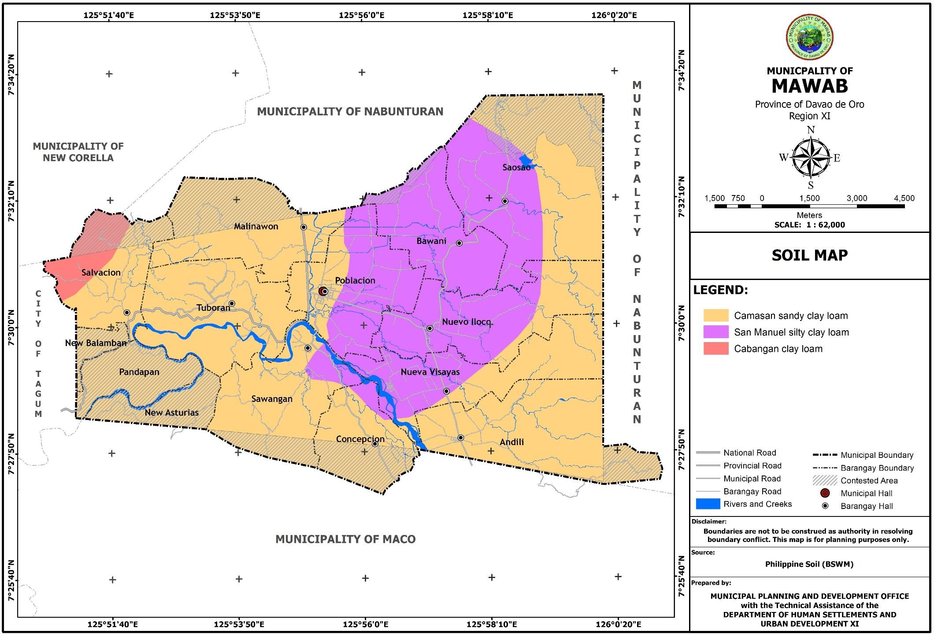

**Figure 11. Hydrologic Map**

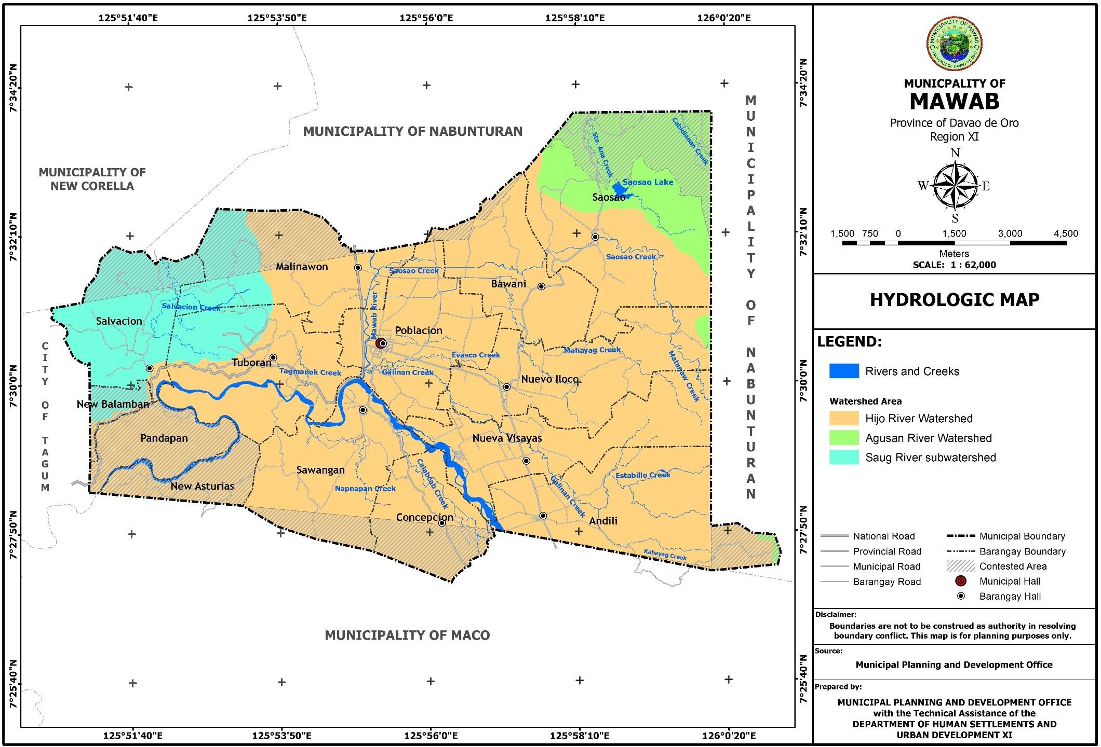

**Figure 12. Watershed Areas Map**

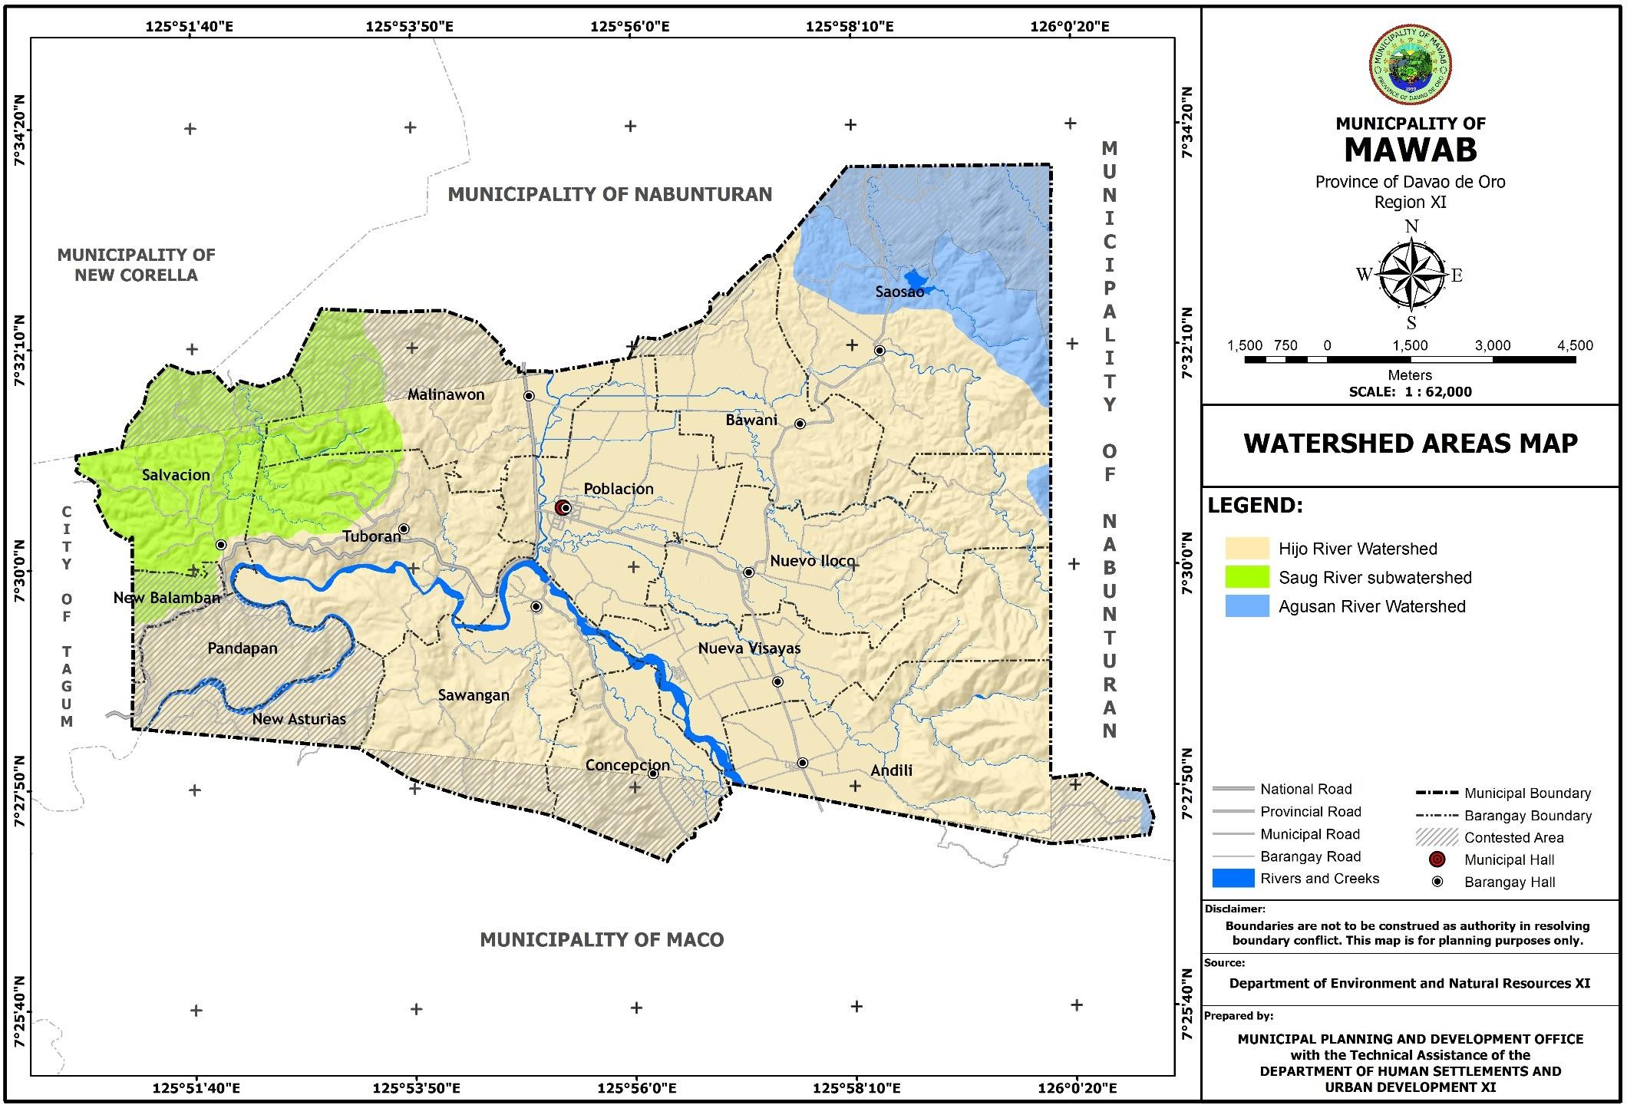

**Figure 13. Flood Susceptibility Map**

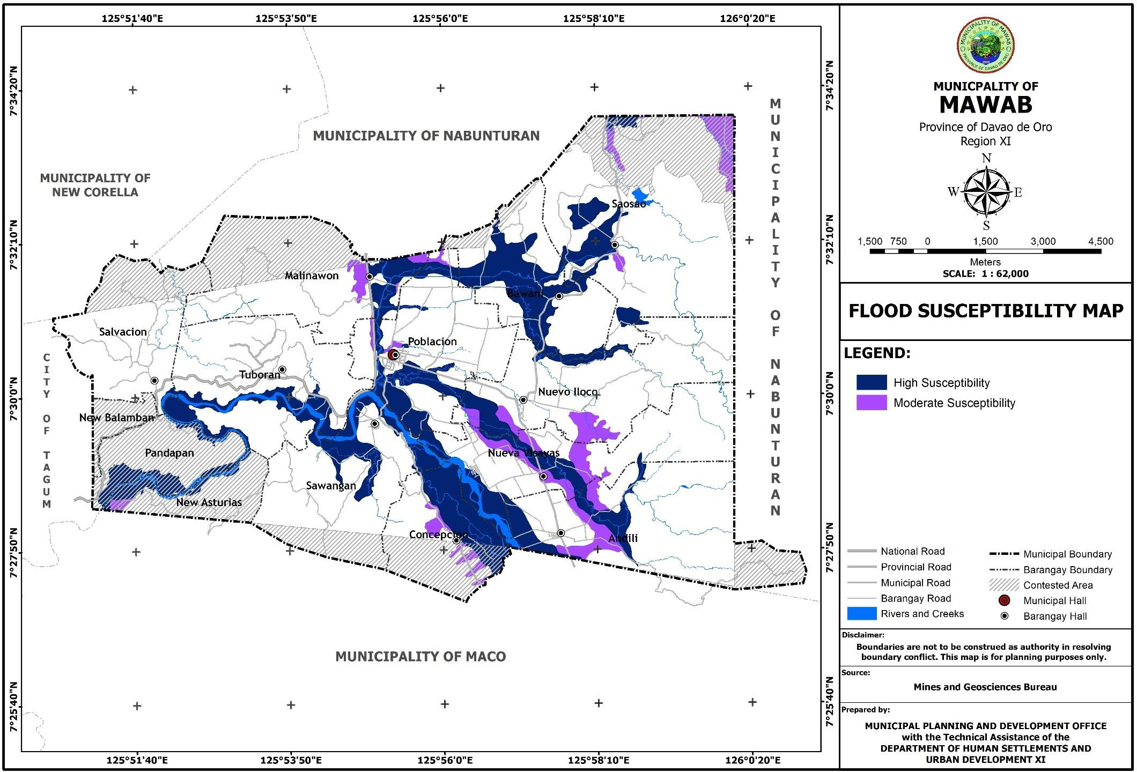

**Figure 14. Landslide Susceptibility Map**

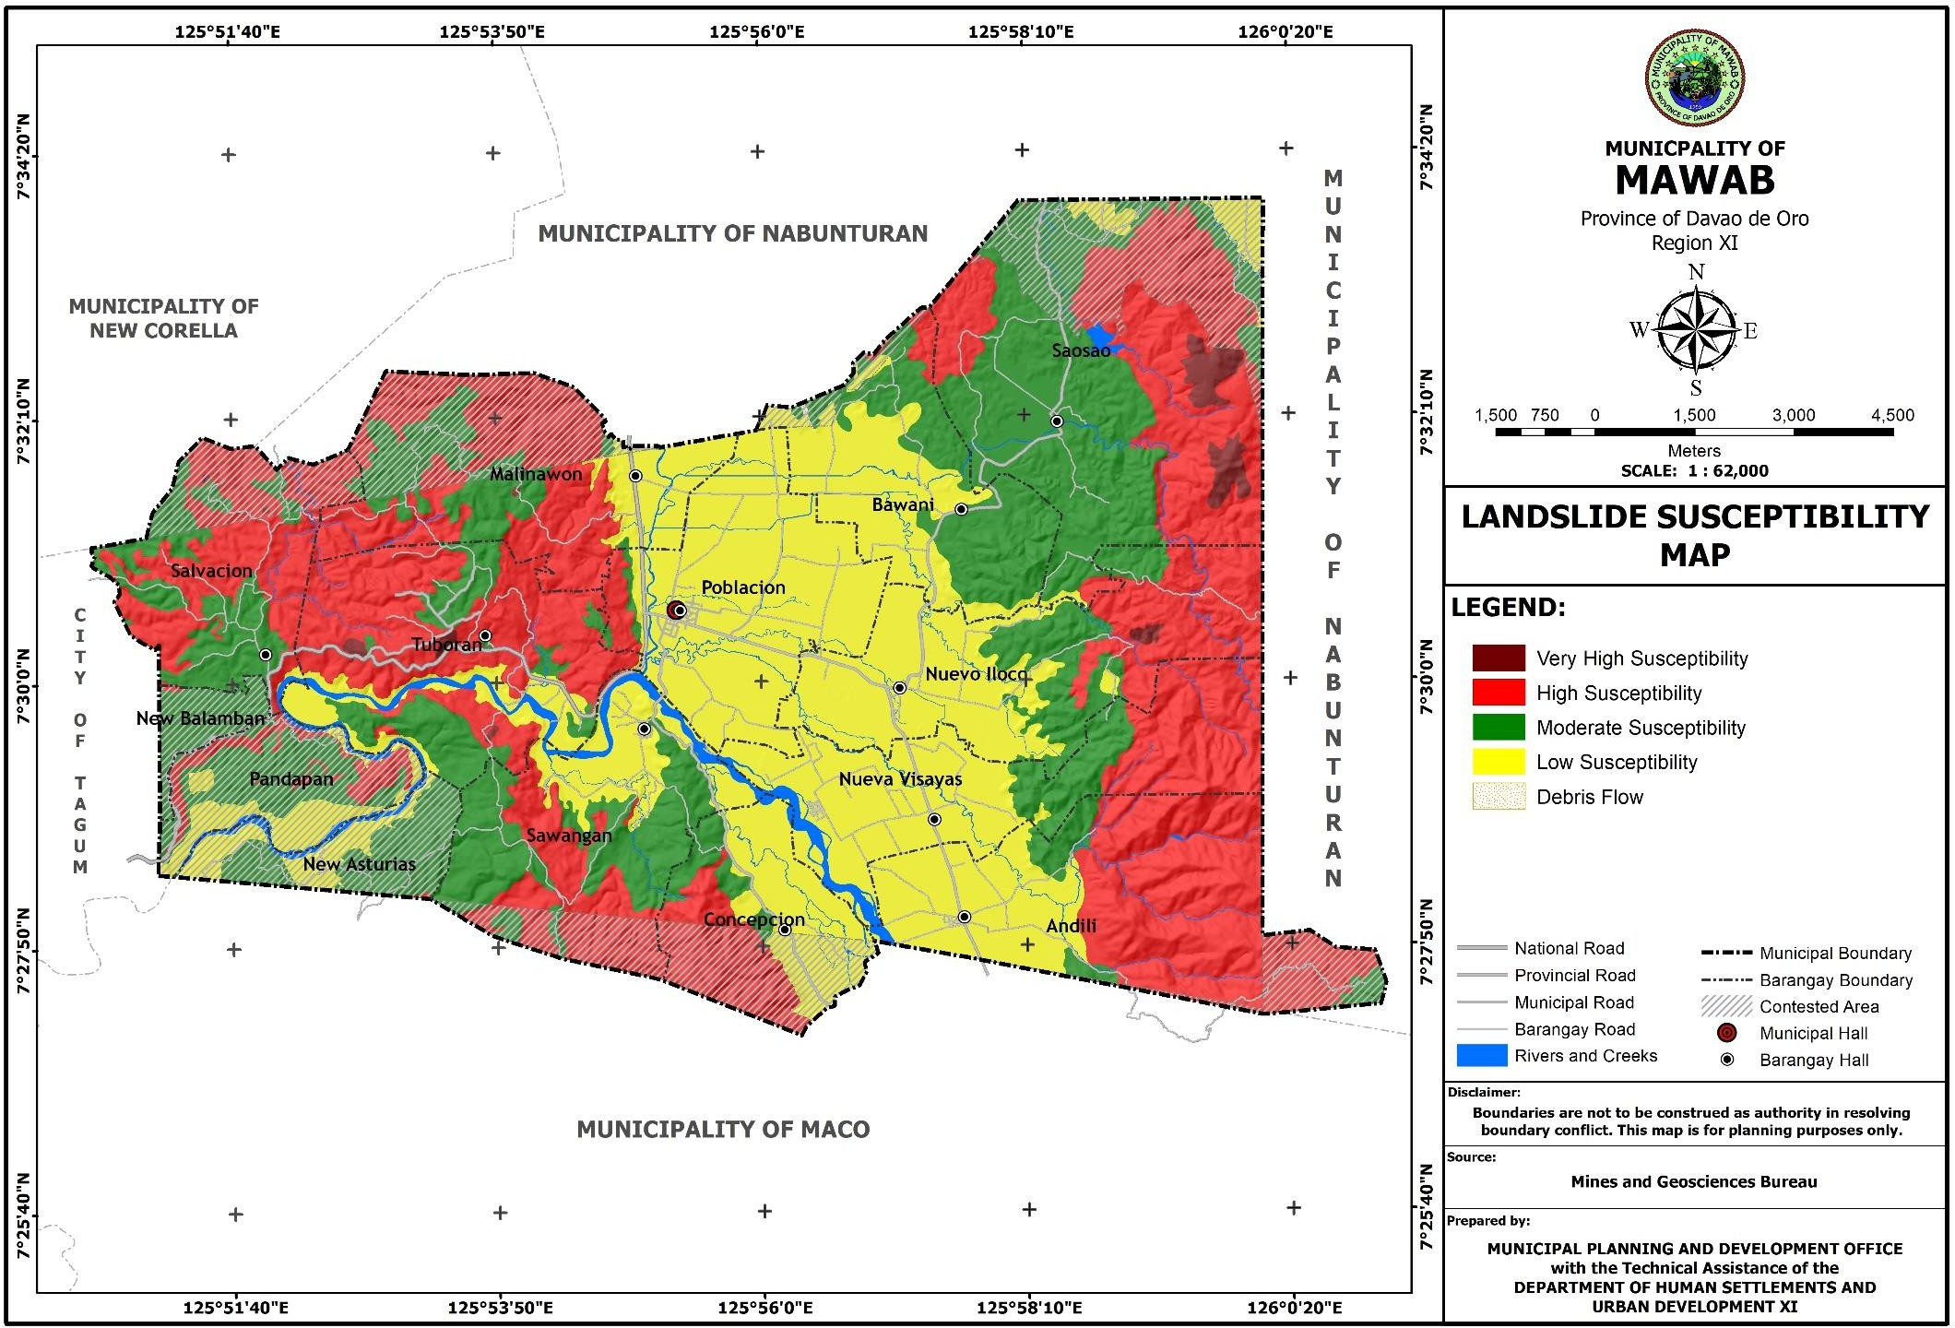

**Figure 15. Fault Line Map**

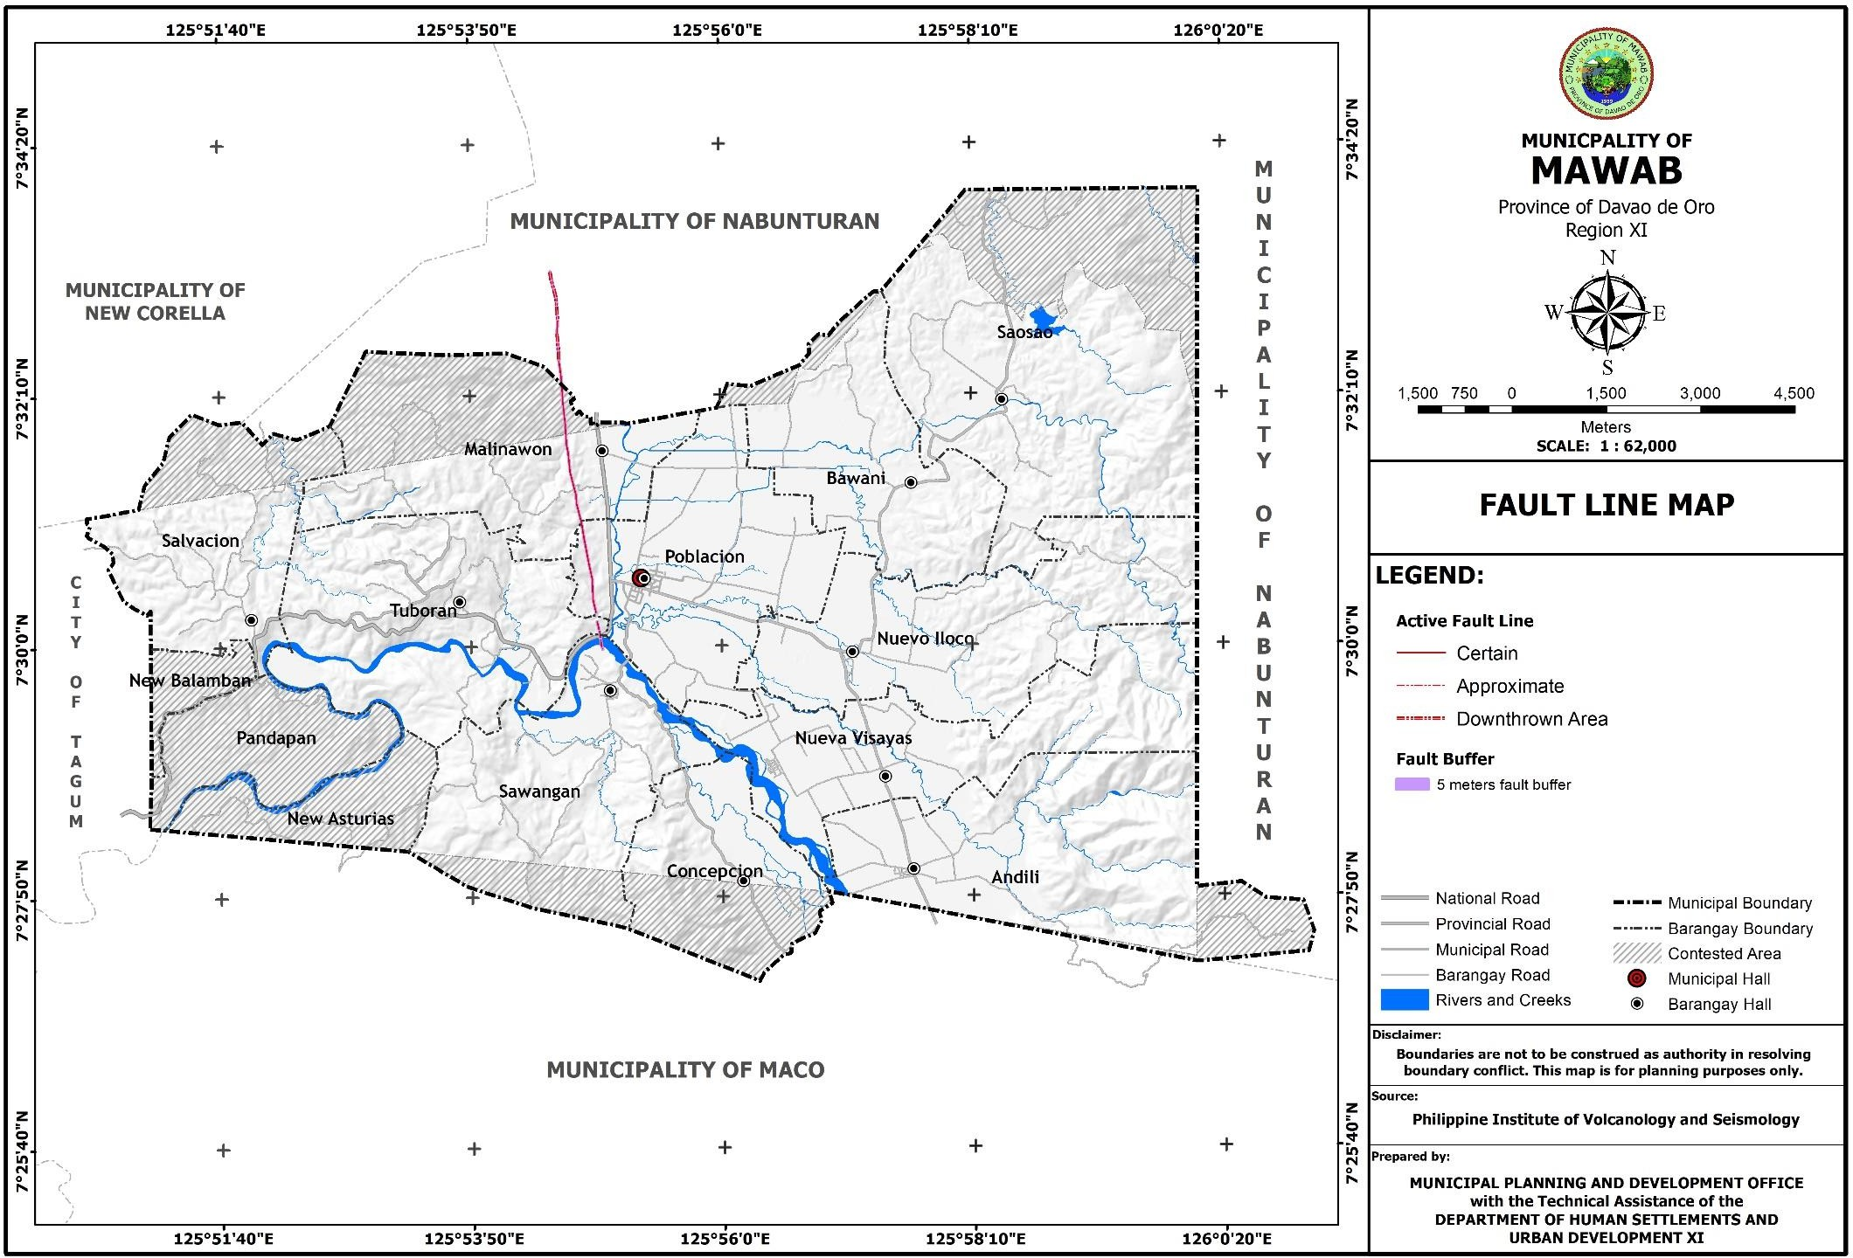

**Figure 16. Liquefaction Susceptibility Map**

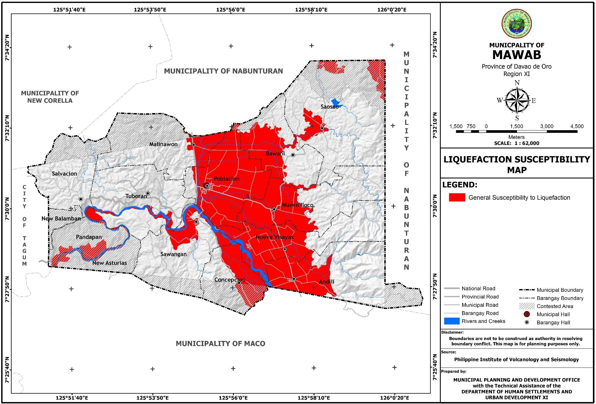

**Figure 17. Soil Suitability Map**

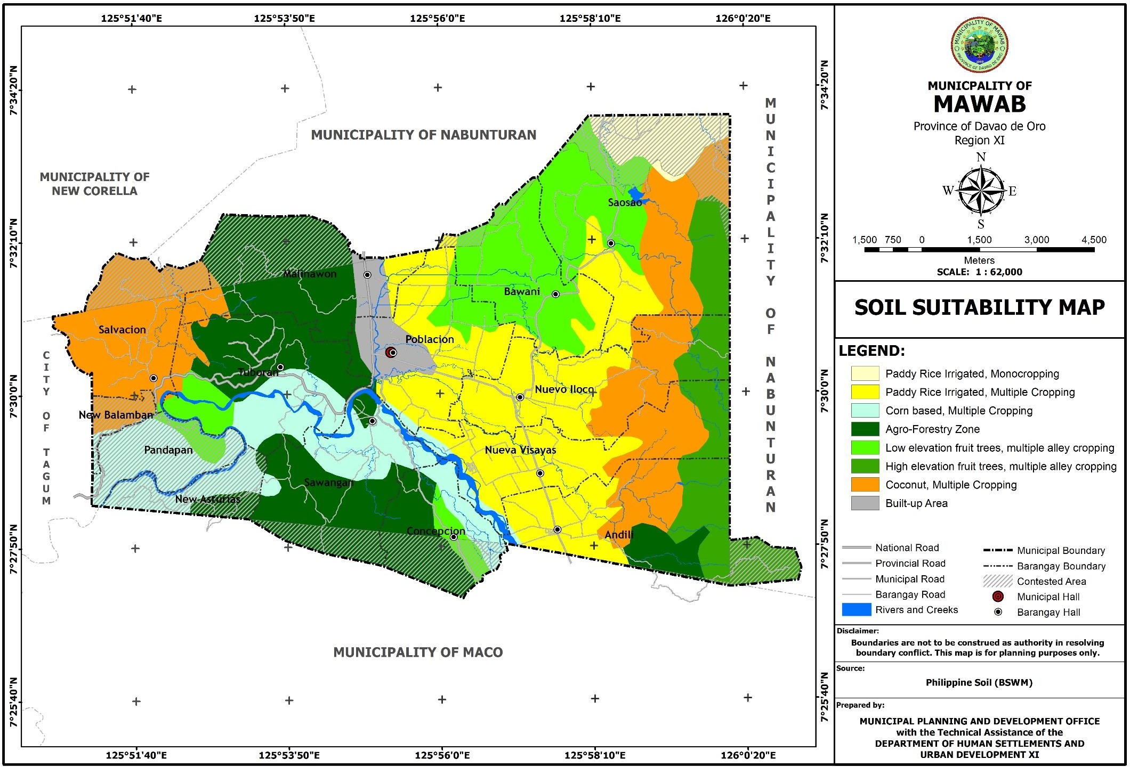

* 1. HAZARD PROFILE
     1. **Inventory of Hazard**

The table below shows the inventory of hazards the municipality has experienced. Out of the 11 barangays, apart from Barangay Salvacion, the remaining 10 barangays are highly susceptible to flooding. Only barangay Salvacion has not experienced flooding considering that its terrain is hilly and rolling. For landslide, barangays Tuboran, Malinawon and Salvacion are very highly susceptible areas, while highly susceptible areas are Andili, Bawani, Concepcion, Nueva Visayas, Nuevo Iloco, Poblacion, Saosao and Sawangan. There is also an active fault in the municipality with certain susceptibility of earthquake, landslide or liquefaction in Barangay Malinawon and Barangay Poblacion and approximate susceptibility in barangays Sawangan and Tuboran. For liquefaction, all of the eleven barangays are generally-susceptible considering the soil type of the municipality which are commonly sandy and silty.

**Table 31. Inventory of Hazards and their description**

|  |  |  |  |  |  |  |  |  |
| --- | --- | --- | --- | --- | --- | --- | --- | --- |
| **MAP INFORMATION** | | | | **HAZARD DESCRIPTION** | | | | |
| **Hazard** | **Source** | **Scale** | **Format/D ata/Refer**  **ence System** | **Susceptibili ty** | **Magnitude/ Intensity** | **Speed of Onset** | **Likelihood of Occurrence** | **Areas Covered** |
| **1** | **2** | **3** | **4** | **5** | **6** | **7** | **8** | **9** |
| Flood | MGB | 1:62,000 | WGS 84/ UTM  Zone 51N | High | 2 meters and above | sudden | floods triggered by 180mm 2-  3days rainfall with an estimated yearly recurrence | Andili Bawani Concepcion Malinawon Nueva Visayas Nuevo Iloco Poblacion Saosao Sawangan  Tuboran |
| Landslide | MGB | 1:62,000 | WGS 84/ UTM  Zone 51N | Very High | about 1meter high of saturated soil | Slow | Depending on the amount of rain present on the identified landslide-  prone areas | Malinawon Salvacion Tuboran |
| High | .5 meter high of saturated soil | Slow | Depending on the amount of rain present on the identified landslide- prone areas | Andili, Bawani, Concepcion, Nueva Visayas, Nuevo Iloco, Poblacion, Saosao,  Sawangan |
| Active Faults | MGB | 1:62,000 | WGS 84/  UTM Zone 51N | Certain | No Data Available | No Data Available | No Data Available | Malinawon, Poblacion |
| Approximate | No Data Available | No Data Available | No Data Available | Sawangan Tuboran |
| Liquefaction | MGB | 1:62,000 | WGS 84/  UTM Zone 51N | General | No Data Available | No Data Available | No Data Available | Andili, Bawani, Concepcion, Malinawon, Nueva Visayas, Nuevo Iloco, Poblacion, Salvacion, Saosao, Sawangan,  Tuboran |

* + 1. **Records of Previous Disaster**

The latest hazard event that the municipality has experienced was happened on January 26, 2019 which is a low pressure area (LPA) causing flooding and landslide. Affected barangays were Andili, Bawani, Malinawon, Nueva Visayas, Poblacion, Saosao and Tuboran. It distressed the population, infrastructure facilities and agricultural products.

**Table 32. Records of Previous Disasters**

|  |  |  |  |  |  |  |  |  |  |  |  |  |  |  |
| --- | --- | --- | --- | --- | --- | --- | --- | --- | --- | --- | --- | --- | --- | --- |
| Hazard Events and Description | Affected Barangays | No. of casualties (Number of Individuals) | | | No. of affected | | No. of houses damaged | | Damage to properties in Philippine Pesos (PhP) | | | | | Source of Informati on |
| Dead | Injured | Missing | Perso ns | Famili es | Total ly | Partia lly | Infra | Agri | Inst. | Private/ Comm'l | Total |
| January 26, 2019 LPA (Flooding and Landslide) | Andili | 0 | 0 | 0 | 48 | 16 | 0 | 0 | 0 | 0 | 0 | 0 |  |  |
| Bawani | 0 | 0 | 0 | 0 | 0 | 0 | 0 | 0 | 160,000 | 0 | 0 |  |  |
| Malinawon | 0 | 0 | 0 | 160 | 47 | 0 | 0 | 0 | 128,000 | 0 | 0 |  |  |
| Nueva Visayas | 0 | 0 | 0 | 16 | 3 | 0 | 0 | 0 | 130,000 | 0 | 0 |  |  |
| Poblacion | 0 | 0 | 0 | 116 | 34 | 0 | 0 | 0 | 0 | 0 | 0 |  |  |
| Saosao | 0 | 0 | 0 | 0 | 0 | 0 | 0 | 0 | 145,000 | 0 | 0 |  |  |
| Tuboran | 0 | 0 | 0 | 0 | 0 | 0 | 0 | 2M | 0 | 0 | 0 |  |  |
| Typhoon Pablo, Dec. 4, 2012 |  | 1 | 29 | 0 | 0 | 3299 | 0 | 0 | 8,998,200 | 30,078,200 | 3,330,000 | 0 |  |  |

* + 1. **Likelihood of Occurrence**

Of the 11 barangays in the municipality, apart from Barangay Salvacion, all experience flooding around two times a year. Rain-induced landslide occurs once a year in barangays Andili, Concepcion, Malinawon, Nuevo Iloco, Salvacion and Sawangan, 4 times a year in Barangay Poblacion and 7 times a year in Barangay Tuboran.

**Table 33. Likelihood of Occurrence of Hazard per Barangay**

|  |  |  |  |  |
| --- | --- | --- | --- | --- |
| **Barangay** | **Flood** | **Rain-Induced Landslide** | **Active Faults** | **Liquefaction** |
| Andili | Twice a year | Once a year | - | No data Available |
| Bawani | Twice a year | - | - | No data Available |
| Concepcion | Twice a year | Once a year | - | No data Available |
| Malinawon | Twice a year | Once a year | No data Available | No data Available |
| Nueva Visayas | Twice a year | - | - | No data Available |
| Nuevo Iloco | Twice a year | Once a year | - | No data Available |
| Poblacion | Twice a year | 4 times a year | No data Available | No data Available |
| Salvacion | - | Once a year | - | No data Available |
| Saosao | Twice a year | - | - | No data Available |
| Sawangan | Twice a year | Once a year | No data Available | No data Available |
| Tuboran | Twice a year | 7 times a year | No data Available | No data Available |

Source: MDRRMO

* 1. PHYSICAL/INFRASTRUCTURE RESOURCES
     1. **Transportation Network (Internal and External Linkages)**

The road network system of the municipality consists of the national road, provincial road, municipal road and barangay road. The total length of the national road totalled to 15.264 km. and are 100% concreted. The provincial road length totalled to 25.277 km., of which 18.633 km. are concreted and 6.644 km. are gravelled. The municipal road has a total length of 6.312 km., of which 4.711 km. are concreted and 1.601 km. are gravelled. The barangay road length totalled to 147.487 km. with 19.758 km. concreted, 67.582 km. gravelled and 60.147 km. earth filled. (Table 31)

Bridges and other transportation facilities are also present in the municipality. There is a total of 26 bridges linking the road network of the municipality, of which 8 are Reinforced Concrete Deck Girder (RCDG) bridges, 2 are steel bridges, 4 are hanging bridges, 11 are local footbridges and 1 is a wood bridge. Other transportation facilities available are 1 bus terminal, 4 barangay mini-terminals and 1 airstrip. (Table 32)

**Table 34. Road Network System, Year 2018**

|  |  |  |  |  |
| --- | --- | --- | --- | --- |
| **Roads by System Classification (Road Section)** | **Total Length (km)** | **Road Surface Type** | | |
| **Concrete** | **Gravel** | **Earth** |
| **L (km)** | **L (km)** | **L (km)** |
| National Road | 15.264 | 15.264 | - | - |
| Provincial Road | 25.277 | 18.633 | 6.644 | - |
| Municipal Road | 6.312 | 4.711 | 1.601 | - |
| Barangay Road | 147.487 | 19.758 | 67.582 | 60.147 |
| **TOTAL** | **194.34** | **58.366** | **75.827** | **60.147** |

Source: Municipal Engineering Office

**Table 35. Bridge and Other Transportation Facilities**

|  |  |  |
| --- | --- | --- |
| **Type** | **Number** | **Location** |
| Reinforced Concrete Deck Girder (RCDG) Bridge | 8 | P-8, Malinawon; P-1, Nueva Visayas; P-2 and P-3 Poblacion; P-7, Salvacion; P-2, Saosao; P-1, Sawangan; P-3, Tuboran; |
| Steel Bridge | 2 | P-8A, Mahayag, Nuevo Iloco; P-4, Tabon-tabon, Bawani; |
| Hanging Bridge | 4 | P-6, Andili; P-3, Nueva Visayas; P-3, Malinawon; P-8, Tuboran; |
| Local Footbridge | 11 | P-17, P-18, P-8, P-11, P-2, P-3, P-20, P-11, P-9A,  Poblacion, P-3, Saosao; P-7, Estabillo, Andili |
| Wood Bridge | 1 | P-15, Poblacion; |
| Bus Terminal | 1 | P-2, Poblacion; |
| Barangay Mini-Terminal | 4 | P-4, Andili; P-4, Poblacion; P-1, Sawangan; P-2, Nuevo Iloco; |
| Airstrip | 1 | P-5, Tabon-tabon, Bawani; |

Source: Municipal Engineering Office

**Figure 18. Road Network and Bridges Map**

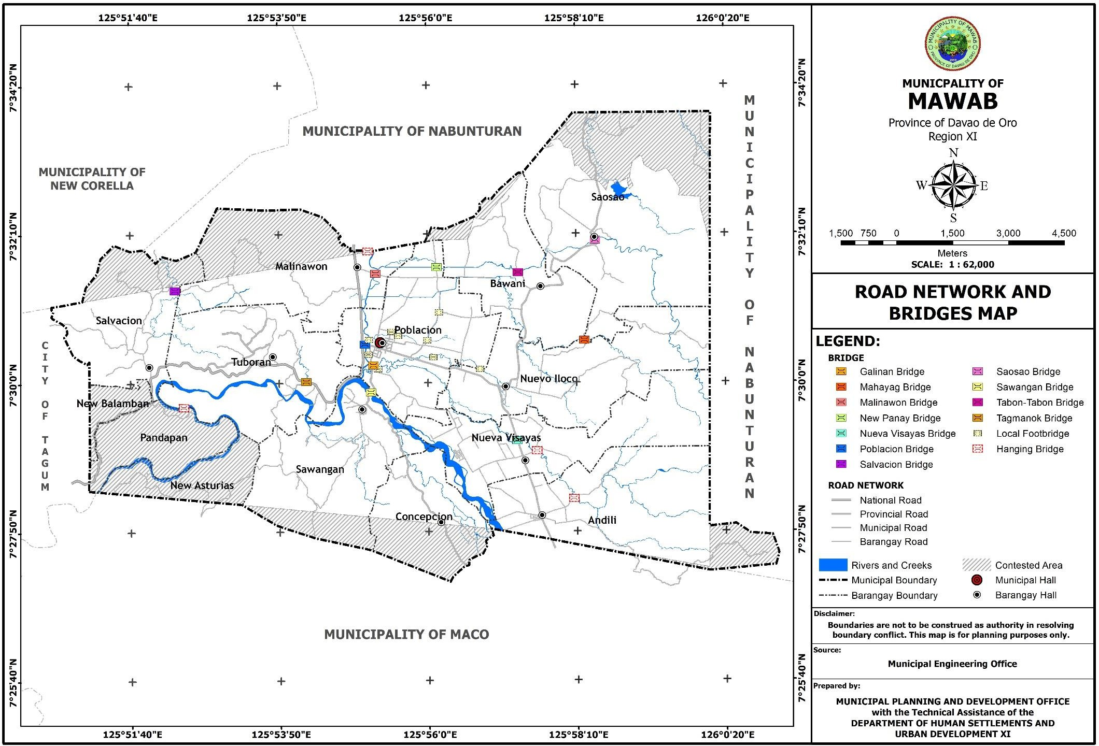

**Figure 19. Transportation Facilities Map**

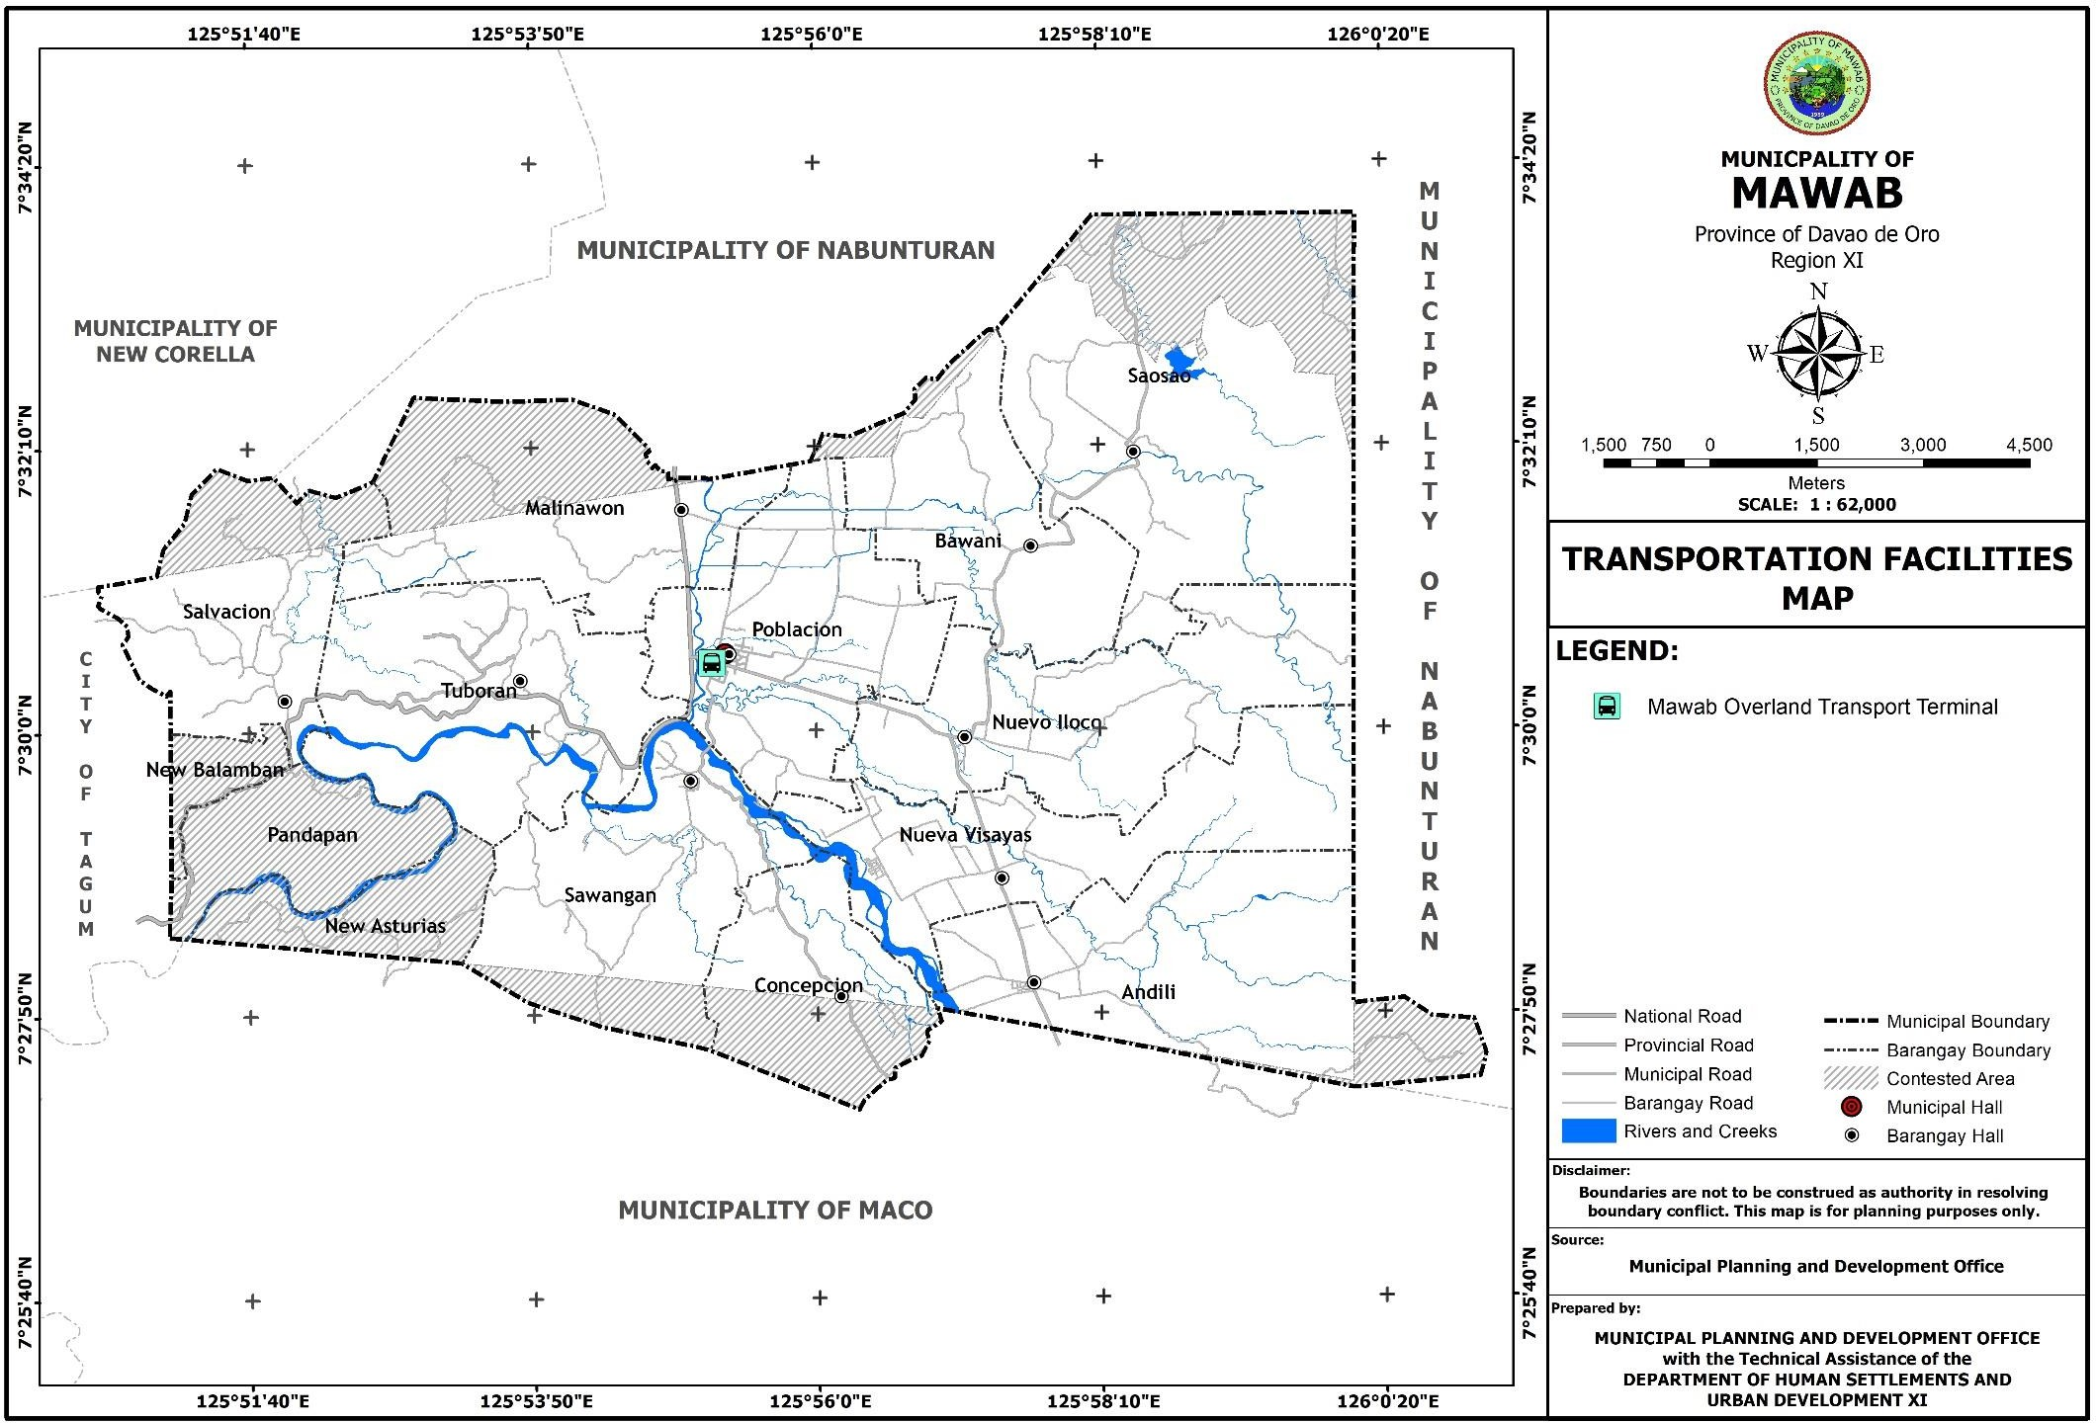

* + 1. **Social Services Facilities/Utilities/Amenities**

The available social service facilities available in Mawab are 3 hospitals, 1 rural health unit, 10 barangay health stations, 1 birthing facility and 2 private clinics for health. There are also 18 public primary/elementary schools, 2 private elementary schools, 4 public secondary schools, 3 private secondary schools, and 24 day care centers as education facilities. Mawab also has 6 Senior Citizen Day Centers, 1 Women’s building, 11 covered courts/mini-gyms, 43 open basketball courts, 1 police station, 1 fire station, 6 army/police detachments and 2 military camps, all of which will serve the social welfare, sports, protective services and other related social needs of the municipality’s residents. Although some of these facilities are distributed among the 11 barangays of Mawab, most are located in Barangay Poblacion as it is the seat of government.

**Table 36. Number of Social Services Facilities**

|  |  |  |
| --- | --- | --- |
| **Name of Facilities** | **Number** | **Location** |
| Hospital | 3 | Poblacion |
| Rural Health Unit | 1 | Poblacion |
| Barangay Health Station | 10 | Andili, Bawani, Concepcion, Malinawon, Nueva Visayas, Nuevo Iloco, Salvacion,  Saosao, Sawangan, Tuboran |
| Birthing Facility | 1 | Poblacion |
| Private Clinic | 2 | Poblacion |
| Public Primary/Elementary School | 18 | Andili, Bawani, Concepcion, Malinawon, Nueva Visayas, Nuevo Iloco, Poblacion, Salvacion, Saosao, Sawangan, Tuboran |
| Private Elementary School | 2 | Nueva Visayas, Poblacion |
| Public Secondary School | 4 | Andili, Nuevo Iloco, Poblacion, Tuboran |
| Private Secondary School | 3 | Nueva Visayas, Poblacion |
| Day Care Centers | 24 | Andili, Bawani, Concepcion, Malinawon,  Nueva Visayas, Nuevo Iloco, Poblacion, Salvacion, Saosao, Sawangan, Tuboran |
| Senior Citizen Day Center | 6 | Andili, Bawani, Malinawon, Nuevo Iloco, Poblacion, Saosao |
| Women’s Building | 1 | Tuboran |
| Covered Court/Mini-gym | 11 | Andili, Bawani, Concepcion, Malinawon, Nueva Visayas, Nuevo Iloco, Poblacion,  Salvacion, Saosao, Sawangan, Tuboran |
| Open Basketball Court | 43 | Andili, Bawani, Concepcion, Malinawon,  Nueva Visayas, Nuevo Iloco, Poblacion, Salvacion, Saosao, Sawangan, Tuboran |
| Police Station | 1 | Poblacion |
| Fire Station | 1 | Poblacion |
| Army/Police Detachment | 6 | Andili, Poblacion, Salvacion, Tuboran |
| Military Camp | 2 | Nueva Visayas, Tuboran |

**Figure 20. Health and Sanitation Facilities Map**

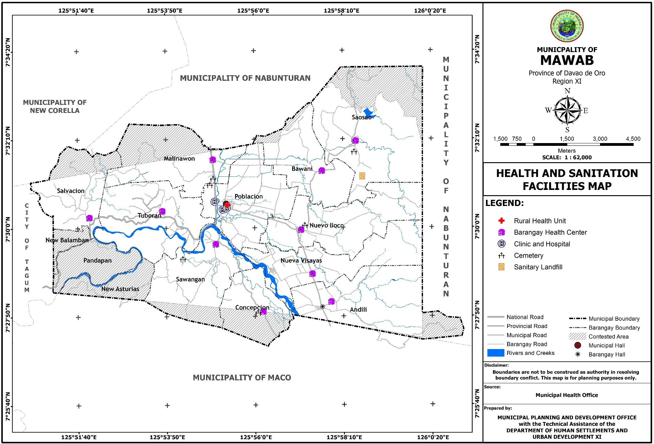

**Figure 21. Education Facilities Map**

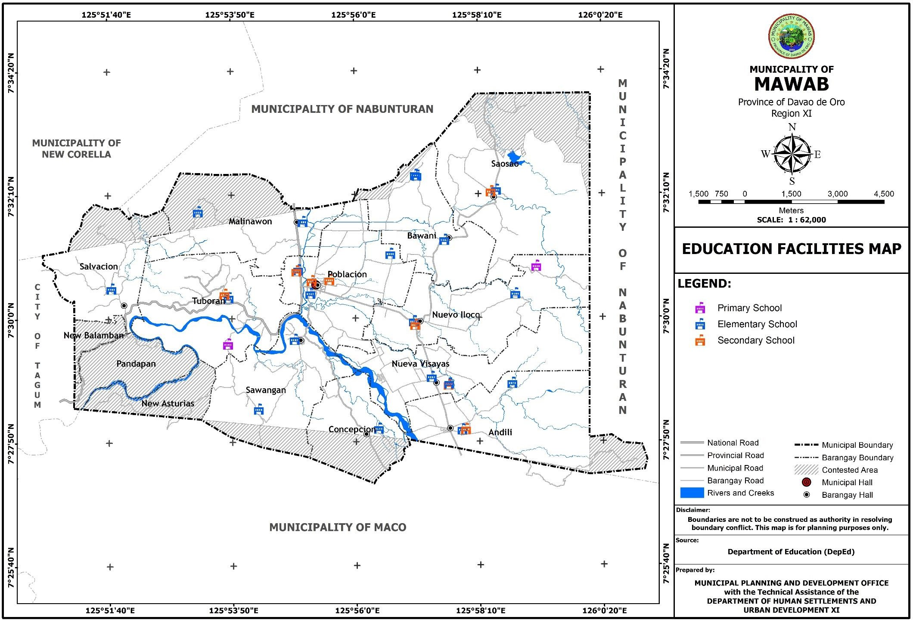

**Figure 22. Social Welfare Services Facilities Map**

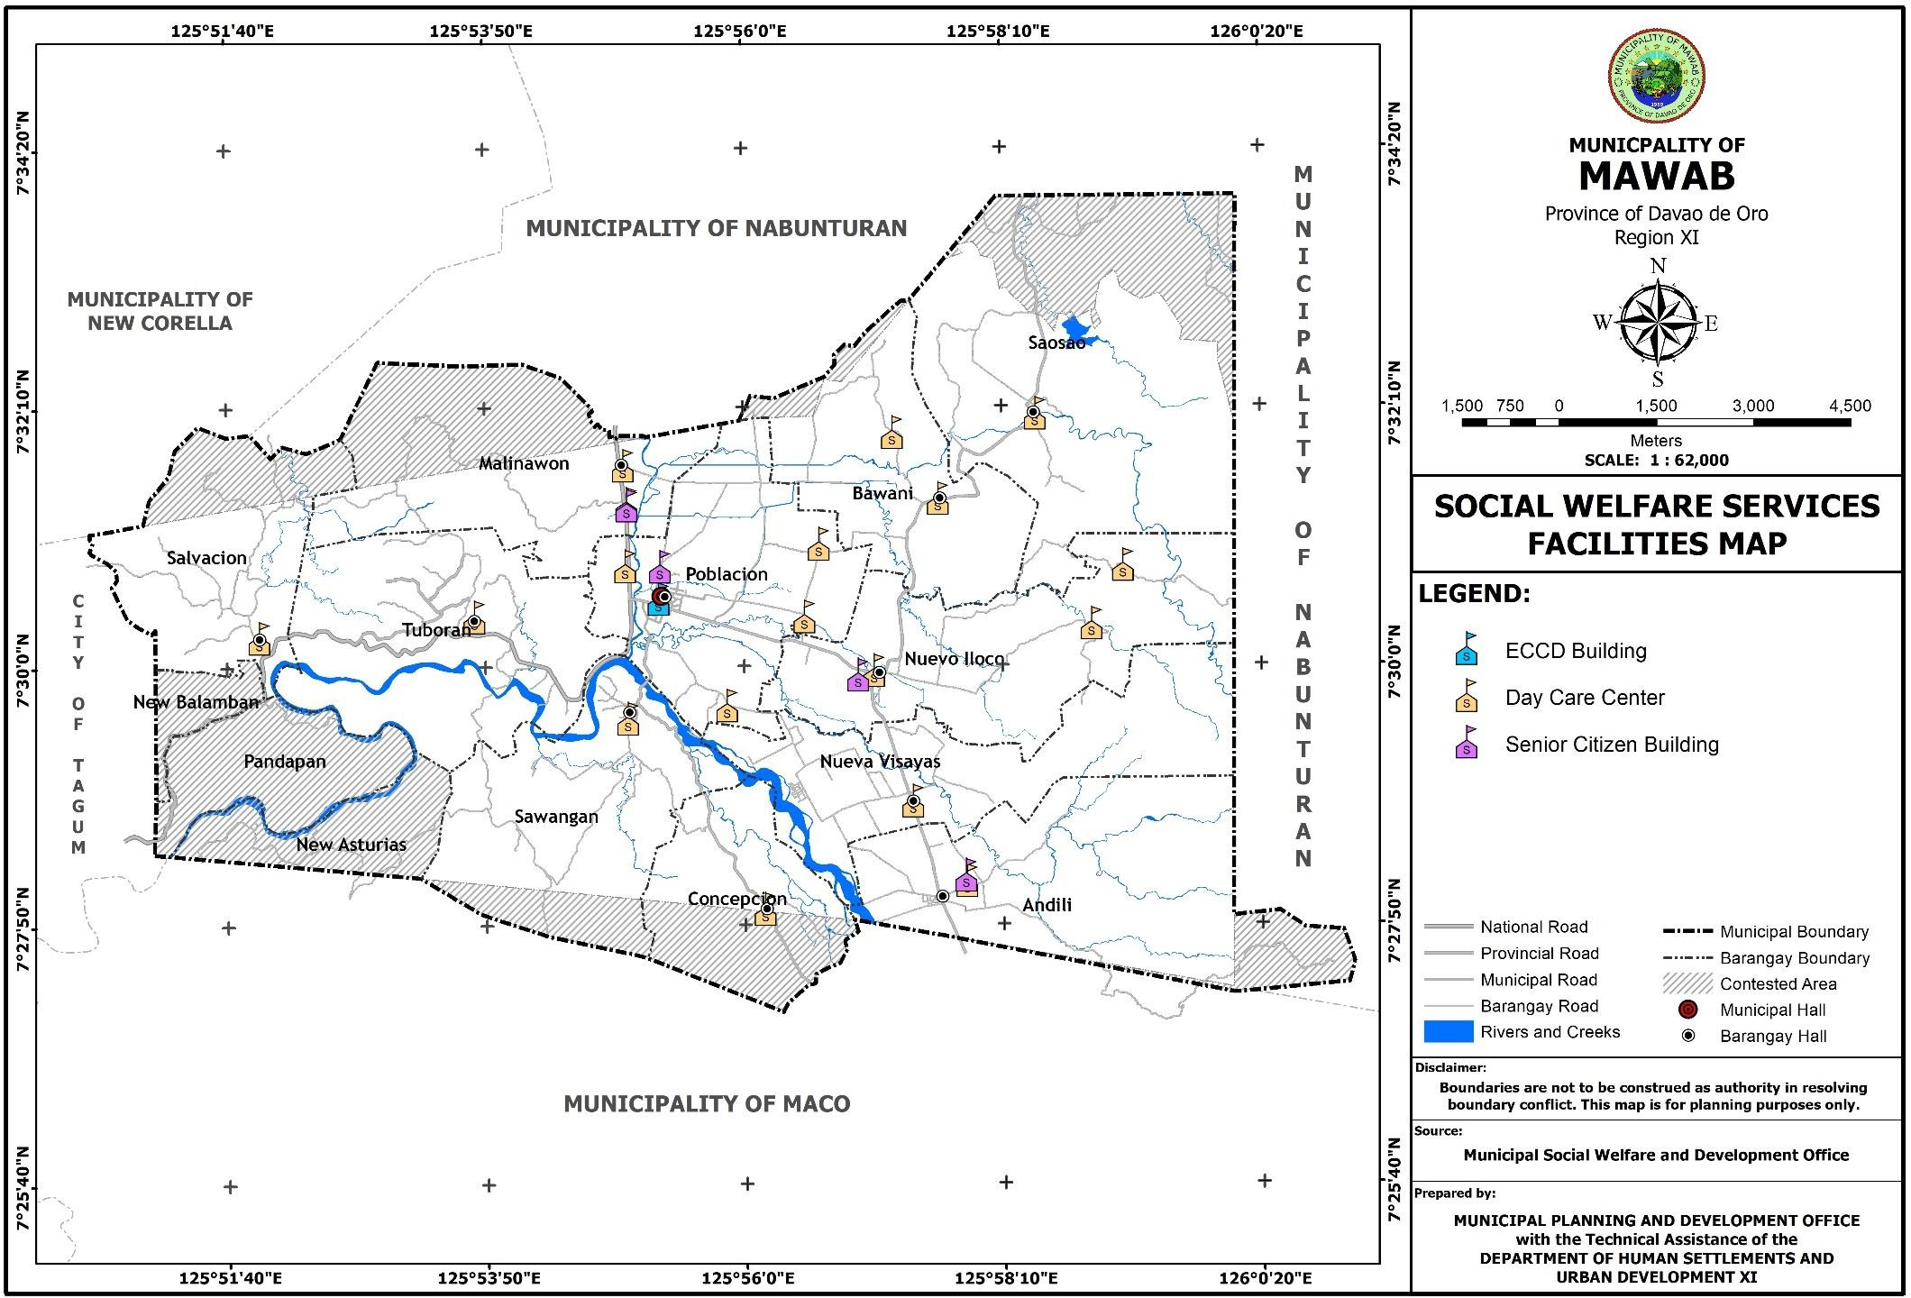

**Figure 23. Protective Services Facilities Map**

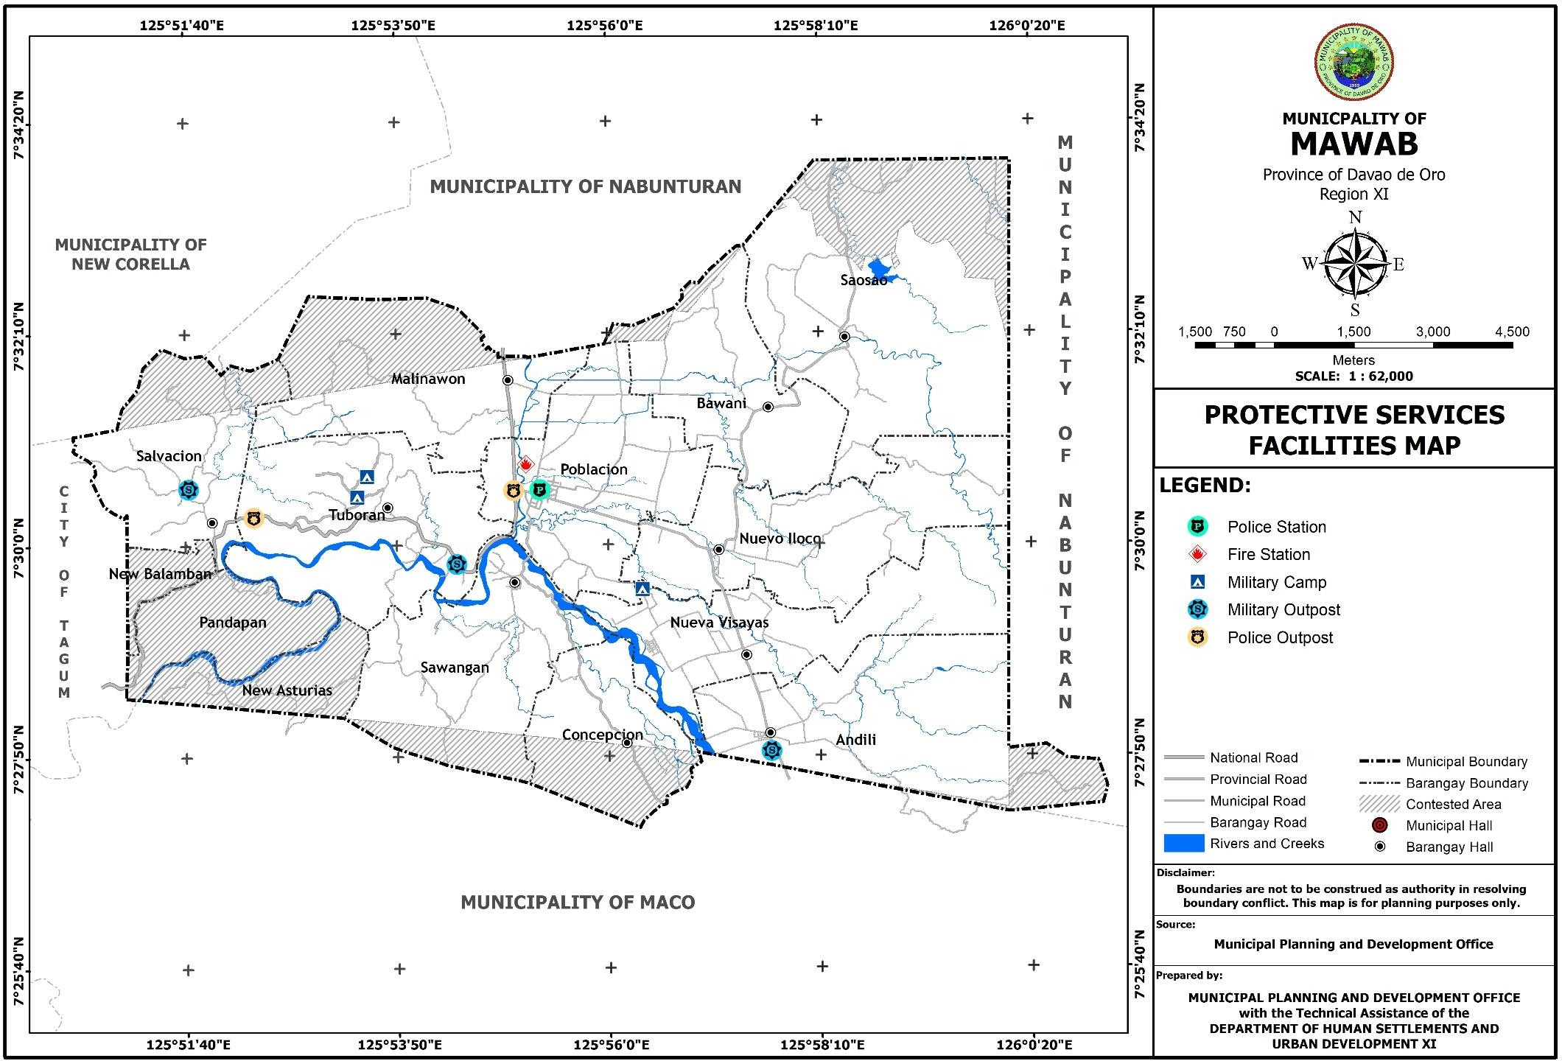

**Figure 24. Sports and Recreation Facilities Map**

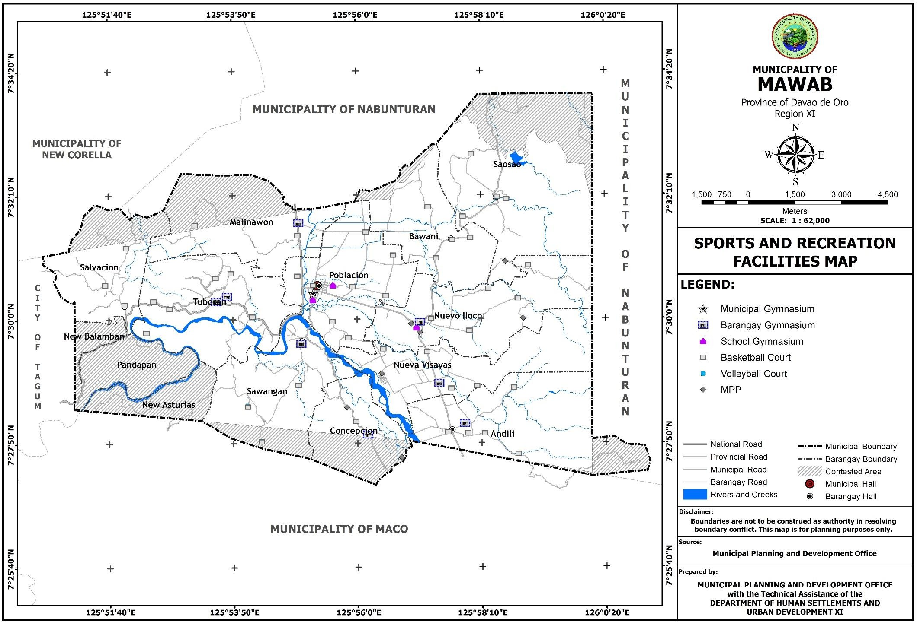

* + 1. **Utilities**

The power facilities which are available in Mawab are electricity and streetlights which can be found on all of its 11 barangays. There is also solar power available in barangays Andili and Tuboran. (Table 34)

There are also communication facilities that exist in the municipality, specifically, there are 9 communication towers which were placed all-over Barangay Andili, Nuevo Iloco, Poblacion and Tuboran; there are also 3 radio-based facilities which are located in Poblacion and Tuboran, 1 post office in Poblacion and 12 internet cafes which can be found in Malinawon, Nuevo Iloco and Poblacion. (Table 35)

**Table 37. Power Facilities**

|  |  |  |
| --- | --- | --- |
| No. of Barangays energized | 11 | Andili, Bawani, Concepcion, Malinawon, Nueva Visayas, Nuevo Iloco, Poblacion, Salvacion, Saosao, Sawangan, Tuboran |
| No. of Streetlights | 483 | 11 Barangays |
| No. of Barangays with Solar Power facility | 2 | Andili, Tuboran |

**Table 38. Communication Facilities**

|  |  |  |
| --- | --- | --- |
| No. of Communication Tower | 9 | Andili, Nuevo Iloco, Poblacion, Tuboran |
| No. of Radio Based | 3 | Poblacion, Tuboran |
| Post Office | 1 | Poblacion |
| Internet Café | 12 | Malinawon, Nuevo Iloco, Poblacion |

**Figure 25. Power Facilities map**

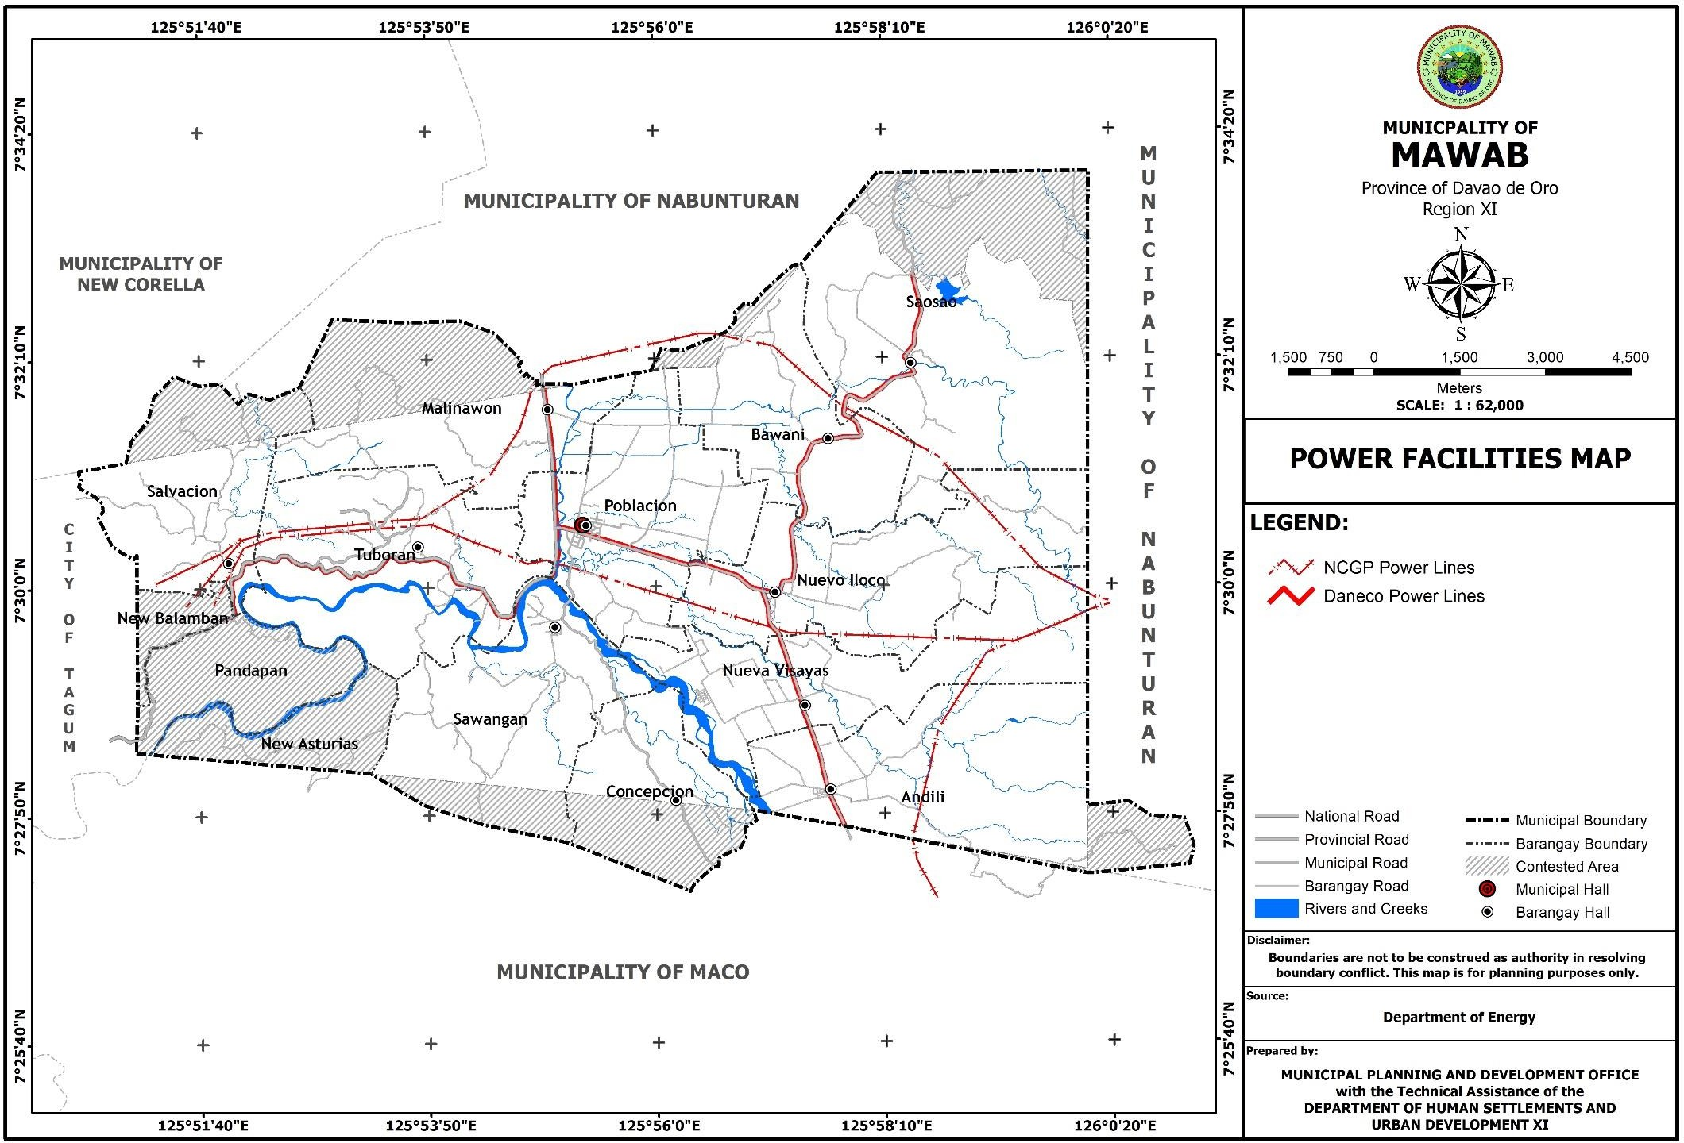

**Figure 26. Information and Communication Technology Facilities Map**

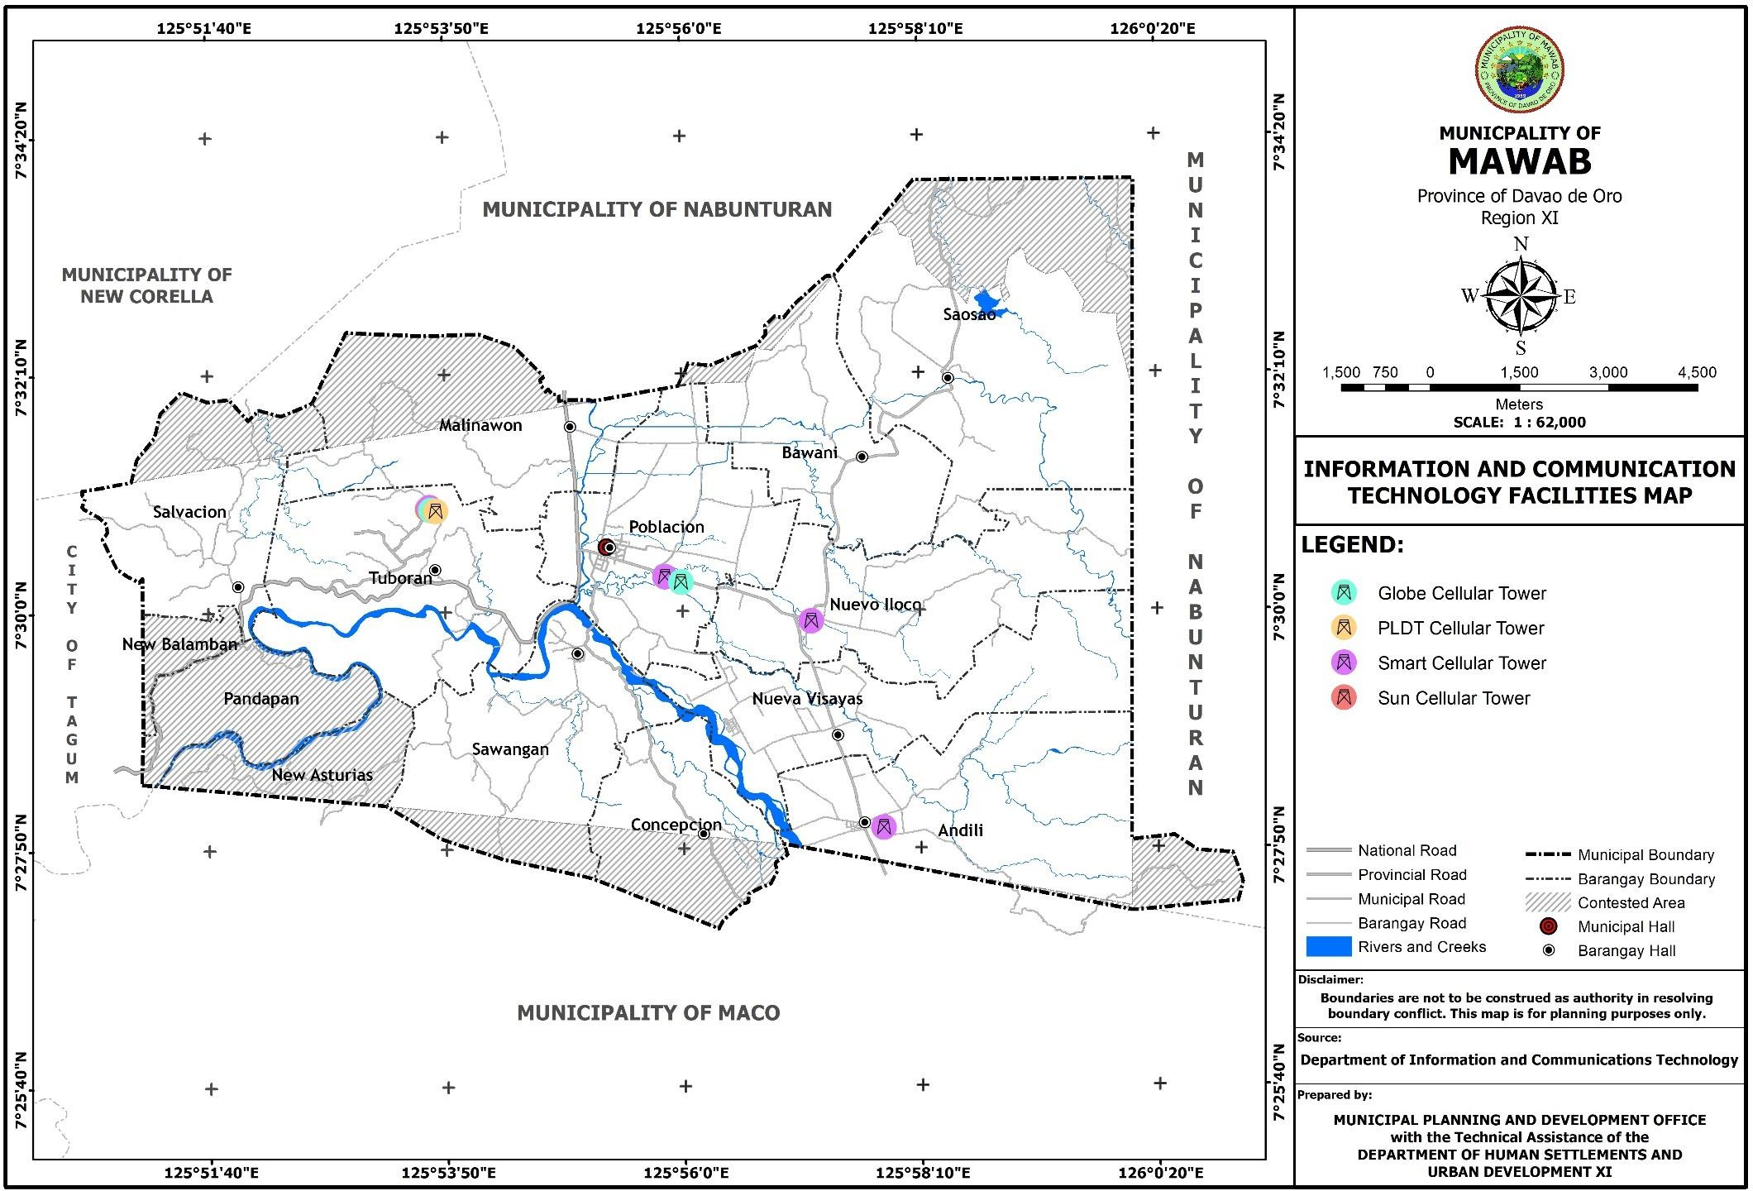

* + 1. **Water**

There are 3 water facility types that exist in the municipality. One of these are the level III water systems (metered) which are operated by the Municipal Local Government Unit (MLGU) of Mawab, Barangay Local Government Units (BLGUs) of Bawani, Malinawon, Nuevo Iloco, Saosao and Sawangan, and also by the ANUVIMCO Water Services and JOE Water Services. Another one is the Level II Water System (non-metered) which is operated by BLGU Salvacion. Finally, there is the Level I water system which is comprised of the developed springs and deep wells which were established by the individual households themselves for domestic use.

**Table 39. Water Facilities**

|  |  |  |  |
| --- | --- | --- | --- |
| Level III (metered) | 4 | MLGU | Poblacion, Malinawon |
| 1 | BLGU | Bawani, Malinawon, Nuevo Iloco, Saosao, Sawangan |
| 2 | ANUVIMCO  Water  Services, JOE Water Services | Andili, Nueva Visayas, Sawangan |
| Level II (non- metered) | 3 | BLGU | Salvacion |
| Level I: Developed Spring | 15 | Individuals | Concepcion, Malinawon, Nuevo Iloco, Poblacion, Salvacion, Tuboran |

* + 1. **Waste Management**

The municipality has already identified a site for the future establishment of a municipal sanitary landfill which is located in Barangay Saosao. There are also existing Materials Recovery Facilities (MRFs) that can be found in the 11 barangays of the municipality for the waste disposal of each household.

**Table 40. Inventory of Waste Disposal Facilities/Equipment**

|  |  |  |
| --- | --- | --- |
| **Equipment** | **No. of Units** | **Location** |
| Sanitary Landfill | 1 | Saosao |
| Material Recovery Facilities | 11 | 11 Barangays |

**Figure 27. Water Facilities Map**

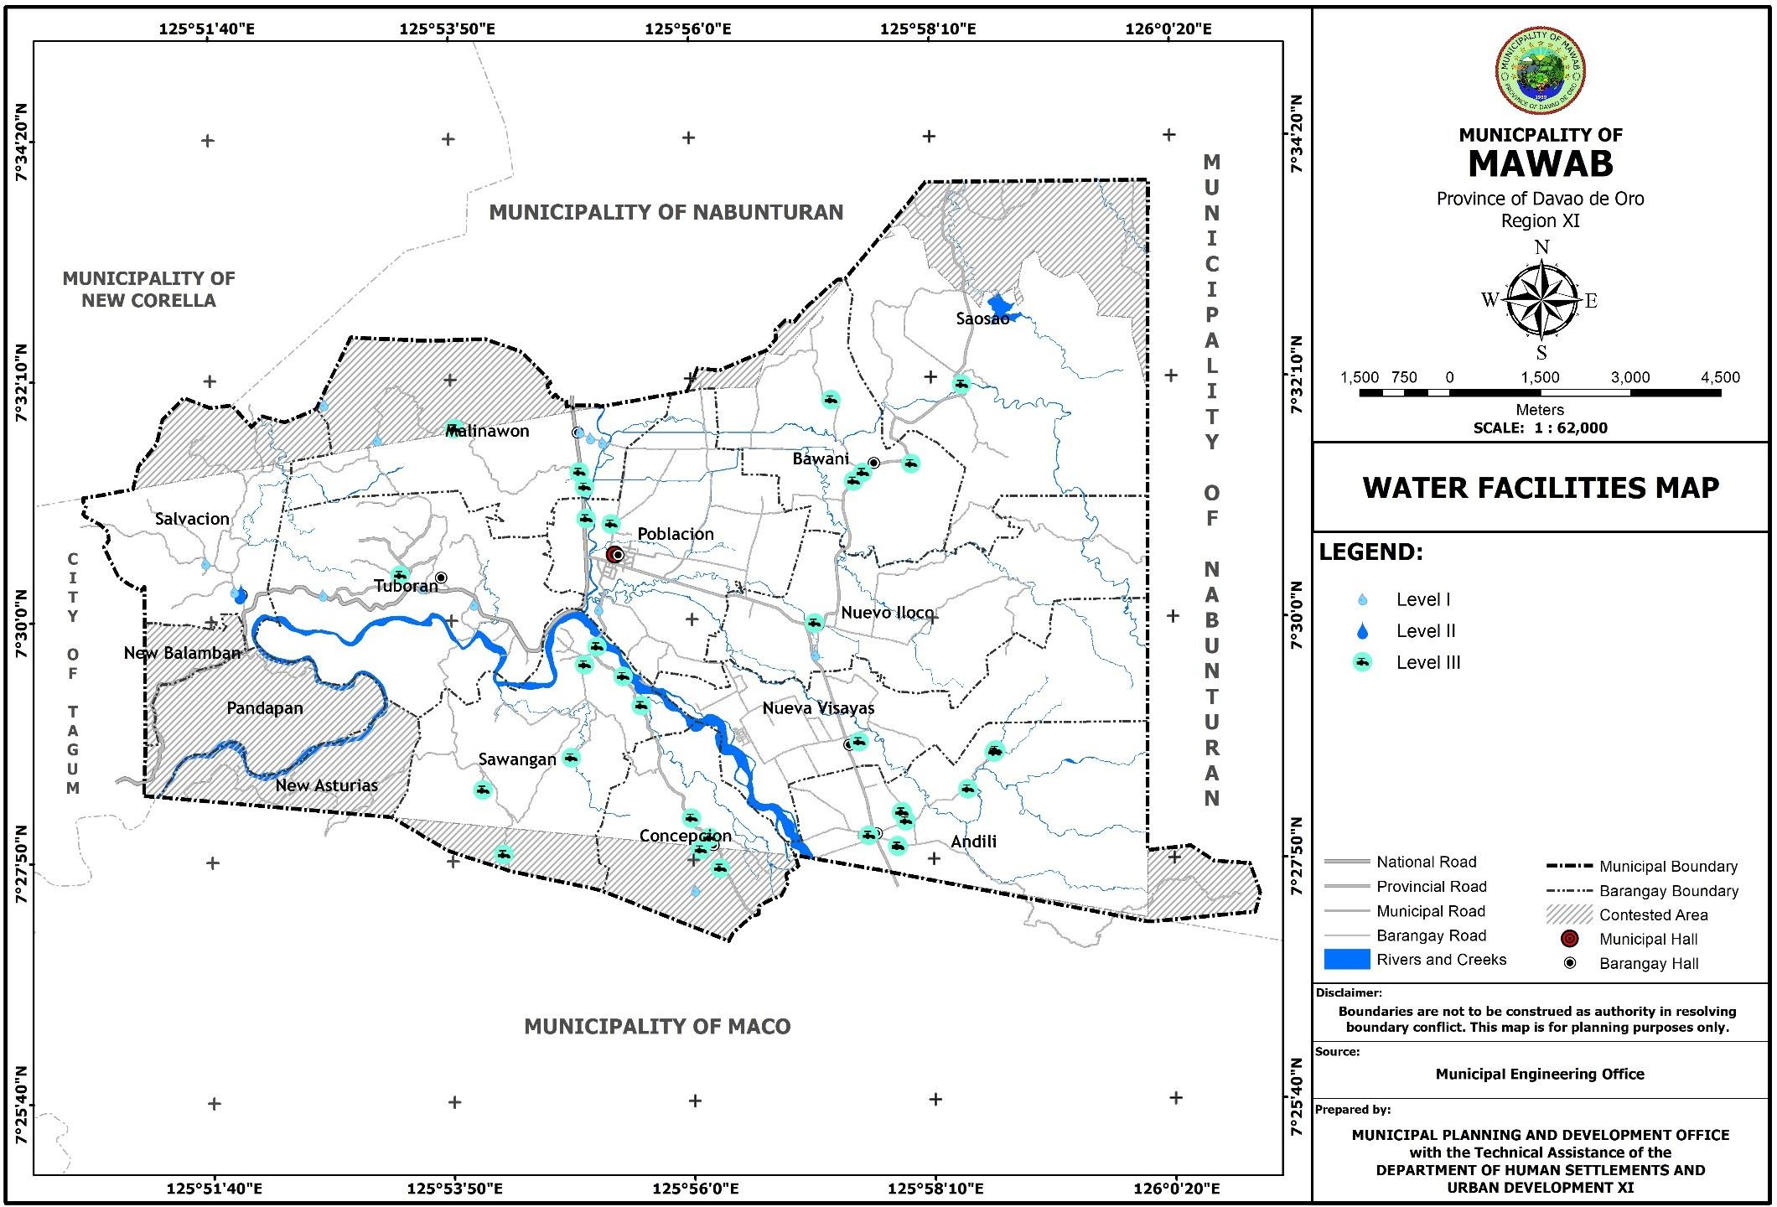

###### THE ECONOMIC STRUCTURE

* + 1. **Revenue Sources on Agriculture, Industries, Commerce and Trade, Tourism**

1. **Agriculture.** Mawab’s economy is tending towards urbanization with its driver of the economy still the Agriculture sector. It is the highest generator of employment in the municipality which include the landowner-farmers and laborers. Per record from the Municipal Agriculture Office (MAGRO), 35 percent or 2,869 households engaged in agricultural crop production. Crops grown are classified into permanent and annual/seasonal crops. Permanent crops include coconut, fruit trees (durian and lanzones) and cacao while seasonal crops are banana, abaca, vegetables, rice, corn and rootcrops. Area covered by agricultural activity is approximately 8,923.519 hectares with more than 895.69 hectares planted with Cavendish banana.
2. **Commerce and Trade.** This sector is the secondary source of employment. There are about 793 business establishments registered in the municipality in 2019 and are mostly into retail trade or “sari-sari” stores. There are also business establishments which offer professional skills, expertise and other similar services to the municipality like repair shops, personal service shops, trucking services and other establishments. Other business establishments are eateries, gas stations, financial institutions, water refilling stations, internet café, clinic and others. In 2019, the municipality has generated a total income of about Php 9,040,429.92 from business permits.

This sector will continue to progress once the new public market (wet and dry) and its corresponding facilities (i.e. bagsakan center, livestock auction center and block tiendas) will be completed including those of the surrounding commercial areas.

* + 1. **Employment**

Per 2015 Census of Population, 15 years old and above has a total population of 25,343 or 68.37 percent of the total population. Of the total, 23,391 are in the labor force. The labor force population consists of the employed 10,221 males or 78% and 3,898 females or 31.8% of the total labor force. Remaining 2,881 males or 22% and 8,343 females or 68.2% of the total labor force are unemployed. The remaining 1,962 of the 15 years old above who have no job are counted as not in the labor force. They are either retired employees, full time students, plain housewives or persons with disabilities. Laborers and unskilled workers accounted the highest number of employed individuals followed by individuals engaged in farming activities. The rest were engaged in business, government service, professionals, special occupations and service workers.

* + 1. **Average Family Income & Expenditures vis-à-vis poverty level**

Per Philippine Statistics Authority’s (PSA’s) municipal and city level small area poverty estimates, the poverty incidence of the municipality for 2009, 2012 and 2015 are 32.7, 32.3 and 24.9, respectively. This indicates that for 2015, a total of 2,060 households out of the 8,272 households in the municipality have income below the poverty threshold.

* 1. Existing Land and Water Use

The municipality’s total land area of 14,350.165 hectares has various land uses broken down into specific land use category such as the forest/forestland; agricultural; water uses; mining and quarrying; urban use areas that includes residential, commercial, institutional, industrial, parks and recreation, infrastructure utilities; and other uses. Existing general land uses by barangay is derived through Geographic Information System (GIS) technology for data interpretation which is presented in Table 37.

The value of the total land area reflected in this section is not consistent with the total land area reflected in Table 40 due to the exclusion of the other claimed/contested areas in digitizing the existing land use map of the municipality.

**Forest**

The existing area in the forestland covered with forests comprises 4,585.094 hectares or 31.95 percent of the total land area. This forestland area is a production forest planted with trees located in Barangays Andili, Concepcion, Malinawon, Nueva Visayas, Nuevo Iloco, Salvacion, Saosao, Sawangan and Tuboran. Most of these barangays are recipients of the National Greening Program (NGP) of the national government. Only barangays Bawani and Poblacion have no forestland area.

**Agriculture**

The agricultural area currently comprises the 8,923.519 hectares or 62.18 percent of the total land area of Mawab. A total of 890.332 hectares or 9.98 percent of the total agricultural area is categorized as protection agriculture and is planted with rice, while a total of 8,033.187 hectares or 90.02 percent is production agriculture and is planted with bananas, coconut, corn, fruit trees and other high-value commercial crops. All of the protection and production areas are alienable and disposable lands. Agricultural land within the urban area is approximately 1,028.255 hectares or 7.17 percent of the total land area.

**Water**

1. **Production: Fish pond/Lake.** This is an area devoted to raising of freshwater fishes located in Barangay Poblacion and Saosao with a total of 17.759 hectares. The common freshwater fish grown in the pond and lake is tilapia.
2. **Protection: Rivers/Creeks.** The municipality is traversed by four (4) major rivers, namely: Hijo River, Mawab River, Galinan River and Gumawan River. There are also creeks which serve as tributaries to these major rivers. Among of these creeks are Estabillo Creek, Saosao Creek, Kaputian Creek, Calabcab Creek, Napnapan Creek and other creeks. All these surface waters occupy a total land area of 200.597 hectares covering 1.40 percent of the total land area of the municipality. The barangay with the highest area occupied by surface waters is Barangay Nueva Visayas with a total area of 39.648 hectares.

**Urban Use Areas**

The total urban use areas in the municipality is about 560.026 hectares with the urban barangay comprises the 24.63 percent (137.914 hectares) and rural barangays of about 75.37 percent (422.112 hectares). Out of the 11 barangays, Barangay Poblacion is the only barangay considered as urban and the center of the socio-economic activities of the municipality while the 10 barangays are rural barangays.

* 1. **Residential.** The existing residential area consisting of individual housing units covers 81.969 hectares or 14.64 percent of the total urban use area. Barangay Poblacion has the largest residential area with a total of 20.26 hectares, followed by Nuevo Iloco with a total of 11.02 hecatres. Barangay Concepcion has the

smallest residential area with a total of 2.282 hectares. Residential structures are mostly concentrated in the urban area and at the barangay centers of rural barangays where social service facilities such as schools, churches/chapels, basketball courts/gym and other recreational facilities are present. There are also residential structures located along major roads, barangay roads and some in a secluded area of each barangay like forest land.

* 1. **Commercial.** The existing commercial area occupies 8.642 hectares or 1.54 percent of the total urban use area of the municipality. This consists of the areas occupied by the public market, eateries, wholesale and retail stores, gasoline stations, pharmacies, funeral parlors, private clinics, bakeshops, satellite markets in some barangays and other commercial establishments. In Poblacion, commercial establishments are concentrated nearby the public market and along major roads. The most numbered business establishments are the “sari-sari” stores utilizing the front portion of residential buildings.
  2. **Institutional.** This use is a combined total areas occupied by the municipal building, barangay halls, police and fire stations, military camp, health facilities, day care centers, public and private schools, churches/chapels, and other government and private institutions. Around 13.888 hectares or 2.48 percent of the total urban use area is utilized for this use with the largest utilization of 3.906 hectares located in barangay Poblacion.
  3. **Agri-Industrial.** The agri-industrial establishments in the municipality include rice and corn mills, banana packing plants, piggery and poultry farm. The agri- industrial area occupies about 8.243 hectares or 1.47 percent of the total urban use area. Barangay Poblacion has the largest utilization for this use with an area of 4.073 hectares with banana packing, piggery and poultry structures occupied most of it.
  4. **Industrial.** This area comprises .148 hectares or 0.03 percent of the total urban use area. Only 2 barangay have the two industrial area in the municipality. These areas are located in Barangays Nueva Visayas and Tuboran. The gold processing plant facilities in Nueva Visayas occupies .088 hectare while the stone crusher facilities in Barangay Tuboran occupies .06 hectare.
  5. **Parks and Recreation.** The existing area being occupied by the parks and recreational facilities is 5.647 hectares or 1.01 percent of the total urban use area. This area includes the school playgrounds, covered courts, open basketball courts and other recreational facilities. The parks and recreational facilities in the urban area occupies an aggregate area of 1.968 hectares or 0.35 percent of the total urban use area of which has the largest utilization in this area.
  6. **Infrastructure/Utilities.** The total land area presently occupied by infrastructures and utilities in the municipality is totaled to 133.853 hectares or

23.90 percent of the total urban use area. This includes all the national roads, provincial roads, municipal roads, barangay roads, bridges, transport terminals, communication utilities, drainage, power, water lines and reservoirs, multi-purpose pavements and airstrip. Barangay Poblacion has the largest area utilization for infrastructure/utilities with a total of 22.461 hectares or 4.01 percent of the total urban use area. This is followed by Barangay Tuboran with a total of 22.087 hectares or 3.94 percent of the total urban use area.

* 1. **Open/Vacant Space.** This covers all the accumulated vacant spaces within the urban use area which totals to 296.546 hectares or 52.95 percent of the total urban use area. This includes unutilized lots within residential, commercial, institutional, industrial zones and other open spaces in the urban use area of the 11 barangays. Included to this use also are the river/creek easements. Barangay Tuboran has the highest proportion of vacant/open spaces with a total of 113.762 hectares or 20.31 percent of the total urban use area.
  2. **Special Uses:**
  3. **Cockpit.** A privately-owned cockpit utilizes only an area of .096 hectare in Barangay Poblacion which regularly open during Sundays and sometimes on other days for special events/occasion like fiestas and holidays.
  4. **Sanitary Landfill**. The area presently utilized for this use is about 3.953 hectares or .71 percent of the total urban use area. This facility is located at Barangay Saosao which has a distance of 8.469 kilometers from the urban barangay. Non-recyclable wastes of the 11 barangays are brought to the facility for storage, recycling or burying of residual wastes.

**Quarrying.** There are 17 quarrying areas in the municipality occupying 63.170 hectares the hijo river bed. These quarry areas serve the need for aggregate materials in the municipality with location at Andili, Concepcion, Nueva Visayas, Salvacion, Sawangan and Tuboran where the Hijo River traverses.

**Table 41. Existing Land and Water Uses, 2019 Municipality of Mawab**

|  |  |  |
| --- | --- | --- |
| **Land Uses** | **Area** | **Percent to total** |
| Forest | ***4,585.094*** | ***31.95*** |
| Agriculture | ***8,923.52*** | ***62.18*** |
| - Protection | 890.332 | 6.20 |
| - Production | 8033.188 | 55.98 |
| Water | ***218.356*** | ***1.52*** |
| - Protection | 200.597 | 1.40 |
| - Production | 17.759 | 0.12 |
| Urban Areas | ***560.026*** | ***3.90*** |
| - Residential | 81.969 | 14.64 |
| - Commercial | 8.642 | 1.54 |
| - Institutional | 13.888 | 2.48 |
| - Agri-Industrial | 8.243 | 1.47 |
| - Industrial | 0.148 | 0.03 |
| - Parks and Recreation | 5.647 | 1.01 |
| - Infrastructure | 133.853 | 23.90 |
| - Open Space | 296.546 | 52.95 |
| - Special Uses |  |  |
| * Cockpit | 0.096 | 0.02 |
| * Sanitary Landfill | 3.953 | 0.71 |
| * Cemetery | 7.041 | 1.26 |
| Mining and Quarrying | ***63.17*** | ***0.44*** |
| **TOTAL** | **14,350.165** | **100** |

**Table 42. Existing Land and Water Uses by Barangay, Year 2019**

|  |  |  |  |  |  |  |  |  |  |  |  |  |  |  |  |  |  |  |
| --- | --- | --- | --- | --- | --- | --- | --- | --- | --- | --- | --- | --- | --- | --- | --- | --- | --- | --- |
| **Barangay** | **Production Forest** | **Agriculture Areas** | | **WATER USES** | | **URBAN USE AREAS** | | | | | | | | |  | | |  |
| **Protectio n Agricul ture** | **Production Agricul ture** | **Protectio n Water** | **Producti on Water** | **Residen tial** | **Comm ercial** | **Institu tional** | **Special Institutio nal** | **Agri- Indus trial** | **Indus trial** | **Parks and Recreati on** | **Infrastruc ture** | **Open Space** | **Cockpit** | **Sanitary Landfill** | **Cemetery** | **Mining and Quarrying** |
| ANDILI | 1015.278 | 0 | 515.221 | 18.862 | 0 | 10.429 | 1.04 | 1.698 | 0 | 0.053 | 0 | 1.089 | 8.623 | 5.599 | 0 | 0 | 0 | 1.299 |
| BAWANI | 0 | 221.111 | 772.277 | 7.623 | 0 | 4.617 | 0.064 | 0.588 | 0 | 0.058 | 0 | 0.214 | 11.461 | 2.44 | 0 | 0 | 0 | 0 |
| CONCEPCION | 348.834 | 0 | 381.264 | 9.93 | 0 | 2.282 | 0.025 | 0.231 | 0 | 0 | 0 | 0.128 | 2.678 | 3.571 | 0 | 0 | 0 | 2.525 |
| MALINAWON | 481.382 | 31.411 | 721.878 | 5.852 | 0 | 5.464 | 0.534 | 0.45 | 0 | 1.886 | 0 | 0.188 | 9.942 | 20.309 | 0 | 0 | 1.766 | 0 |
| NUEVA VISAYAS | 481.495 | 13.203 | 639.068 | 39.648 | 0 | 4.777 | 0.133 | 0.637 | 0 | 1.146 | 0.088 | 0.251 | 10.304 | 43.508 | 0 | 0 | 0 | 7.213 |
| NUEVO ILOCO | 159.929 | 282.243 | 897.109 | 11.166 | 0 | 11.02 | 0.963 | 0.978 | 0 | 0.131 | 0 | 0.507 | 12.995 | 4.73 | 0 | 0 | 1.999 | 0 |
| POBLACION | 0 | 220.374 | 807.881 | 16.384 | 5.178 | 20.26 | 4.459 | 3.906 | 0 | 4.073 | 0 | 1.968 | 22.461 | 79.591 | 0.096 | 0 | 1.103 | 0 |
| SALVACION | 67.267 | 0 | 856.614 | 4.71 | 0 | 3.361 | 0.163 | 0.364 | 0 | 0.734 | 0 | 0.33 | 7.657 | 5.06 | 0 | 0 | 0 | 3.251 |
| SAOSAO | 511.99 | 121.99 | 1659.071 | 12.439 | 12.581 | 9.042 | 0.267 | 0.732 | 0 | 0.131 | 0 | 0.419 | 13.375 | 2.783 | 0 | 3.953 | 1.494 | 0 |
| SAWANGAN | 774.26 | 0 | 367.354 | 35.415 | 0 | 4.407 | 0.697 | 0.466 | 0 | 0.031 | 0 | 0.215 | 12.27 | 15.193 | 0 | 0 | 0.679 | 25.748 |
| TUBORAN | 744.659 | 0 | 415.45 | 38.568 | 0 | 6.31 | 0.297 | 0.886 | 2.952 | 0 | 0.06 | 0.338 | 22.087 | 113.762 | 0 | 0 | 0 | 23.134 |
| **TOTAL** | **4,585.094** | **890.332** | **8,033.187** | **200.597** | **17.759** | **81.969** | **8.642** | **10.936** | **2.952** | **8.243** | **0.148** | **5.647** | **133.853** | **296.546** | **0.096** | **3.953** | **7.041** | **63.17** |

**Figure 28. General Existing Land and Water Use Map**

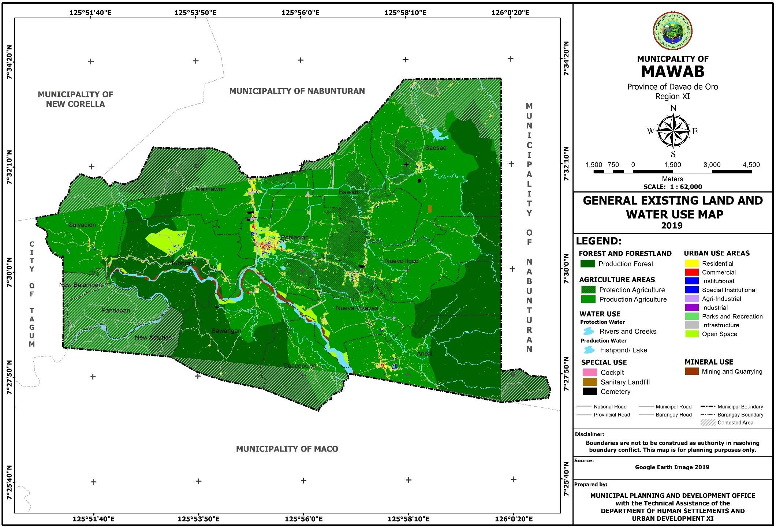

**Figure 29. Existing Land and Water Use Map of Barangay Andili**

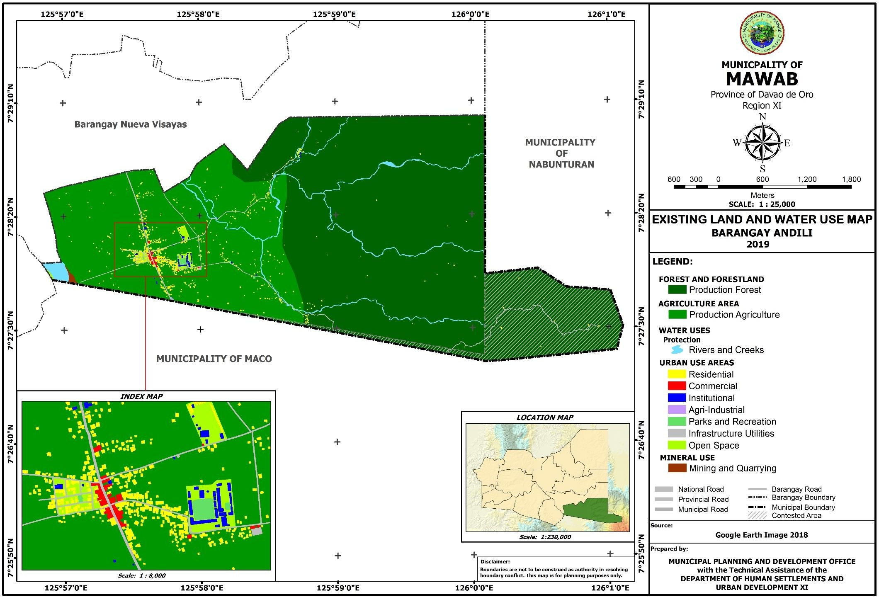

**Figure 30. Existing Land and Water Use Map of Barangay Bawani**

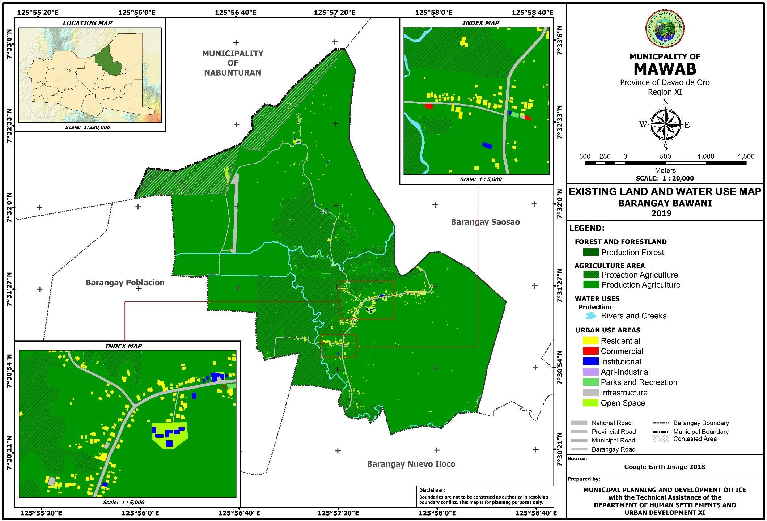

**Figure 31. Existing Land and Water Use Map of Barangay Concepcion**

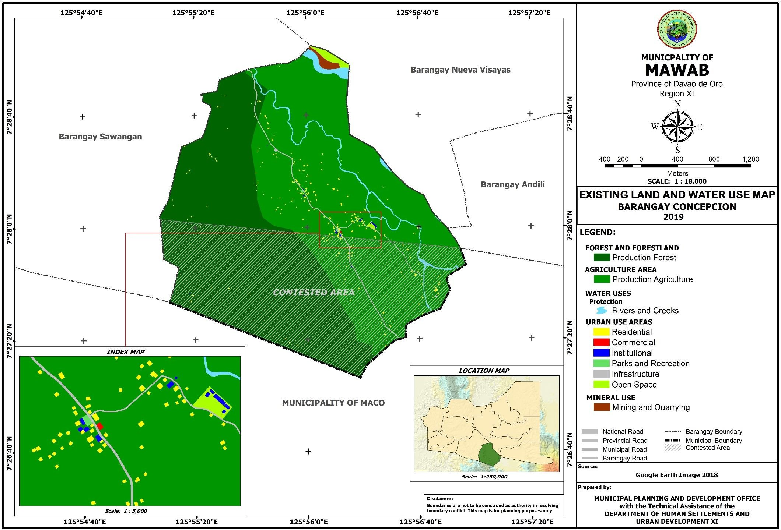

**Figure 32. Existing Land and Water Use Map of Barangay Malinawon**

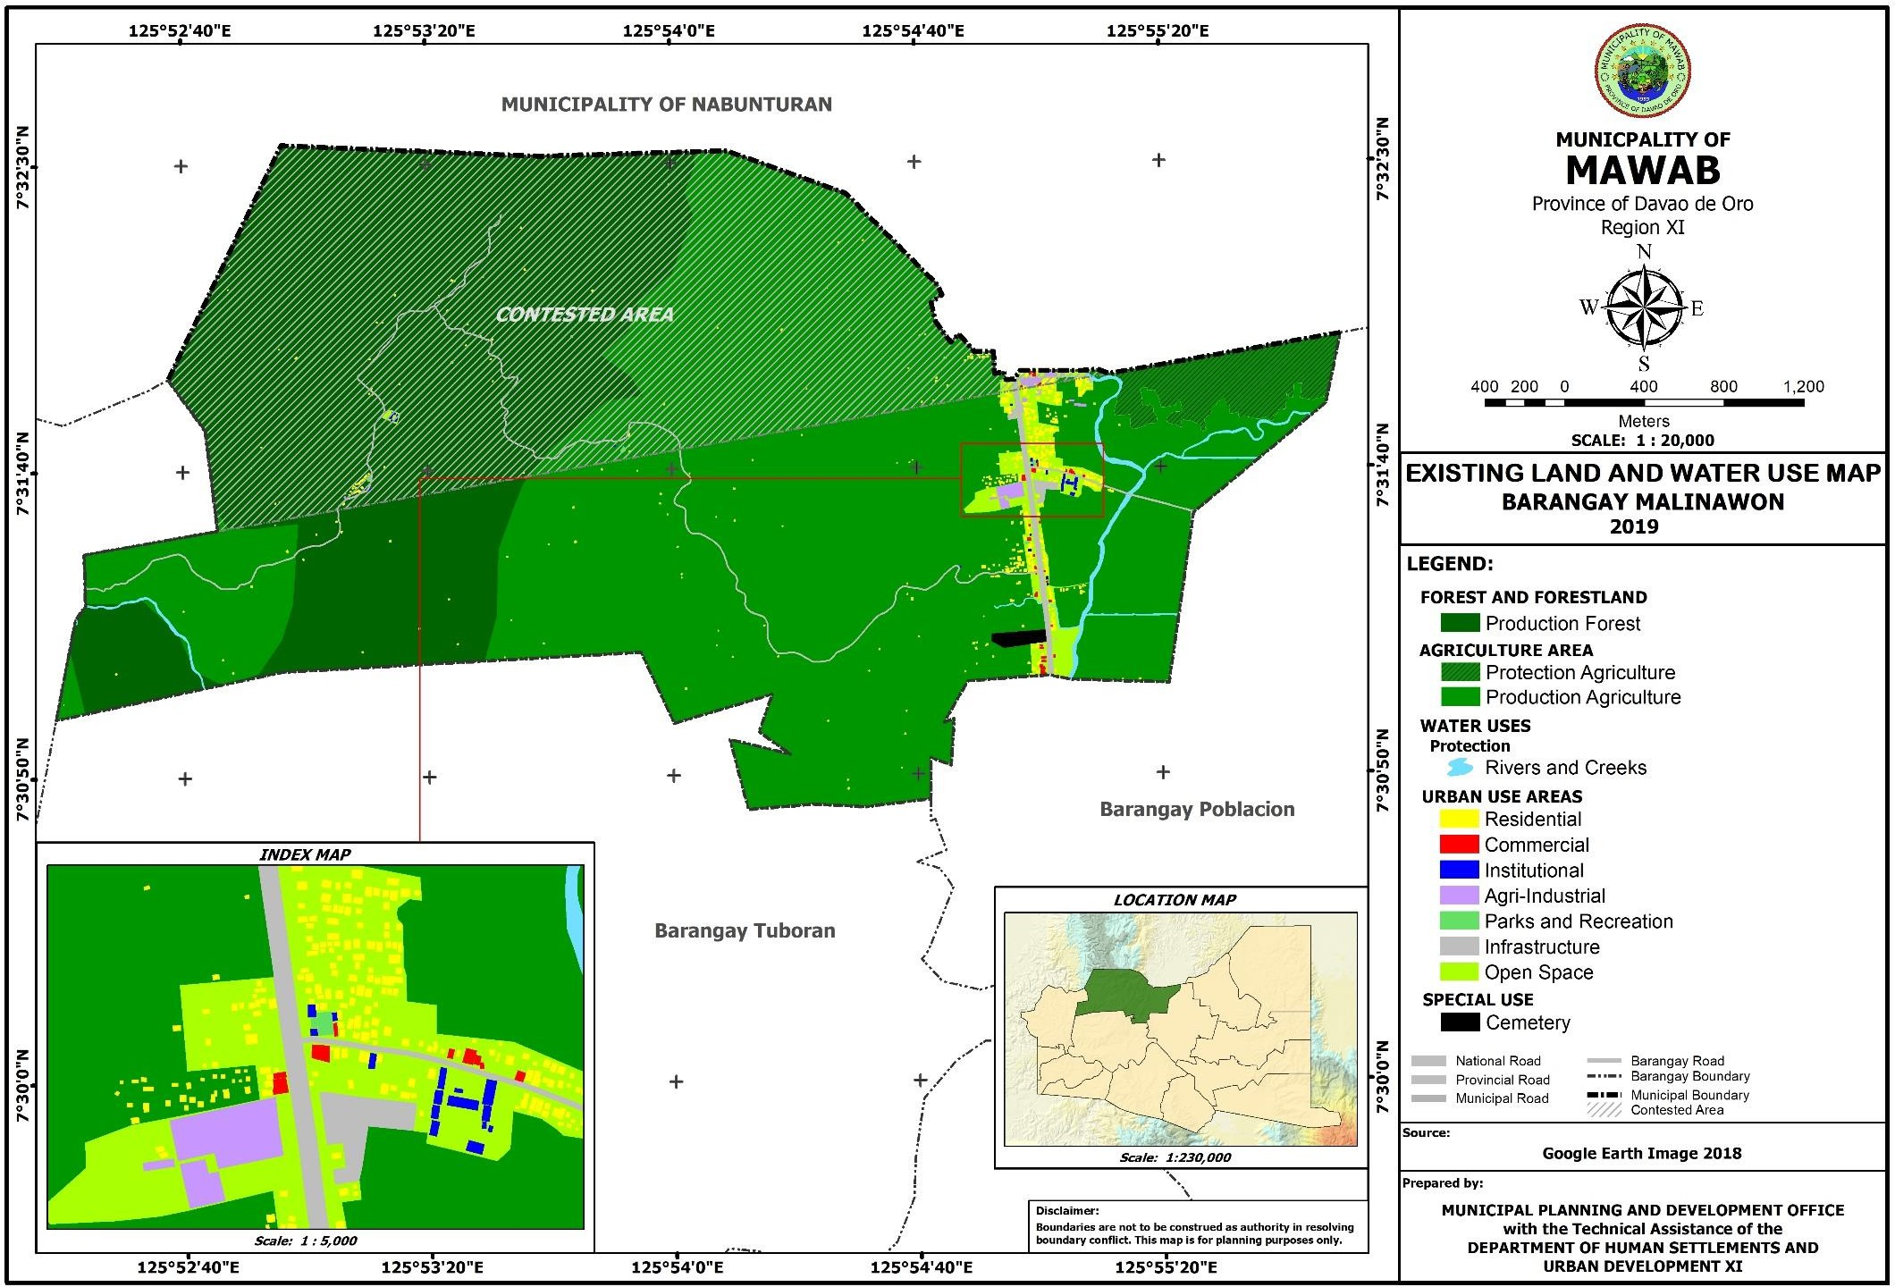

**Figure 33. Existing Land and Water Use Map of Barangay Nueva Visayas**

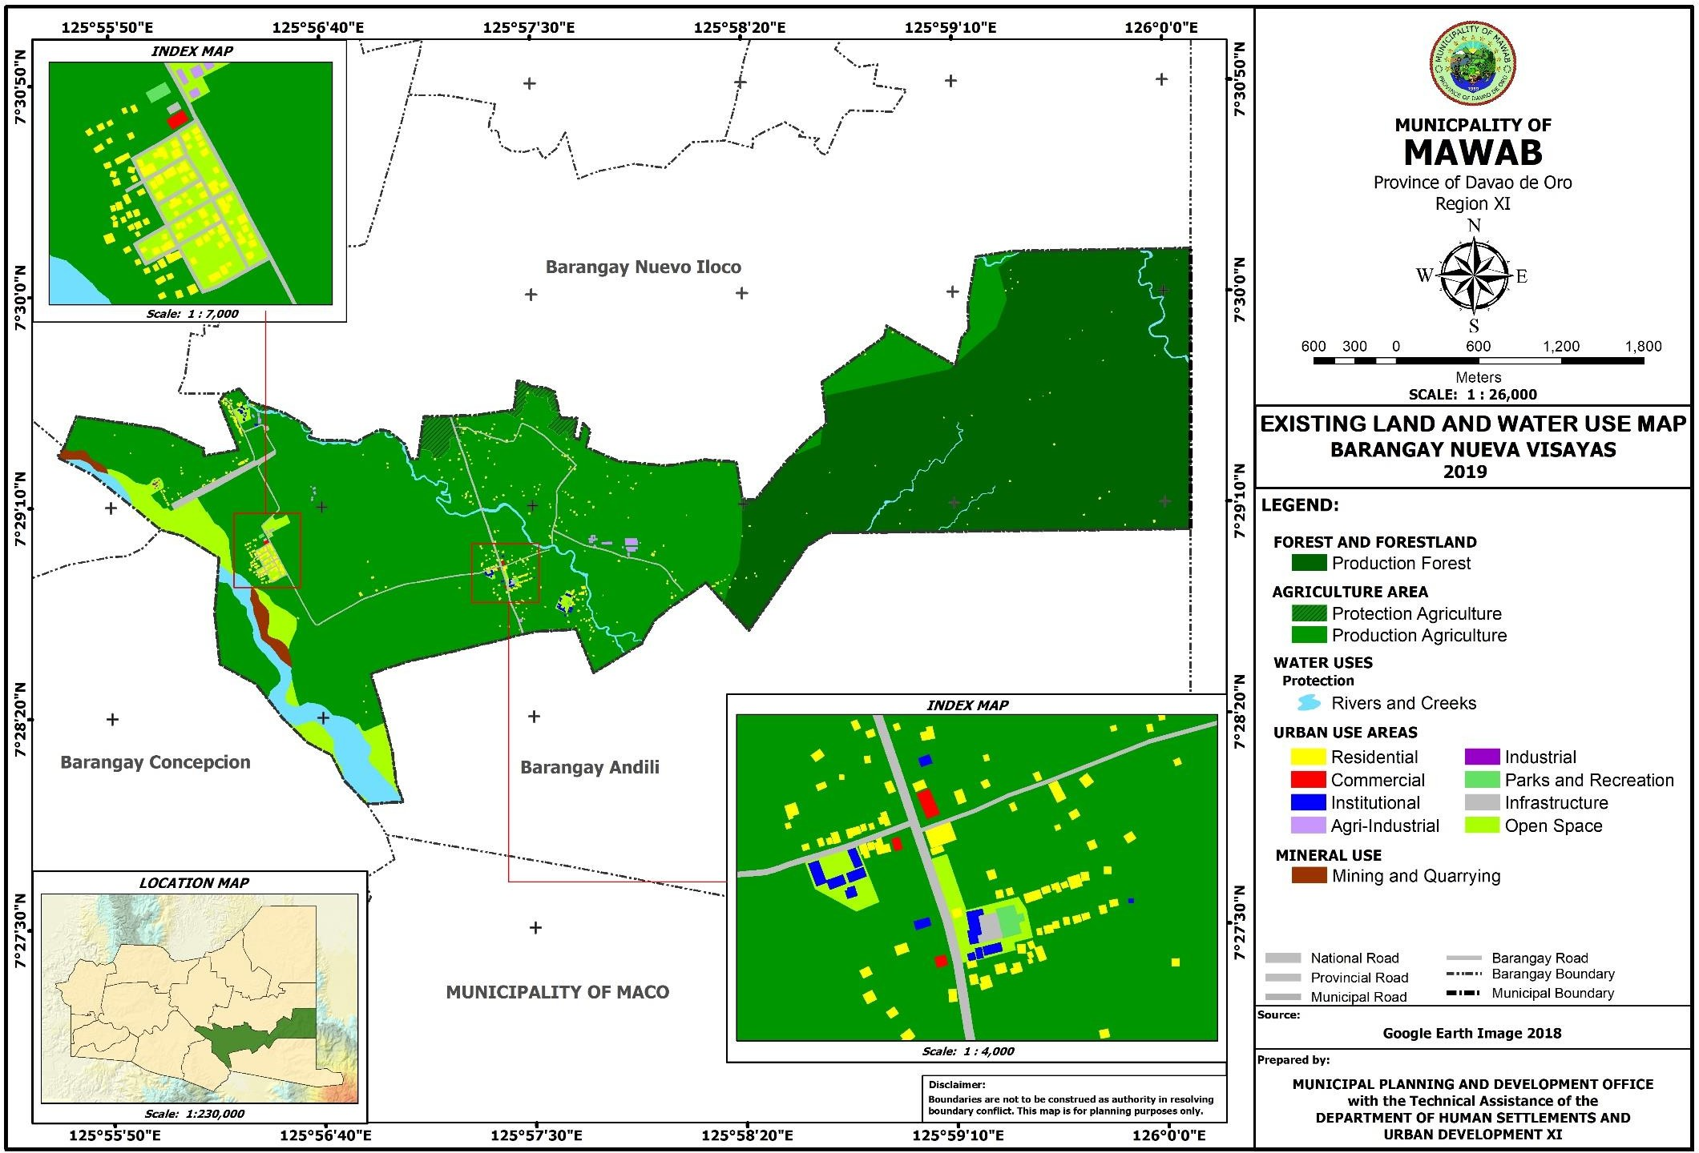

**Figure 34. Existing Land and Water Use Map of Barangay Nuevo Iloco**

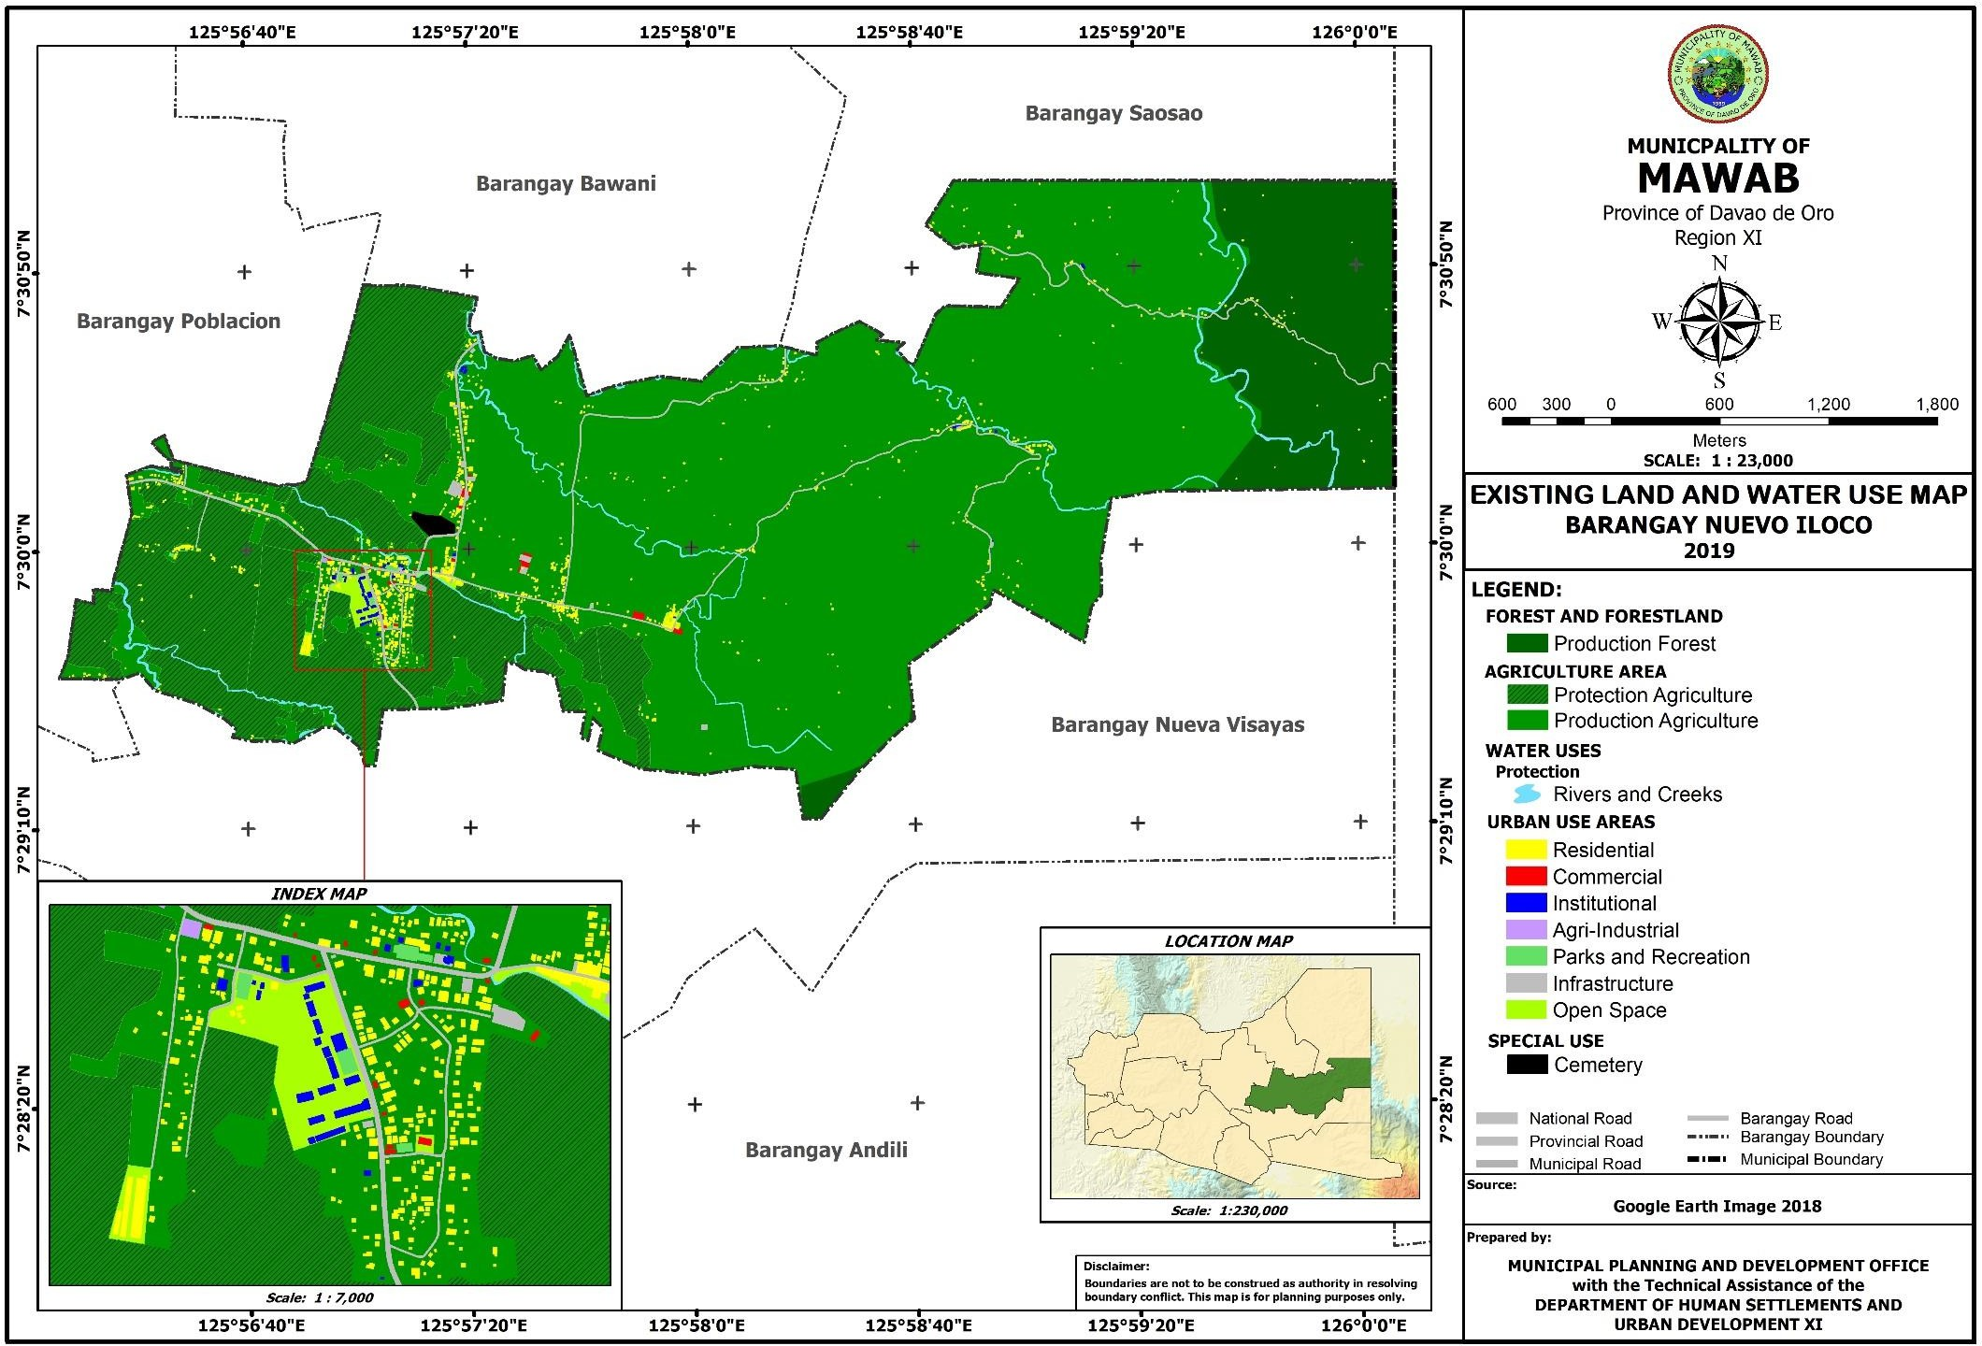

**Figure 35. Existing Land and Water Use Map of Barangay Poblacion**

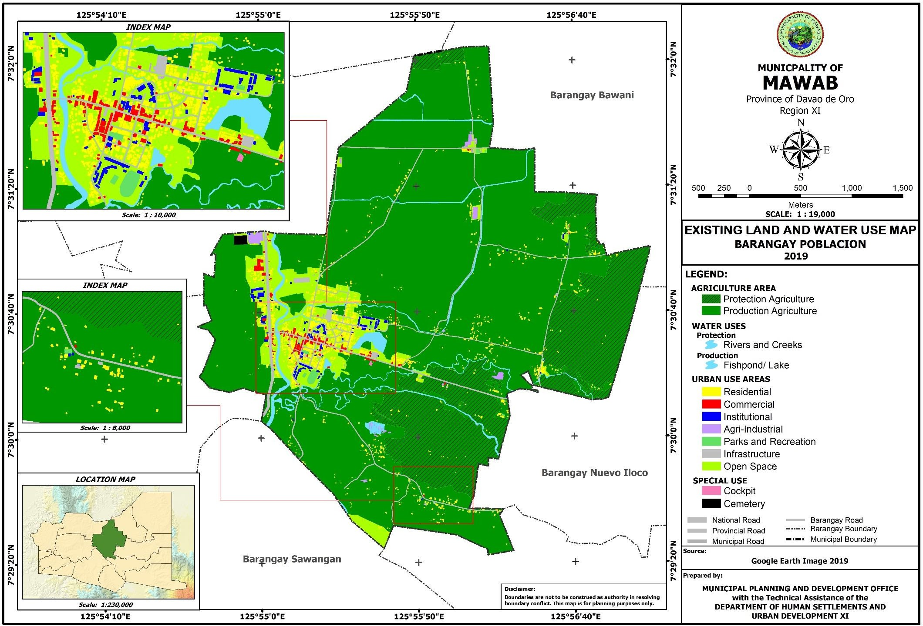

**Figure 36. Existing Land and Water Use Map of Barangay Salvacion**

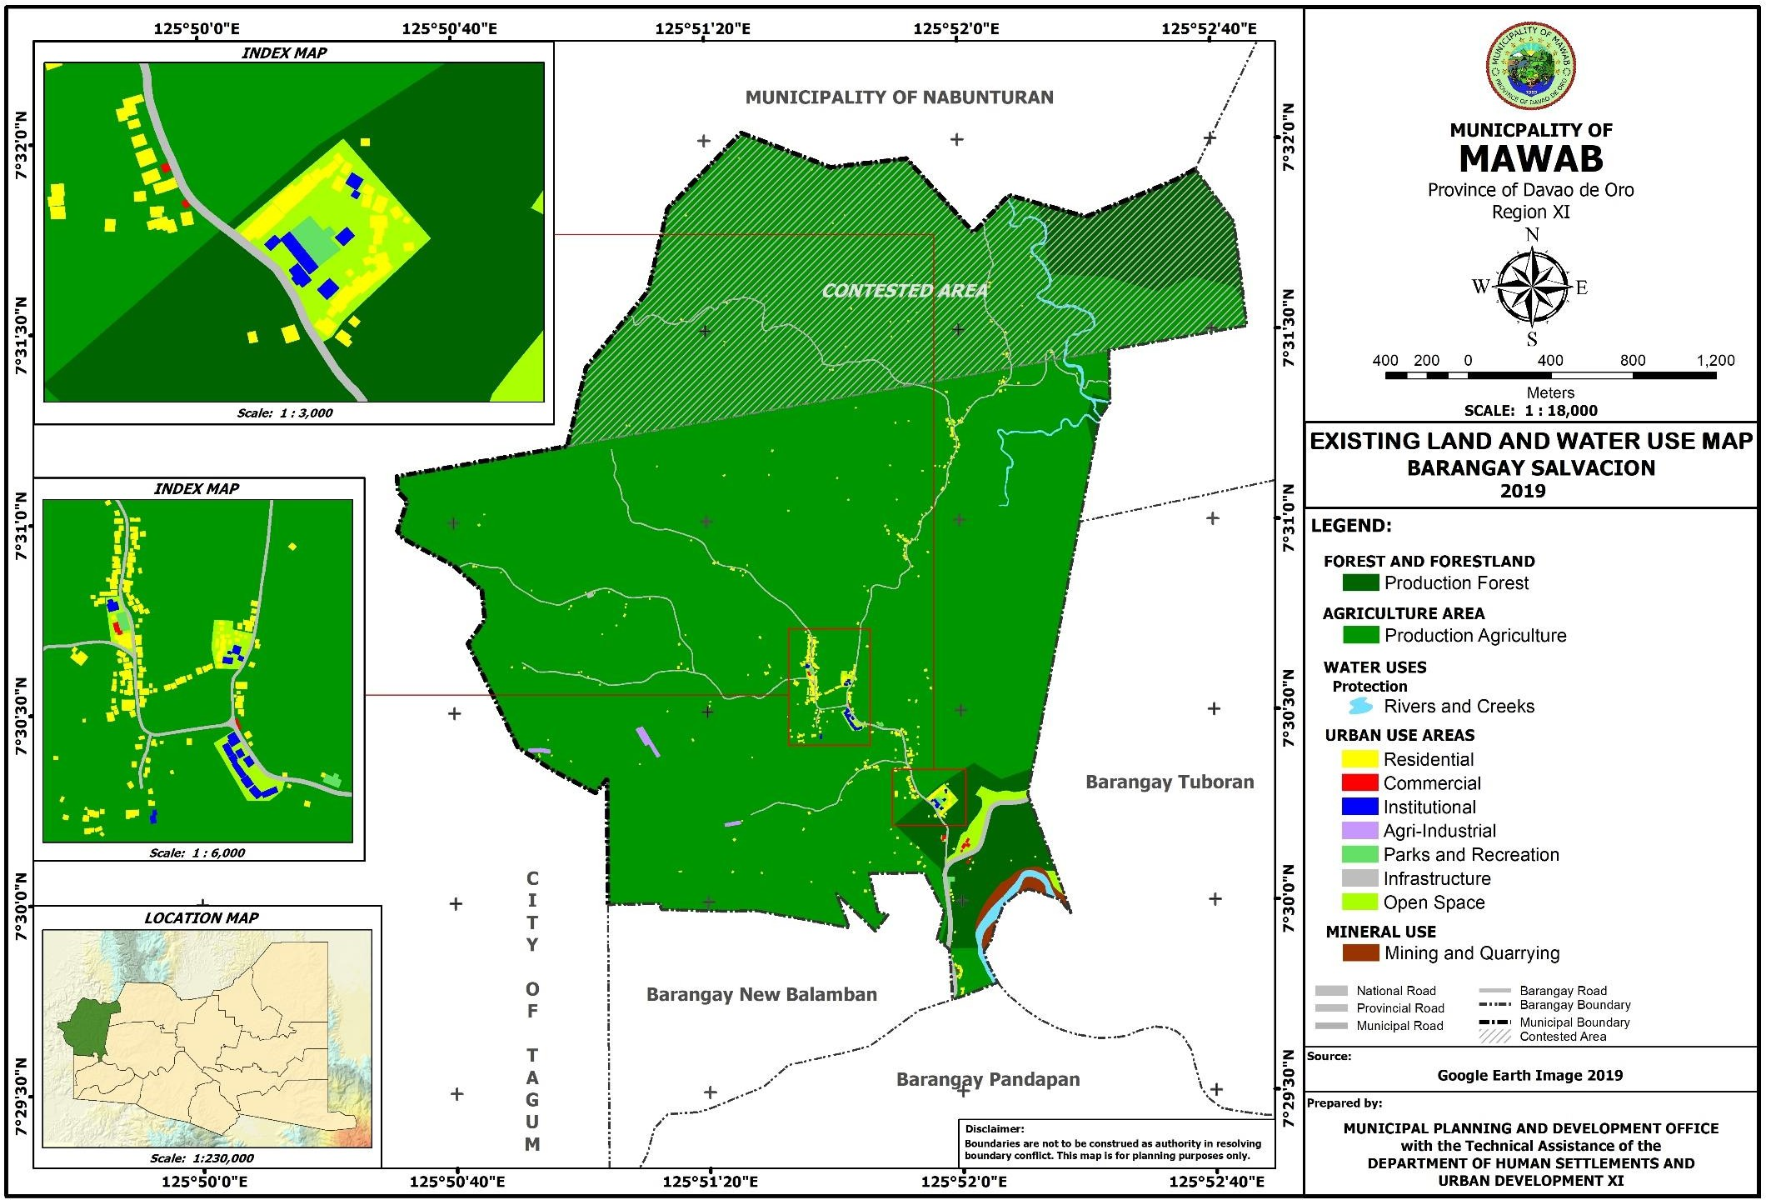

**Figure 37. Existing Land and Water Use Map of Barangay Saosao**

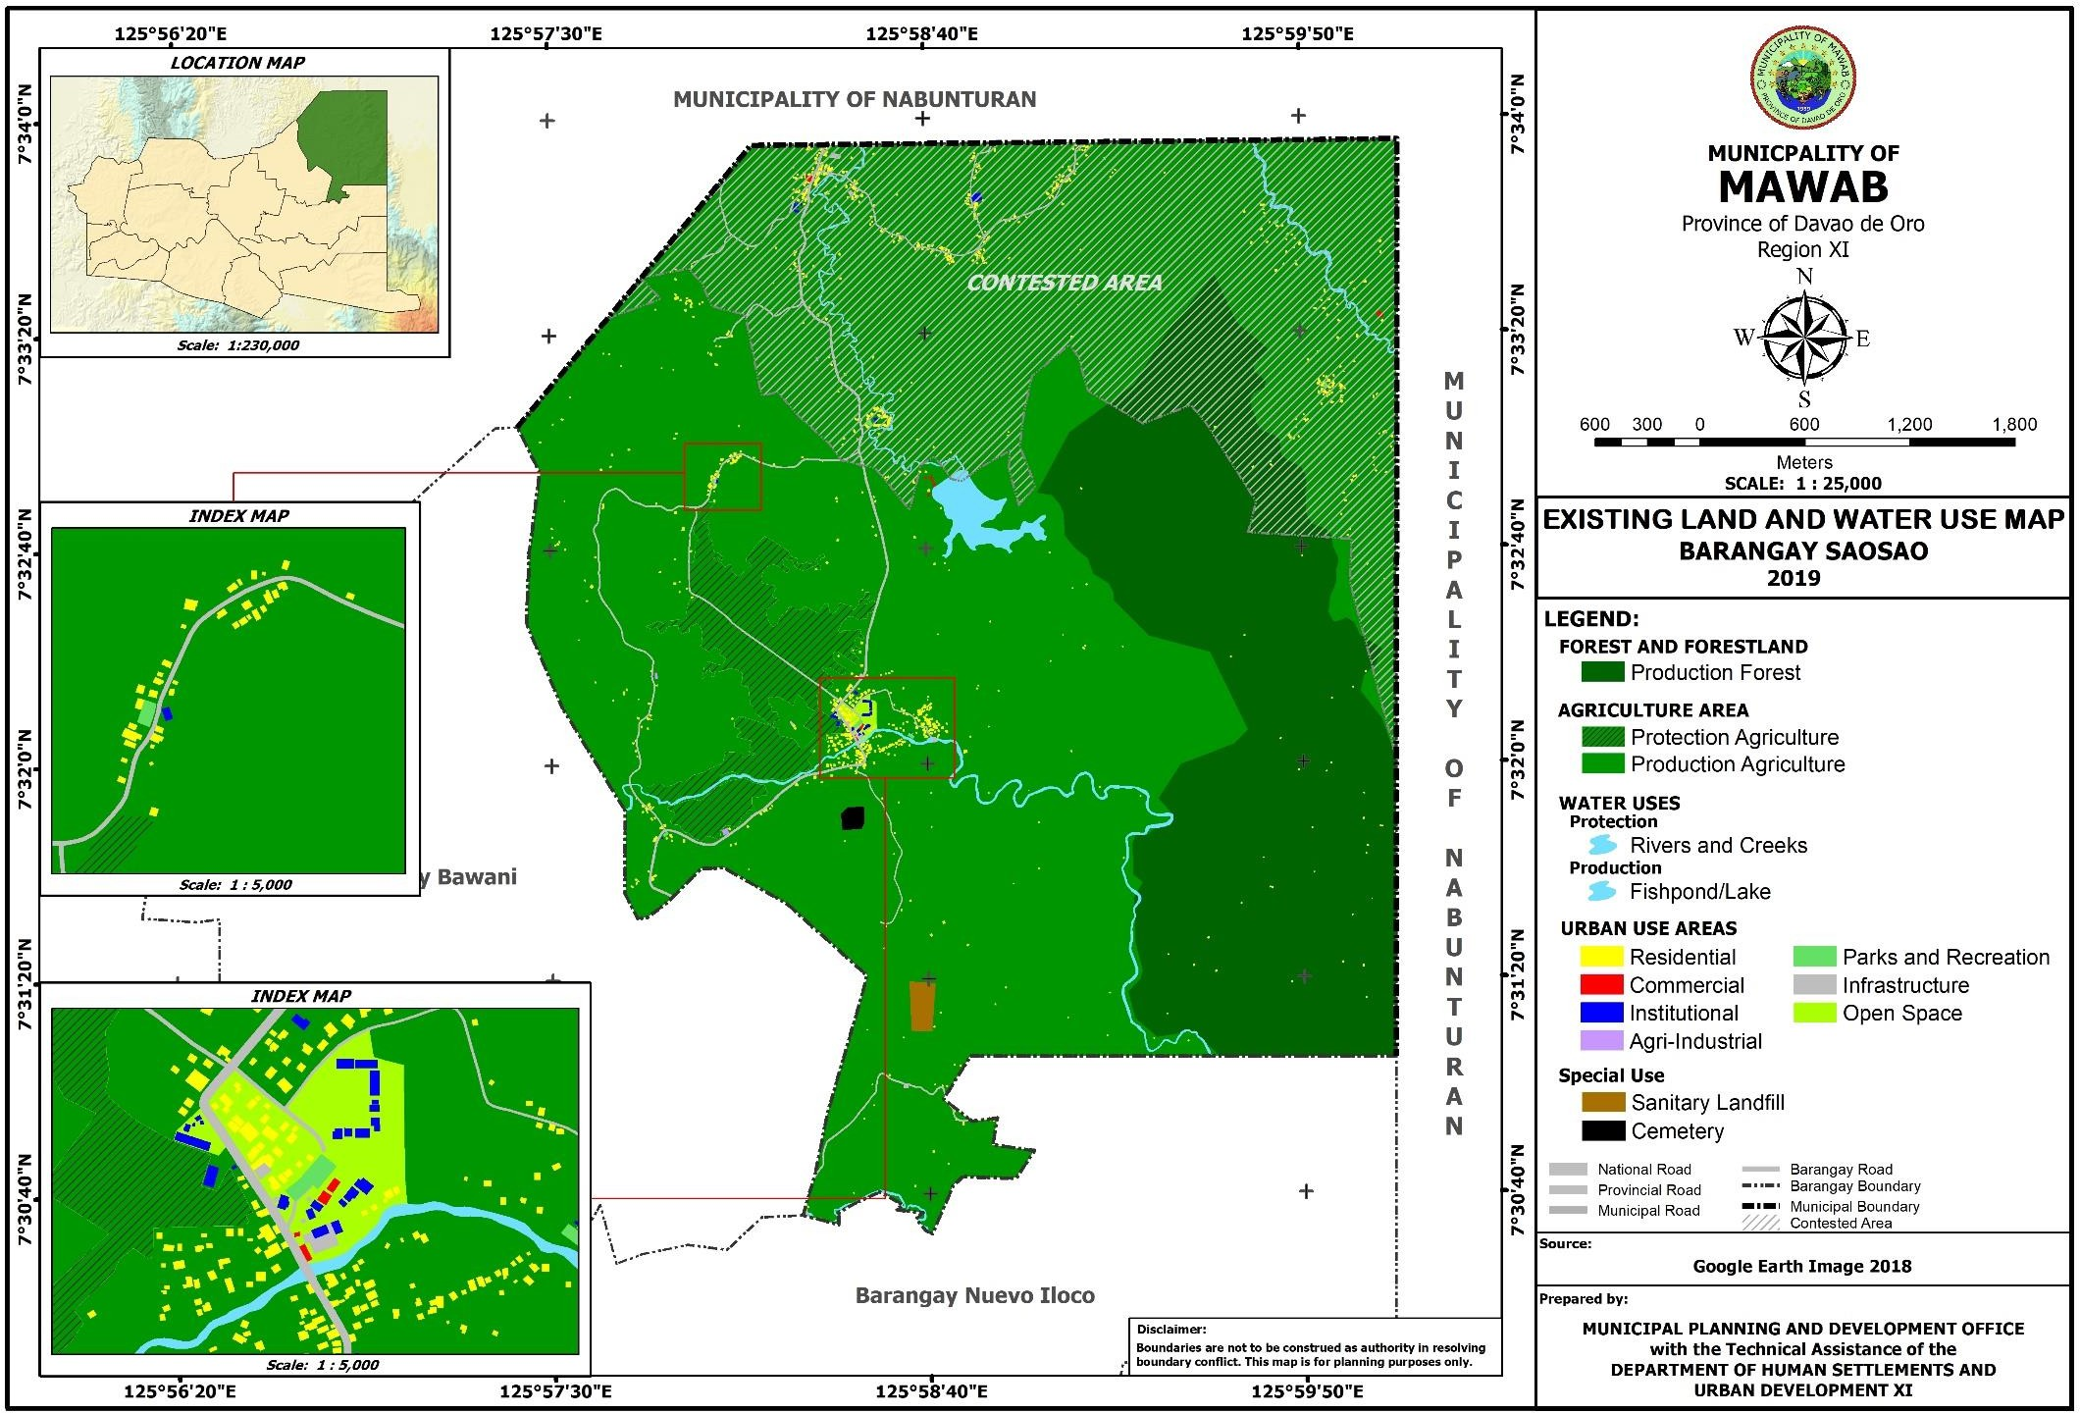

**Figure 38. Existing Land and Water Use Map of Barangay Sawangan**

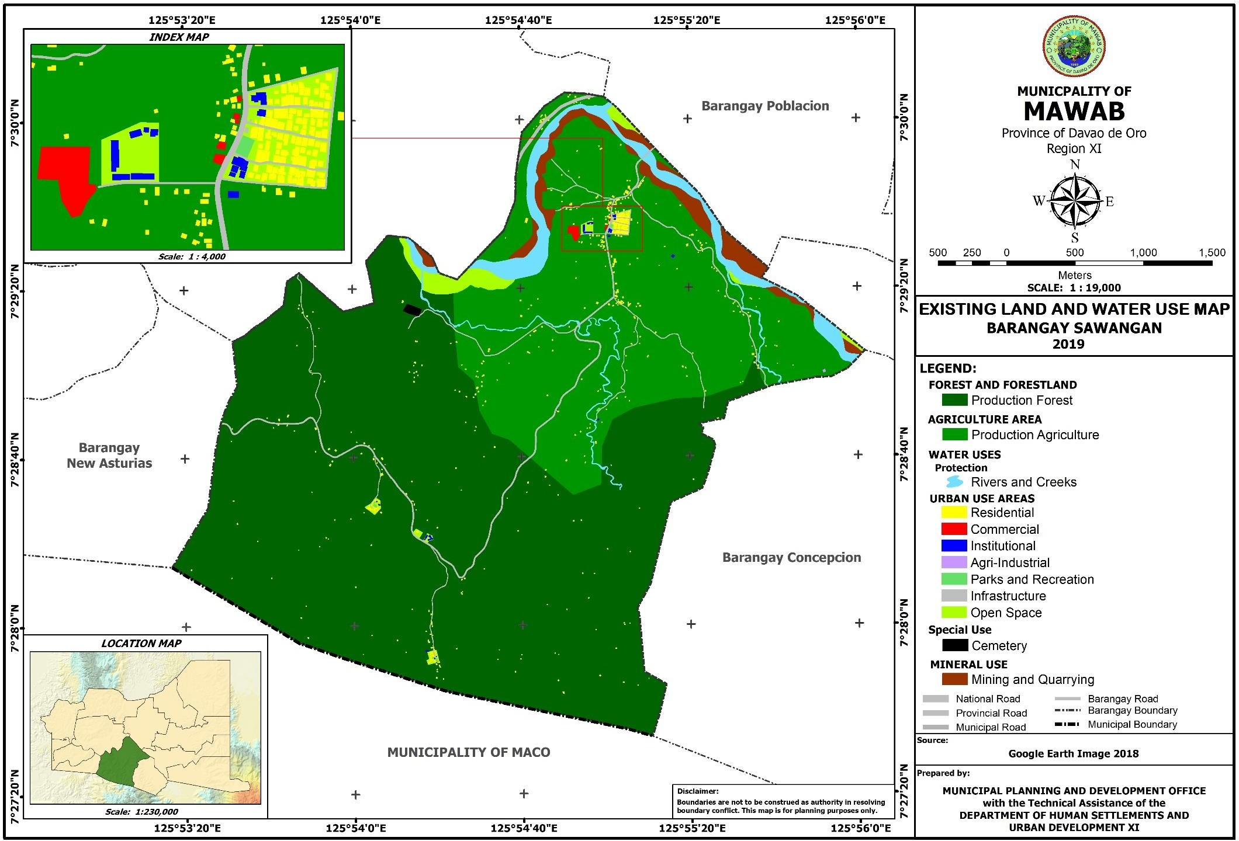

**Figure 39. Existing Land and Water Use Map of Barangay Tuboran**

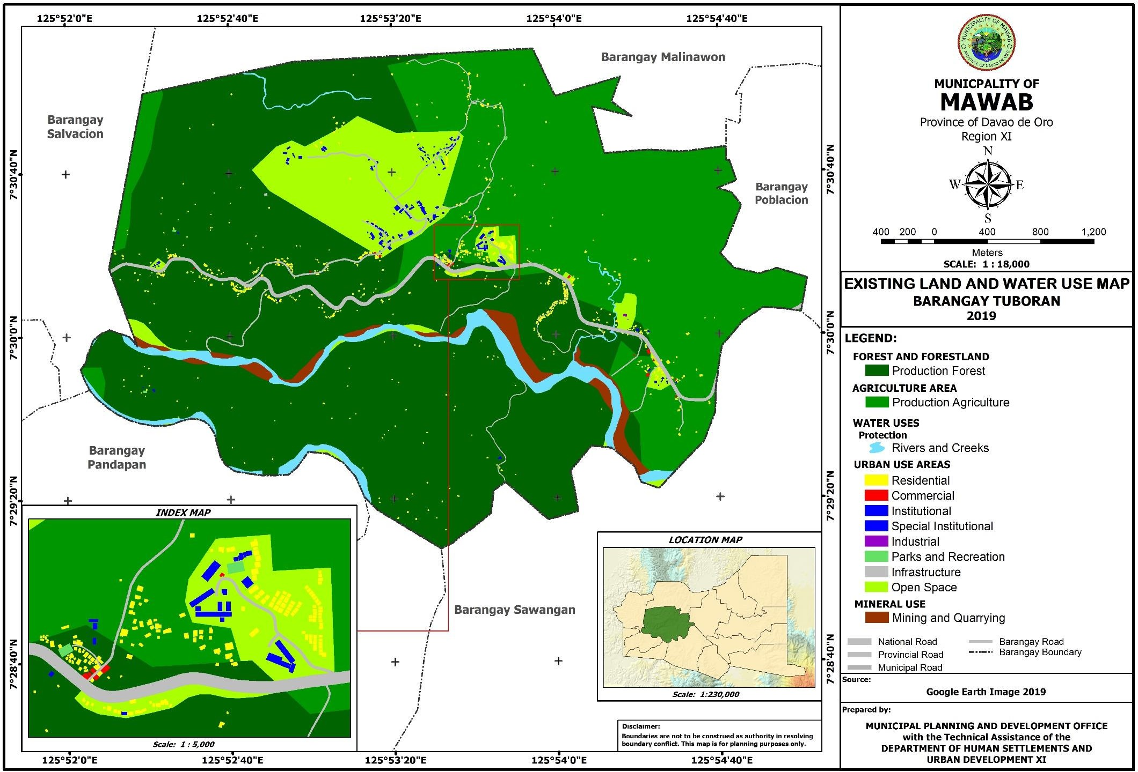

###### LAND USE TREND

* + 1. **Comparative data on existing land uses (previous and current)**

Numerical figure shows that in 2007 built-up/urban use areas had a total of 195 hectares. After twelve (12) years it increased to 548.936 hectares posting an increase of 353.936 hectares or 181.51 percent. In the same manner, Agriculture areas increased to 8,923.52 from 7,560.42 hectares in 2007. This registered an increase of 1,363.10 hectares or 18.03 percent. Although the agriculture area of the municipality has increased, strengthening the implementation of M.C. 54 must be done to regulate the reclassification and conversion of the land. M.C. 54 prescribes the guidelines governing Section 20 of R.A. 7160, otherwise known as the Local Government Code of 1991, authorizing cities and municipalities to reclassify agricultural lands into non- agricultural uses, however, Section C and I, states that such reclassification shall be limited to a maximum of the percentage of the total agricultural land of a city or municipality at the time of the passage of the Ordinance as follows:

1. For highly urbanized and independent component cities, 15%
2. For component cities and first class to third class municipalities, 10%
3. For fourth to sixth class municipalities, 5%,

Provided that agricultural lands distributed to agrarian reform beneficiaries pursuant to Republic Act 6657, otherwise known as the Comprehensive Agrarian Reform Law, shall not be affected by said reclassification and the conversion of such lands into other purposes shall be governed by Section 65 of said act.

Agriculture has the largest area with a total of 7,560.42 has. or 44.60 percent to the total area in the year 2007, and a total of 8,923.52 has. or 62.18 percent to the total land area in the year 2019. With the total land area of the agricultural land in the municipality, some were re- classified into non-agricultural use such as residential, industrial and commercial. In the year 2007 up to 2019, there were 870.59 has. or 9.7561 percent of the total land area of the municipality has been re-classified from agricultural zone to urban use zone.

Mining and quarrying has also increase from 50 hectares in 2007 to 63.17 in 2019. This denotes for an increase of 13.17 hectares or 26.34 percent. For open water space/water use, an increase of 48.356 hectares or 28.44 percent from 170 hectares in 2007 to 218.356 in 2019. Special uses increased to 11.09 hectares from 10.20 hectares or an increase of .89 hectare or

8.73 percent.

The resulting increases directly reduces the forest areas from 6,955 hectares in 2007 to 4,585.094 in 2019. This shows a decrease of 2,369.906 hectares or 34.07 percent.

The total land area value in 2007 is not consistent with the total land area value in 2019 considering that the former value is an existing data per the creation of the municipality and included the other claimed areas while the latter value is generated through GIS and excluded the other claimed areas.

**Table 43. Comparative General Land Use Plan**

|  |  |  |  |  |
| --- | --- | --- | --- | --- |
| **Land Use** | **Previous (2007)** | | **Existing (2019)** | |
| **Area (has.)** | **% to Total Area** | **Area (has.)** | **% to Total Area** |
| Built-up areas/Urban Use Areas | 195.00 | 1.15 | 548.936 | 3.83 |
| Agriculture | 7,560.42 | 44.60 | 8,923.52 | 62.18 |
| Forest | 6,955.00 | 41.03 | 4,585.094 | 31.95 |
| Mining and Quarrying | 50.00 | 0.30 | 63.17 | 0.44 |
| Open Water Space/Water Use | 170.00 | 1.00 | 218.356 | 1.52 |
| Open Grassland | 323.51 | 1.91 | - |  |

|  |  |  |  |  |
| --- | --- | --- | --- | --- |
| Swamps/Marshes | 10.50 | 0.06 | - |  |
| Special Use (Cemeteries, Cockpit, Dump) | 10.20 | 0.06 | 11.09 | .08 |
| Transport Utilities | 300.00 | 1.77 | - |  |
| Other Uses | 1,377.37 | 8.12 | - |  |
| **Total** | **16,952** | **100** | **14,350.165** | **100** |

Source: Municipal Planning and Dev’t. Office

* 1. COMPARATIVE/COMPETITIVE ADVANTAGES

With the listed resources and capacity of the municipality below, the LGU’s aim to uplift the socio-economic environment and hasten the economic growth will hopefully be achieved effectively. Moreover, favourable external factors that offer positive outcome could give the LGU a competitive advantage. Thus, efficient utilization of these resources and capabilities are vital in propelling development in the municipality and maintain a competitive edge where these assets and capabilities are required.

**STRENGTHS**

1. Rich and abundant agricultural land and support resources for production;
2. Abundant potable water supply;
3. Sufficient agricultural land;
4. Presence of Mineral deposits (White clay, ore, sand and gravel);
5. Strong human resources for agricultural production of which 75%-80% are farmers;
6. Availability of rice mills, corn-coffee mills, slipper factory and banana chips factory;
7. There is a reserve of labor force;
8. High literacy rate;
9. Existence of banana plantations;
10. Stable peace and order situation;
11. Active participation of the private sector in forest conservation and effective forestry management;
12. The municipality has three basic soil types with natural fertility that gives the land high yield on any crop raised and is very slightly susceptible to erosion;
13. The presence of various environmental progress such as the Community-Based Forest Management Progress (CBFM);

**OPPORTUNITIES**

1. Intensification of eco-tourism industry within the province and the municipality;
2. Accessibility to market centers;
3. High potential agricultural products supplier for Davao de Oro;
4. Availability of funding donors and support facilities both from local and national organizations and institutions;
5. The agri-industrialization campaign of the present administration;
6. The strong government and private sector participation and involvement in forestry conservation, protection and utilization;
7. The acquisition of agricultural equipment in the farm mechanization program of the Department of Agriculture (DA) coupled with packages on Agricultural technologies and the capabilities of the Agricultural technologists in implementing the Agri-Techno transfer program;
8. The on-going SAFDZ program implementation of the Department of Agriculture (DA) that ensures agricultural production within the Network of Protected Agricultural Areas (NPAA) or the Network of Protected Agricultural Areas Development (NPAAD);

###### PRIORITY ISSUES AND CONCERNS (WEAKNESSES)

This nine-year Comprehensive Land Use Plan shall focus on addressing the following major concerns:

1. Increasing unemployment rate;
2. Lack of financial and technical support to farmers;
3. Absence of alternative source of income other than agriculture;
4. Depleting natural resources, i.e. forest;
5. Increase dependency to inorganic farming and chemically induced agricultural production;
6. Malnutrition problem;
7. No proper waste/garbage disposal site;
8. Poor accessibility to water and sanitation;
9. Most of the farmers persist on their cultural and traditional farming practices instead of adopting the modern agricultural technologies that can increase their production;
10. Agricultural support facilities are still inadequate to meet the demands of farm producers and managers;
11. Decreasing forestland area due to utilization of forest areas to other purposes like agricultural farming and housing areas and lack of training and exposure on forest management;

# II

**THE LAND USE PLAN**

## CHAPTER 2

###### II THE COMPREHENSIVE LAND USE PLAN

SWOT ANALYSIS

The SWOT analysis is a method to determine the comparative advantage of the municipality in relation to its neighboring municipalities by assessing its strengths, weaknesses and the presence of opportunities and threats. It is a framework for identifying and analyzing the internal and external factors that can have an impact on the development of the municipality. Strength(s) refer to the present environmental and ecological features or attributes that enhances or aids in the development of a municipality. Weaknesses refer to the present human, fiscal, physical attributes and natural resources that limit or inhibit the municipality’s economic progress attributed to the development of the area. Opportunities refer to economic, social, political, technological and competitive trends and events that could significantly benefit the municipality in the future. Threat(s) consists of economic, social, political, technological and competitive trends and events that potentially harmful to the municipality’s present or future development.

SWOT Analysis could be an important strategy-formulation matching tool that results in the development of four (4) types of strategies, namely: SO Strategies, WO Strategies, ST Strategies, WT Strategies.

**SWOT ANALYSIS MATRIX,** Municipality of Mawab

|  |  |  |
| --- | --- | --- |
| **SWOT MATRIX** | ***STRENGTHS*** | ***WEAKNESSES*** |
|  | 1. Rich and abundant agricultural land and support resources for production; 2. Abundant potable water supply; 3. Sufficient agricultural land; 4. Presence of Mineral deposits (White clay, ore, sand and gravel); 5. Strong human resources for agricultural production of which 75%-80% are farmers; 6. Presence of rice mills, corn-coffee mills, slipper factory and banana chips factory; 7. There is reserve of labor force; 8. High literacy rate; 9. Presence of banana plantations; 10. Stable peace and order situation; 11. presence of active participation of private sector in forest conservation and effective forestry management; 12. The municipality has three basic soil types   with natural fertility that gives the land high yield | 1. Increasing unemployment rate; 2. Lack of financial and technical support to farmers; 3. Absence of alternative source of income other than agriculture; 4. Depleting natural resources, i.e. forest; 5. Increase dependency to inorganic farming and chemically induced agricultural production; 6. Malnutrition problem; 7. No proper waste/garbage disposal site; 8. Poor accessibility to water and sanitation; 9. Most of the farmers persist on their cultural and traditional farming practices instead of adopting the modern agricultural technologies that can increase their production; 10. Agricultural support facilities are still inadequate to meet the demands of farm producers and managers; 11. Decreasing forestland area due to utilization of   forest areas to other |

|  |  |  |
| --- | --- | --- |
|  | on any crop raised and is very slightly susceptible to erosion;   1. Abundant water supply; 2. The presence of various environmental progress such as the Community- Based Forest   Management Progress (CBFM); | purposes like agricultural |
| farming and housing |
| areas and lack of |
| training and exposure on |
| forest management; |
| ***OPPORTUNITIES*** | ***SO STRATEGIES*** | ***WO STRATEGIES*** |
| 1. Intensification of eco- tourism industry within the province and the municipality; 2. Accessibility to market centers; 3. High potential agricultural products supplier for Compostela Valley; 4. Presence of funding donors and support facilities both from local and national organizations and institutions; 5. The agri-industrialization campaign of the present administration; 6. The strong government and private sector participation and involvement in forestry conservation, protection and utilization; 7. The acquisition of agricultural equipment in the farm mechanization program of the Department of Agriculture (DA) coupled with packages on Agricultural technologies and the capabilities of the Agricultural technologists in implementing the Agri- Techno transfer program; 8. The on-going SAFDZ program implementation of the Department of Agriculture (DA) that ensures agricultural production within the Network of Protected Agricultural Areas (NPAA) or the Network of Protected Agricultural   Areas Development (NPAAD); | 1. Rich and abundant agricultural land and support resources for production (S1), Accessibility to market centers (O2), High potential agricultural products supplier for Compostela Valley (O3); 2. Abundant potable water supply (S2), Presence of funding donors and support facilities both from local and national organizations and institutions (O4); 3. Sufficient agricultural land (S3), High potential agricultural products supplier for Davao de Oro (03); 4. Sufficient agricultural land (S3), Presence of funding donors and support facilities both from local and national organizations and institutions (04); | 1. Increasing unemployment rate (W1), The agri- industrialization campaign of the present administration (05); 2. Lack of financial and technical support to farmers (W2), Presence of funding donors and support facilities both from local and national organizations and institutions (04); |

|  |  |  |
| --- | --- | --- |
| ***THREAT*** | ***ST STRATEGIES*** | ***WT STRATEGIES*** |
| 1. The possible erruption of Lake Leonard; 2. Boundary disputes between the City of Tagum and the Municipalities of Nabunturan and Maco; 3. Siltation due to erosion from denuded forest; 4. Forest denudation due to the presence of indigenous tribes and farmer-settlers who are engaged in indiscriminate cutting of trees for their various crop production and money making business, top soil deterioration due to erosion during rainy season and inadequate upland farming technology such as SALT that will arrest soil erosion and financial constraints that will deter/hamper the implementation of appropriate programs and projects on forestland protection and conservation; 5. Presence of fault line that traversed the agricultural lands of barangays Tuboran, Sawangan, Poblacion and Malinawon; 6. Continuous deterioration/depletion of top soil due to erosion during heavy down pour; 7. Inadequate reforestation programs and projects; 8. Chemical pollution from banana plantations, expansion of banana plantations in the rice fields, installation of hydro pumps by banana plantation that may result to drying up of free flowing water sources of the municipality; 9. Occasional floods and drought and the on- going economic crisis that will aggravate   farmer’s in capacity to undertake agricultural production; | 1. High literacy rate (S8), Fault line that crosses Poblacion specifically the public market (T1), The possible eruption of Lake Leonard (T3); | 1. Depleting natural resources, i.e. forest (W4), Siltation due to erosion from denuded forest (T5); |

## VISION

“A progressive, dynamic, ecologically-balanced, peaceful, disaster-resilient, climate change adaptive, gender sensitive Municipality with a sustained agri-industrial and eco-tourism development where the constituents enjoy better quality of life by living in a highly urbanized setting with a rural concept, within the context of a participative, democratic governance and principled leadership.”

## MISSION

To develop and establish a self-sufficient, self-reliant and God-centered municipality and uplift the socio-economic environment of the constituents and hastens economic growth and development through sustainable agricultural productivity and vibrant economic interchange among stakeholders and market players by strengthening effective sectoral and socio-political and cultural linkages.

## GOALS

* + 1. **Ecosystem Analysis**

***Forest and Water Bodies*:** Establish an eco-friendly environment through proper conservation, preservation and protection and utilization of the natural resources and achieve a sustainable natural resources management and development.

* + 1. **Sectoral Studies**
       1. **Economic**
          1. **Agriculture**

To sustainably ensure food sufficiency and security through a double agricultural development approach to empower the farming and fishing communities to move from their current subsistence state to a level that they can undertake and sustain a profitable enterprise on their own, enabling them to uplift the quality of their lives and contribute more toward national development and stability;

* + - * 1. **Forestry**

To establish an eco-friendly environment through appropriate conservation, protection and utilization scheme of the natural resources and achieve a sustainable forest management and development systems and practices;

* + - * 1. **Trade and Commerce**

To promote vibrant economy through strong market linkages with local and international business players, inventors and other market enthusiasts in the establishment of big scale shopping centers, wholesale trade centers and agro- based industries with the provision of business investment incentives, pro-business policies, subsides, tax holidays and adequate infrastructure support facilities and utilities;

* + - * 1. **Industry**

To strengthen and develop a profitable and sustainable resource-based and labor intensive agri-industry for the upliftment of the constituent’s economic condition and spur economic development of the municipality;

* + - * 1. **Tourism**

To showcase the municipality of Mawab as the View Deck of Davao de Oro province to local and foreign tourist for business opportunities and jobs generation;

* + - 1. **Social**
         1. **Health**

To alleviate the general health condition of the constituents through the delivery of effective and efficient basic health services;

* + - * 1. **Education**

To broaden academic competence and improve opportunities for competitive education in both government and private academic institutions to prepare the school-age going population to be professionally and technically prepared for gainful employment and to meet challenges in socio-economic development;

* + - * 1. **Housing**

To provide safe, decent and quality housing units to the homeless and low come population of the municipality in a wholesome housing environment;

* + - * 1. **Social Welfare**

To alleviate the living conditions and quality of life of the poorest of the poor and the disadvantaged sector of the municipality through comprehensive and integrated social welfare services program;

* + - * 1. **Protective Services**

To ensure an orderly and peaceful environment where the constituents can enjoy a life to the fullest without fear and uncertainty;

* + - * 1. **Sports and Recreation**

To enhance the wholistic development of self-confidence, self-discipline, teamwork and excellence of the constituents of the municipality particularly the youth through a comprehensive and responsive sports development program and recreational activities;

* + - 1. **Infrastructure**
         1. **Transportation**

To improve/upgrade existing road network linkages and its component bridges;

To improve and maintain farm to market roads (FMR);

To expand the concreting of the municipality and barangay roads specially in the urban barangay;

To ensure efficient land transportation services between and among the barangays;

To improve the economical Public Transport Terminal facilities;

To execute appropriate measures in arresting annual flooding affected barangays;

To legislate measures and policies affecting the safety and security of the riding public;

* + - * 1. **Power**

To improve the adequacy of power supply to sustain the needs of both the household and the industrial consumers of the municipality;

To put in place an accessibility measures for an effective and responsive quality power service system;

To install mechanisms in correcting/preventing occasional occurrences of power fluctuations;

To provide an adequate power delivery system to serve the immediate and long- term power requirements of the various components of the commercial and industrial sectors;

To establish measures for the eradication/prevention of power pilferage in the municipality;

To advocate appropriate energy conservation and utilization.

* + - * 1. **Water**

Ensure a sustainable supply of potable water to adequately meet the needs of the constituents for the socio-economic development of the municipality;

* + - * 1. **Communication and Information Technology**

Establish a comprehensive communication system for the entire municipality to improve the standards of living of the constituents and boost the socio-economic activities;

* + - 1. **Special Studies**
         1. **Ancestral Domain**

To empower the Indigenous People/Indigenous Cultural Communities (IP/ICC) for the advancement of their collective rights and welfare;

* + - * 1. **Climate and Disaster Risk Assessment (CDRA)**

To increase the resilience of the communities to disasters/calamities;

## OBJECTIVES

* + 1. **Ecosystem Analysis Forest and Water Bodies**
* To raise the level of awareness and participation of the constituents and private sectors on the preservation and conservation of forest ecosystem;
* To promote sustainable management of the ecosystems (water and forest);
* To preserve and conserve critical watersheds areas;
* To delineate and protect easement of rivers and creeks from all types of obstructions and illegal structures; and
* To promote periodical dredging and rehabilitation of silted/dilapidated portion of main water bodies;
  + 1. **Sectoral Studies**
       1. **Economic**

1. **Agriculture**
   * To raise the productivity and real income of the farmers and the inland fisherfolks;
   * To maintain the surplus production on rice and corn;
   * To raise fish production sufficiency level;
   * To increase livestock and poultry production both in backyard and commercial scale;
   * To empower farmers and inland fisherfolks and other farm workers in raising their productivity;
   * To provide techno-transfer programs and services on modern farming technologies and innovations; and
   * To put in-place a one-stop shop agri-info and products based marketing system.
2. **Forestry**
   * To conserve, protect and properly utilize forest lands and its resources to prevent further forest degradation and massive forest destruction;
   * To expand existing programs and projects on forest rehabilitation/ reforestation;
   * To provide alternative source of income for upland farmers to reduce dependence on forestland resources;
   * To strengthen the enforcement of forest protection laws.
3. **Trade and Commerce:**
   * To invite encourage and strengthen market linkages with local and international business players, investors and other potential business enthusiast to establish, operate and manage big scale shopping centers, wholesale trade centers, agro and non-agro-based industries in the municipality with the provision of conducive working business climate and other marketing support policies, facilities and utilities;
   * To enhance the development of a progressive and effective trade and marketing system;
   * To delineate strategic position of trading centers and commercial establishments with due considerations to future growth and expansion;
   * To formulate municipal investment code for the provision of investment incentives and sound business policies;
   * To provide gainful opportunities for export and import trading;
   * To promote saving consciousness and institute campaigns in increasing deposits for business capitalization; and
   * To produce business opportunities investment brochures.
4. **Industry**
   * To enhance and strengthen the sustainability of the small, medium cottage and large scale industries;
   * To promote a resourced-base and labor-intensive industries for productive employment opportunities;
   * To maximize the utilization and transformation of agri-products;
   * To encourage value-added processing of agri-products;
   * To provide wide access for gainful economic undertakings and employment; and
   * To develop and strengthen the pottery industry of the municipality.
5. **Tourism**
   * To fully develop the view deck site of the municipality for showcasing the panoramic view of Mawab;
   * To develop the existing and other potential tourism areas anchored on the principle of sustainable and ecologically friendly tourism development direction;
   * To intensify the provision of accessibility and other support facilities and utilities to further the tourism development of the municipality according to the Tourism Development Guidelines and Standards;
   * To generate additional tourism related employment among the unemployed constituents of the municipality;
   * To establish data banking on the volume/number of tourist visitors and the gross annual receipt;
   * To facilitate the opportunities for profitable investments of potential tourism entrepreneurs;
   * To increase the awareness level of the constituents on the protection, preservation and utilization of scenic natural resources;
   * To formulate and implement Tourism Investment Program; and
   * To package Tourism Investment and Marketing scheme in Region XI.
     + 1. Social
6. **Health**
   * To provide adequate and doable health programs and projects;
   * To raise the quality of existing health facilities;
   * To improve access of the rural population to primary health care programs and services;
   * To establish health statistics databank system;
   * To put in place workable monitoring mechanism for the health status of the populace for early detection and treatment of any diseases;
   * To ensure an effective and efficient implementation of health care services, programs and projects;
   * To reduce the incidence of morbidity and mortality;
   * To decrease the prevalence of malnutrition among children;
   * To promote environmental sanitation;
   * To augment Medical Health personnel to meet the standard ratio; and
   * To raise the level of awareness of the constituents on proper health care and disease prevention.
7. **Education**
   * To provide support in ensuring quality education through the provision of modern academic physical facilities and equipment, adequate learning materials and competent mentors;
   * To provide opportunities to the school faculty members in upgrading/enhancing their competence in all fields of academic excellence;
   * To provide all out support in all academic programs, projects competitions and other extra-curricular activities;
   * To institutionalize municipal scholarship program for the poor, interested and deserving students;
   * To extend adequate support to the Non-formal Education such as Alternative Learning System and the likes;
   * To enhance opportunities for the graduates to have a gainful employment; and
   * To continuously support to the Special Program for employment of Students (SPES).
8. **Housing**
   * To identify, delineate and develop suitable lands for low-cost housing units;
   * To promote equitable utilization of residential lots in urban use areas;
   * To establish measures to reduce the presence of illegal settlers in prime land highly suitable for major economic activities;
   * To maintain a sound, safe, healthy and ecologically friendly environment in housing project areas;
   * To provide/improve/upgrade/rehabilitate infrastructure and other support facilities in residential areas;
   * To provide adequate support facilities and logistics for the maintenance of peace and order in residential areas; and
   * To resettle populace living at danger zones areas (landslide prone, fault line areas and flood prone areas).
9. **Social Welfare**
   * To improve the systems and mechanisms in the delivery of basic social welfare services to the disadvantaged, marginalized group and socially dislocated individuals and families;
   * To provide complimentary support to all social welfare institutions and organizations in the municipality;
   * To provide appropriate assistance to the constituents adversely affected by man-made and natural disasters and calamities;
   * To provide educational materials/books/references for the child development centers and other social welfare institutions and organizations in the municipality;
   * To fast track the implementation, monitoring and evaluation of various social welfare programs, projects and activities;
   * To enhance the opportunity for economic undertakings of the less privileged constituents of the municipality; and
   * To provide support to illegal drug offenders to reform, rehab and reintegrate themselves in the community;
10. **Protective Services**
    * To augment the number of police force and firemen in accordance to the minimum standard police/firemen-to-population ratio of the PNP;
    * To provide adequate financial support for the acquisition of additional protective services equipment and the construction of necessary facilities and purchase of logistics;
    * To strengthen and implement to the letter the existing peace and order policies and ordinances with justice and fairness;
    * To serve and protect the constituents from any harassment and abuses in all forms of people in authority;
    * To enhance people’s active participation in the maintenance of a peaceful and orderly community;
    * To improve and strengthen civil-military relation and coordination for a more progressive and peaceful municipality;
    * To enhance the skills and capabilities of both the police force and firemen for an effective and efficient delivery of basic protective services;
    * To raise the level of awareness of the people on fire prevention techniques and measures and all active related laws and ordinances; and
    * To uphold the constitutional mandate of civilian authority over the military.
11. **Sports and Recreation**
    * To formulate and implement a well-crafted and tailored-fit sports development program and recreational activities;
    * To provide appropriate scheme for the improvement of various sports and recreational facilities in the municipality;
    * To put-in place mechanisms for the provision of adequate sports and recreational facilities;
    * To provide adequate annual appropriations for sports and recreational development program of the municipality;
    * To sustainably conduct a healthy sports competition activities to foster self- confidence, self-discipline, teamwork, excellence and camaraderie;
    * To conduct strong advocacy program on sports and recreational activities to raise the awareness level of the constituents in maintaining and promoting good health through physical activities;
    * To maintain existing tourist destinations and develop other potential tourist sports as come-on and added features in promoting constituents appreciation and participation in ecologically friendly recreational pursuits;
    * To prioritize the full development of the municipality’s view deck scenic spot at Barangay Salvacion; and
    * To foster close coordination with the Non-Government Organizations (NGO’s) and Private Sectors (PS’s) in the promotion and implementation of sports and recreational activities of the municipality.
      + 1. Infrastructure

**A. Transportation**

* To improve/upgrade existing road network linkages and its component bridges;
* To improve and maintain farm to market roads (FMR);
* To expand the concreting of the municipality and barangay roads specially in the urban barangay;
* To ensure efficient land transportation services between and among the barangays;
* To improve the economical Public Transport Terminal facilities;
* To execute appropriate measures in arresting annual flooding affected barangays;
* To legislate measures and policies affecting the safety and security of the riding public.

**E. Power**

* To improve the adequacy of power supply to sustain the needs of both the household and the industrial consumers of the municipality;
* To put in place an accessibility measures for an effective and responsive quality power service system;
* To install mechanisms in correcting/preventing occasional occurrences of power fluctuations;
* To provide an adequate power delivery system to serve the immediate and long-term power requirements of the various components of the commercial and industrial sectors;
* To establish measures for the eradication/prevention of power pilferage in the municipality;
* To advocate appropriate energy conservation and utilization.

**F. Water**

* To augment the capacity of the existing level II and III Water system of the municipality;
* To expand the service coverage of operating water systems of the municipality;
* To develop and protect potential water resources of the municipality;
* To provide full protection and development of all Level I water system and other water resources;
* To protect, conserve and develop potential surface water resources for industrial, agricultural, irrigation and poultry and livestock purposes;
* To encourage potential private sectors/organizations and cooperatives to invest in the construction and installation of level III water system;
* To upgrade and augment water supply related infrastructure support facilities;
* To provide investment incentives to all water system investors/operators;
* To conduct education and information campaign on water conservation;
* To establish strong linkages and coordination with the National, Provincial and Local Water Agencies/Districts/Entries for the proper management and operation of water system projects; and
* To adopt a sustainable and holistic approach to water resources development that includes supply, distribution, treatment and sanitation.

**G. Communication and Information Technology**

* To improve postal services through the augmentation of municipal post office personnel and the adequate provision of postal facilities;
* To extend postal services to unserved areas with efficient and effective delivery system;
* To install telephone system;
* To enhance quality of telecommunication services and facilities;
* To enhance the free flow of printed mass media communications in the entire municipality;
* To enhance inter-barangays telecommunication services; and
* To encourage Cellular Mobile Telephone Services providers to install towers in unserved barangays of the municipality.
  + - 1. Special Studies

1. **Ancestral Domain**
   * To recognize customary laws in the Ancestral Domain;
   * To promote and strengthen the culture, traditions and institutions of the Indigenous Peoples;
   * To identify areas within the Ancestral Domain for strict preservation and protection;
   * To sustainably utilize the natural resources in CADT areas; and
   * To facilitate cooperation of all agencies and institutions to converge their programs, projects and services for the development of the Indigenous Peoples.
2. **Climate and Disaster Risk Assessment (CDRA)**
   * To reduce vulnerability and exposure to natural hazards;
   * To reduce private and public losses caused by natural hazards;
   * To improve emergency assistance to the constituents;
   * To secure the DRRM supplies and equipment to be used during emergencies;
   * To ensure a healthy and productive environment that is resilient to climate hazards and natural disasters;
   * To incorporate emergency management improvements;
   * To address the identified risk concerns through available and possible strategies and land use practices;
   * To implement infrastructures that address properly the mitigation of calamities and effects of disasters;
   * To enhance knowledge and skills of volunteer groups following the operating procedures during disasters/calamities;
   * To increase awareness of the residents with regards to disaster preparedness; and
   * Ensure that open space development enhances and incorporates the surrounding environment without modifying or compromising conservation, recreation and landscape values.

###### SCALOGRAM

Scalogram is an analysis that indicates the centrality of settlements (11 barangays) of the municipality. Of the 11 barangays, Barangay Poblacion being the urban area, tend to be the center of development where main shops, offices, and other facilities are situated to provide various goods and services to the people living in other areas.

It can be used to categorize barangays into all levels of functional complexity and determine the types and diversity of services and facilities located in central places at various levels of hierarchy.

The scalogram shows rough associations among services and facilities in specific locations and potential linkages among them.

**SCALOGRAM OF THE MUNICIPALITY OF MAWAB**

|  |  |  |  |  |  |  |  |  |  |  |  |  |  |  |  |  |  |  |  |  |  |  |  |  |  |  |  |  |  |  |  |  |  |  |  |  |  |  |  |  |  |  |  |  |  |  |  |  |  |  |  |  |  |  |  |  |  |
| --- | --- | --- | --- | --- | --- | --- | --- | --- | --- | --- | --- | --- | --- | --- | --- | --- | --- | --- | --- | --- | --- | --- | --- | --- | --- | --- | --- | --- | --- | --- | --- | --- | --- | --- | --- | --- | --- | --- | --- | --- | --- | --- | --- | --- | --- | --- | --- | --- | --- | --- | --- | --- | --- | --- | --- | --- | --- |
| Settlements | SOCIAL | | | | | | | | | | | | ECONOMIC | | | | | | | | | | | | | | | | INFRASTRUCTURE | | | | | | | | | | | | | | | INSTITUTIONAL | | | | | | | | | | | | | |
| Public Elem. Sch. | Health Center | Day Care Center | Public Cemetery | Senior Citizen Building | Public High School | Private High School | Gawad Kalinga Project | Private Elem. Sch. | Private Pre-school | Private Hospital | Private Clinic | Wholesale/Retail Stores | Cellular Phone Services | Talipapa | Automotive/Welding Shops | Internet Café | Ricemill and Cornmill | Eatery | Public Market | Drugstores | Appliance Store | Funeral Parlor | Lodging Houses | Lending Institutions | Credit Cooperative | Gasoline Station | Cockpit | Multi-purpose pavement | Basketball Court | Drainage System | Roads | Power Supply | Material Recovery Facility | Bridges | Gymnasium/Mini Gym | Irrigation | Communal Water Source | Level III Water Supply | Warehouse | View Deck | Bus Station | Sanitary Landfill | Barangay Hall | Churches/Chapels | Religious Organizatios | Farmer’s Association | Military Command Post | Police Outpost/BDS | Tribal Hall | Police Station | Detention Cell | Post Office | Slaughter House | Mosque | Pottery | Centrality Index |
| Poblacion | 2 | 1 | 4 |  |  |  |  |  |  |  |  |  |  |  | 1 |  |  |  |  |  | 3 |  |  |  |  |  |  |  |  |  |  |  |  |  |  |  |  |  |  |  |  |  |  | 1 |  |  |  |  |  |  |  |  |  |  |  |  | 49 |
| Andili | 2 | 1 | 2 |  |  |  |  |  |  |  |  |  |  |  | 1 |  |  |  |  |  | 1 |  |  |  |  |  |  |  |  |  |  |  |  |  |  |  |  |  |  |  |  |  |  | 1 |  |  |  |  |  |  |  |  |  |  |  |  | 33 |
| Nuevo Iloco | 3 | 1 | 4 |  |  |  |  |  |  |  |  |  |  |  | 1 |  |  |  |  |  |  |  |  |  |  |  |  |  |  |  |  |  |  |  |  |  |  |  |  |  |  |  |  | 1 |  |  |  |  |  |  |  |  |  |  |  |  | 32 |
| Nueva Visayas | 1 | 1 | 2 |  |  |  |  |  |  |  |  |  |  |  | 1 |  |  |  |  |  |  |  |  |  |  |  |  |  |  |  |  |  |  |  |  |  |  |  |  |  |  |  |  | 1 |  |  |  |  |  |  |  |  |  |  |  |  | 26 |
| Tuboran | 1 | 1 | 2 |  |  |  |  |  |  |  |  |  |  |  |  |  |  |  |  |  |  |  |  |  |  |  |  |  |  |  |  |  |  |  |  |  |  |  |  |  |  |  |  | 1 |  |  |  |  |  |  |  |  |  |  |  |  | 26 |
| Bawani | 2 | 1 | 2 |  |  |  |  |  |  |  |  |  |  |  | 1 |  |  |  |  |  |  |  |  |  |  |  |  |  |  |  |  |  |  |  |  |  |  |  |  |  |  |  |  | 1 |  |  |  |  |  |  |  |  |  |  |  |  | 26 |
| Malinawon | 2 | 1 | 3 |  |  |  |  |  |  |  |  |  |  |  |  |  |  |  |  |  |  |  |  |  |  |  |  |  |  |  |  |  |  |  |  |  |  |  |  |  |  |  |  | 1 |  |  |  |  |  |  |  |  |  |  |  |  | 25 |
| Saosao | 1 | 1 | 1 |  |  |  |  |  |  |  |  |  |  |  | 1 |  |  |  |  |  |  |  |  |  |  |  |  |  |  |  |  |  |  |  |  |  |  |  |  |  |  |  |  | 1 |  |  |  |  |  |  |  |  |  |  |  |  | 24 |
| Salvacion | 1 | 1 | 1 |  |  |  |  |  |  |  |  |  |  |  |  |  |  |  |  |  |  |  |  |  |  |  |  |  |  |  |  |  |  |  |  |  |  |  |  |  |  |  |  | 1 |  |  |  |  |  |  |  |  |  |  |  |  | 24 |
| Sawangan | 1 | 1 | 2 |  |  |  |  |  |  |  |  |  |  |  | 1 |  |  |  |  |  |  |  |  |  |  |  |  |  |  |  |  |  |  |  |  |  |  |  |  |  |  |  |  | 1 |  |  |  |  |  |  |  |  |  |  |  |  | 22 |
| Concepcion | 1 | 1 | 1 |  |  |  |  |  |  |  |  |  |  |  |  |  |  |  |  |  |  |  |  |  |  |  |  |  |  |  |  |  |  |  |  |  |  |  |  |  |  |  |  | 1 |  |  |  |  |  |  |  |  |  |  |  |  | 18 |

|  |  |  |  |  |  |  |  |  |  |  |  |  |  |  |  |  |  |  |  |  |  |  |  |  |  |  |  |  |  |  |  |  |  |  |  |  |  |  |  |  |  |  |  |  |  |  |  |  |  |  |  |  |  |  |  |  |  |  |
| --- | --- | --- | --- | --- | --- | --- | --- | --- | --- | --- | --- | --- | --- | --- | --- | --- | --- | --- | --- | --- | --- | --- | --- | --- | --- | --- | --- | --- | --- | --- | --- | --- | --- | --- | --- | --- | --- | --- | --- | --- | --- | --- | --- | --- | --- | --- | --- | --- | --- | --- | --- | --- | --- | --- | --- | --- | --- | --- |
| **CENTRALITY INDICES** | | | | | | | | | | | | | | | | | | | | | | | | | | | | | | | | | | | | | | | | | | | | | | | | | | | | | | | | | | |
| **Settlements** | **SOCIAL** | | | | | | | | | | | | **ECONOMIC** | | | | | | | | | | | | | | | | **INFRASTRUCTURE** | | | | | | | | | | | | | | | **INSTITUTIONAL** | | | | | | | | | | | | | | |
| **Public Elem. Sch.** | **Health Center** | **Day Care Center** | **Public Cemetery** | **Senior Citizen Building** | **Public High School** | **Private High School** | **Gawad Kalinga Project** | **Private Elem. Sch.** | **Private Pre-school** | **Private Hospital** | **Private Clinic** | **Wholesale/Retail Stores** | **Cellular Phone Services** | **Talipapa** | **Automotive/Welding Shops** | **Internet Café** | **Ricemill and Cornmill** | **Eatery** | **Public Market** | **Drugstores** | **Appliance Store** | **Funeral Parlor** | **Lodging Houses** | **Lending Institutions** | **Credit Cooperative** | **Gasoline Station** | **Cockpit** | **Multi-purpose pavement** | **Basketball Court** | **Drainage System** | **Roads** | **Power Supply** | **Material Recovery Facility** | **Bridges** | **Gymnasium/Mini Gym** | **Irrigation** | **Communal Water Source** | **Level III Water Supply** | **Warehouse** | **View Deck** | **Bus Station** | **Sanitary Landfill** | **Barangay Hall** | **Churches/Chapels** | **Religious Organizatios** | **Farmer’s Association** | **Military Camp** | **Police Outpost/BDS** | **Tribal Hall** | **Police Station** | **Detention Cell** | **Post Office** | **Slaughter House** | **Mosque** | **Pottery** | **TOTAL** | **RATING** |
| Poblacion | 9.09 | 9.09 | 9.09 | 16.66 | 20.00 | 25.00 | 33.33 |  | 50 | 100 | 100 | 100 | 9.09 | 9.09 | 14.29 | 14.29 | 16.66 | 25 | 25 | 50 | 50 | 100 | 100 | 100 | 100 | 100 | 100 | 100 | 9.09 | 9.09 | 9.09 | 9.09 | 9.09 | 9.09 | 10 | 10 | 16.66 |  | 20 | 20 |  | 100 |  | 9.09 | 9.09 | 9.09 | 9.09 | 20 | 20 |  | 100 | 100 | 100 |  |  |  | 1993 | 1 |
| Nuevo  Iloco | 9.09 | 9.09 | 9.09 | 16.66 | 20.00 | 25.00 |  | 33.33 |  |  |  |  | 9.09 | 9.09 | 14.29 | 14.29 | 16.66 | 25 | 25 |  |  |  |  |  |  |  |  |  | 9.09 | 9.09 | 9.09 | 9.09 | 9.09 | 9.09 | 10 | 10 | 16.66 |  | 20 |  |  |  | 100 | 9.09 | 9.09 | 9.09 | 9.09 |  |  | 50 |  |  |  | 100 |  |  | 633.2 | 2 |
| Andili | 9.09 | 9.09 | 9.09 | 16.66 | 20.00 | 25.00 |  | 33.33 |  |  |  |  | 9.09 | 9.09 | 14.29 | 14.29 | 16.66 | 25 | 25 | 50 | 50 |  |  |  |  |  |  |  | 9.09 | 9.09 | 9.09 | 9.09 | 9.09 | 9.09 | 10 | 10 |  |  | 20 | 20 |  |  |  | 9.09 | 9.09 | 9.09 | 9.09 | 20 | 20 |  |  |  |  |  |  |  | 526.6 | 3 |
| Tuboran | 9.09 | 9.09 | 9.09 |  |  | 25.00 |  | 33.33 |  |  |  |  | 9.09 | 9.09 |  | 14.29 |  |  |  |  |  |  |  |  |  |  |  |  | 9.09 | 9.09 | 9.09 | 9.09 | 9.09 | 9.09 | 10 | 10 |  | 16.67 |  |  | 50 |  |  | 9.09 | 9.09 | 9.09 | 9.09 | 20 |  | 50 |  |  |  |  | 100 |  | 465.6 | 4 |
| Bawani | 9.09 | 9.09 | 9.09 |  | 20.00 |  |  |  |  |  |  |  | 9.09 | 9.09 | 14.29 | 14.29 | 16.66 |  |  |  |  |  |  |  |  |  |  |  | 9.09 | 9.09 | 9.09 | 9.09 | 9.09 | 9.09 | 10 |  | 16.66 | 16.67 |  | 20 |  |  |  | 9.09 | 9.09 | 9.09 | 9.09 |  |  |  |  |  |  |  |  | 100 | 364.9 | 5 |
| Nueva  Visayas | 9.09 | 9.09 | 9.09 |  |  |  | 33.33 |  | 50 |  |  |  | 9.09 | 9.09 | 14.29 | 14.29 |  |  |  |  |  |  |  |  |  |  |  |  | 9.09 | 9.09 | 9.09 | 9.09 | 9.09 | 9.09 | 10 | 10 | 16.66 |  | 20 |  |  |  |  | 9.09 | 9.09 | 9.09 | 9.09 | 20 |  |  |  |  |  |  |  |  | 324.9 | 6 |
| Salvacion | 9.09 | 9.09 | 9.09 | 16.66 | 20.00 |  |  |  |  |  |  |  | 9.09 | 9.09 |  |  |  |  | 25 |  |  |  |  |  |  |  |  |  | 9.09 | 9.09 | 9.09 | 9.09 | 9.09 | 9.09 | 10 | 10 |  | 16.67 |  |  | 50 |  |  | 9.09 | 9.09 | 9.09 | 9.09 | 20 | 20 |  |  |  |  |  |  |  | 324.7 | 7 |
| Malinawon | 9.09 | 9.09 | 9.09 |  |  |  |  |  |  |  |  |  | 9.09 | 9.09 |  | 14.29 | 16.66 | 25 |  |  |  |  |  |  |  |  |  |  | 9.09 | 9.09 | 9.09 | 9.09 | 9.09 | 9.09 | 10 | 10 | 16.66 |  | 20 | 20 |  |  |  | 9.09 | 9.09 | 9.09 | 9.09 |  | 20 |  |  |  |  |  |  |  | 289 | 8 |
| Saosao | 9.09 | 9.09 | 9.09 | 16.66 |  |  | 33.33 |  |  |  |  |  | 9.09 | 9.09 | 14.29 |  |  |  |  |  |  |  |  |  |  |  |  |  | 9.09 | 9.09 | 9.09 | 9.09 | 9.09 | 9.09 | 10 | 10 | 16.66 | 16.67 |  | 20 |  |  |  | 9.09 | 9.09 | 9.09 | 9.09 |  |  |  |  |  |  |  |  |  | 274 | 9 |
| Sawangan | 9.09 | 9.09 | 9.09 |  |  |  |  |  |  |  |  |  | 9.09 | 9.09 | 14.29 |  | 16.66 |  |  |  |  |  |  |  |  |  |  |  | 9.09 | 9.09 | 9.09 | 9.09 | 9.09 | 9.09 | 10 | 10 |  | 16.67 |  |  |  |  |  | 9.09 | 9.09 | 9.09 | 9.09 |  | 20 |  |  |  |  |  |  |  | 224 | 10 |
| Concepcion | 9.09 | 9.09 | 9.09 | 16.66 |  |  |  |  |  |  |  |  | 9.09 | 9.09 |  |  |  |  |  |  |  |  |  |  |  |  |  |  | 9.09 | 9.09 | 9.09 | 9.09 | 9.09 | 9.09 |  | 10 |  | 16.67 |  |  |  |  |  | 9.09 | 9.09 | 9.09 | 9.09 |  |  |  |  |  |  |  |  |  | 179.7 | 11 |
| TOTAL CETRALITY | 100 | 100 | 100 | 100 | 100 | 100 | 100 | 100 | 100 | 100 | 100 | 100 | 100 | 100 | 100 | 100 | 100 | 100 | 100 | 100 | 100 | 100 | 100 | 100 | 100 | 100 | 100 | 100 | 100 | 100 | 100 | 100 | 100 | 100 | 100 | 100 | 100 | 100 | 100 | 100 | 100 | 100 | 100 | 100 | 100 | 100 | 100 | 100 | 100 |  | 100 | 100 | 100 | 100 | 100 | 100 | 5600 |  |

###### URBANIZATION AND SETTLEMENT PATTERN

* + 1. **Existing Settlement Pattern**

The existing settlement pattern of the municipality composed of major growth center, minor growth center, emerging growth center and satellite barangays.

1. **Major Growth Center**

The ***Major Growth Center*** is primarily characterized by vertical expansion with commercial and residential land uses of higher density. It is where the central business district is located and where specialized facilities, goods and services to its nodes are provided. Its influence area is the whole municipality. Barangay Poblacion being the only urban barangay is the central business district of the municipality. It has the highest number of facilities/utilities which serve as the first level service center for the outlying banragays in the municipality. It houses major institutional centers such as the municipal hall, churches, schools, hospitals, clinics and among others.

1. **Minor Growth Center**

The ***Minor Growth Center*** function is absorbing the spillover development of the major growth center based on their potential and capacities. It acts as the second level service center for the municipality’s rural population. Among others, amenities/community facilities within this center shall be of medium scale services like commercial, secondary school, and other services deemed necessary. Aside from being expansion of settlement, it is also serves as the catchment areas for commercial, agri-industrial and residential investments. It may also serve as the center of services by farflung barangays. Barangays Andili, Nuevo Iloco and Malinawon are the existing minor growth centers that support the major growth center and its captive market and serve as catchments to minimize congestions in the urban core while at the same time providing neighbourhood service facilities.

1. **Emerging Barangays**

The ***Emerging Barangays*** on the other hand shall also serve as catchment of the spillover development of the minor growth center and provide other services to the satellite barangays. The areas show potentials of becoming minor growth center being the hub of the Philippine Army are barangays Tuboran (10th Infantry Division) and Nueva Visayas (71st Infantry Batallion).

1. **Satellite Barangays**

The ***Satellite Barangays*** are predominantly agri-based barangay that will support the development of emerging growth centers. Barangays under this category are strategically located within the productive agricultural areas of the municipality. They are designated as center for agricultural production. At present, satellite barangays include Bawani, Concepcion, Salvacion, Saosao and Sawangan. These barangays should be provided with the pre and post-harvest facilities to facilitate and increase production capacity of the area. Enhancing vegetation in these barangays through agro-forestry will also stabilize slopes against landslide. Thus, it is more efficient to provide the farmers their own facilities, rather than making them go to the major or minor growth centers to avail of the needed services.

EXISTING AND PROPOSED SETTLEMENT PATTERN

**Table 44. Existing Settlement Pattern**

|  |  |  |
| --- | --- | --- |
| **GROWTH CENTER** | **EXISTING** | **ROLE**  **(Ex. available resources, facilities present in the barangay)** |
| Major Growth Center | Poblacion | * Provision of Education and Health Services; * Provision of Social and Welfare Services; * Center of the economic activities; * Seat of governance |
| Minor Growth Center | Andili  Nuevo Iloco Malinawon | * Expansion of major growth center; * Provide other services to the lower order centers; |
| Emerging Growth Center | Tuboran  Nueva Visayas | * Transition Barangays from satellite to minor growth center; * Provide other services to the lower order centers; |
| Satellite | Bawani Concepcion Salvacion Saosao  Sawangan | - Agricultural production area/agri-based barangays; |

* + 1. **Proposed Settlement Pattern**

In the proposed settlement pattern, Barangay Poblacion, being the only urban barangay in the municipality, continues to be the major growth center of the municipality. Barangays Andili, Malinawon and Nuevo Iloco are the minor growth centers while barangays Tuboran and Nueva Visayas are the emerging growth centers. Finally, the barangays of Bawani, Concepcion, Salvacion, Saosao and Sawangan are considered as satellite barangays. All the barangays, under their respective categories, will serve the same role for the duration of the planning period.

**Table 45. Proposed Settlement Pattern**

|  |  |  |
| --- | --- | --- |
| **GROWTH CENTER** | **EXISTING** | **ROLE**  **(Ex. available resources, facilities present in the barangay)** |
| Major Growth Center | Poblacion | * Provision of Tertiary Health and Education; * Provision of Marketing opportunities; |
| Minor Growth Center | Andili Malinawon  Nuevo Iloco | - Provision of water supply to the populace of Mawab |
| Emerging Growth Center | Tuboran  Nueva Visayas | - Presence of other facilities |
| Satellite | Bawani Concepcion Salvacion Saosao  Sawangan | * Provision of clay – for pottery making * Basic services * Small stores |

**Figure 40. Existing Settlement Pattern Map**

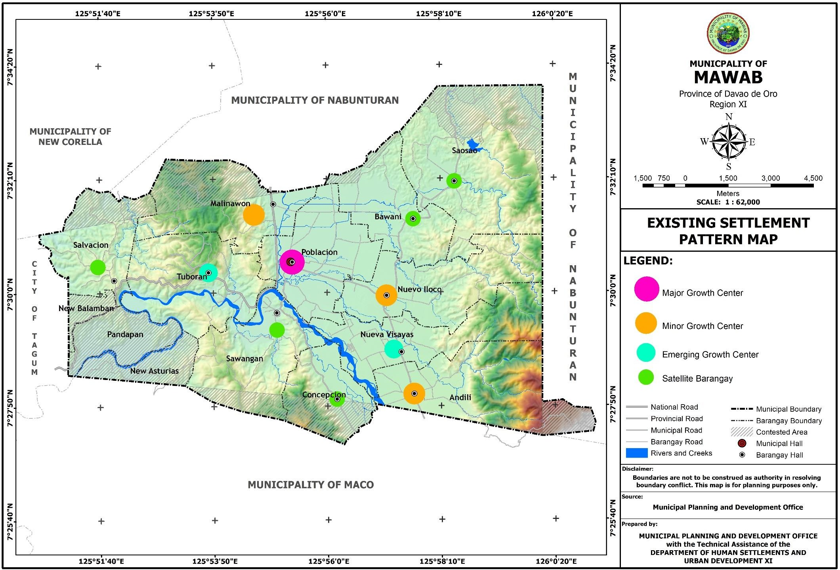

**Figure 41. Proposed Settlement Pattern Map**

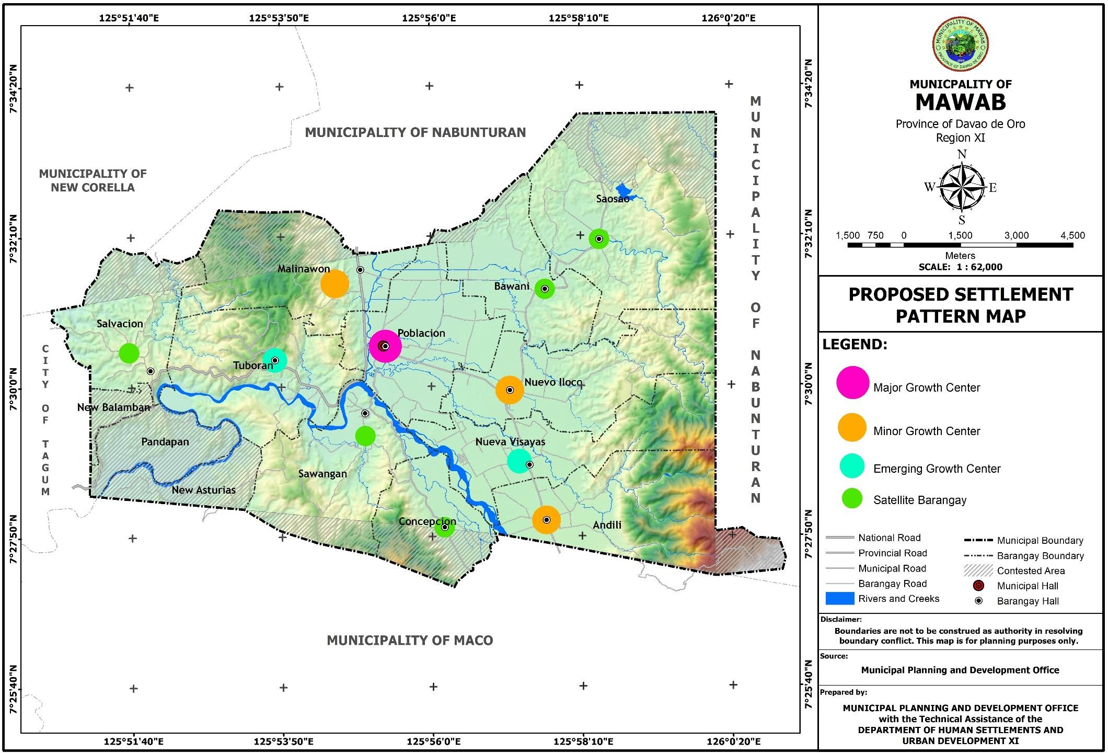

###### THE LAND USE PLAN

1. **Rationale**

The enactment of the Local Government Code of 1991 has put forward a stronger sense of authority and responsibility of the local government units to plan and manage comprehensively its local constituency.

The Municipality of Mawab has engaged itself in this undertaking as a continuing and developing process of achieving progress and sustainable development for its people.

In 1980, the LGU formulated its first Comprehensive Land Use Plan for 1980-1990 with the assistance of the Human Settlement Regulatory Commission (HSRC). In 1993 the Local Government of Mawab began to update its Comprehensive Development Plan with the technical assistance of the Housing and Land Use Regulatory Board (HLURB)-Region XI and the logistical and financial support of the Canadian Integrated Development Agency – Local Government Support Program (CIDA-LGSP).

The revision of the Comprehensive Land Use Plan is being mandated by law pursuant to Article 41 of RA 7160 which provides under paragraph (a) subject to applicable laws, rules, regulations, cities and municipalities shall continue to prepare their respective comprehensive land use plans enacted through zoning ordinances.

The Honorable Mayor, signed the Memorandum of Agreement in behalf of the Municipality of Mawab, by virtue of the authorization of Sangguniang Bayan Resolution No. 055, series of 2015, with the Housing and Land Use Regulatory Board (HLURB) now Department of Human Settlement and Urban Development (DHSUD), represented by Atty. Robert Mauro Miguel T. Palma Gil.

1. **Objectives**

The Municipality of Mawab through this plan sets its goal to attain the total well-being and quality life of its people and empowerment for a meaningful participation in the community development through the attainment of following major objectives:

* + To ensure the growth and development of the municipality consistent with the provincial, regional and national programs and policies;
  + To have a common understanding on the social, economic, cultural and political situation, issues and concerns and strategies and actions to confront it;
  + To ensure coordination and maximization of available resources among sectors, agencies and major stakeholders in the municipality;
  + To enable local government units, corresponding line agencies, business, non-government organizations, people organizations and other stakeholders to provide accurate and substantial programs and services to the people;

1. **Methodology**

The technical planning staff of the Municipal Planning and Development Office and the Technical Working Group serve as an action group of the local development council on the planning process.

The principle of community participation is being employed in the formulation of the plan. The process engages the following: research on the baseline data and information of the municipality according to sectoral classification and area of urgent issues and concerns.

Data input from the barangay level were brought up through the series of consultations and seminar-workshop at the Municipal Development Council level. Community Based Monitoring

System and other data were gathered and validated through Interview of key informants and development stakeholders, review of previous documents primary survey, comparative studies and other related methodologies.

1. **Planning Considerations**
2. **Population Projection**

**Population Projection by barangay**. The growth of population based on the 2015 population count was .72%. Using this as a benchmark in projecting urban-rural distribution by 2029, it is estimated that 29,500 would still belong to the rural population while 11,697 to urban population. Overall, the projected population of Mawab will reach to 41,197 in 2029 from 2015’s 37,065.

**Population Projection by Age Group**. Per 2015 Census of Population by the Philippine Statistics Authority (PSA), the largest share of Mawab’s total population belongs to the age group 5-19 years old which have a total of 11,405 or 30.77% of the total municipal population. These are the school-going age population age-groups of the municipality wherein, by 2029, the same age-group will have the largest share of the population considering that growth rate that is being used in deriving the age-group projection is constant in all age-group.

1. **Functional Role of the Municipality in relation to the Province and in the Region**

The municipality of Mawab being one of the 11 component municipalities of the province of Davao de Oro plays an important functional role of generating agricultural production owing to its agri-based economy. In 2020, the municipality contributed 17.03 percent or 5,320.1 metric tons in palay production of the province recorded at 31,233.5 metric tons. The municipality also has a substantive deposit of clay (white, green) as potential sources for pottery making and bricks production. Moreover, the municipality was identified as one of the local centers of Region XI, as per the Regional Development Plan (RDP) 2017 – 2022, which serves as a production agricultural area that largely depend on the existing major growth and emerging growth centers for its economic and social activities.

Strategically the municipality is gateway of tourism industry with respect to the presence of magnificent caves at Barangay Tuboran. Mawab is the first municipality that will be traversed towards the north region of the province. It prides itself with the view deck landmark of the province located at Barangay Salvacion. The municipality also provides road access towards the various barangays of the municipality of Maco particularly the renowned lake Leonard of New Leyte and the sulfuric hot springs of Barangay Mainit. Mawab is also the bulwark of military defense due to the presence of 10th Infantry Division of the Philippine Army at Barangay Tuboran and the 71st Infantry Battalion in Barangay Nueva Visayas.

1. Development Constraints Areas

The constraints of land use development and allocation of the municipality include among others the following:

* The presence of 1,133.19 hectares of land with 18% slope and in which according to P.D. 389 it should be declared as areas for permanent forest or forest reserves regardless of the condition of vegetable cover. These hectarage of land constitute 6.7 percent of the total 16,952 hectares of the municipality;
* The presence of CARP covered areas;
* The presence of 775.30 hectares of flood prone areas which is 4.62 percent of the total flood prone areas of the province and 8.77 percent of the total land area of the municipality;
* The presence of fault line traversing barangays Malinawon, Tuboran and Sawangan;
* The presence of boundary conflict between the municipality of Maco, City of Tagum and Municipality of Nabunturan;
* The presence of 890.33 hectares irrigated areas which is 86.14 percent of the total rice production area of 1,282.671 hectares;
* The presence of 203.84 hectares built-up areas;

**Table 46. Development Constraints Areas**

|  |  |  |
| --- | --- | --- |
| **Constraints Areas** | **Area in hectare** | **% to total** |
| Forest and Forestland | 4,650.09 | 27.4 |
| 18% Slope and Above | 1,133.19 | 6.7 |
| High risk areas to flooding | 775.30 | 4.6 |
| High risk areas to landslide | 583.42 | 3.4 |
| Irrigated/Irrigable Areas | 890.33 | 5.3 |
| Existing Urban Use/Built-up Areas | 203.84 | 1.2 |
| Military Reservation | 99.22 | 0.6 |
| Rivers and Creeks | 200.60 | 1.2 |
| Contested Area | 2,602.25 | 15.4 |
| **Total Constraints Area** | **11,138.24** | **65.7** |
| Total Municipality Area | ***16,952.00*** |  |
| **Less: Total Constraints Areas** | 11,138.24 |  |
| **TOTAL AVAILABLE LAND SUPPLY FOR URBAN EXPANSION/USE** | **5,813.76** | **34.3** |

Source: Development Constraints Map

**Figure 42. Development Constraints Map**

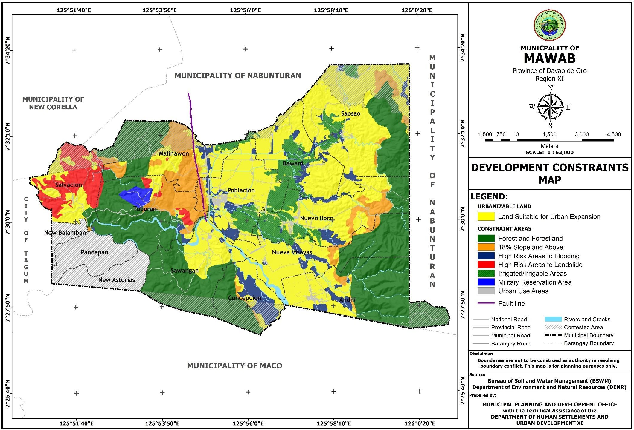

1. **Land Use Issues/Problems (Biophysical Environment Matrix)**

The biophysical environment matrix below shows the existing conditions of various land uses per maps overlaid. This provides the basis from which potential impacts will be predicted and informs the assessment of their significance.

**Table 47. Biophysical Environment Matrix**

|  |  |  |  |
| --- | --- | --- | --- |
| **MAPS OVERLOAD** | **ISSUES/CONCERN** | **EXPLANATION** | **IMPLICATIONS WHEN UNRESOLVED** |
| Land Classification + Existing Land Use Map | Forest Area with settlement, infra, facilities and crops cultivation | Presence of landless households/increase in population relying on upland farming | Encroachment in the forestland/ deforestation/ erosion/ landslide/ siltation |
|  |  | Road construction traversed the forestland to serve the upland farmers | Damage of infrastructure facilities affecting the socio-  economic activities in the area |
| Geology + Existing Land Use Map + Slope | Land slide prone areas/fault line with crop production, settlements and other developments | Presence of landless households relying on upland farming  Absence of vulnerability/risk assessment in the past by MGB | Damage or loss of life and properties, crops & infrastructure damage |
|  |  | Forest occupants are not aware of forestry laws |  |
| Existing Land Use + Flooding Map | Cultivation, settlements and other infrastructures along the river/creek easements or flood  prone areas | Presence of landless households/increase in population | Crop damage, settlement and infrastructure damage, loss of life and properties |
|  |  |  | Increased poverty |
| Slope + Erosion + Existing Land Use Map | 18% slopes & above (landslide prone areas) with settlements, cultivation and  infrastructure development | Displacement of farmers/ labourers in the lowland | Loss of life and properties  Damage of properties Increased poverty |
| Existing Land Use Map  + Elevation + Slope | Cultivation, settlements,  tourism structures, cemetery and other infrastructures on highly elevated/  landslide prone areas | Displacement of  farmers/ labourers in the lowland | Loss of life and  properties  Damage of properties Increased poverty |

1. Urbanizable Land and Absorptive Capacity

The urbanizable lands in the municipality suitable for urban growth and expansion such as growth centers, new settlement areas, industrial states, etc… is barangay Poblacion, the only existing urban center. Barangays Andili, Nuevo Iloco and Malinawon are best for the dispersed urbanization dive that will spur and boost the economic activities of the municipality.

Mawab is an urbanizing agricultural municipality. Though agriculture is considered a major livelihood activity and land use in the municipality, encroachment of urban activities is very evident especially in upland areas. Emerging pattern of development within the municipality, specifically barangays nearby urban core show increasing potentials for urbanization.

The available lands and the town’s absorptive capacity support the urban functions of the area. Urbanizable lands which refer to areas still available for urban expansion and display a marked and high probability of becoming urban lands which are found to be suitable for urban uses at varying degrees comprise 5,813.73 hectares. These areas are relatively flat, safe from climate change and geohazards and outside the protection/conservation areas of the municipality. Barangays covered in the urbanizable land includes all barangays with alienable and disposable land.

Absorptive capacity which refers to the capacity of an area to accommodate anticipated increases in population and the corresponding growth in settlements vis-à-vis available urbanizable lands based on standard of 150 persons per hectares for low density or 151-250 for medium density; thus, the projected increase of population of 4,132 (or 922 households) within the planning period can still be accommodated in the above available urbanizable lands. But since some barangays do not have this urbanizable land, the LGU can assigned areas for urban expansion particularly on moderately susceptible to hazard, provided all mitigating measures be in placed such as gabions/dikes, appropriate building and structural designs and other applicable land use planning options. Any development must be sustainable, thus a development is warranted.

1. **Pertinent Government Policies (Laws /Issuances)**

|  |  |
| --- | --- |
| **PERTINENT GOVERNMENT LAW OF LAND USE PLAN PLANNING:** | |
| **1.) R.A. 6657- (O7/26/87)** | Otherwise known as the Comprehensive Agrarian Reform Law of 1998 (CARL) empowers the Department of Agrarian Reform to authorize, under certain conditions, the classification of conversion of lands awarded  to agrarian reform beneficiaries. |
| **2.) R.A 7160- (10/10/91)** | Local Government Code of 1991 states that;  Subject to applicable laws, rules and regulations cities and municipalities shall continue to prepare their respective land use plans  enacted through zoning ordinances which shall be primary bases for the future use of land resources. |
| **3.) R.A 7279** | Otherwise known as the Urban Development and Housing Act of  1992.  Article IV, Section 7 – mandates the various local government units to conduct inventory of lands for socialized housing and their integration into Comprehensive Land Use Plans and Zoning Ordinances of their respective cities and municipalities. This shall adhere to the site criteria.  Section B – Identification of Sites for Socialized housing and resettlement for the immediate and future needs of the underprivileged and homeless in the urban areas taking into consideration the degree of:   1. Availability of basic services/facilities 2. Accessibility 3. Proximity to job sites and economic opportunities |
| **4.) R.A 7586 (06/01/92)** | Otherwise known as the NIPAS Act – an act providing for the Establishment and Management of National Integrated Protected Areas System in order to maintain the essential ecological processes and life-  support system, to preserve genetic diversity, to greatest sustainable use of resources conditions to the greatest extent possible. |

Otherwise known as the Forestry Reform Code authorizes the President of the Philippines by proclamation upon recommendation of the Director to declare all lands of the public domain eighteen percent (18%) in the slope or over as permanent forest reserves, regardless of the condition of the vegetation cover, occupancy or use any kind, and thereafter such forest reserves shall not be alienated or dispose of, but shall remain in public.

**Section 18** – Areas within timber concession between 18% in slopes which are timbered and or have adequate residual stocking and presently supporting a processing plant shall not be released as alienable and disposable but shall remain as part of the permanent forest.

**Section 22** – Local Government may acquire private or public land for the purposes of establishing a municipal or city forest, tree park, watershed or pasture land.

Parcels of Land less than 18% in slope and less than 250 hectares, regardless of size which are found within the surrounded wholly or partly by a body of public forest purposes shall be considered as part thereof.

Areas along streams or rivers maybe utilized as kaingin relocation centers, forest villages. A strip of land 50 meters above normal high water line on each side of rivers and streams which channels less than 5 meters wide shall be retained as permanent forest for streams bank protection.

**5.) P.D 389**

|  |  |
| --- | --- |
|  | Strips of land, mangrove and swampland not less than 50 meters from the shoreline shall be retained as permanent forest for shoreline protection.  A possession of thirty (30) years or more is needed for existing alienable or disposable lands even if 18% in slope or over but covered by approved public land application, the possession being actual, continuous and adverse and public. |
| **6). P.D. 705-** | **Amends Forestry Reform Code**  This provide for system of land classification into agricultural, industrial or commercial, residential, resettlements, mineral, timber or forest and grazing lands, and into such other classes as nor or may hereafter be provided by law, rules and regulations. Section 15 further states that no land of the public domain 18% in the slope or over shall be classified as alienable and disposable, nor any forest land 50% or over in the slope as  grazing land. |
| **7). P.D. 635** | This amended Section 112 of R.A 141, as amended. This section shall now read as follows. Section 112 – said land shall further be subject to a right-of-way not exceeding sixty (60) meters in width for public highways,  railroads, irrigation, ditches, aqueducts, telegraph, and telephone lines. |
| **8)**  **Administrative Order No. 20 (12/07/1992)** | Interim Guidelines on Agricultural Land Use Conversion   1. All agricultural lands classified hereunder shall not be subject to and non-negotiable for conversion:    1. All irrigated lands where water is available to support rice and other crop production, and all irrigated lands where water is not available for rice and other crop production but are within areas programmed for irrigation facility rehabilitation by the Department of Agriculture (DA) and National Irrigation Administration (NIA);   and   * 1. All irrigable lands already covered by irrigation projects with firm funding commitments at the time of the application for land use conversion.  1. All agricultural lands other than those referred hereunder as non- negotiable for conversion may be converted only upon strict   compliance with existing laws, rules and regulations. |
| **9) R.A. 10121 (05/27/2010)** | **Philippine Disaster Risk Reduction and Management Act** |
|  | Section 2 (a) of the Law states: It shall be the policy of the state to uphold the people’s constitutional rights to life and property by addressing the root causes of vulnerabilities to disasters, strengthening the country’s institutional capacity for disaster risk reduction and management and building resilience of local communities to disasters including climate change impacts. |
|  | Further, Section 11 (2) of the same law states that the LDRRMC shall ensure the integration of disaster risk reduction and climate change adaptation into local development plans, programs and budgets as a strategy in  sustainable development and poverty reduction. |
| **10.R.A. 9729 (10/23/2009)** | **Climate Change Act** |
|  | An Act mainstreaming Climate Change into Government Policy Formulations, Establishing the Framework Strategy and Program on Climate Change, Creating for this Purpose the Climate Change Commission, and for other Purposes. Further, the law encouraged the state to systematically integrate the concept of climate change in various phases of policy formulation, development plans, poverty reduction strategies and other development tools and techniques by all agencies and instrumentalities of  the government. |

###### DEVELOPMENT THRUST AND SPATIAL STRATEGY

* + 1. **Alternative Development Thrusts/Strategy**

The alternative spatial strategies presented in this plan are the outputs of the SWOT analysis conducted in the economic and land use sectors. These are the basis for the selection of development options for the municipality. The alternative spatial strategies include the following:

1) Agricultural Development Alternative; 2) Commercial Development Alternative; 3) Agri- Industrial Development Alternative.

* + - 1. **Alternative 1- Agricultural Development**

In this development strategy, the municipal resources will focus on the attainment of food security in a wholistic agricultural development scheme with the end view of empowering the farming and fishing communities to uplift their socio-economic condition, undertake and sustain profitable enterprise of their own and contribute their fair share to the municipal, provincial and national development. For this strategy, the prime agricultural land or areas covered under the Network of Protected Agricultural Areas System (NPAAS) will be preserved and maintained. Other areas delineated for agricultural uses will be supported with an appropriate infrastructure support facilities such as irrigations, farm to market roads, pre and post-harvest facilities.

* + - 1. **Alternative 2- Commercial Development**

This development strategy aims to intensify the municipal’s commercial base. It further intends to support the business enterprise development, by being investor friendly, implementing Investment Incentive scheme to attract more investors in the locality and provision of infrastructure support, in order to become a first income class municipality. 5 barangays of Mawab is being traversed by the national highway. These are barangays Salvacion, Tuboran, Sawangan, Poblacion and Malinawon. These areas are strategic for comer cial development considering that these areas are gateways to the northern and southern part of the Mindanao Island.

* + - 1. **Alternative 3- Agri-Industrialization Development**

This development strategy will propel the municipality in achieving its goals and objectives through agriculture and industrialization. This two-pronged scheme will pursue its agricultural development parallel to the national government’s food security program in tandem with industrialization. The municipality is blessed with a great deposit of white clay and other clay types that are potential source for the municipality’s pottery making development and industrialization. There are also various rice and corn milling plants in the municipality particularly in Barangay Malinawon. Piggery and poultry were also present in the municipality with huge areas located in Barangay Nueva Visayas. Gold milling plants are also flourishing in barangay Andili and the nearby barangay. Significant investments on infrastructure and other infra-support facilities has to be provided in partnership with the investors and private sectors.

* + 1. **Evaluation of Alternative Thrusts/Strategies Using Goal Achievement Matrix**

The criteria used to evaluate the performance of the Agricultural Development Strategies and the rest of the development schemes are gauged against the objectives detailed in the goal statements.

Spatial strategy is a straight forward process of testing alternative strategies in choosing the most appropriate development scheme for the municipality.

|  |  |  |  |  |  |  |  |
| --- | --- | --- | --- | --- | --- | --- | --- |
| **GOAL ACHIEVEMENT MATRIX** | | | | | | | |
|  | | | | | | | |
| **GOALS** | **Weights** | **Alternative 1 : Agricultural**  **Development** | | **Alternative 2: Commercial**  **Development** | | **Alternative 3: Agri- Industrialization**  **Development** | |
| **A. SOCIAL** |  | **Rating** | **Weighted Rating** | **Rating** | **Weighted Rating** | **Rating** | **Weighted Rating** |
| 1. Provide comprehensive delivery of equitable and accessible basic social services in the field of health, education, housing, social welfare, protective services and  sports and recreation so that the municipal constituents may fully enjoy the best quality of life. | 10% | 2 | 0.2 | 3 | 0.3 | 2 | 0.2 |
| 2. Firm up and sustainably maintain effective, efficient and dynamic local governance tailored-fit to the present and future needs of the constituents, and also the scheme of the socio-political development in tandem with the Non- Government Organization(NGOs), Private Sector (PS's) and  Cooperatives. | 5% | 3 | 0.15 | 2 | 0.1 | 1 | 0.05 |
| 3. Provide knowledge, skills and Ability (KSA) Enhancement Training/Workshop for Human Resources Development to become active civil service agents in rendering appropriate and quality public services. | 5% | 2 | 0.1 | 2 | 0.1 | 1 | 0.05 |
| 4. Augment police manpower to ensure the safety and peace and order situation of the municipality so that the constituents may live in a peaceful environment. | 10% | 3 | 0.3 | 2 | 0.2 | 2 | 0.2 |

|  |  |  |  |  |  |  |  |
| --- | --- | --- | --- | --- | --- | --- | --- |
| 5. Ensure the preservation and conservation of the socio- cultural heritage in the municipality particularly the cultural  practices of the indigenous peoples (lPs’). | 5% | 2 | 0.1 | 1 | 0.05 | 1 | 0.05 |
| **B. ECONOMIC** |  |  |  |  |  |  |  |
| 1. Increase and sustain the food sufficiency level of the municipality by employing the modern farming technologies and sustainable farming practices and management under a holistic agricultural development approach to alleviate and empower the farming communities to raise their socio-  economic condition; | 10% | 3 | 0.3 | 2 | 0.2 | 3 | 0.3 |
| 2. Attain and sustain a vibrant economy through the establishment of medium scale shopping centers, wholesale trade centers, and agro-based industries that will generate employment opportunities, together with the private investors and other market players/stakeholders increased support and interest in investing by enhancing and then solidifying the LGUs’ business investment incentives, pro- business policies, subsidies, tax holidays and appropriately  in-placed infra-support facilities; | 15% | 3 | 0.45 | 3 | 0.45 | 3 | 0.45 |
| 3. Improve and develop potential eco-tourism areas in the municipality as additional attraction for both the local and foreign tourist to boost economic stability. | 5% | 3 | 0.15 | 3 | 0.15 | 2 | 0.1 |
| 4. Increase local Revenue Generation to reduce dependence on the Internal Revenue Allotment (IRA) in financing the local government operation and the implementation of  various socio-economic projects. | 10% | 3 | 0.3 | 3 | 0.3 | 3 | 0.3 |
|  |  |  |  |  |  |  |  |

|  |  |  |  |  |  |  |  |
| --- | --- | --- | --- | --- | --- | --- | --- |
| **C. INFRASTRUCTURE** |  |  |  |  |  |  |  |
| 1. Provide adequate basic infrastructure facilities and utilities such as transportation, power, communication, water, drainage, and sewerage, and solid and liquid waste disposal to accelerate the socio-economic progress and  growth of the municipality and ease the way of living of the populace; | 10% | 3 | 0.3 | 3 | 0.3 | 2 | 0.2 |
| **D. ECOSYSTEM** (Forest, Water Bodies) |  |  |  |  |  |  |  |
|  |  |  |  |  |  |  |
| 1. Establish an eco-friendly environment through proper conservation, preservation and protection and  utilization of the natural resources and achieve a sustainable forest management and development. | 5% | 2 | 0.1 | 2 | 0.1 | 2 | 0.1 |
| 2. Allocate and appropriately manage municipal land resource equitably to various uses to meet the land  requirement of the present and future land development of various sectors. | 10% | 2 | 0.2 | 3 | 0.3 | 2 | 0.2 |
| **E. SPECIAL AREAS** |  |  |  |  |  |  |  |
| (Ancestral Domain, Heritage |  |  |  |  |  |  |  |
| Conservation) |  |  |  |  |  |  |  |
| **TOTAL** | **100%** |  | **2.65** |  | **2.55** |  | **2.2** |

* + 1. **Preferred Development Thrust and Spatial Strategy**

After thorough and critical evaluation using the Goals Achievement Matrix (GAM) of the three (3) proposed development alternatives, the following summary of results are obtained:

|  |  |  |
| --- | --- | --- |
| **Proposed Alternative** | **Scores (Points)** | **Rank** |
| Alternative 1 – Agricultural Development | 3.35 | 1st |
| Alternative 2 – Commercial Development | 3.20 | 2nd |
| Alternative 3 – Agri-Industrialization Development | 3.15 | 3rd |

Based on the presented results, Alternative 1, which is the Agricultural Development, obtained the highest score of 3.35 points and ranks first among the 3 proposed alternatives. The highest ranking strategy is chosen as the preferred development framework, thus, Alternative 1 emerged as the preferred strategy. For this reason, all the plan components that include the settlement plan, land use plan and infrastructure plan will be anchored on this development alternative.

|  |  |  |  |  |  |  |  |
| --- | --- | --- | --- | --- | --- | --- | --- |
| **DEVELOPMENT THRUST EVALUATION** | | | | | | | |
| **Criteria** | **Weight** | **AGRICULTURAL DEVELOPMENT** | | **COMMERCIAL DEVELOPMENT** | | **AGRI- INDUSTRIALIZATION DEVELOPMENT** | |
| Rating | Weighted Rating | Rating | Weighted Rating | Rating | Weighted Rating |
| 1. Cost of new support infrastructure(i.e Transportation, Power, Communication, Irrigation) | 15% | 4 | **0.6** | 4 | **0.6** | **4** | **0.6** |
|  |  |  |  |  |  |  |  |
| 2. Is the option consistent with the vision and achievement of identified goals and objectives? | 10% | 3 | **0.3** | 3 | **0.3** | 4 | **0.4** |
|  |  |  |  |  |  |  |  |
| 3. Will the option generate enough economic opportunities and improve income levels of the local inhabitants (sensitivities and enhance adaptive capacities of households and individuals)? | 15% | 4 | **0.6** | 4 | **0.6** | 3 | **0.45** |
|  |  |  |  |  |  |  |  |
| 4. Will it generate enough local revenues/income in the form of real property taxes and business permits to support/sustain local development? | 5% | 4 | **0.2** | 3 | **0.15** | 2 | **0.1** |
|  |  |  |  |  |  |  |  |
| 5. Do the local inhabitants have the necessary skills and capabiities to pursue the option? | 5% | 2 | **0.1** | 2 | **0.1** | 3 | **0.15** |

|  |  |  |  |  |  |  |  |
| --- | --- | --- | --- | --- | --- | --- | --- |
|  |  |  |  |  |  |  |  |
| 6. Does the Local Government have the capacity and capability to support the development thrust in terms of policy, program and project implementation? | 10% | 2 | **0.2** | 3 | **0.3** | 3 | **0.3** |
|  |  |  |  |  |  |  |  |
| 7. Will it encourage the sustainable and optimal use of local natural resources? | 5% | 4 | **0.2** | 3 | **0.15** | 2 | **0.1** |
|  |  |  |  |  |  |  |  |
| 8. Is the option achievable given the hazard susceptible of the Municipality? | 5% | 3 | **0.15** | 4 | **0.2** | 3 | **0.15** |
|  |  |  |  |  |  |  |  |
| 9. Is the option achievable given the projected changes in the climate (extremes and variability)? | 10% | 4 | **0.4** | 3 | **0.3** | 4 | **0.4** |
|  |  |  |  |  |  |  |  |
| 10. Disaster risk management and climate change adaptation measures needed to pursue the option on the part of the LGU and the private sector. | 10% | 3 | **0.3** | 3 | **0.3** | 3 | **0.3** |
|  |  |  |  |  |  |  |  |
| 11. Does it promote ecological balance and sustainability? | 10% | 3 | **0.3** | 2 | **0.2** | 2 | **0.2** |
|  |  |  |  |  |  |  |  |
| **TOTAL** | **100%** |  | **3.35** |  | **3.20** |  | **3.15** |

The team is opt for the central and nodal type of development to be adopted by the municipality. Considering its existing land use pattern, topography and other geographic constraints, a combination of central and nodal type of development is proposed. Central and nodal type of development is characterized by expansion of development that contiguously grows out the central business district or is supported by growth nodes outside the urban area. This type of development assumes a hierarchical form wherein there is a central dominant area, which is supported by pockets of development nodes in nearby or neighboring areas. Barangay Poblacion being the center for economic activities considered to be the major growth center of the municipality where commerce is concentrated supported by the minor growth centers of Barangays Andili, Malinawon and Nuevo Iloco. Emerging growth centers such as Barangays Tuboran and Nueva Visayas and Satellite Barangays such as Bawani, Concepcion, Salvacion, Saosao and Sawangan identified in the settlement pattern contribute to the attainment of the preferred development thrust of the municipality.

In introducing central and nodal approach to propel development in the municipality, connectivity is very vital. Thus, improvement of basic infrastructure and utilities like road network, power, water and communication shall be done.

**SPATIAL STRATEGY EVALUATION**

|  |  |  |  |  |  |  |  |
| --- | --- | --- | --- | --- | --- | --- | --- |
| **Criteria** | **Weight** | **STRIP/LINEAR DEVELOPMENT** | | **CONCENTRIC DEVELOPMENT** | | **CENTRAL AND NODAL** | |
| Rating | Weighted Rating | Rating | Weighted Rating | Rating | Weighted Rating |
| Financial capacity of the LGU to realize the spatial option (i.e. infrastructure requirements and available public investments), including investment requirements for mitigation and adaptation | 10% | 3 | **0.3** | 3 | **0.3** | **3** | **0.3** |
|  |  |  |  |  |  |  |  |
| Impact on general image and attractiveness of the Municipality | 10% | 2 | **0.2** | 2 | **0.2** | 4 | **0.4** |

|  |  |  |  |  |  |  |  |
| --- | --- | --- | --- | --- | --- | --- | --- |
|  |  |  |  |  |  |  |  |
| Is the effcient access and linkages between the various functional zones feasible (physically and in terms of cost and potential impacts of hazards) | 5% | 2 | **0.1** | 3 | **0.15** | 3 | **0.15** |
|  |  |  |  |  |  |  |  |
| Will the option encourage the equitable distribution of economic benefts within the municipality | 5% | 2 | **0.1** | 4 | **0.2** | 3 | **0.15** |
|  |  |  |  |  |  |  |  |
| Will it contribute to ecological balance and stability | 10% | 3 | **0.3** | 3 | **0.3** | 3 | **0.3** |
|  |  |  |  |  |  |  |  |
| Will the spatial option signifcantly reduce exposure and promote long term human security from natural  hazards | 5% | 2 | **0.1** | 4 | **0.2** | 4 | **0.2** |
|  |  |  |  |  |  |  |  |
| Potential scale and cost for disaster response, recovery and rehabilitation given the potential exposure | 5% | 3 | **0.15** | 2 | **0.1** | 4 | **0.2** |
|  |  |  |  |  |  |  |  |
| If the option is pursued, are current and future capacities enough to comply with the required risk  reduction and management related land use and structural development regulations (building design,  Floor Area Ratio, risk transfer mechanisms) | 10% | 2 | **0.2** | 3 | **0.3** | 3 | **0.3** |

|  |  |  |  |  |  |  |  |
| --- | --- | --- | --- | --- | --- | --- | --- |
|  |  |  |  |  |  |  |  |
| Will it encourage the preservation of prime agricultural areas | 15% | 3 | **0.45** | 4 | **0.6** | 3 | **0.45** |
|  |  |  |  |  |  |  |  |
| Does it ensure the uninterrupted delivery of basic social support services | 15% | 4 | **0.6** | 3 | **0.45** | 3 | **0.45** |
|  |  |  |  |  |  |  |  |
| Abilityof the LGU to effetively monitor and enforce required development regulations and policies. | 10% | 4 | **0.4** | 4 | **0.4** | 4 | **0.4** |
| **TOTAL** | **100%** |  | **2.9** |  | **3.2** |  | **3.3** |

###### THE CONCEPT/STRUCTURE PLAN OF THE MUNICPALITY

Structure plan map is a schematic representation of the chosen spatial strategy. It indicates the approximate location of areas for settlement development, location of key production systems, areas for protection and the various linkage system. In the context of DRR-CCA, the following are given emphasis: a) Indicative location of new expansion settlement areas in relation to hazard susceptibilities; b) Priority areas where mitigation and adaptation measures should be implemented for current or future settlement (expansion) areas, including production areas identified as highly vulnerable to natural hazards and climate change impacts; c) Key linkage and distribution systems with emphasis on its role for disaster risk reduction and climate change adaptation (redundant transportation routes for improved area access, response and evacuation, back-up systems for water distribution); d) Major risk mitigation infrastructure to be established (flood control, sea walls, slope stabilization, etc.); e) Designating highly susceptible hazard areas as protection (buffer easements) or natural resource production areas (where production can be pursued if feasible); and f) Indicating key protection areas for rehabilitation and conservation with emphasis on its contribution to management of climate and disaster risks.

Structure plan of the municipality focuses on the agricultural development considering its functional role in the province. Barangays to be considered are Bawani, Nuevo Iloco, Saosao, Concepcion, Sawangan, Tuboran and Salvacion. Barangay Poblacion being the only urban barangay and as the center for economic activities proposed to be concentrated with commercial and residential development. This will be supported by the 3 minor growth centers of the municipality which are barangays Andili, Malinawon and Nuevo Iloco. For Agri-industrialization, Barangays Nueva Visayas, Malinawon and Salvacion are being taken into consideration where development will be introduced and expanded. For industrialization, proposed development will be introduced in Barangays Tuboran, Poblacion, Nueva Visayas and Andili.

###### BALANCING LAND SUPPLY AND DEMAND

* + 1. **Available Land Supply**

As to the land supply, the municipality has a total land area of 16,952 hectares including the contested/other claimed areas. Of this figure, 11,138.24 hectares or 65.7 percent are constraints areas while the remaining 5,813.76 hectares or 34.3 percent are the available land supply for urban expansion/use. This indicates that there is sufficient land supply to cater the expansion of the urban land uses.

**Table 48. Constraints Areas vs. Available Land Supply**

|  |  |  |
| --- | --- | --- |
| **Constraints Areas** | **Area in hectare** | **% to total** |
| Forest and Forestland | 4,650.09 | 27.4 |
| 18% Slope and Above | 1,133.19 | 6.7 |
| High risk areas to flooding | 775.30 | 4.6 |
| High risk areas to landslide | 583.42 | 3.4 |
| Irrigated/Irrigable Areas | 890.33 | 5.3 |
| Existing Urban Use/Built-up Areas | 203.84 | 1.2 |
| Military Reservation | 99.22 | 0.6 |
| Rivers and Creeks | 200.60 | 1.2 |
| Contested Area | 2,602.25 | 15.4 |
| **Total Constraints Area** | **11,138.24** | **65.7** |
| Total Municipality Area | ***16,952.00*** |  |
| **Less: Total Constraints Areas** | 11,138.24 |  |
| **TOTAL AVAILABLE LAND SUPPLY FOR URBAN EXPANSION/USE** | **5,813.76** | **34.3** |

|  |  |
| --- | --- |
| **Particulars** | **Area (has.)** |
| Total Municipality Area | 16,952 |
| Less: Total Constraint Areas | 11,138.24 |
| Total Available Land Supply for Urban Expansion/Use | 5,813.76 |
| Total Land Demand/Area Requirement | 297.67019 |
| Existing Land Use | 250.399 |
| Total Additional Area Requirement | 102.4785 |

**Figure 43. Structure/Concept Plan Map**

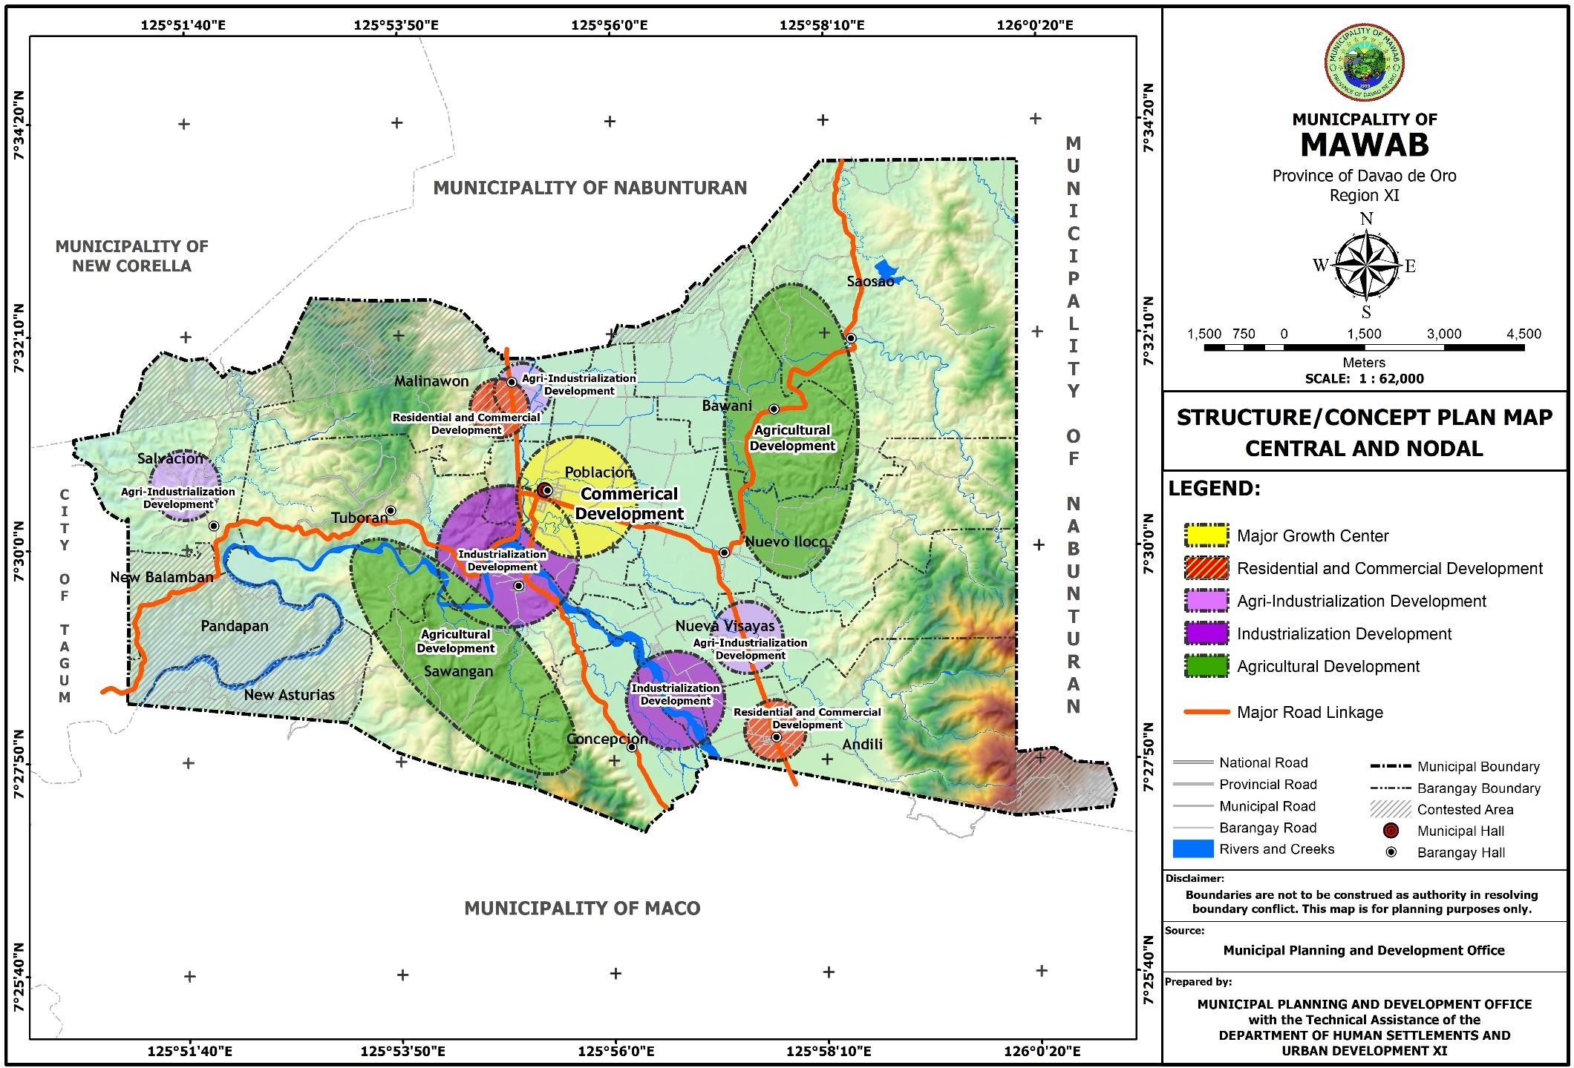

* + 1. **Additional Area Requirement**

Shown in the table below are the land use requirements for the urban expansion in the municipality, per land use category and by barangay. A total of 102.4785 hectares land area is required within the planning period for urban expansion. With the available land supply of 5,813.76 hectares, as presented in 2.10.1, the additional area requirement can be accommodated. The largest land use requirement is recorded in Barangay Poblacion with a total of 18.2479 hectares followed by Barangay Saosao with 17.3253 hectares. The smallest land use requirement is recorded in Barangay Sawangan with 3.8749 hectares and in Barangay Concepcion with 3.9450 hectares.

**Table 49. Additional Urban Land Area Requirement**

|  |  |  |  |  |  |
| --- | --- | --- | --- | --- | --- |
| **BARANGAY** | **LAND USE CATEGORY** | **AREA REQUIREMEN**  **T (ha.)** | **EXISTIN G LAND USE (ha.)** | **AREA ADJUST MENT AFTER**  **CDRA** | **ADDITONAL AREA REQUIREMENT TO BE PLOTTED IN THE MAP** |
| (A) | (B) | ( C ) | (D) | ( E ) (B-C-D) |
| ANDILI | Residential | 12.775 | 10.429 |  | 2.346 |
| Commercial | 0.214635 | 1.04 |  | -0.825365 |
| Institutional |  | 1.698 |  | -1.698 |
| Agri-Industrial | 4.3448 | 0.053 |  | 4.2918 |
| Parks and Recreation | 2.7155 | 1.089 |  | 1.6265 |
| Infrastructure/ Utilities |  |  |  |  |
| Rural Areas | 7.728315 | 8.478 |  | -0.749685 |
| Sub-total |  |  |  | 8.2643 |
| BAWANI | Residential | 4.4086 | 4.617 |  | -0.2084 |
| Commercial | 0.083115 | 0.064 |  | 0.019115 |
| Institutional |  | 0.588 |  | -0.588 |
| Agri-Industrial | 1.732 | 0.058 |  | 1.674 |
| Parks and Recreation | 1.0825 | 0.214 |  | 0.8685 |
| Infrastructure/ Utilities |  |  |  |  |
| Rural Areas | 14.90082 | 6.969 |  | 7.93182 |
| Sub-total |  |  |  | 10.4934 |
| CONCEPCION | Residential | 2.587 | 2.282 |  | 0.305 |
| Commercial | 0.03999 | 0.025 |  | 0.01499 |
| Institutional |  | 0.231 |  | -0.231 |
| Parks and Recreation | 0.622 | 0.128 |  | 0.494 |
| Infrastructure/ Utilities |  |  |  |  |
| Rural Areas | 5.71896 | 2.588 |  | 3.13096 |
| Sub-total |  |  |  | 3.9450 |
| MALINAWON | Residential | 6.101 | 5.464 |  | 0.637 |
| Commercial | 0.15432 | 0.534 |  | -0.37968 |
| Institutional |  | 0.45 |  | -0.45 |
| Agri-Industrial | 2.4984 | 1.886 |  | 0.6124 |
| Parks and Recreation | 1.5615 | 0.188 |  | 1.3735 |
| Infrastructure/ Utilities |  |  |  |  |
| Rural Areas | 11.299335 | 8.954 |  | 2.345335 |
| Special Uses |  |  |  |  |

|  |  |  |  |  |  |
| --- | --- | --- | --- | --- | --- |
|  | Cemetery |  | 1.766 |  | -1.766 |
| Sub-total |  |  |  | 4.9682 |
| NUEVA VISAYAS | Residential | 5.304 | 4.777 |  | 0.527 |
| Commercial | 0.10548 | 0.133 |  | -0.02752 |
| Institutional |  | 0.637 |  | -0.637 |
| Industrial |  |  |  |  |
| I - 1 (.8 ha. /  1000 pop) | 2.0712 | 0.088 |  | 1.9832 |
| Agri-Industrial | 2.0712 | 1.146 |  | 0.9252 |
| Parks and Recreation | 1.2945 | 0.251 |  | 1.0435 |
| Infrastructure/ Utilities |  |  |  |  |
| Rural Areas | 9.784065 | 7.073 |  | 2.711065 |
| Sub-total |  |  |  | 7.1900 |
| NUEVO ILOCO | Residential | 12.609 | 11.02 |  | 1.589 |
| Commercial | 0.23397 | 0.963 |  | -0.72903 |
| Institutional |  | 0.978 |  | -0.978 |
| Agri-Industrial | 4.0392 | 0.131 |  | 3.9082 |
| Parks and Recreation | 2.5245 | 0.507 |  | 2.0175 |
| Infrastructure/ Utilities |  |  |  |  |
| Rural Areas | 17.69028 | 11.412 |  | 6.27828 |
| Special Uses |  |  |  |  |
| Cemetery |  | 1.999 |  | -1.999 |
| Sub-total |  |  |  | 13.7930 |
| POBLACION | Residential | 21.83 | 20.26 |  | 1.57 |
| Commercial | 0.537975 | 4.459 |  | -3.921025 |
| Institutional |  | 3.906 |  | -3.906 |
| Agri-Industrial | 9.3576 | 4.073 |  | 5.2846 |
| Parks and Recreation | 5.8485 | 1.968 |  | 3.8805 |
| Infrastructure/ Utilities |  |  |  |  |
| Urban Areas | 28.0728 | 20.56 |  | 7.5128 |
| Special Uses |  |  |  |  |
| Cemetery |  | 1.103 |  | -1.103 |
| Cockpit |  | 0.096 |  | -0.096 |
| Sub-total |  |  |  | 18.2479 |
| SALVACION | Residential | 3.355 | 3.361 |  | -0.006 |
| Commercial | 0.07428 | 0.163 |  | -0.08872 |
| Institutional |  | 0.364 |  | -0.364 |
| Agri-Industrial | 2.0104 | 0.734 |  | 1.2764 |
| Parks and Recreation | 1.2565 | 0.33 |  | 0.9265 |
| Infrastructure/ Utilities |  |  |  |  |
| Rural Areas | 12.84921 | 7.61 |  | 5.23921 |
| Sub-total |  |  |  | 7.4421 |
| SAOSAO | Residential | 10.963 | 9.042 |  | 1.921 |
| Commercial | 0.181275 | 0.267 |  | -0.085725 |
| Institutional |  | 0.732 |  | -0.732 |
| Agri-Industrial | 1.3504 | 0.131 |  | 1.2194 |
| Parks and Recreation | 0.844 | 0.419 |  | 0.425 |

|  |  |  |  |  |  |
| --- | --- | --- | --- | --- | --- |
|  | Infrastructure/ Utilities |  |  |  |  |
| Rural Areas | 26.715915 | 12.956 |  | 13.759915 |
| Sanitary Landfill |  | 3.953 |  | -3.953 |
| Special Uses |  |  |  |  |
| Cemetery |  | 1.494 |  | -1.494 |
| Sub-total |  |  |  | 17.3253 |
| SAWANGAN | Residential | 5.118 | 4.407 |  | 0.711 |
| Commercial | 0.097425 | 0.697 |  | -0.599575 |
| Institutional |  | 0.466 |  | -0.466 |
| Agri-Industrial | 2.0984 | 0.031 |  | 2.0674 |
| Parks and Recreation | 1.3115 | 0.215 |  | 1.0965 |
| Infrastructure/ Utilities |  |  |  |  |
| Rural Areas | 5.51031 | 12.261 |  | -6.75069 |
| Special Uses |  |  |  |  |
| Cemetery |  | 0.679 |  | -0.679 |
| Sub-total |  |  |  | 3.8749 |
| TUBORAN | Residential | 7.187 | 6.31 |  | 0.877 |
| Commercial | 0.118365 | 0.297 |  | -0.178635 |
| Institutional |  | 0.886 |  | -0.886 |
| Special Institutional |  | 2.952 |  |  |
| Industrial |  |  |  |  |
| I - 1 (.8 ha. /  1000 pop) | 2.4592 | 0.06 |  | 2.3992 |
| Agri-Industrial | 2.4592 | 0 |  | 2.4592 |
| Parks and Recreation | 1.537 | 0.338 |  | 1.199 |
| Infrastructure/ Utilities |  |  |  |  |
| Rural Areas | 6.23175 | 21.911 |  | -15.67925 |
| Sub-total |  |  |  | 6.9344 |
| **TOTAL** |  | **297.67019** | **250.399** |  | **102.4785** |

Source: Municipal Planning and Dev’t. Office

* + 1. **Strategic Interventions for the Availability of Lands**

1. **The Zoning Ordinance.** The Zoning Ordinance shall serve as the strategic intervention in the implementation of the Land Use Plan. It is a regulatory measure which is enacted to identify the various land use districts or zones, designate the allowable uses therein and prescribe physical and performance standards based on the approved general and urban land use plans as reflected in the Comprehensive Land Use Plan of the municipality.
2. **The Local Development Investment Program (LDIP).** Local Development Investment Program (LDIP) is a 3-year planning document that ranks priority projects, programs and activities (PPAs) identified in the Comprehensive Land Use Plan/Comprehensive Development Plan for implementation especially projects protecting our lands/structures (flood control measures, greening program, retrofitting, etc).
3. **Eminent Domain.** This is a strategic intervention that allows the government to expropriate land if such land has been determined or proved to have a use that would benefit a better majority.
4. **Revenue Code/Taxation.** Taxes are considered revenue generating measures to finance the programs and projects of the municipality’s development plan but also as a way to encourage and discourage certain activities in the municipality. Aside from financing programs and projects, taxation has the added purpose of influencing types of development in specific areas like granting tax exemption or tax holidays for bigger investments.
5. **Police Power**. One of the implementation tools of the local government is its police power. Municipal ordinances would protect the safety, health, welfare and interest of its constituency. Police power covers such regulatory measures as zoning, building and subdivision standards, grant or deny issuance of municipal permits and environmental protection ordinances, etc. The police power regulations are usually enforced through the issuance or non-issuance of permits to applicants who want to build on, develop, improve or change the land uses of his property.
6. **Encourage investments of commercial buildings within the Central Business District.** To maintain the attractiveness of the Central Business District (CBD), mixed type of development should be encouraged in the area. More shops, finance establishments and eateries/restaurants that will cater the needs of the residents are to be established in the area or construction of residential or accommodation facilities (such as boarding houses/apartments/hotel) to enliven the commercial and service industries.
7. **Increase Density of Zones to accommodate more development.** Just at the outskirts of the CBD are lands designated for residential use per previous Comprehensive Land Use Plan. These can accommodate more residences which are now slowly subdivided by landowners to residential lots. These show that there is interest from the landowners to accommodate more residences within their subdivisions. This offers an opportunity for compact development and shorter commuting distances for residents.
8. Increase in use density (densification) e.g., infilling of vacant lots, vertical (high-rise) development, redevelopment.
9. Reclamation subject to environmental and other laws and regulations.
10. Possible conversion of development constrained areas with the least perceived negative impact and subject to appropriate mitigating measures.

###### THE PROPOSED LAND AND WATER USE ANALYSIS

This component of the Land Use Plan, designates broad land areas of the municipality into its functional uses with the identified development regulations and limitations. The plan identifies areas suitable for urban development such as growth centers, industrial areas among others; prescribes areas where development must be properly and carefully regulated, conserved, and preserved.

This proposed General Land Use Plan outlines the following land use categories:

1. Forest
2. Easement
3. Agriculture
4. Water Use
5. Urban Use
6. Buffer
7. Cemetery

Within the next 10-year plan period (2020-2029), the municipality needs a total of 7,856.548 hectares for agriculture. It is 54.76 percent of the total land area which needs the biggest area allocation to ensure food sufficiency and security in the municipality. This is comprise of 955.995 hectares agriculture protection area and 6,900.553 hectares agriculture production area.

Forestal area requires the second biggest land allocation with a total of 4,337.845 or 30.23 percent of the total land area. This allocation is primarily intended for the production of timber producing tree species, agro-forestry and other non-timber species like bamboo or rattan to supply the raw material requirements in the municipality. Crop production is also allowed in the production forest provided that forest resources will be managed and utilized sustainably. There was no identified protection forest area in the municipality. Land areas with 50% slope and above 1000 masl are within the contested area between Mawab and Nabunturan.

Urban use areas allocated with 1,260.756 hectares or 8.80 percent of the total land area. This will be distributed to residential area which shares the widest area of 417.237 or 2.91 percent of the total urban use area. This will be followed with infrastructure computed at 300.546 hectares or 2.09 percent of the total urban use area. Institutional and special institutional uses allotted with a total of 146.914 or 1.02 percent of the total urban use area for municipal/barangay government structures, schools, clinics and hospitals, churches and other institutional facilities. A total of 137.124 hectares or .96 percent of the total urban use area will be allocated for the expansion of agri-industrial. For commercial area, a total of 86.241 hectares or .60 percent of the total urban use area is being allotted with Barangay Poblacion with the widest shares being the central business district and the only urban barangay in the municipality. Industrial area has an allocation of 89.182 hectares or .62 percent of the total urban use area for its development and expansion with Barangay Nueva Visayas with the widest share. The municipality has also allotted an area for development of socialized housing with a total of 22.516 hectares or .16 percent of the total urban use area. Parks and recreation shares about 1.122 hectares or .01 percent of the total urban use area. For tourism, a total of .615 hectare or .004 percent of the total urban use area is allotted for the development of said use located at Barangay Bawani. Mahayahay Cave located in Barangay Tuboran with an exit point in Barangay Salvacion is an identified tourist spot. However, the cave is within the military reservation area of the municipality, thus restricting tourism activities to be conducted in the site due to certain rules and regulations to be considered. A total of 59.259 hectares buffer area or .41 percent of the total urban use area composed of 50- meter for industrial area, 40-meter for agri-industrial area, 25-meter for cemetery area and 100- meter for sanitary landfill area is allocated from residential and agricultural uses.

A total of 605.392 hectares or 4.22 percent of the total land use is being allocated for easements. This includes the river/creek easement with 5-meter easement in urban area, 20- meter easement in agricultural area and 40-meter easement in forestal area.

Water use in the municipality has a total of 281.964 hectares or 1.96 percent of the total land area comprise of water protection which includes the rivers and creeks with an area of

269.383 hectares or 1.88 percent of the total water use area and water production which includes fish ponds and small water impounding with an area of 12.581 hectares or .09 percent of the total water use.

An allocation of 7.659 hectares or .05 percent of the total land area for cemetery use.

**Table 50. Proposed Land and Water Uses, 2020-2029**

|  |  |  |  |  |
| --- | --- | --- | --- | --- |
| **Land Use Category** | **Existing** | | **Proposed** | |
| **Area (hectares)** | **% to Total** | **Area (hectares)** | **% to Total** |
| Forest | **4,585.094** | **31.95** | **4,337.845** | **30.23** |
| Easement Area |  |  | **605.392** | **4.22** |
| Agriculture | **8,923.52** | **62.18** | **7,856.548** | **54.76** |
| - Protection | 890.332 | 6.20 | 955.995 | 6.66 |
| - Production | 8,033.188 | 55.98 | 6,900.553 | 48.10 |
| Water | **218.356** | **1.52** | **281.964** | **1.96** |
| - Protection | 200.597 | 1.40 | 269.383 | 1.88 |
| - Production | 17.759 | 0.12 | 12.581 | 0.09 |
| Urban Areas | **560.026** | **3.90** | **1,260.756** | **8.80** |
| - Residential | 81.969 | 14.64 | 417.237 | 2.91 |
| - Socialized Housing | - | - | 22.516 | 0.16 |
| - Commercial | 8.642 | 1.54 | 86.241 | 0.60 |
| - Institutional | 13.888 | 2.48 | 50.697 | 0.35 |
| - Special Institutional | - | - | 96.217 | 0.67 |
| - Agri-Industrial | 8.243 | 1.47 | 137.124 | 0.96 |
| - Industrial | 0.148 | 0.03 | 89.182 | 0.62 |
| - Parks and Recreation | 5.647 | 1.01 | 1.122 | 0.01 |
| - Infrastructure | 133.853 | 23.90 | 300.546 | 2.09 |
| - Open Space | 296.546 | 52.95 |  |  |
| - Tourism Area | - | - | 0.615 | 0.004 |
| - Buffer area | - | - | 59.259 | 0.41 |
| Special Uses |  |  |  |  |
| - Cockpit | 0.096 | 0.02 |  |  |
| - Sanitary Landfill | 3.953 | 0.71 |  |  |
| - Cemetery | 7.041 | 1.26 | **7.659** | **0.05** |
| Mining and Quarrying | **63.17** | **0.44** |  |  |
| **TOTAL** | **14,350.165** | **100** | **14,350.165** | **100** |

Source: Municipal Planning and Dev’t Office

PROPOSED LAND AND WATER USE BY BARANGAY

**Table 51. Proposed Land and Water use By Barangay, 2020-2029**

|  |  |  |  |  |  |  |  |  |  |  |  |  |  |  |  |  |  |  |
| --- | --- | --- | --- | --- | --- | --- | --- | --- | --- | --- | --- | --- | --- | --- | --- | --- | --- | --- |
| **BARANGAY** | Production Forest | **Agriculture Area** | | **Water Use** | | **Urban Use Areas** | | | | | | | | | | | | Cemetery |
| Protection Agriculture | Production Agriculture | Protection Water | Producti on Water | Residential Area | Socialize d Housing | Commerc ial Area | Industri al Area | Agri- Industrial Area | Institutio nal Area | Special Institutio nal Area | Parks and Recreati on Area | Tourism Area | Infrastruct ure Utilities Area | Easement Area | Buffer area |
| Andili | 921.698 |  | 361.324 | 20.291 |  | 82.683 | 0.962 | 16.723 | 36.10 |  | 5.672 |  |  |  | 18.201 | 111.995 | 2.347 |  |
| Bawani |  | 217.068 | 709.507 | 7.661 |  | 19.442 |  | 4.277 |  |  | 8.518 |  |  | 0.615 | 18.182 | 35.183 |  |  |
| Concepcion | 347.041 |  | 336.682 | 12.447 |  | 12.529 |  |  |  |  | 1.086 |  |  |  | 8.436 | 33.247 |  |  |
| Malinawon | 477.068 | 32.98 | 670.052 | 7.427 |  | 35.092 |  | 11.227 |  | 3.702 | 1.293 |  |  |  | 19.383 | 20.405 | 0.742 | 1.697 |
| Nueva Visayas | 454.699 | 12.503 | 520.672 | 52.365 |  | 31.824 |  | 4.73 | 30.601 | 29.945 | 5.833 |  |  |  | 13.259 | 69.623 | 15.419 |  |
| Nuevo Iloco | 148.128 | 318.569 | 749.16 | 11.125 |  | 44.82 |  | 6.497 |  | 0.322 | 5.634 |  |  |  | 22.135 | 72.78 | 2.475 | 2.1 |
| Poblacion |  | 254.022 | 598.761 | 17.418 |  | 104.095 | 21.554 | 40.387 | 5.081 | 12.79 | 12.442 |  | 1.122 |  | 53.662 | 56.806 | 8.357 | 1.243 |
| Salvacion | 63.527 |  | 732.269 | 7.835 |  | 13.124 |  |  |  | 87.936 | 0.771 |  |  |  | 19.741 | 15.59 | 8.702 |  |
| Saosao | 506.931 | 120.853 | 1543.606 | 12.392 | 12.581 | 39.673 |  |  |  | 2.429 | 4.036 |  |  |  | 30.689 | 60.521 | 15.048 | 1.494 |
| Sawangan | 756.135 |  | 302.597 | 57.891 |  | 18.16 |  | 2.4 | 3.081 |  | 2.325 |  |  |  | 42.538 | 49.494 | 0.975 | 1.125 |
| Tuboran | 662.618 |  | 375.923 | 62.531 |  | 15.795 |  |  | 14.319 |  | 3.087 | 96.217 |  |  | 53.062 | 79.748 | 5.194 |  |
| **TOTAL** | **4,337.845** | **955.995** | **6,900.553** | **269.383** | **12.581** | **417.237** | **22.516** | **86.241** | **89.182** | **137.124** | **50.697** | **96.217** | **1.122** | **0.615** | **299.288** | **605.392** | **59.525** | **7.659** |

**Figure 44. General Proposed Land and Water Use Map**

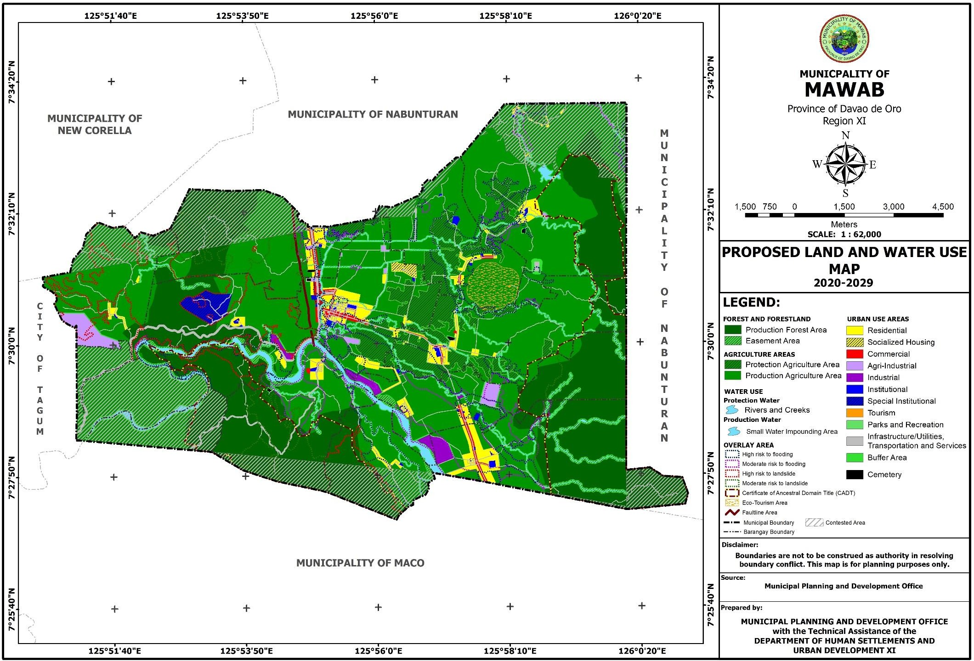

**Figure 45. Proposed Land and Water Use Map of Barangay Andili**

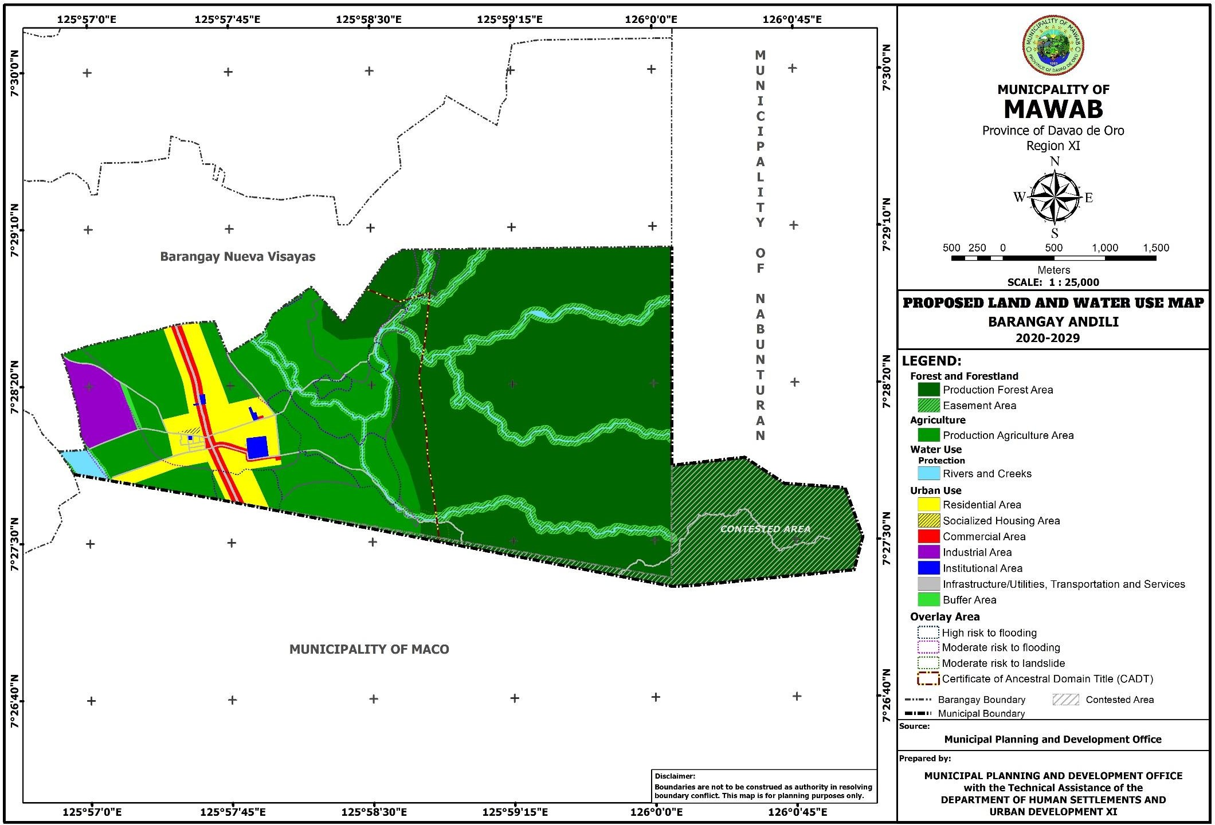

**Figure 46. Proposed Land and Water Use Map of Barangay Bawani**

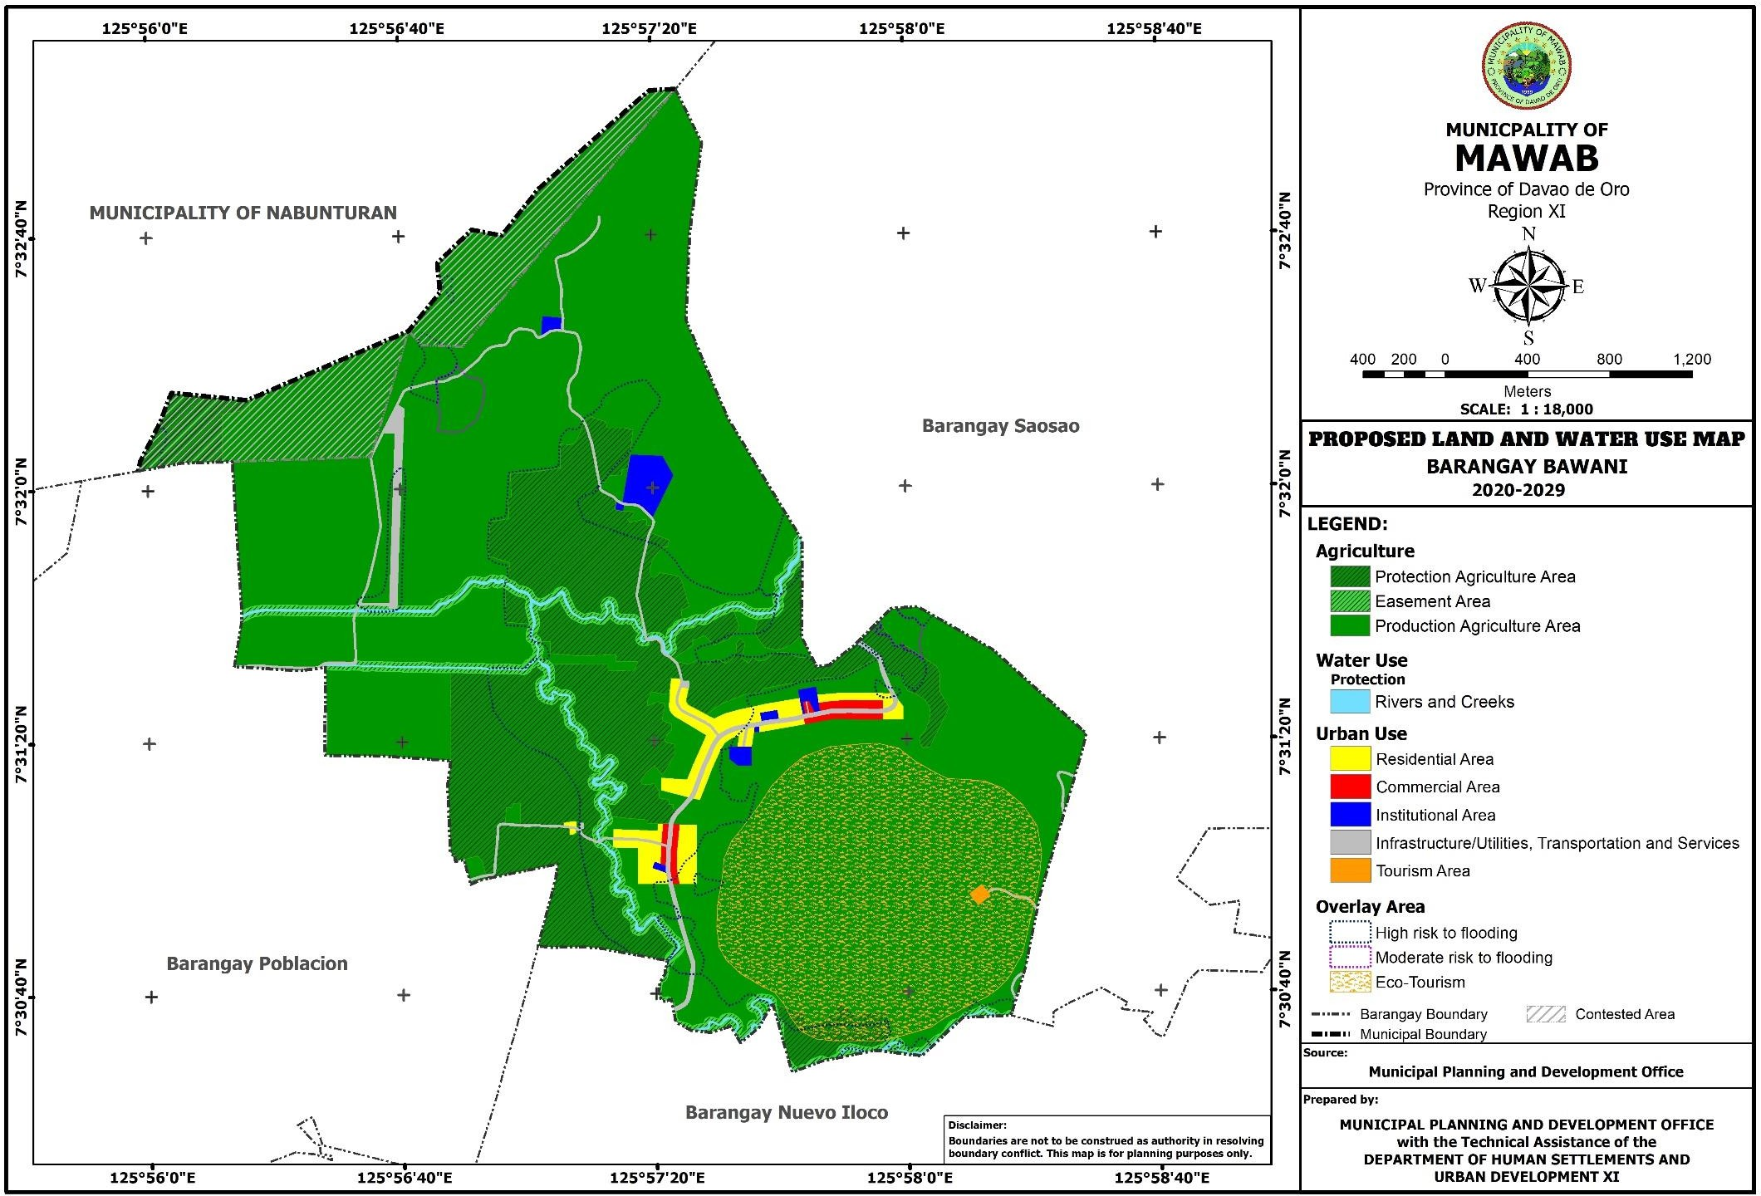

**Figure 47. Proposed Land and Water Use Map of Barangay Concepcion**

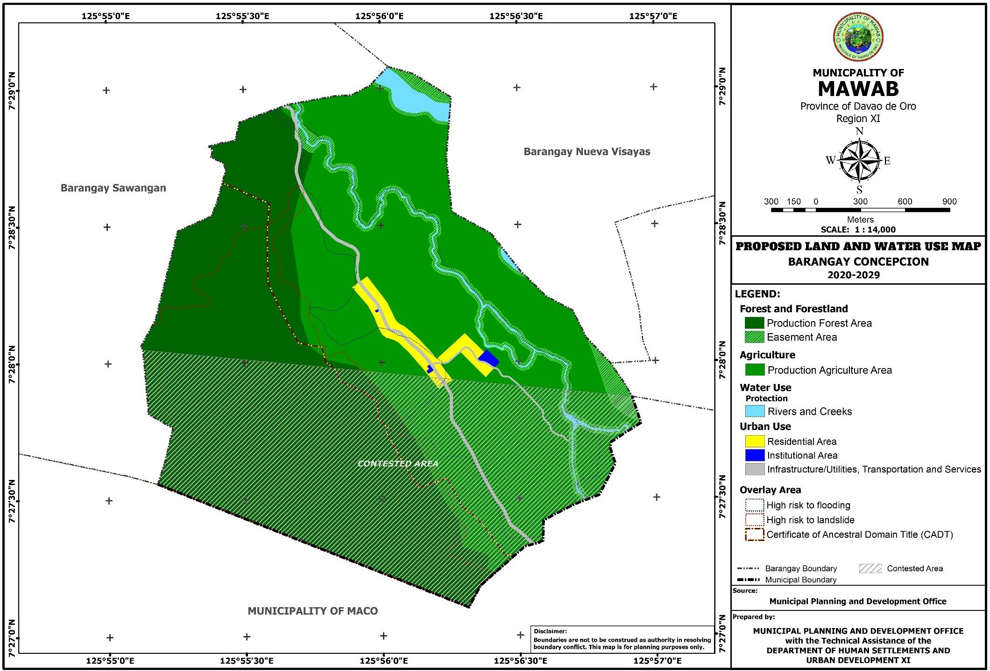

**Figure 48. Proposed Land and Water Use Map of Barangay Malinawon**

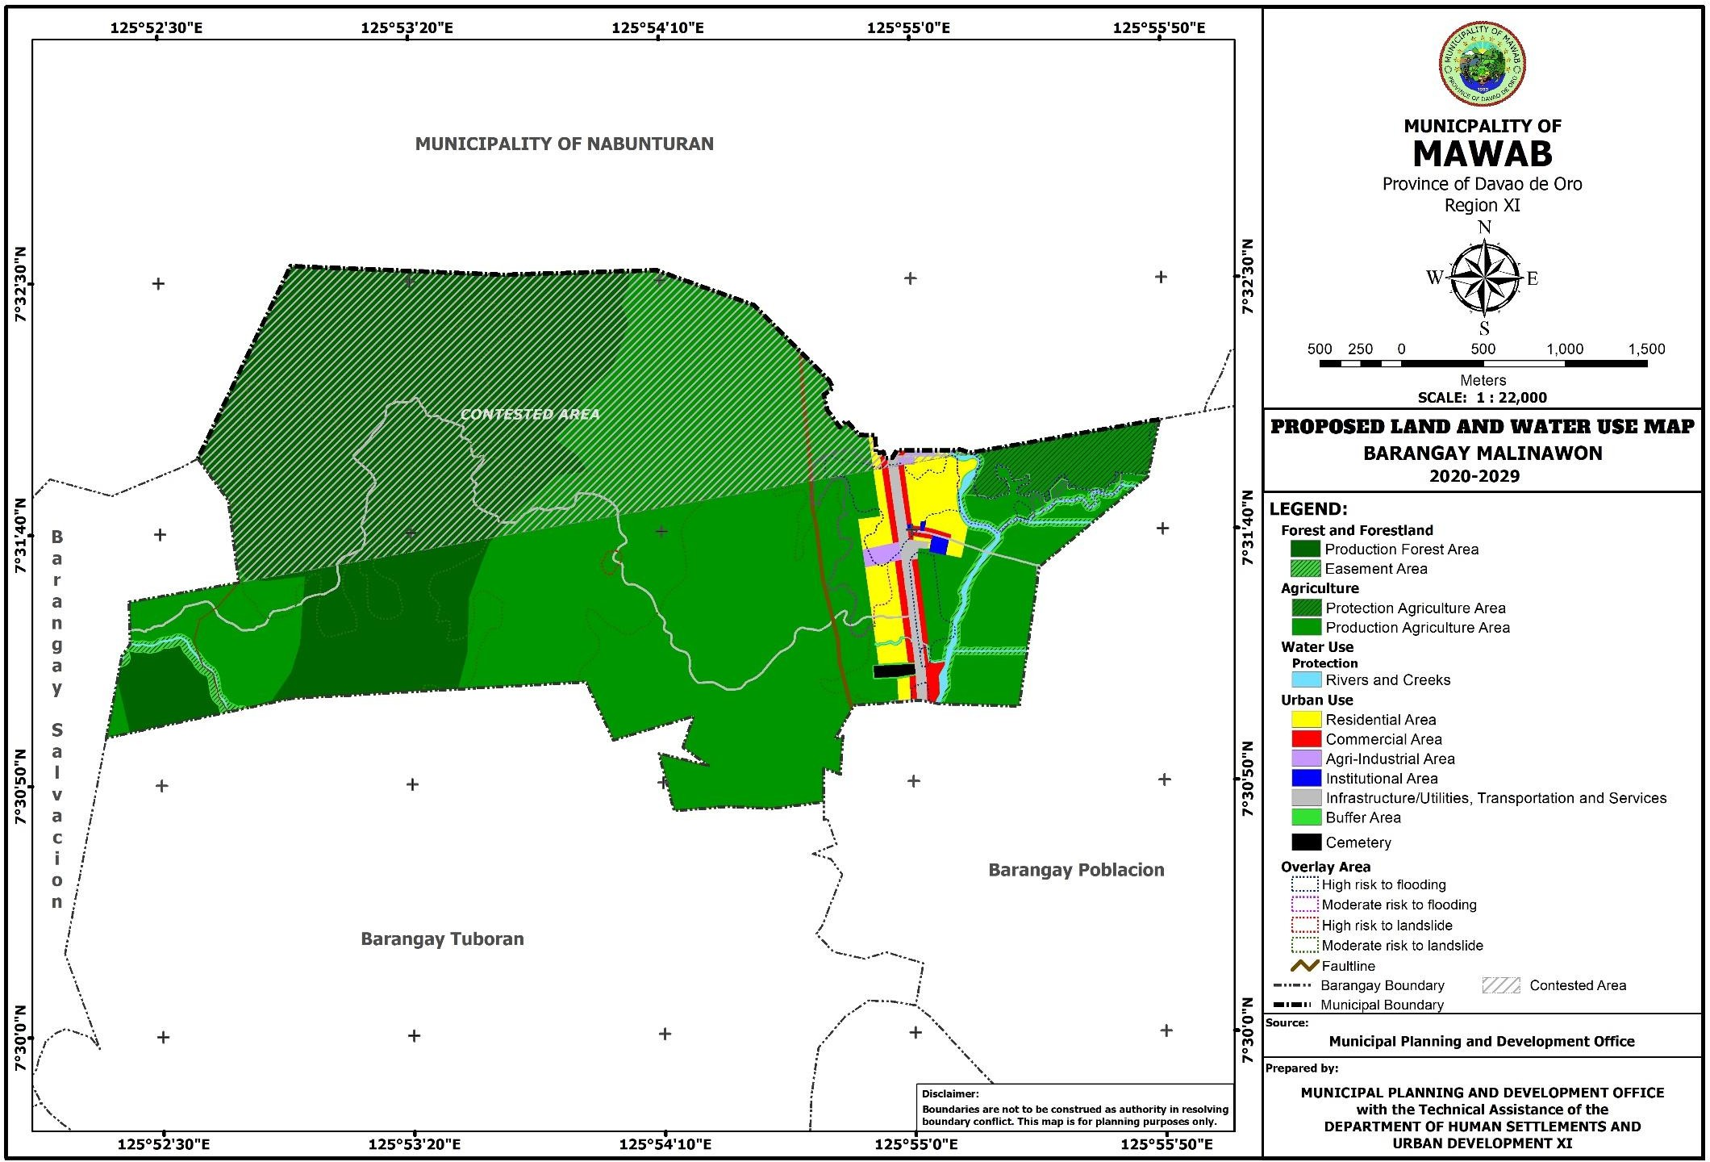

**Figure 49. Proposed Land and Water Use Map of Barangay Nueva Visayas**

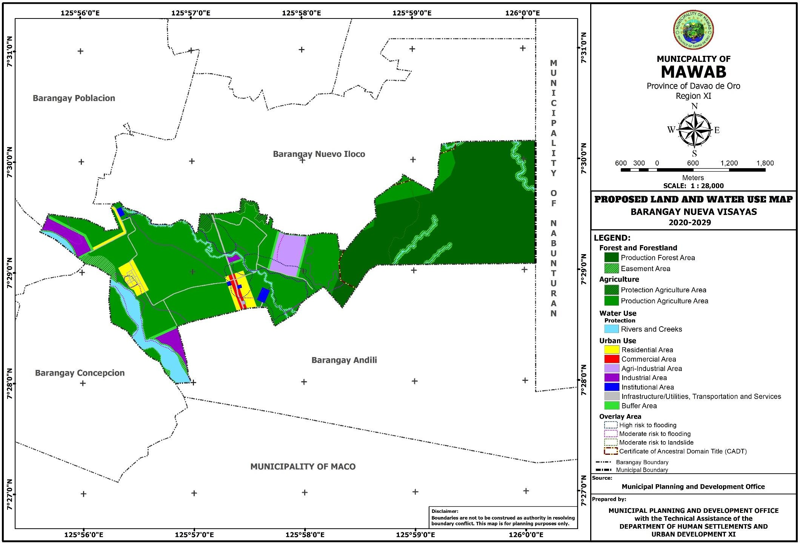

**Figure 50. Proposed Land and Water Use Map of Barangay Nuevo Iloco**

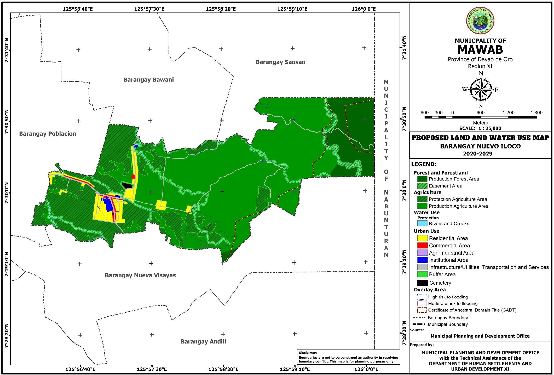

**Figure 51. Proposed Land and Water Use Map of Barangay Poblacion**

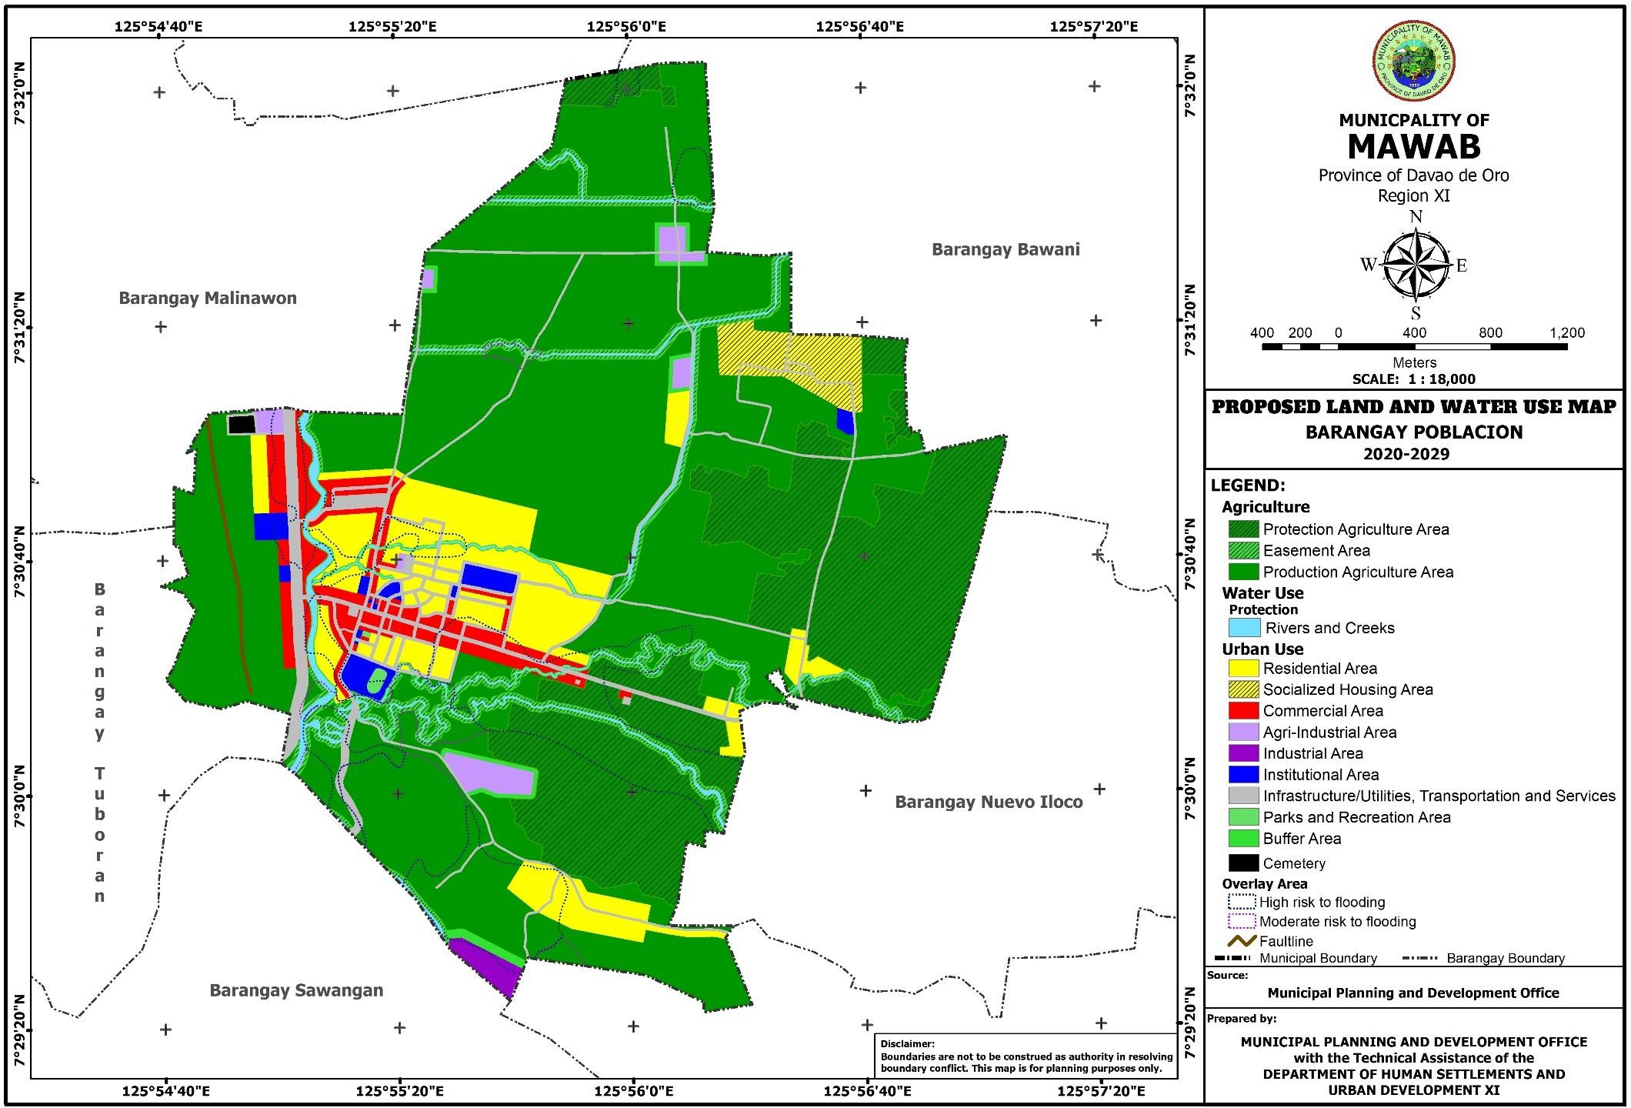

**Figure 52. Proposed Land and Water Use Map of Barangay Salvacion**

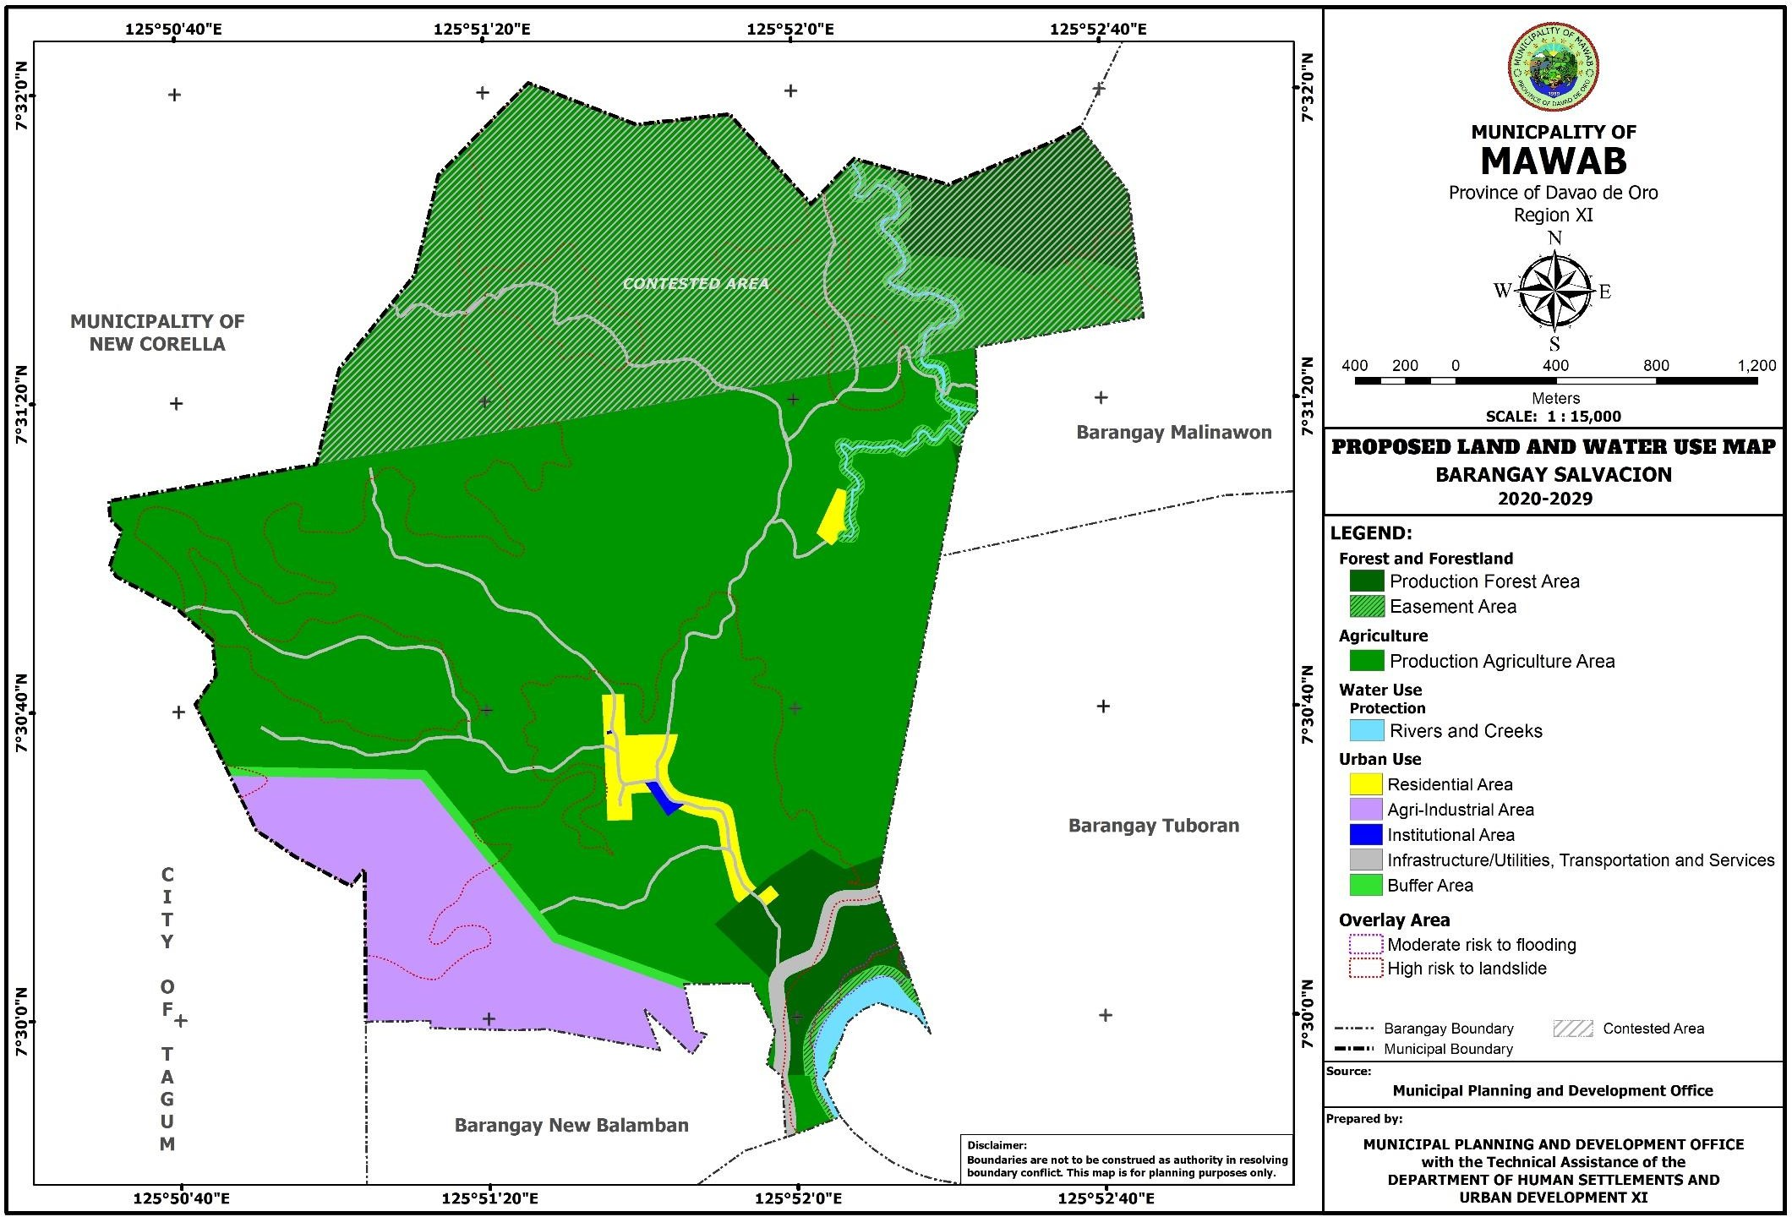

**Figure 53. Proposed Land and Water Use Map of Barangay Saosao**

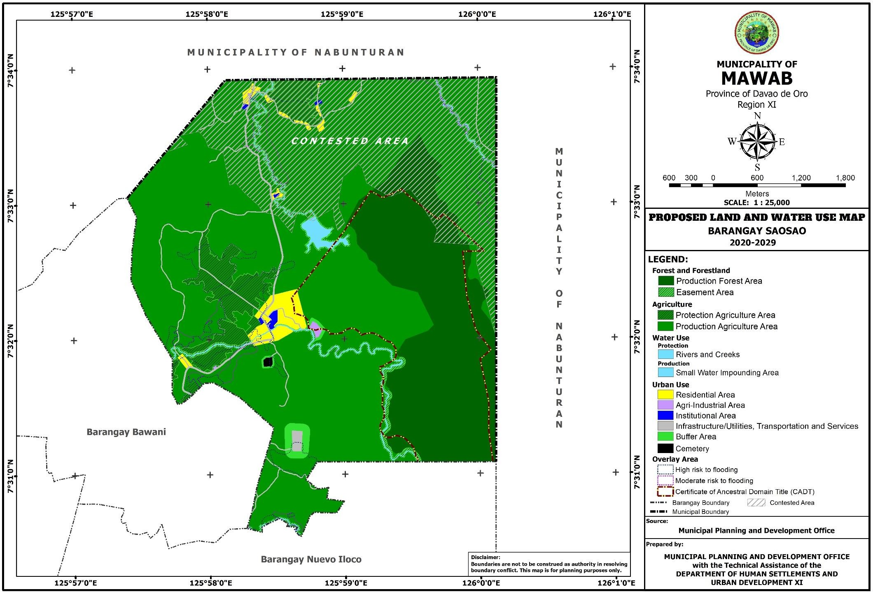

**Figure 54. Proposed Land and Water Use Map of Barangay Sawangan**

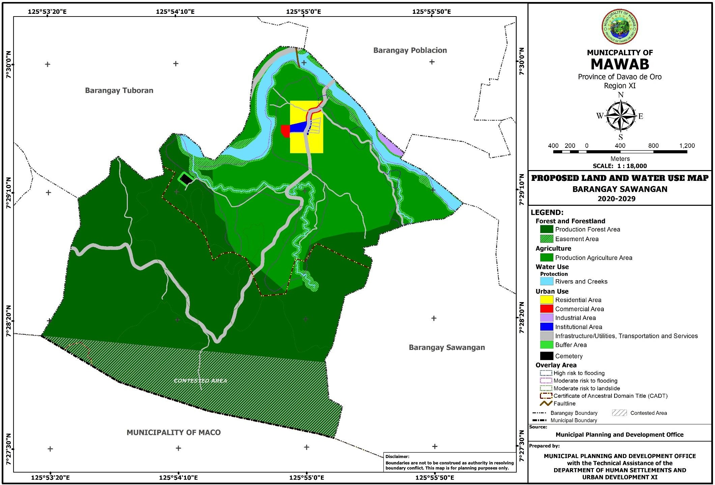

**Figure 55. Proposed Land and Water Use Map of Barangay Tuboran**

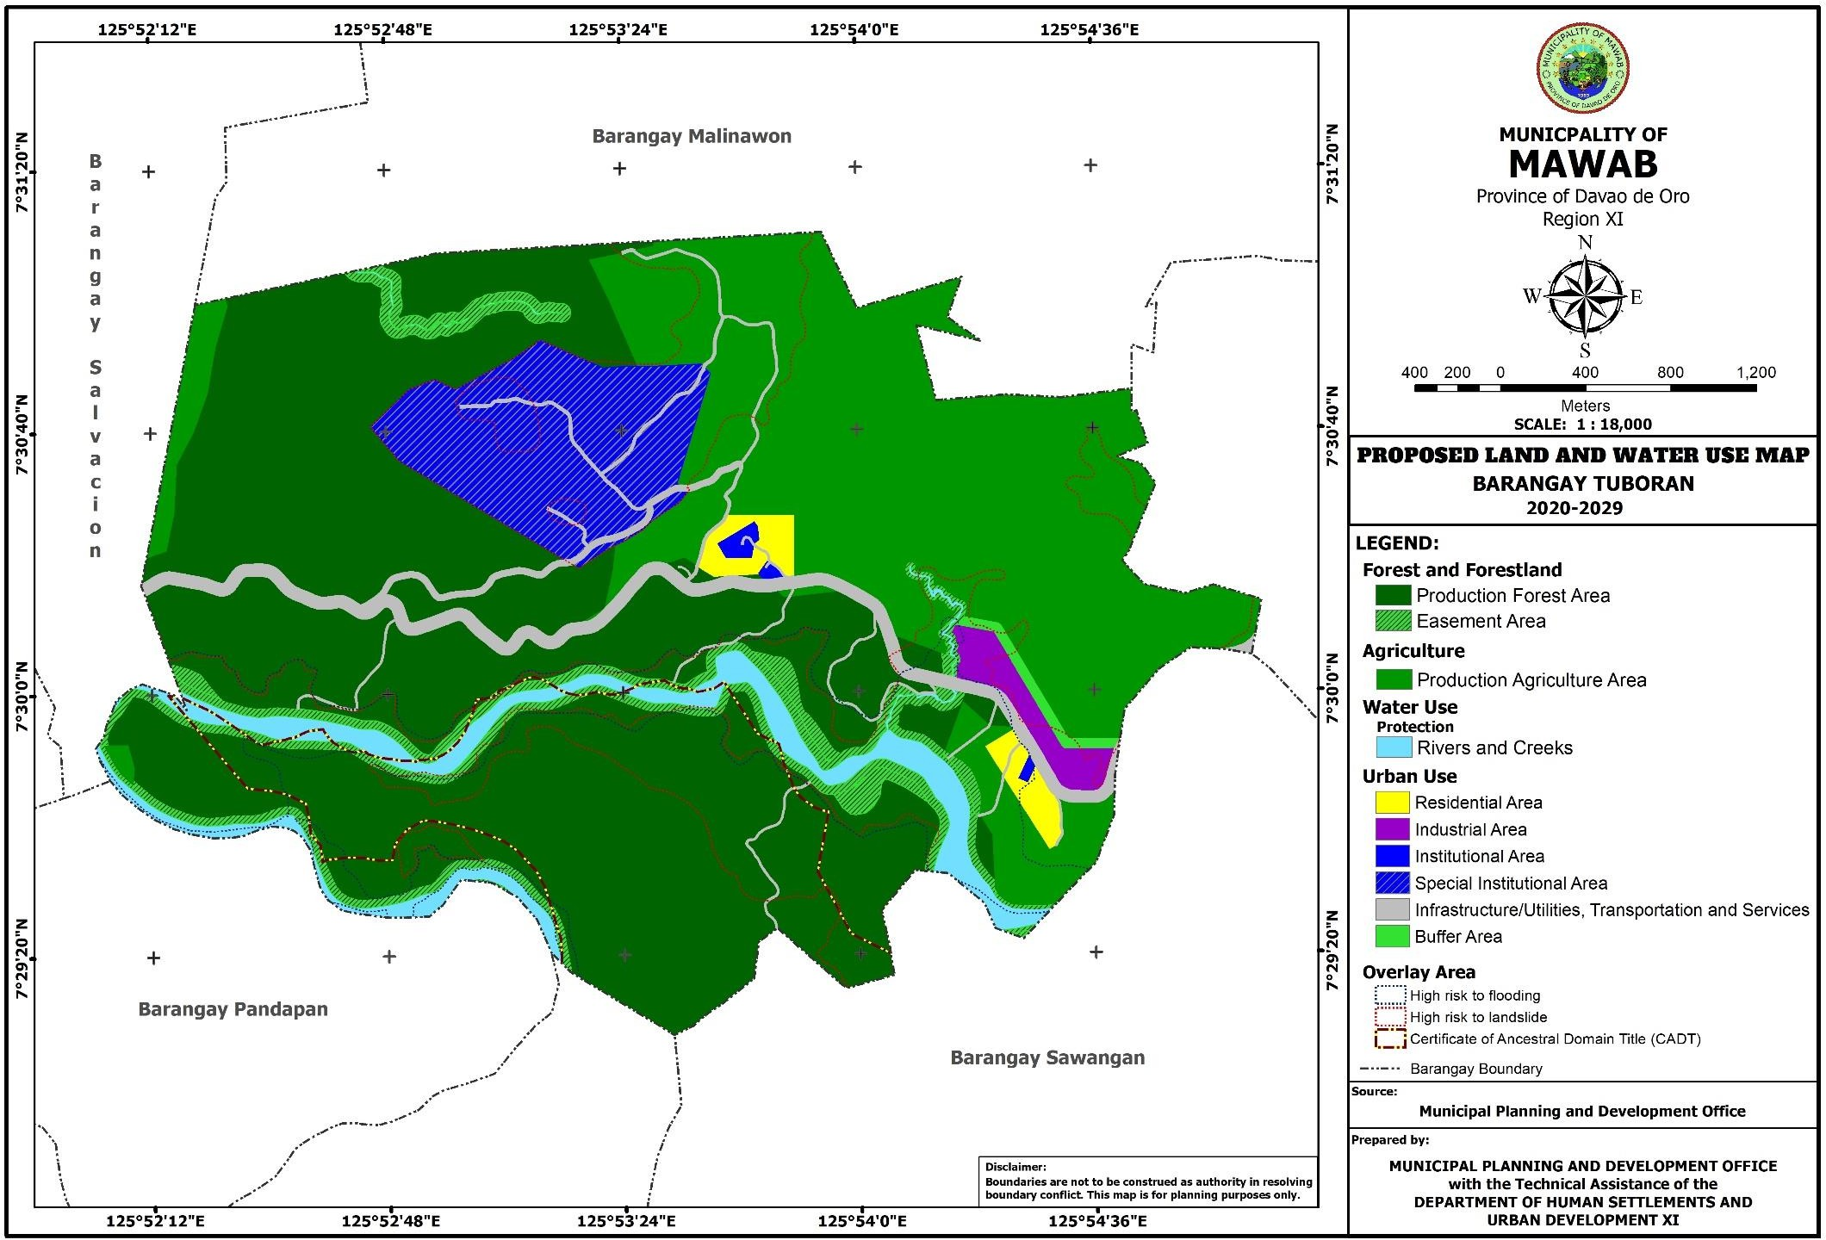

###### LAND USE POLICIES

Land use is the predominant activity or function on a specific land area or location at a given time; the manner of utilization of land, including its allocation, development management; refers to man’s activities on the land where settlements, agriculture, forestry, mining and quarrying, grazing and water uses are the most predominant. This part of the plan provides land use policy options that will serve as guide for the enactment of the municipality’s zoning ordinance and other regulatory measures. Presented below are the set of general land use policies drawn up to guide the municipality’s land use in order to promote development while minimizing adverse effect to environment, to enable land to efficiently and effectively used for its intended use and to complement and enhance the existing landscape character.

1. **Production Forest**
   1. Massive reforestation of severely denuded forestland to conserve and prevent further soil erosion and siltation of river beds;
   2. Introduction and promotion of integrated agro-forestry activities in the forestland;
   3. Strict implementation of DENR rules and policies on conservation, protection and utilization of natural resources in the forestland;
   4. Mobilization of people’s participation in the conservation of forest resources;
   5. Maximize the utilization and management of forest products to alleviate the economic condition of the populace;
   6. Establish barangay nurseries particularly in the barangays with forestland;
   7. Allocate regular financial support for various forestry programs and projects;
   8. Enhance strong collaboration and cooperation between and among local adjacent municipal LGUs, national agencies, NGO’s and PO’s in the wholistic forestlands development;
   9. Increase the awareness level of the constituents through progressive Education, Information Campaign on forestry development;
   10. Introduce tailored fit livelihood projects and programs for the indigenous people and upland farmers to lessen their dependence on forestland products.
2. **Agriculture**
   1. Organic agriculture shall be promoted to protect and maintain ecological balance;
   2. Limit exportable banana plantation in areas with slope not more than 18% and elevation of 1000 meters above sea level;
   3. Introduce climate change resilient crops and cropping pattern;
   4. Prevent incompatible activity by applying stricter controls to forms of development not directly related to agriculture production or its values-adding activities;
   5. Intensify and diversify crop production in CARP covered areas;
   6. Provide agricultural support facilities and service, such as post-harvest facilities, demonstration farms and nurseries;
   7. Provide agriculturist important infrastructure facilities that include commend irrigation facilities and all weather farm to market roads;
   8. Provide social welfare and development programs and projects like health services and potable water supply;
   9. Enhance the working between and among the municipality of DAR and other National line agencies in speedy completion of land transfer and non–land transfer activities;
   10. Facilitate effective implementation of new policies and guidelines on land valuation which is the major bottleneck in land acquisition;
   11. Institutionalize a more efficient and responsive strategy in accomplishing set targets on land distribution;
   12. Provide support to NGO’s to become active partners with DAR and other line agencies in providing support service delivery to the beneficiaries, in educating farmer beneficiaries to redirect their priorities and outlook as a new land owners and in organizing a viable association or cooperative;
   13. Promote people organization’s involvement in the planning, implementation, monitoring and evaluation of the extent of compliance of the CARP directives;
   14. Provide social infrastructure support facilities to ARC’s areas;
   15. Coordinate with the Department of Trade and Industry (DTI) for the establishment of Municipal Agri-Products Price Watch Monitoring Center;
   16. Provide and promote investment environment and incentives for the establishment of value agri-products processing industry;
   17. Put in place mechanisms to restrict the conversion of potential rice field and fish pond areas to other non-agricultural uses to ensure the expansion of areas for rice and fish production;
   18. Disallow/Discourage the crop shifting of rice fields to other crops such as banana (Cavendish) to sustain surplus in rice production;
   19. Empower and enhance the knowledge, skills and abilities of the Agricultural Technologist to ensure effectiveness in the conduct of techno-transfer programs and activities on modern farming technologies and innovations;
   20. Provide/Upgrade incentives/subsidies to both backyard and commercial livestock and poultry raisers/producers;
   21. Support/Strengthen the organized farmers’ associations and cooperatives to ensure their active participation in agricultural development endeavors of the municipality;
   22. Institutionalize the adoption of ecologically friendly agricultural technology;
   23. Strict implementation of the Agricultural and Fishery Modernization Act (AFMA);
   24. Enhance, strengthen and systematize research and development pursuits on agriculture and fishery production;
   25. Provision of adequate agri-infra support facilities i.e. irrigation system, farm to market roads, pre and post-harvest facilities and the likes;
   26. Integrate livestock raising activities in coconut and fruit bearing trees farm;
   27. Introduce and promote integrated inter-cropping approach particularly in coconut and fruit tree farms;
   28. Promote the production or use of relatively cheaper organic fertilizers to improve land capability;
   29. Establish demonstration farms and nurseries;
   30. Provide alternative livelihood programs and activities to augment farmers income; and
   31. Establish one-stop shop agri-products marketing and information enter.
3. **Protection Water/Rivers and Creeks**
   1. Establish river bank protection measures (i.e. construction of dike, straightening of rivers and creeks and improvement of drainage system);
   2. Rehabilitate critical water bodies/protect waterways and legal easements through tree planting and vegetative protection;
   3. Strict implementation of RA 9275 or the Clean Water Act to improve the quality of water bodies and RA 9002 or the Solid Waste Management Act;
   4. Enforcement of water code in order to recover legal easements: 5 meters for urban uses, 20 meters for agricultural use and 40 meters for forest use;
   5. Implementation of No Build Up Zone on the riparian zone;
   6. Develop portion/s along waterways as linear or pocket parks and recreational spaces for community use;
   7. Activities that are highly pollutive will be prohibited over the identified water resource area;
   8. Allow people’s full and active participation in the sustainable development, conservation, utilization and management of the water resources through the strengthening of water associations and fisherfolks association.
   9. Encourage agro-forestry projects in flood prone areas to minimize settlement area and population exposure;
   10. Formulate a flood risk management plan;
   11. Monitor the quality of water at regular frequency for decision making whether to institute management interventions to improve quality;
   12. Establish redundant/back-up and looping systems as alternative systems for access and distribution;
   13. Prioritize the development and protection of potential spring sources and other water resources;
   14. Protect and rehabilitate watershed areas;
   15. Require and monitor anti-pollution devices in pollutant industries;
   16. Conduct information and education campaign on environmental protection.
4. **Residential**
   1. Encourage Low Density development in highly susceptible areas and moderate to high density development in areas less susceptible to floods and landslide assuming building design standards/regulation are followed. Density and bulk control measures include Floor Area Ratio, minimum lot sizes and building height restrictions;
   2. Situate propose settlement areas outside of flood and landslide prone areas;
   3. Institute risk mitigation measures such as density control and building design regulations, establishment of evacuation routes, and/or establishment of dikes and other flood and landslide control infrastructure;
   4. Redirect settlement growth by locating propulsive centers and central facilities outside or in low susceptible flood and landslide areas where risks can be managed within acceptable levels;
   5. Develop innovative, affordable and sustainable housing;
   6. Require green space/built in the following: Residential - equivalent to 5% of the lot area;
   7. Land banking for the expansion of municipal government centre and for the development of in-barangay resettlement sites to accommodate families within high risk areas;
   8. Encourage and strengthen government and private partnership in the provision of resilient and affordable housing;
   9. Protect residential areas from conflicting uses such as toxic and industries like ore processing, piggery and other heavy industry;
   10. Strict implementation of the National Building Code and integration of green architecture for new buildings shall be observed;
   11. Construction of an Evacuation Center shall be given priority;
   12. Improve the integration of ecologically sensitive design principles into housing development;
   13. Discourage residential development in areas with high susceptibility to flooding and landslide;
   14. Existing residential developments shall be required/advised to adapt and implement mitigating measures such as flood proofing technologies and other appropriate protective actions.
5. **Commercial**
   1. Require green space/belt equivalent to 5% of the Commercial, Institutional and Industrial lots – or reduction of greenhouse gas emission (energy consumption, and etc.);
6. **Industrial**
   1. Buffer of 50 meters shall be established surrounding the I-2 Zone; Provide appropriate infrastructure and utilities in industrial zone to meet the desire of investors;
   2. Promote sustainable industrial practices, such as industrial ecology.
7. **Institutional**
   1. For critical point facilities (i.e. hospital, municipal hall, fire/police stations, evacuation sites, schools, barangay hall, day care center and other government buildings), higher protection standards will be required, where free boards are above the 2050 base flood elevation;
   2. Design should also account for the expected flood water flow velocity and direction;
   3. Promotion of climate adoptive design and materials to reduce use of electricity;
   4. Foundation of buildings should be constructed to account for erosion, scour or setting;
   5. Encourage onsite water storage facilities;
   6. Require retrofitting of existing buildings high-risk or highly vulnerable buildings using recommended building design standards as prescribed in the Building Code and the Structural Code of the Philippines;
   7. When buildings and/or areas are totally damaged by floods, consider other options like relocation;
   8. Construction of dike, retaining wall, drainage system, and straightening of rivers to protect hazard exposed elements.
8. **Parks and Playgrounds**
   1. Open spaces, buffer strip and riparian are NO Build Zone;
   2. Buffer strips shall be developed as Greenbelt;
   3. Consider the development of community gardens particularly in areas with minimal local open space;
   4. Open spaces, buffer strip and riparian are NO Build Zone and shall be developed as Greenbelt;
   5. Develop the existing oval ground into a recreational park with a mix of recreational, leisure and tourism related opportunities;
   6. Design open space and recreation facilities to cater for people with special needs, including people of different cultures, ages or with disabilities;
   7. Ensure that open space development enhances and incorporates the surrounding environment without modifying or compromising conservation, recreation and landscape values.

###### PRIORITY PROGRAMS AND PROJECTS

* + 1. **Ecosystem Analysis: Forest and Water Bodies**

1. Soil Conservation and Water Management Program;
2. Social Responsibility Awareness Development Program;
3. Upland Livelihood Development Program;
4. Bantay Gubat Program;
5. Protection and Rehabilitation of Watershed Areas Program;
6. Environmental Law Enforcement Program;
7. Establishment of Buffer Zones.
   * 1. **Sectoral Studies**
        1. **Economic:**
8. **Agriculture and Agrarian:**
   1. **Agricultural Capability Building Development Program;**
      1. IPM on rice, corn and vegetable
      2. Livestock and poultry production
      3. Sustainable agri-farming approach
      4. Root crops processing and utilization
   2. Diversified Agricultural Crop Production and development Program;
   3. Livestock and Poultry Production and Development Program;
   4. In-land Fisheries Production and Development Program;
   5. Demo Farm/Nurseries Development Program (SALT, HVCC and Multi-cropping method);
   6. Livestock and Poultry Dispersal Program;
   7. Rice, Corn and Vegetable Seeds Distribution Program;
   8. Artificial Breeding Center Development Program;
   9. Small Water Impounding Project;
   10. Fingerlings Production and Dispersal Program;
   11. Watershed Conservation, Protection, Utilization and Development Program;
   12. Pre and Post-Harvest Facilities Development Program.
9. **Forestry:**
   1. Community Based Forest Management Programs (CBFMP)
   2. Integrated Social Forestry Program
   3. Community Forestry Program
   4. Agro-forestry Program
   5. CBFM Nurseries development Program
   6. Sustainable Forest Management Program
10. **Trade and Commerce:**
    1. Business Investment Promotion Program
    2. Business Networking and Linkage Program
    3. Commercial Land Acquisition and Development Project
    4. Development of Public Market
    5. Construction of Public Commercial Buildings and Facilities Project
    6. Entrepreneurship Development Program
    7. Business Information, Education and Campaign Program
    8. Establishment of One-stop Business Information Center
    9. Business Conference Roadshow Program
    10. Development of Public Transport Terminal
11. **Industry:**
    1. Industrial Area Expansion Development Project
    2. Municipal Industry Development Program
    3. Industry Information Build-up Center Program
    4. Industry Technology Transfer Program
    5. Industrial Zone Development Program
    6. Agro-industrial Development Program
    7. Entrepreneurship Skills Development Program
    8. Industry Infra-Support Development Program
    9. Industrial Technology and Value Added Development Program
    10. Industrial Skills Development Program
    11. Education and Information Campaign for Industrial Development Program
12. **Tourism:**
    1. View Deck Development Project
    2. Tourist Destinations Development Projects
    3. Tourism Promotion Program
    4. Formulation of Municipal Tourism Master Plan Project
    5. Municipal Tourism Investment Incentive Code Project
    6. Tourism Infrastructure Support Facilities and Utilities Development Project
    7. Tourism Management Enhancement Program
    8. Tourism Development Networking Program
    9. Sto. Niño Hot Spring Development Project
    10. Cawa-cawa Waterfalls Development Project
    11. Tuboran Caves Development Project
    12. Kaputian Waterfalls Development Project
    13. One-Stop-Municipal Tourism Information Center Program
    14. Annual Cultural Festivity Program
    15. Establishment of Municipal Tourism Office
    16. Annual Tourism Industry Business Conference Forum
    17. Tourism Advocacy Program
        * 1. **Social:**
13. **Health:**
    1. Upgrading of Barangay Health Stations Program
    2. Disease Prevention and Control Program
    3. Maternal and Child Health Care Program
    4. Family Health Care and Welfare Program
    5. Dental Health Care Program
    6. Primary Health Care Program
    7. Expanded Immunization Program
    8. Family Planning Program
    9. Nutrition Awareness Program
    10. Diarrhea Disease Control Program
    11. National Tuberculosis Program (NTP/DOST)
    12. Under Five Clinic (UFC) Program
    13. Leprosy Control Program
    14. Malaria Disease Control Program
    15. Schistosomiasis Control Program
    16. Cancer Detection Program
    17. Sexually Transmitted Disease (STD’s) Prevention and Control Program
    18. Acquired Immune Deficiency Symptom (AIDS) Prevention and Control Program
    19. Dengue Control Program
    20. Filaria Health Education and Treatment Program
    21. Rabies Prevention and Treatment Program
    22. Blood Sufficiency and Safety Program
    23. Soil Transmitted Helmintch Control Program
    24. Cardio-Vascular Disease Control Program
    25. Environmental Sanitation Program
    26. Health Database System Development and Installation Program
    27. Health Monitoring System Development and Installation Program
    28. Laboratory and Biological Service Water Analysis
    29. Pre-marriage and Counseling Program
    30. Medical Personnel Augmentation Program
    31. Medical Personnel Capability Building and Skills Enhancement Program
    32. Financial Assistance for all BHW’s and BNS
    33. Strengthening of Barangay Nutrition Council
14. **Education:**
    1. Repair/Rehabilitation/Maintenance of School Building Program
    2. Construction of School Buildings and other School Facilities Project
    3. Teaching Force Augmentation program
    4. Procurement of Educational Materials/Books/References Program
    5. Capability and Competence Enhancement Program
    6. Expansion of Non-formal Education program
    7. Municipal Scholarship Program
    8. Alternative Learning System (ALS) Program
    9. Job Employment Program
    10. Special Education Program
    11. Special Program for Employment of Students (SPES)
    12. Establishment of School Parks and Playgrounds Program
    13. Information, Education Campaign (IEC) Program
    14. Computer Literacy Program
15. **Housing:**
    1. Formulation of Housing/Resettlement/Subdivision Development Plan
    2. Development of Resettlement Area Project
    3. Physical Inventory of Illegal Settlers Program
    4. Construction of Low-Cost Housing Project
    5. Housing Investment Incentive Program
    6. Construction of Infrastructure Support Facilities Project
    7. Resettlement/Subdivision Tree Parks and Production Forest Protection, Conservation and Development Program
    8. Housing Cooperative Development Program
    9. Development/Installation of Housing Databank System
    10. Housing One-Stop Information Center Program
    11. Social Welfare Relocation Program
    12. Housing Emergency Shelter Assistance Program
16. **Social Welfare:**
    1. Family Welfare Community Program
    2. Socio-Economic Livelihood Skills Training Program
    3. Early Childhood Care and Development Program
    4. Educational Support Program for Child Development Centers, Social Welfare Institutions and Organizations
    5. Responsible Parenting Program
    6. SEA-K and Tindahan Natin Outlet Program
    7. Urban Poor Relocation and Development Program
    8. Pottery Development Project
    9. Child Welfare Program
    10. Youth Welfare Program
    11. Crisis Intervention Program
    12. Elderly Welfare Program
    13. Persons with Disability Development Welfare Program
    14. Project Monitoring and Evaluation Program
    15. Research and Statistics Development Program
    16. Gender and Development Program
    17. Construction of Crisis Center Project
    18. Construction of Barangay Council of Women Building Project
    19. Construction of Senior Citizens Building Project
    20. Sustainability of CIDSS Projects
17. **Protective Services:**
    1. Police Force and Firemen Augmentation Program
    2. Development of Municipal Fire Station Project
    3. Development of Municipal Police Station Project
    4. Construction of Barangay Police Outposts Project
    5. Crime Prevention Program
    6. Police Force and Firemen Skills and Capabilities Enhancement Program
    7. Peace and Order and Public Safety Advocacy Program
    8. Acquisition of Protective Services Equipment Program
    9. Rehabilitation/Improvement of Municipal Jail Project
    10. Civilian Volunteer Organization (CVO) Strengthening Program
    11. Barangay Peace and Order Consultation Program
    12. People’s Law Enforcement Board (PLEB) Strengthening Program
    13. Fire Prevention and Preparedness Program
    14. Installation of Fire Hydrants Project
18. **Sports and Recreation:**
    1. Municipal Park and Playground Site Acquisition and Development Project
    2. Formulation of Comprehensive Municipal Sports Development Program
    3. Volleyball Courts Construction Project
    4. Municipal Gymnasium Improvement/Rehabilitation Project
    5. Barangay and Inter-Barangay Sports Competition Program
    6. Municipal Offices and Employees Annual Sports Fest Program
    7. Acquisition of Sports Equipment Program
    8. Annual Sports Clinic and Sports Awareness Program
    9. Sports and Recreation Development Program
    10. Tourist Spots Development Program
    11. Completion of Municipal View Deck Project
    12. Sports and Recreation Advocacy Program
        * 1. **Infrastructure:**
19. **Transportation and Drainage:**
    1. Concreting of Barangay Linkages Roads
    2. Expansion of Road Concreting of Municipal Roads
    3. Development of Public Transport Terminal
    4. Construction of Barangay Mini-Terminals
    5. Rehabilitation of Barangay Roads
    6. Acquisition of Heavy Equipment
    7. Traffic Management Program
    8. Construction of Footbridges
    9. Construction/Rehabilitation of Bridges
    10. Construction/Rehabilitation of Farm-to-Market Roads
    11. Flood Control Mitigation Program
    12. Barangay Flood Control and Drainage and Sewerage System Project
    13. Annual Desiltation Program
    14. Repair and Maintenance of Drainage and Sewerage System Project
    15. Formulation of Municipal Flood Control and Drainage and Sewerage System Development Plan
20. **Power:**
    1. Power Utilities Capacity Improvement Program
    2. Energy Conservation and Utilization Program
    3. Power Lines Distribution, Upgrading and Rehabilitation Program
    4. Power Pilferage Eradication Program
    5. Households Energization Program
    6. Infrastructure Support Facilities Development Program
21. **Water:**
    1. Water Supply Development and Protection Project
    2. Water System Expansion Project
    3. Waterworks System Operation and Management Capability Building Program
    4. Waterworks System Investment Promotion Program
    5. Rehabilitation and Water-Infra Support Facilities Project
    6. Rehabilitation and Protection of Watershed Areas Program
    7. Waterworks System Feasibility Study
    8. Waterworks System Development Project
    9. Formulation of Municipal Water System Master Plan Project
    10. Water Conservation, Protection and Utilization Education and Information Campaign Program
    11. Deep Wells Construction/Rehabilitation Project
    12. Shallow Wells Construction/Rehabilitation Project
    13. Communal Faucets Installation Project
22. **Communication and Information Technology:**
    1. Telephone System Installation Program
    2. Telecommunications Development and Expansion Program
    3. Postal Services Development Program
    4. Communication Development Program
    5. Installation of Municipal Information Office and Officer
    6. Establishment of Website
    7. Establishment of Local Area Network
    8. Formulation of Business Incentives Code
       * 1. **Special Studies:**
23. **Ancestral Domain:**
    1. Revision of the ADSDPP
    2. Alternative Livelihood Program for IPs below Poverty Threshold
24. **Climate and Disaster Risk Assessment (CDRA):**
    1. Relocation of Settlements in High Risk Areas Program
    2. Mandatory Relocation on Dwelling Units within 5, 20, 40 meter River Easements Program
    3. Identification and Development of Resettlement Sites
    4. Development of Regulations with Emphasis on Hazard Resistant Designs Program
    5. Livelihood for Families below Poverty Threshold Program
    6. Establishment of Early Warning System along Rivers and Creeks
    7. Relocation of Informal Settlers Program;
    8. Construction of Low Cost Housing Projects
    9. Retrofitting of Existing Structures along Rivers and Creeks
    10. Provision of Adequate Agri-infra Support Facilities
    11. Establishment of Demonstration Farms and Nurseries
    12. Integration and Promotion of Integrated Inter-cropping Approach Program
    13. Advocacy on Crop Insurance System
    14. No Conversion of Potential Rice Fields to other Non-agricultural Uses Program
    15. Employing of Infrastructure to Hazard Resilient and Climate Proofed Design
    16. Desiltation of rivers, creeks and drainage system
    17. Installation/Upgrading of Early Warning System
    18. Construction of Disaster Resilient Evacuation Center
    19. Disaster Preparedness Capacity Development Program
    20. Information, Education, Campaign (IEC) Program
    21. Science-Based Early Warning System Program
    22. Quick Response and Relief Operation Program
    23. Volunteers/Responders Accident Insurance Program
    24. Updating of Municipal Disaster Risk Reduction Management Plan

#### PLAN IMPLEMENTATION SCHEME

The Comprehensive Land Use Plan (CLUP), as plan for a long-term management of the local territory, provides the skeletal-circulatory framework of the municipality’s physical development. Hence, to implement the Comprehensive Land Use Plan and Zoning Ordinance (ZO) effectively, it requires resources, institutional structures and procedures, among others, to be realized. Here are different mechanisms to implement the CLUP.

1. **Strengthen and Build Local Institutional Mechanisms**
   1. Review the organizational structure, staff and composition and responsible offices in the local government unit vis-a-vis the requirements to effectively implement the CLUP/ZO. To improve the development performance and attain the municipality’s vision, goals and objectives, some offices may need to augment and strengthen their staff or may establish new office/s to implement CLUP.

**Table 52. Review of Organization Structure and Support**

|  |  |  |  |
| --- | --- | --- | --- |
| **OFFICE** | **FUNCTIONS** | **ISSUES AND CONCERN** | **RECOMMENDED ACTION** |
| MPDO | Lead office in implementing the CLUP/ZO and oversee the whole  implementation of the CLUP/ZO; | Inadequate Staff/No plantilla position for Zoning Officer;  Lack of Training; | Creation of additional plantilla position; and  Capacity Building; |
| MEO | Determine the suitability of the area for the implementation of infrastructure projects; | Inadequate Staff; Lack of training;  Lack of equipment; | Creation of additional plantilla position;  Capacity Building;  Acquisition of Equipment (heavy equipment, office  equipment); |
| MDRRMO | Implement DRR measures as mandated in RA10121; | Inadequate Staff;  Lack of Training; | Creation of additional plantilla position;  Capacity Building; |
| MENRO | Identify and implement programs and projects relative to the environment; | Absence of Office; Inadequate Staff; Lack of training; Lack of equipment | Creation of additional plantilla position;  Capacity Building; Hire additional staff; Acquisition of Equipment (to support implementation of solid waste management; |
| MASSO | Assessment and valuation of lands; | Lack of training;  Lack of equipment; | Capability Building;  Acquisition of GIS; |

|  |  |  |  |
| --- | --- | --- | --- |
|  |  | Absence of Geographic Information System (GIS) Parcelliary map; |  |
| LZRC | Review of ZO application for reclassification; | Lack of training re: land zoning/rezoning/ reclassification/processing of Locational Clearance | Capacity Building; |
| LZBA | Act on LC application with variances/ exception and non-conforming  uses; |

Constitution/Reconstitution/Strengthening of Special Bodies such as:

1. **Municipal Project Review Committee (MPRC)** - functions to review and monitor development projects;
2. **Municipal Urban Development Housing Board (MUDHB)** - tasks to manage housing programs;
3. **Municipal Development Council (MDC)** - tasks to formulate development plans;
4. **Municipal Forest Land Use Plan Steering Committee (MFLUPSC)** - tasks to oversee the Forest Land Use Plan implementation and monitoring; and
5. **Municipal Ecological Solid Waste Management Board (MESWMB)** - tasks to oversee the Ecological Solid Waste Management Plan implementation and monitoring;
   1. Creation or strengthening of the operating units as provided by the Zoning Ordinance. This is to ensure transparency, accountability, efficiency, and compliance with recent national policies. Membership, functions and duties of the units shall be based on the approved Zoning Ordinance.
      1. Establish operating units as provided for in the approved Zoning Ordinance such as:
         * Local Zoning Officer;
         * Local Zoning and Review Committee;
         * Local Zoning Board of Appeals;
      2. Establish a permitting system to govern land and water use development regulation consistent and in compliance with the approved CLUP and ZO. This shall be in terms of processing and approval of local applications for:

|  |  |
| --- | --- |
| **LICENSE/PERMIT** | **OFFICE CONCERNED** |
| Location Clearance, Zoning Certification and Zoning Clearance for Development  Projects | Local Zoning Administrator |
| Building Permits | Building Official – Municipal  Engineering Office |
| Development Permits for development projects covered to Municipal Ordinance  No. , Series of | Local Chief Executive |
| Business Permits | Business Permit and Licensing Office |
| Local Revenue Assessment | Municipal Assessor’s Office |
| Environmental Clearance | Municipal Environment and Natural  Resources Office |

|  |  |
| --- | --- |
| Procurement Clearance/Permit | Bids and Awards Committee |
| Sanitary Permit | Municipal Health Office |

* + 1. Assess applications for land use development permits and management schemes based on the following considerations:
       - Conformity with the approved integrated Zoning Ordinance and CLUP in terms of site zoning classification, use regulations, area regulations, documentary requirements and others;
    2. Determine whether proposed development project is a permitted use, allowable use or a possible variance within the zone applied for; and
    3. Use Decision Guidelines for Land Development Projects/Development Assessment Guidelines in assessing projects.
  1. Other Development Regulations in addition to the approved ZO to fully implement the approved CLUP are as follows:
     1. Review existing local ordinances related to land use development/control for possible inconsistencies with the approved CLUP/ZO and possible gaps in existing local development ordinances which include:
        + Provide revenue and non-revenue incentives;
        + Detailed area development regulations/standards particularly for high risk/danger zones, CADT areas, etc.
        + Subdivision development regulations.
     2. Prepare amendments in existing statutory ordinances found to be inconsistent with the CLUP/ZO;
     3. Prepare draft ordinance that will respond to the identified gaps in legislative measures needed to implement the approved CLUP/ZO.

1. **Information, Education and Communication Plan/Advocacy**

|  |  |
| --- | --- |
| **ACTIVITIES** | **OFFICE CONCERNED** |
| Creation of Educator’s Pool | MO |
| Posting of the CLUP/Zoning Ordinance in the LGU’s Website | MPDO |
| Posting of approved Land Use and Zoning Maps in conspicuous places in the municipality | MPDO |
| Broadcasting CLUP/ZO at the local broadcast station | MIO |
| Conduct of information dissemination thru Video Presentation of the salient points of the CLUP/ZO to be provided to every BLGU for presenting during General Assembly or any others activities | MPDO/MIO |
| Production of IEC materials (ie. Leaflets/brochures, posters, flyers, maps, etc.) for distribution to different BLGU’s | MIO |
| Conduct of Technical Orientation and briefings to the Barangay level | MPDO/MIO |

a.) Establishment of Inter-LGU Partnership and/or co-management agreements

Alliance building or inter-local partnership is considered important in addressing common issues and problems in the area by implementing programs and projects in partnership with the different stakeholders concerned. Economic development, environmental protection and management and integrated health development are the most common purposes of establishing partnerships. Thus, forging of a Memorandum of Agreement (MOA) or Memorandum of Understanding (MOU) with other LGUs, NGAs, NGOs and the local stakeholders is important by committing themselves to working together to develop and implement a specific program/project under this long-term plan.

1. **CLUP/Zoning Ordinance to be Localized in the Barangay Level**
2. Review and localize the municipal land use and zoning maps at the barangay level. MPDC shall call for a technical orientation and briefing of local barangay officials and facilitate the discussion and provisions of the CLUP/ZO and other relevant ordinances and programs. The concerned barangay officials and members shall then conduct a review of their current barangay development plans (BDPs)/ADSDPP for consistency and refinements, if warranted.
3. Assist in localizing the CLUP and ZO at the barangay level. The MPDO shall provide technical assistance and support to the barangays who will revise and update the BDPs to be consistent with the land use and zoning maps arrangement policies in the approved CLUP and ZO.
4. Adopt and integrate the enhance/revised BDP into the CDP.
5. **Other Tools and Instruments to Implement CLUP**
6. Revenue and Fiscal Incentives;
7. Land value assessment also provides incentives for developers to concentrate their investments on areas with high market value;
8. Permits, licensing and fees systems/Conduct of One Stop Shop;
9. Regulatory mechanisms related to ordinances that impose specific physical, spatial or environmental quality standards or requirements for compliance (which include the Forest Land Use Plan);
10. Other planning and policy implementation instruments such as creation of watchdog bodies, conduct of consultation prior to any major changes in the CLUP/ZO, collocation of services/infrastructure to targeted areas or constituencies and adoption of local environmental codes and building codes, among others;
11. Capital Investment Programming: Local Development Investment Program and Annual Investment Program;
12. Working with National Agencies. The LGU should work hand-in-hand with the following agencies for the effective implementation of the CLUP and Zoning Ordinance, to wit:

|  |  |
| --- | --- |
| **CONCERNS** | **NGAs** |
| Infrastructure | Department of Public Works and Highways (DPWH) |
| Forest Management | Department of Environment and Natural Resources (DENR) |
| Ancestral Domain | National Commission on Indigenous Peoples (NCIP) |
| Eco-Tourism | Department of Tourism (DOT) |
| Climate Change Adaptation and Disaster Risk Reduction and Management | National Disaster Risk Reduction and Management Council (NDRRMC)  Mines and Geosciences Bureau (MGB)  Philippines Atmospheric, Geophysical and Astronomical Services Administration (PAG- ASA)  Philippine Institute of Volcanology Seismology (PHIVOLCS) |
| Agriculture | Department of Agriculture (DA)  National Irrigation Administration (NIA) Department of Agrarian Reform (DAR) |

##### MONITORING AND EVALUATION

The Monitoring, Review and Evaluation (MRE) of the CLUP and ZO implementation is a major activity that needs to be strengthened. Thus, it is important that an effective MRE system be established, in order to track the progress of the Comprehensive Land Use Plan (CLUP) implementation. This mandate has been highlighted per Section 3 of EO 72 and Section 5 of MC

54. An effective MRE system is a guide for the LGU to focus their development efforts and interventions towards the achievement of their vision.

Here are some ways in monitoring the municipality’s CLUP implementation to be reported to the Local Chief Executive (LCE) for his information and guidance. Persons responsible for the MRE are the following:

1. Organize a Monitoring, Review and Evaluation Body
   1. **Project Monitoring Committee (PMC)** - Under the Local Government Code, the Local Development Council (LDC) is responsible for LGU plan preparation and MRE. Within the LDC, an MRE body shall be created which is called the Project Monitoring Committee chaired by a Civil Society Organization (CSO) representative tasked to monitor, review and evaluate development programs and projects in the municipality;
   2. May organize a multi-sectoral MRE body with additional composition:

**Table 53. Proposed Composition of Multi-Sectoral Monitoring Body**

|  |  |  |
| --- | --- | --- |
| **Thematic Areas** | **Additional Members** | |
| Ancestral Domains | NCIP | To assess compliance with IPRA Law. |
| Forestry | NIA/Local Water System Office | Assess the impact of CLUP  implementation on water yield and quality. |
| DRRMO | To assess the contribution of the CLUP to disaster risk reduction |
| DENR/MENRO | **Forester** – Determine whether the CLUP implementation contributed to improving the rehabilitation and development of production forestlands.  **Biodiversity Specialist** - Assess whether identified protection areas are conserved.  Monitor compliance of what is provided in the existing forest laws. |
| DOT/ Local Tourism Office | Assess the impact of CLUP implementation in tourism development |
| Water Bodies | DA/MAGRO | Assess the productive and sustainable management and use of rivers and  water resources |
| NWRB/ LOCAL WATER SYSTEM | Coordinate and regulate all water related activities in the municipality  that has impact on physical environment and economy |
| DENR/ MENRO | Assess the implementation of Water Code of the Philippines in the municipality |
| DOT/ LOCAL TOURISM OFFICE | Assess the implementation of sustainable tourism enterprises and activities under the Sustainable |

|  |  |  |
| --- | --- | --- |
|  |  | Tourism-Biodiversity Conservation Framework and Implementation Plan |
| Climate Change/ Disaster Risk | DRRMO | Monitor the mainstreaming of DRR and CCA in the development processes and assess the contribution of the CLUP to  disaster risk reduction |
| MENRO | Assess the impact of CLUP implementation in measuring carbon footprint and implementation of local ordinances on environmental  management |
| PHIVOLCS | Assess the impact of CLUP in mitigating disasters |
| PAGASA | Assess the impact of CLUP implementation by optimizing use of hazard warnings, weather forecasts and other specialized information and services primarily for the protection of  life and property |
| MGB | Assess the impact of the CLUP implementation in mitigating DRR and CCA based on hazard assessment  information provided by the MGB |
| DPWH | Assess the impact of CLUP in mitigating DRR and CCA through implementation of infrastructure  measures |

1. **Local Zoning and Review Committee (LZRC)** – tasks to review the Zoning Ordinance to determine amendments/revision necessary in the ordinance;
2. **Municipal Project Review Committee (MPRC)** – tasked to review and monitor development projects in terms of land use, environmental impacts, economic or social impacts.

The development of an MRE systems and procedures shall ensure that changes in land uses and progress in priority programs and projects implementation are tracked. Moreover, an assessment on the CLUP and ZO implementation reflects its impact in achieving improvements in quality of life of the locality.

1. Develop MRE Systems and Procedures to ensure that changes in land uses and progress in priority PPAs implementation are tracked. This could be done through the following steps:
   1. Establish indicators, baseline and determine frequency and format of MRE of the following areas:
      * Quality of Life Assessment: using the essential elements of the vision adopted by municipality through the Vision Reality Gap Analysis.
      * Land Use Changes: based on land use locational clearances, permits, approved application for reclassification, and DAR conversion/exemption approval issued.
      * Priority Programs and Projects Implementation: Local Development Investment Program (LDIP) and Annual Investment Program (AIP) wherein priority programs and projects are listed.
      * Project Implementation Monitoring System/Scheme (PMS): a systematic design of monitoring a particular project by regular gathering of feedback about the progress of a project in terms of inputs, operations and outputs, and a timely provision of appropriate support or intervention with the following references:

Logical Framework, Project Profile, Project Design, Feasibility Study and Program of Works.

* 1. Develop a CLUP Progress Report Card or Citizen’s Report Card to track progress or level of changes leading to the desired results of the CLUP vision to be facilitated by the MPDO in coordination with the CLUP-LZRC-PMT.
  2. Monitor land use changes through issued locational clearances, exceptions, variances, approved application for reclassification and/or DAR conversion/exemption approval;
  3. Consolidated monitoring initiated by the LGU, national agencies, private sector, NGOs/CSOs or local citizenry in the course of the CLUP implementation, by way of the following, to wit:
     + Data Inventory and Gathering (survey, FGD, or use of social media to obtain feedbacks);
     + Develop Performance Criteria and Indicators;
     + Set a benchmark for the rating system of the CLUP Progress Report Card;

1. Actual Conduct of MRE. The conduct of actual MRE should be based on established parameters provided re: Guidelines on the Evaluation of CLUP/ZO for updating/Re- planning.
   1. For monitoring and review, the MPDC shall:
      * Coordinate with all relevant local and national agencies, including research/academic, private sector, NGOs/CSOs groups, to generate and consolidate necessary information for MRE;
      * Prepare the CLUP Progress Report Card in cooperation with other relevant local and national agencies and institutions; and
      * Provide monitoring reports to the SB, LDC and LCE on an annual basis.
   2. MRE body shall evaluate the results of the monitoring activities. Evaluation may be done in two ways:
      * During the period of implementation with the following concerns: policies affecting the project; attainment of sectoral goals and objectives; adequacy of institutional arrangements; and the appropriateness of project design and the level of resources.
      * After the period of implementation (Post Evaluation) - analyses on project outcomes and the underlying factors which contribute to the project’s success or failure so that it can identify the features that deserve replication in future projects as well as the pitfalls that need to be avoided.
2. Review of CLUP and Zoning Ordinance for Updating

A CLUP and ZO review shall be conducted every four years or as the need arises. The continuous monitoring of CLUP outcome and results indicators and the operationalization of the different implementing mechanisms, including local citizen bodies created for monitoring the implementation, would make the review or updating of the CLUP more effective and systematic.

Report, findings and recommendations should be submitted to the Mayor, SB for consideration and appropriate action.

1. Submit the Report. Submit the report, findings and recommendations to the Mayor, Sangguniang Bayan and other concerned for consideration and appropriate action.

**Annex 1. Sample Report Card Performance Indicators**

|  |  |
| --- | --- |
| **Thematic Area** | **Indicator** |
| **Forestry** | * Area of open access forestlands placed under tenure * Area of bare/open forestlands/AD areas developed into agro forestry, and tree plantations * Reduction in damages due to flooding * Decrease or increase in water yield * Other indicators as may be agreed during stakeholders consultation |
| **Climate Change/ Disaster Risk** | **Land Use**   * Population in areas with high susceptibility to hazards * No. of informal settlers in areas with high susceptibility to hazards * No. of building in areas with high susceptibility to hazards * No. of Businesses in areas with high susceptibility to hazards |
| **Transportation**   * No. of road links exposed to hazard * No. of bridges exposed to hazard * No. of vulnerable links with no alternative routes |
| **Zoning**   * No. of permits granted in high risk areas * No. of non-conforming uses in high risk areas * No. of public projects approved in high risk areas * Amount of public expenditure in high risk areas |

**Annex 2. Guidelines on the Evaluation of CLUP/ZO for Updating/Replanning Purposes**

**(Ref: HLURB Region X)**

1. **Objectives:**

To provide bases in recommending decisions as to whether an area/locality needs to replan, update and/or amend their CLUP/ZO.

* + To identify areas for re-planning/updating;
  + To provide systems and procedures on the assessment/evaluation of the implementation of the approved CLUP/ZO; and
  + To ensure the integration of solutions on issues/problems identified in the course of implementing the CLUP/ZO.

1. **Tools for Evaluation/Assessment**
   * DZA report on applications for Certificate of Zoning Compliance (CZC), Exception, Variance, CNC (Certificate of Non-Conformance, where applicable);
   * Decisions of the Regional Officers (ROs) on Locational Clearance (LC) applications (before the devolution of the LC issuance function to the LGU);
   * Decisions of Zoning Administrator/Zoning Officer/Enforcement Officer (Upon the devolution of HLURB function);
   * Decisions of the SP/SB on subdivisions, including subdivisions 9 lots and below, farm lot, memorial parks and Socialized Housing Project counterpart; and
   * Decisions on violations of the ZO
2. **Parameters**
   * Nature and number of CZCs issued;
   * Nature and number of Variances, Exceptions, CZCs issued;
   * Amount of change and rate of increase
   * Nature and number of structures without CZCs; and
   * Nature and number of subdivision projects (9 lots and below, farm lot, SHP and memorial parks)
3. **Project Inventory**
   * Location of projects with CZCs/LCs;
   * Location of subdivision projects with DPs;
   * Projects in the LDIP, whether implemented or not;
   * Other projects not in the LDIP but implemented;
   * Revisit VISION, development thrusts not only of the city/municipality but also that of the province, region and nation as a whole, (the in-thing, the buzz-word for the Season, e.g., Countryside Agricultural Development, Newly Industrialized Country, Sustainable Development, Gender Sensitivity, etc.);
   * Interview with Local Government Officials, NGOs, POs, Civil Society;
   * Actual development in the city/municipality as against the proposals in the Development plan;
   * All revisions/rezoning found to be too harsh for implementation; and
   * All projects implemented as against projects programmed for implementation.
4. **Procedural Guidelines**
   * Check the completeness of the CLUP;
   * Determine the degree and/or extent by which the CLUP and ZO have been implemented/enforced;
   * Prepare inventory of projects;
   * Conduct field investigations;
   * Conduct interviews with public and private sectors/officials;
5. **Review Questionnaire**
6. Do the CLUP and ZO contain substantial elements as indicated in the CLUP/ZO guidelines?
7. Has the CLUP/ZO been fully implemented / enforced by the locality?
8. Are the proposed programs and projects indicated in the plan being implemented in the identified locations and in the timeframes as scheduled/ programmed?
9. Are those the priority projects of the city?
10. Are the intended clientele benefited by the projects?
11. Are there other projects implemented which are not included in the CLUP?
12. If yes, do these projects support the development need of the city?
13. Is the actual development of the city still within the conceptual framework of the CLUP/ ZO (How much of non-urban areas have been converted to urban uses, % of non-urban to total urban area)
14. Is the overspill due to lack of available space in non-urban areas?
15. Are there deviations between the actual development and the proposed land use/ZO? If yes, identify the specific areas where there are deviations and the development projects (classification and location) taking place.

Deviations from proposed land use/ZO are considered significant when:

* + The number of non-conforming applications/projects for specific classification granted within the zone is 50% and above of the total number of applications within the city.
  + The land area covered by identified non-conforming project classification is 50% and above of the area of the given zone.
  + The programs and projects identified in the LDIP are not implemented by at least 20%.

1. Do the goals and objectives, and projections of the plan still support the current development trend? If no, elaborate.
2. Has the local government met difficulties/setbacks in the implementation of the CLU P/ZO? If yes, specify and discuss.
3. **Re-Plan**
   * Current developments in terms of urbanization has overtaken the projections indicated in the CLUP; and
   * CLUP/ZO has been outdated by the LGU’s emerging functional role, goals and objectives, and requirements brought about by current developments.
4. **Re-Zone/Update**
   * Development is still within the confines of the plan, but certain proposed zones have been developed into other uses.
   * Development has reached the limit of the plan within the immediate period, thus, the need to update projections, requirements and land use proposal, CLUP Guidebook 2013 Volume 1 235 etc.
   * If the approved plan has not been enforced, it should be updated to keep abreast with current developments.
5. **Status Quo**
   * If at least ten (10) out of the twelve (12) questions in the questionnaire for review have been answered “yes”
   * If the plan and actual developments are at par.
   * If you answered “yes” to review questions 8 and 10, there is a need to re-plan.